**CSCE A385 Programming Assignment 3**

Computer Graphics

Shanan Almario

**Program Notes**

IDE: Visual Studios 2015

**Problem 1 Code Description**

The code outputs a little town made up of 4 houses, 2 mountains, and a tree that had been instanced so that there are many of them. The town has roads and a patch of water on the right, and the town sits on a green square plane.

**Interaction:**

*Keyboard*:

x: will move the space counter clockwise on the x-axis

X: will move the space clockwise on the x-axis

y: will move the space counter clockwise on the y-axis

Y: will move the space clockwise on the y-axis

z: will move the space counter clockwise on the z-axis

Z: will move the space clockwise on the z-axis

*Mouse:*

If the mouse is moved up, then the object is rotated around the x-axis, clockwise in the y-z coordinate plane.

If the mouse is moved horizontally to the right/left, then the object is rotated around the y-axis, clockwise in the z-x coordinate plane.

**Problem 1**

The assignment was to draw a scene with a flying camera. Mouse implementations have also been added for debugging purposes and may be ignored. The scene consists of three of one type of house, and one of another type of house, two mountains, trees, roads, and water.

This assignment was structured similar to the cannon assignment where each object that is not a copy of another is a sibling in the tree. Those that are a copy of an object are children. All siblings have their own draw and build methods.

The resize routine will change the image of the scene so that it matches the size of the window.

*Scene Structure Tree* 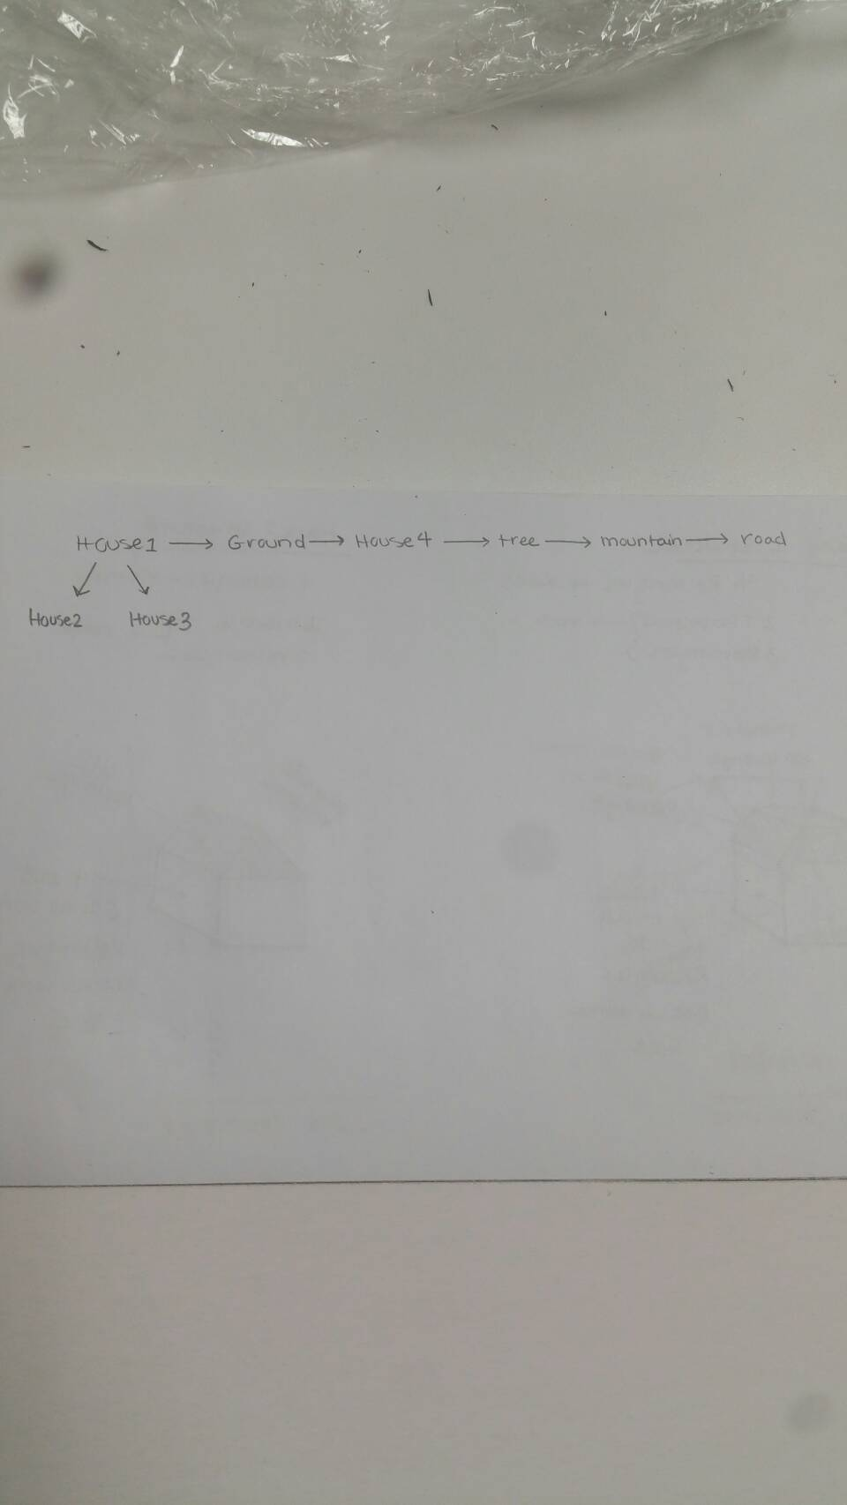

*Build Functions*

*House1 and House2 Structures*

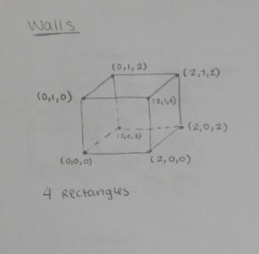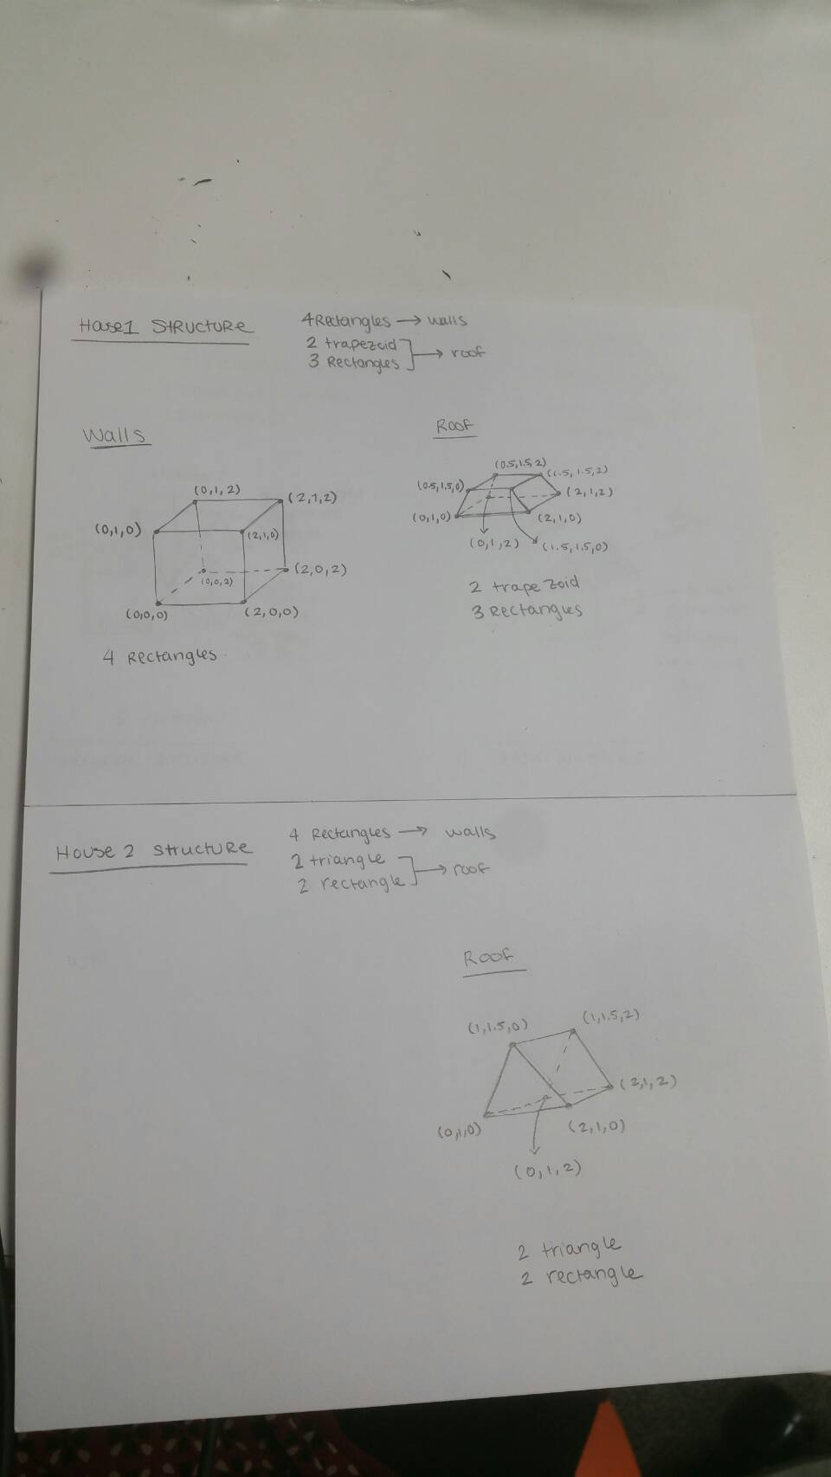

*Mountain, Tree, and Road Structures*

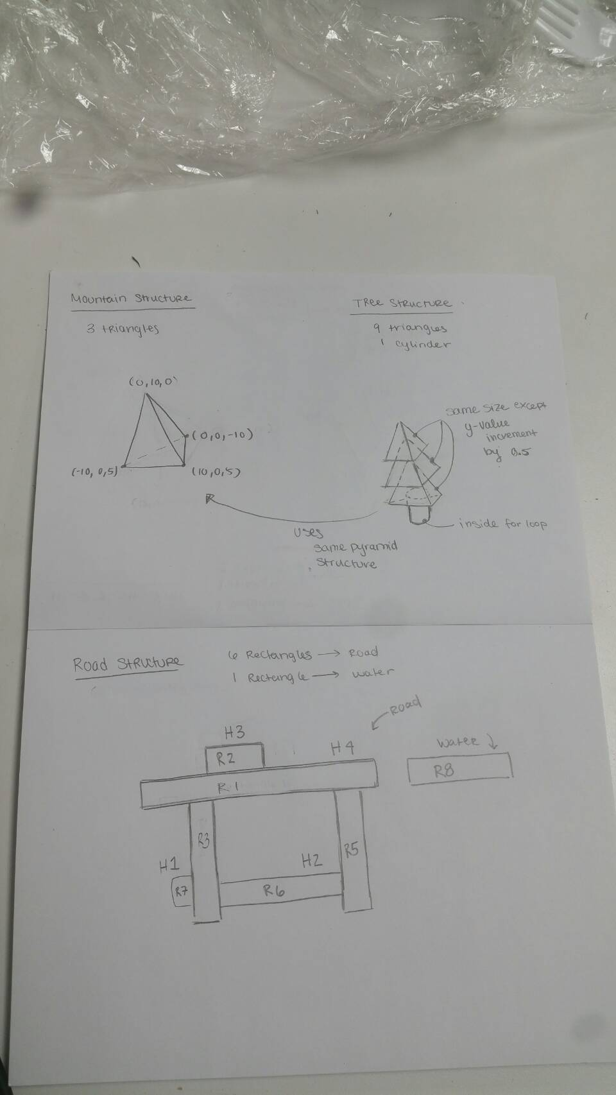

*Problem 1*

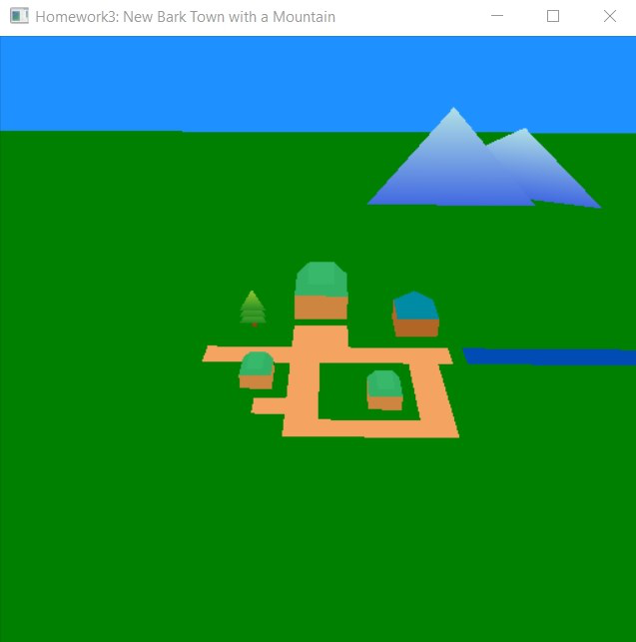

**Problem 2**

Using the same structure, instancing was added by creating another buffer that holds the vector shifts and saving it within the tree vertex array object as an attribute. The shader was changed for the tree program so that the attribute array can be manipulated so that the tree object so that they will render in different places.

In the scene, the trees were drawn so that they outlined the town, and then another patch of randomly placed trees were added using instancing.

*Problem 2*

