This document describes how to build the product LNA4P4G5GW.

**Step 1: Assemble PCB**

Assemble PCB-10525. Do not install 2.2 uF capacitor.

**Step 2: Assemble SMA Connector using Conductive Glue**

The conductive glue only has 10 minutes life. Therefore, we should only install at most 10 LNAs in each batch.

**Step 3: Test LNA on VNA.**

**Step 4: Test LNA on NF**

**Step 5: Install EMI Gasket**

Cut 3” of SHI-80003 0.062” EMI Gasket based on Figure 1.

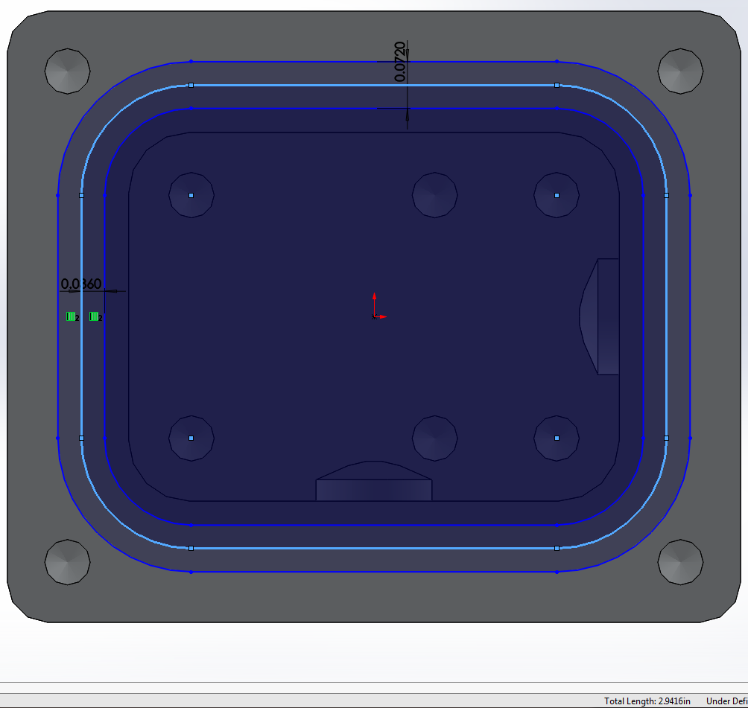

Figure . EMI Gasket (2.94”+0.060” = 3”)

**Step 6: Install EMI Shield Rubber Cover**

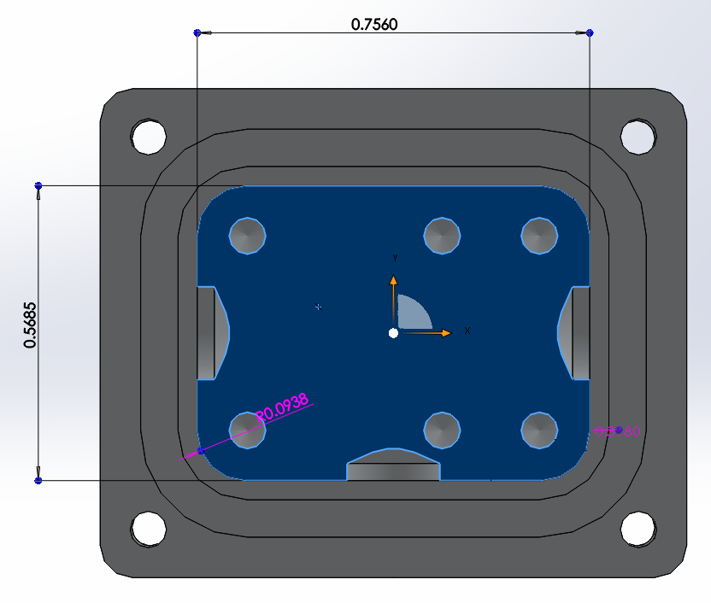

Figure 2. EMI Shield Rubber Cover (0.525”x0.715”x0.125”)

Slightly cut four corners by surgical knife to make sure it fit in the Enclosure. Never try to push the cover with force on the Enclosure.

**Step 7: Apply Product Label and RevB label**

**Step 8: Install ComTech Backplate**