**50Ω Wide Band, Ultra Low Noise (0.3dB) LNA**

Case PN: 6DD2W6H41SA2W

**Features:**

**Applications:**

**\* 4.5G, 5G Massive MIMO**

**\* Repeaters/DAS**

**\* Mobile Infrastructure**

**\* LTE/WCDMA/CDMA/GSM**

**\* General Purpose Wireless**

**\* SDR & Ham Radio**

**\* Test Instrumentation**

**\* Frequency Range: 100 MHz to 6 GHz;**

**\* Noise Figure: typical 0.3 dB @ 1.9 GHz**

**\* Gain: 19.5 dB small signal Gain at 1.9 GHz**

**\* Output P1dB: +22 dBm CW**

**\* +39 dBm OIP3 at 65mA current**

**\* +3.3 to +5V Supply (+5V recommended)**

**\* SMA Female Connector (ROHS Compliant)**

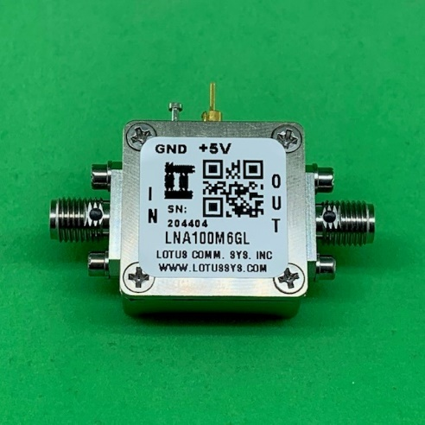 **\* High Quality Rogers RO4350 RF PCB**

**(very low loss and high thermal performance)**

**\* EMI Shielded (&IP67 Waterproof)**

**General Description:**

|  |
| --- |
| **LNA100M6GLW** is an ultra-low noise, high-linearity amplifier in a small 15/16”x15/16”x0.49” shielded RF enclosure. At 1.9GHz, the LNA provides 19.5 dB gain, +39 dBm OIP3 at a 65mA bias setting, and 0.3 dB noise figure. The LNA can be biased from a single supply +3.3V to +5V. The LNA is EMI shielded and IP67 waterproof. |

**Electrical Specifications:**

|  |  |  |  |  |  |  |
| --- | --- | --- | --- | --- | --- | --- |
| **Item** | **Parameter** | **Condition** | **Electrical Specification** | | | |
| **MIN** | **TYP** | **MAX** | **UNITS** |
| 1 | Operational Frequency Range |  | 100 |  | 6000 | MHz |
| 2 | Test Frequency |  |  | 1900 |  | MHz |
| 3 | Gain |  | 17.5 | 19.5 |  | dB |
| 4 | Input Return Loss |  |  | 12.2 |  | dB |
| 5 | Output Return Loss |  |  | 13.5 |  | dB |
| 6 | Noise Figure |  |  | 0.3 | 0.5 | dB |
| 7 | Output P1dB |  | +21 | +22.7 |  | dBm |
| 8 | Output IP3 | Pout=+2 dBm/tone, ∆f=1MHz | +35 | +39.3 |  | dBm |
| 9 | Operating Current (Quiescent) |  |  | 65 |  | mA |

**Absolute Maximum Ratings**

|  |  |  |  |
| --- | --- | --- | --- |
| **Item** | **Parameter** | **Rating** | **UNITS** |
| 1 | Max Device Voltage | +7 | V |
| 2 | Max Input Power,CW,50Ω,T=25oC | +22 | dBm |
| 3 | Operating Temperature | -40 to +85 | oC |
| 4 | Max Storage Temperature | -65 to +150 | oC |

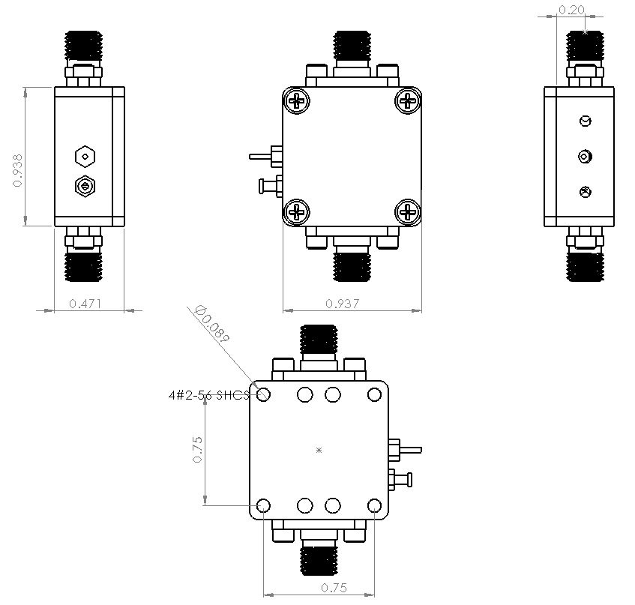**Outline Drawing (inch)**

Four #2-56 Holes on the Bottom for Mounting

**S-Parameters**

**Noise Figure (including PCB+SMA Connectors)**

|  |  |
| --- | --- |
| RF Frequency  (GHz) | Noise Figure (dB) |
| 0.1 | 0.39 |
| 0.69 | 0.52 |
| 1.28 | 0.42 |
| 1.87 | 0.51 |
| 2.46 | 0.60 |
| 3.05 | 0.77 |
| 3.64 | 0.92 |
| 4.23 | 1.01 |
| 4.82 | 1.35 |
| 5.41 | 1.48 |
| 6.0 | 1.50 |