Digital Communications Project

Toka Magdi                    3236

Mostafa Ali Mansour      3250

Louay Hesham Saber    3303

Mahinour El Sheikh        3334

Essam Ewaisha              3336

Yomna Barakat                3341

Fatma Nader                  3346

# Experiment 1: *Introduction of probability error calculation*



“Measured” in AWGN method will make the function measure power before adding the noise. We can achieve almost no errors with SNR of value 16~17 dB or more.

# Experiment 2: *Performance of matched filters and correlators*

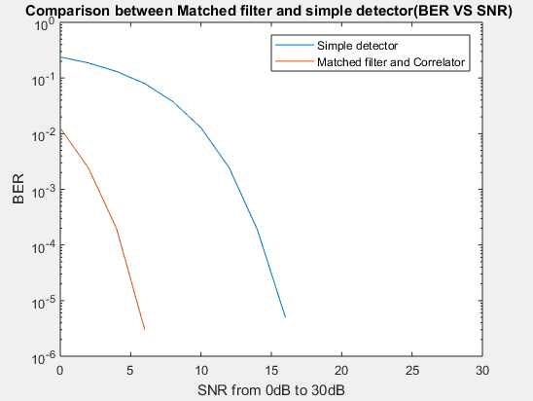

* The matched filter is the optimal linear filter for maximizing the signal-to-noise ratio (SNR) in the presence of additive stochastic noise. It gives better results than the simple detector.
* The probability of detection increases with increasing SNR.
* The SNR system is nearly without an error at value 6 dB.
* Used references:
  + <https://stackoverflow.com/questions/26085639/create-continuous-time-waveform-from-bit-sequence-matlab>
  + <https://ch.mathworks.com/help/phased/ug/matched-filtering.html>
  + <https://crewes.org/ForOurSponsors/ResearchReports/2002/2002-46.pdf>

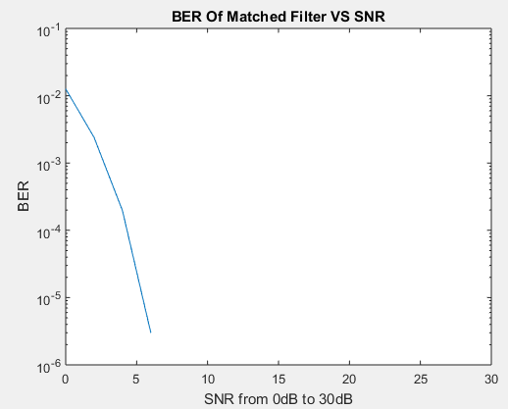

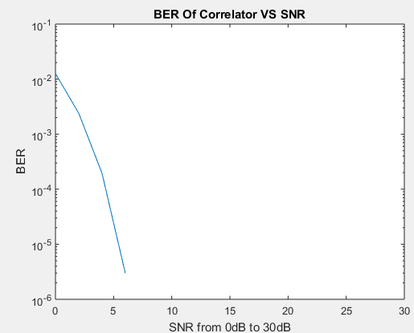

# Experiment 4: *Pulse code Modulation*

|  |
| --- |
| N=3 |
|  |
| The value of MSE when n = 3 is 0.001193 |

|  |
| --- |
| N=4 |
|  |
| The value of MSE when n = 4 is 0.000306 |

|  |
| --- |
| N=5 |
|  |
| The value of MSE when n = 5 is 0.000078 |

|  |
| --- |
| N=5 |
|  |
| The value of MSE when n = 10 is 0.000000 |

**AS seen above as number of bits increase the signal become smoother and mean square quantization error decrease.**

**Part 2: Sampling distortion**

|  |
| --- |
|  |
|  |
|  |

|  |
| --- |
| **Sampling** |
| |  |  |  | | --- | --- | --- | | **Over sampling** | **Critical sampling** | **Under sampling** | | **fs>2fm**  **signal can be recovered by using low pass filter** | **Fs = 2fm**  **Can be recovered by ideal low pass filter** | **Fs < 2fm**  **Unable to reconstruct signal after transmission** | |

# Experiment 5: Delta – Modulation types

For the following figures (Delta =0.3, Fs=10000)

Sine wave modulation:

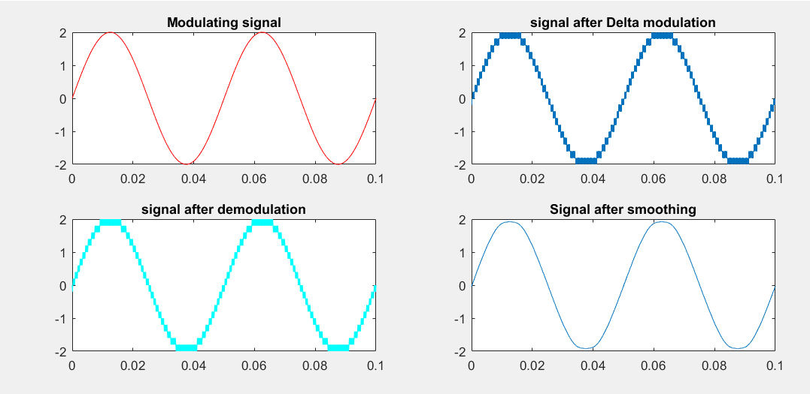

**The mean-squared error is 0.0012**

2)Square wave modulation.

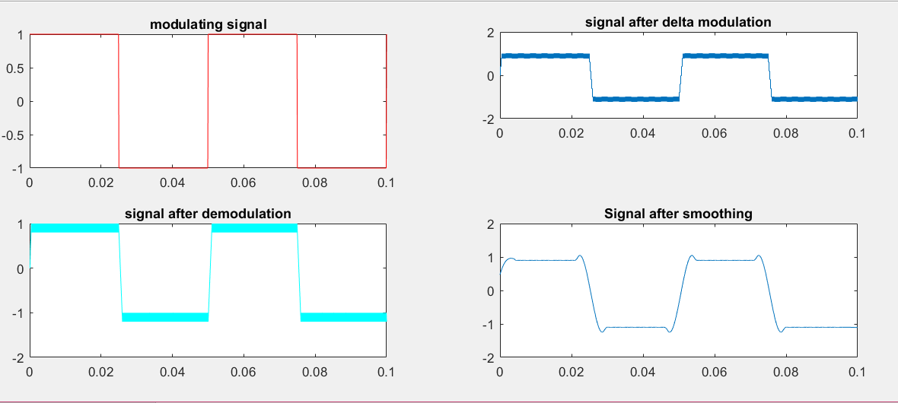

**The mean-squared error is 0.0627.**

3)DC voltage

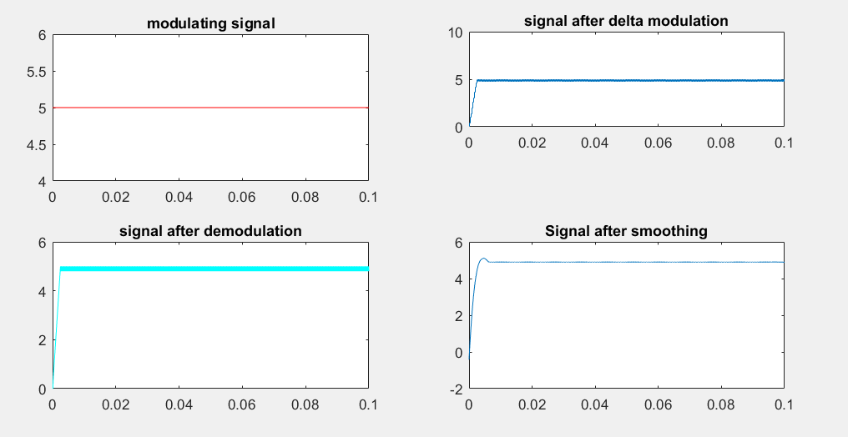

**The mean-squared error is 0.2297**

**Comment:**

As seen above, the lowest error is that of the sine wave, this is because in the case of the DC voltage granular noise is introduced and in the case of square wave as well the granular noise will affect the signal as it stays constant then gets affected by the slope overload when it decreases from one to zero in very small time.

**How to overcome errors that result from delta modulation?**

1. **Slope overload distortion**

This distortion arises because of large dynamic range of input signal. To reduce this error, the step size must be increased when slope of signal x(t) is high. Since the step size of delta modulator remains fixed, its maximum or minimum slopes occur along straight lines. Therefore, this modulator is known as Linear Delta Modulator (LDM).

1. **Granular noise**

Granular noise occurs when step size is too large compared to small variations in the input signal. This means that for very small variations in the input signal, the staircase signal is changed by large amount because of large step size. The error between the input and approximated signal is called granular noise. The solution to this problem is to make step size small. Adaptive Delta Modulation

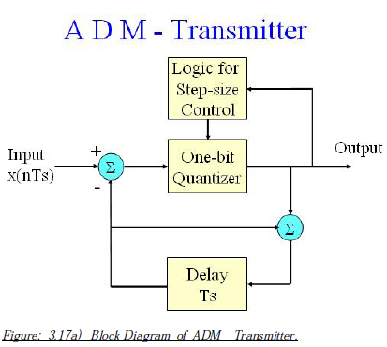To overcome the quantization error due to slope overload distortion and granular noise, the step size (Δ) is made adaptive to variations in input signal x(t). Particularly in the step segment of the x(t) , the step size is increased. Also, if the input is varying slowly, the step size is reduced. Then this method is known as Adaptive Delta Modulation (ADM). The adaptive delta modulators can take continuous changes in the step size or discrete changes in the step size