Digital Communications Project

Toka Magdi                    3236

Mostafa Ali Mansour      3250

Louay Hesham Saber    3303

Mahinour El Sheikh        3334

Essam Ewaisha              3336

Yomna Barakat                3341

Fatma Nader                  3346

# Experiment 1: *Introduction of probability error calculation*



“Measured” in AWGN method will make the function measure power before adding the noise. We can achieve almost no errors with SNR of value 16~17 dB or more.

# Experiment 2: *Performance of matched filters and correlators*

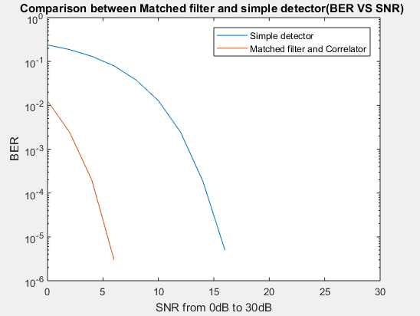

* The matched filter is the optimal linear filter for maximizing the signal-to-noise ratio (SNR) in the presence of additive stochastic noise. It gives better results than the simple detector.
* The probability of detection increases with increasing SNR.
* The SNR system is nearly without an error at value 6 dB.

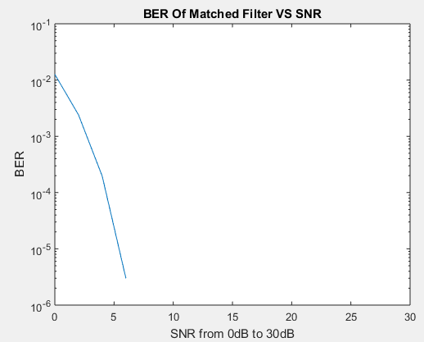

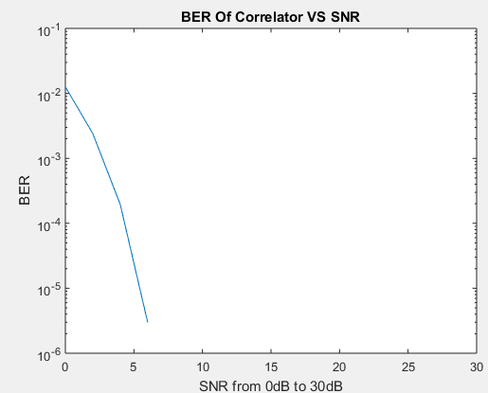

# Experiment 3: *Performance of Different Modulation types:*

*\* note we used a binary Data vector of 1000 since 1^6 is so long to run.*

*We tried using built in functions first and got the following result :*

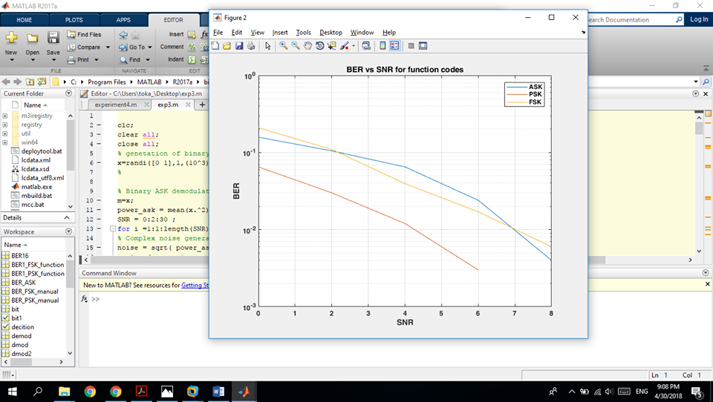

then we used the functions that we made and got this result :

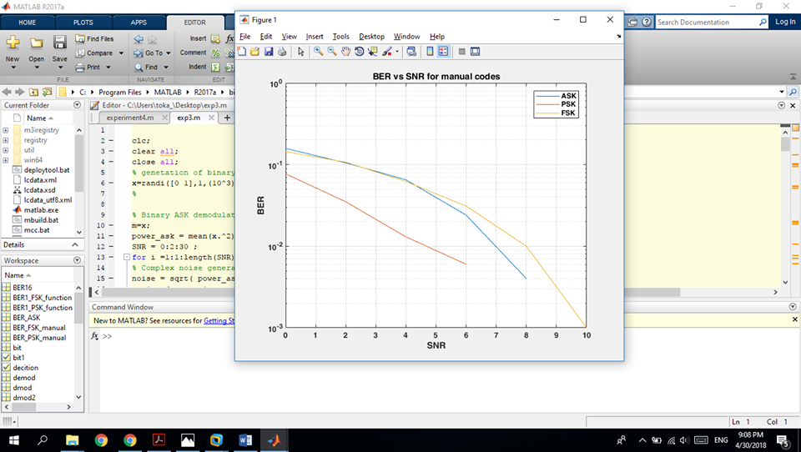

16-QAM plot of BER and SNR 0 to 30 :

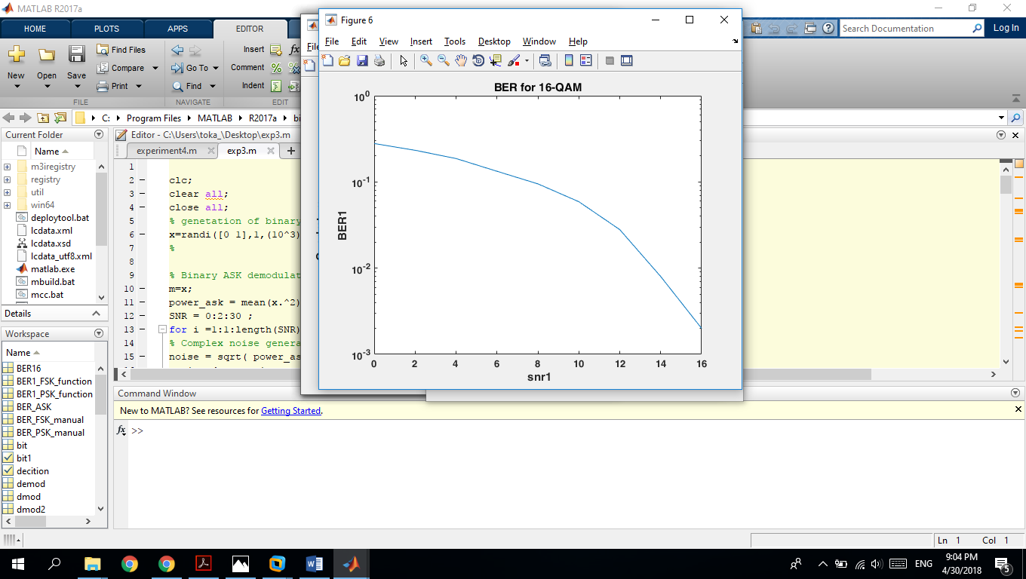

constellation diagram of the 16QAM at SNR = 0 dB:

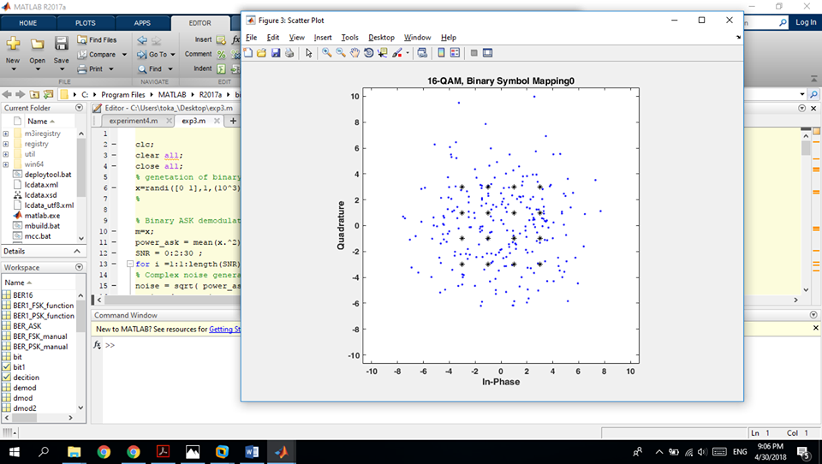

# 

# constellation diagram of the 16QAM at SNR = 15 dB

# constellation diagram of the 16QAM at SNR = 30 dB

# 

# PSK is the best modulation because from the graph we can see that at any snr its always the PSK that has the smallest value.

At which value of SNR the system is nearly without error (for

each type of modulation)?

ASK at SNR 8

PSK at SNR at 6

FSK at 10

16-QAM at 16

# Experiment 4: *Pulse code Modulation*

|  |
| --- |
| N=3 |
|  |
| The value of MSE when n = 3 is 0.001193 |

|  |
| --- |
| N=4 |
|  |
| The value of MSE when n = 4 is 0.000306 |

|  |
| --- |
| N=5 |
|  |
| The value of MSE when n = 5 is 0.000078 |

|  |
| --- |
| N=5 |
|  |
| The value of MSE when n = 10 is 0.000000 |

**AS seen above as number of bits increase the signal become smoother and mean square quantization error decrease.**

**Part 2: Sampling distortion**

|  |
| --- |
|  |
|  |
|  |

|  |
| --- |
| **Sampling** |
| |  |  |  | | --- | --- | --- | | **Over sampling** | **Critical sampling** | **Under sampling** | | **fs>2fm**  **signal can be recovered by using low pass filter** | **Fs = 2fm**  **Can be recovered by ideal low pass filter** | **Fs < 2fm**  **Unable to reconstruct signal after transmission** | |

# Experiment 5: Delta – Modulation types

For the following figures (Delta =0.3, Fs=10000)

Sine wave modulation:

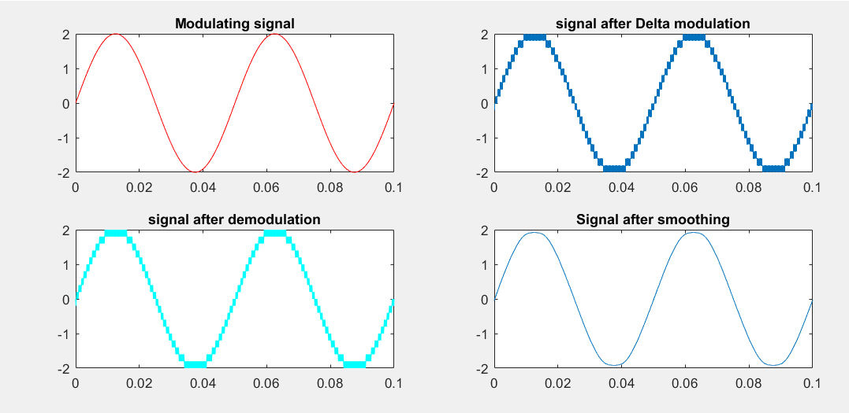

**The mean-squared error is 0.0012**

2)Square wave modulation.

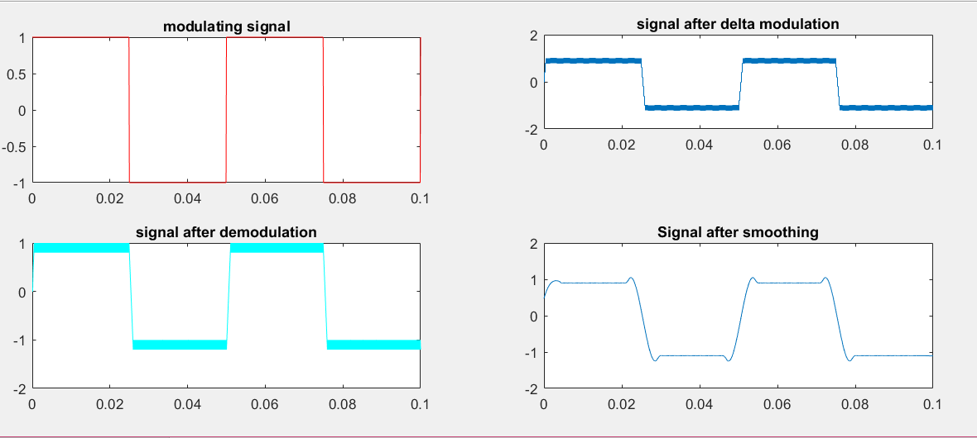

**The mean-squared error is 0.0627.**

3)DC voltage

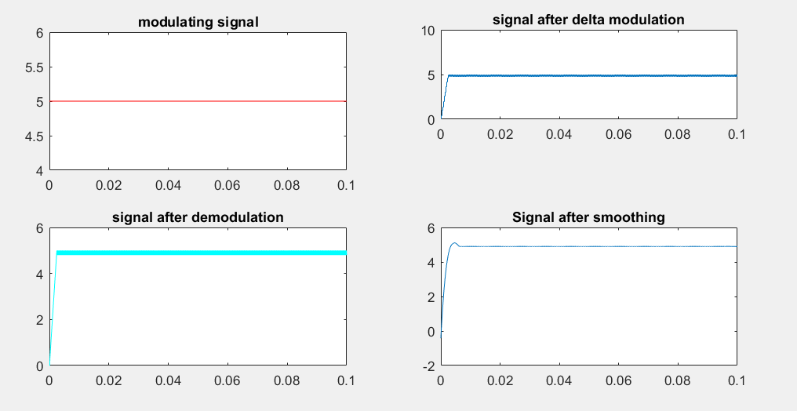

**The mean-squared error is 0.2297**

4)Delta = 0.1* old delta:

The height of the stairs function becomes very small and therefore the modulation doesn’t become as accurate.

**The mean-squared error is 0.0328**

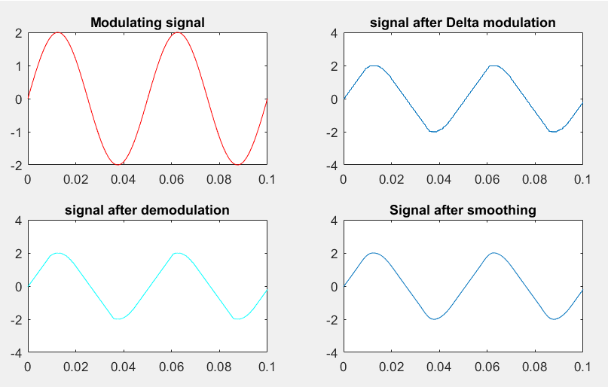

5) Ts= 0.1*Ts old

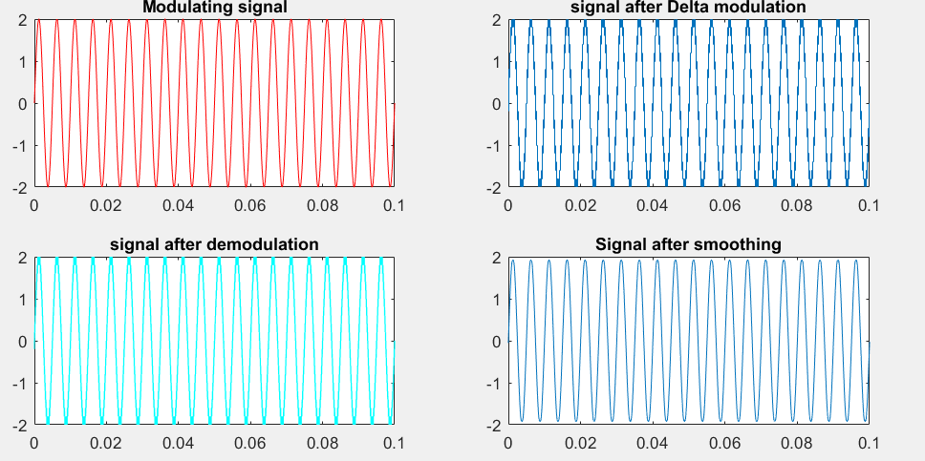

The mean-squared error is 0.0012

**Comments for all diagrams:**

As seen above, the lowest error is that of the sine wave, this is because in the case of the DC voltage granular noise is introduced and in the case of square wave as well the granular noise will affect the signal as it stays constant then gets affected by the slope overload when it decreases from one to zero in very small time.

**How to overcome errors that result from delta modulation?**

1. **Slope overload distortion**

This distortion arises because of large dynamic range of input signal. To reduce this error, the step size must be increased when slope of signal x(t) is high. Since the step size of delta modulator remains fixed, its maximum or minimum slopes occur along straight lines. Therefore, this modulator is known as Linear Delta Modulator (LDM).

1. **Granular noise**

Granular noise occurs when step size is too large compared to small variations in the input signal. This means that for very small variations in the input signal, the staircase signal is changed by large amount because of large step size. The error between the input and approximated signal is called granular noise. The solution to this problem is to make step size small. Adaptive Delta Modulation

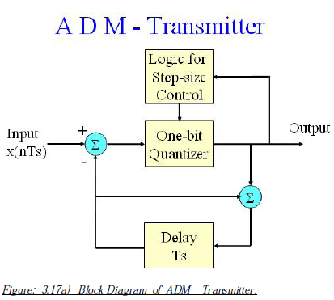To overcome the quantization error due to slope overload distortion and granular noise, the step size (Δ) is made adaptive to variations in input signal x(t). Particularly in the step segment of the x(t) , the step size is increased. Also, if the input is varying slowly, the step size is reduced. Then this method is known as Adaptive Delta Modulation (ADM). The adaptive delta modulators can take continuous changes in the step size or discrete changes in the step size

Experiment 6: LINE ENCODERS

1. **Polar Non return to zero**

If the bit is 0 the cycle will be –A/2 , While if the bit is 1 the cycle will be +A/2

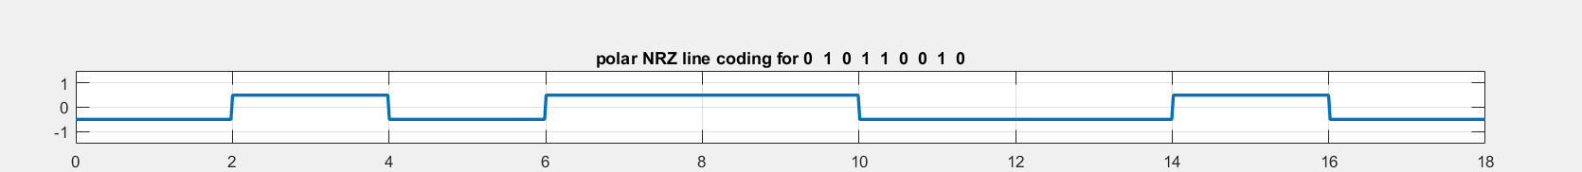

**Advantages:** The polar NRZ line code does not require a DC coupled channel, provided that the data toggles between binary 1’s and 0’s often and that equal numbers of 1’s and 0’s are sent. However, the circuitry that produces the polar NRZ signal requires a negative voltage power supply as well as the positive voltage power supply.

**Advantages:**

* It is simple.
* No DC component

**Disadvantages**:

* No error correction capability.
* No clocking component to synchronize to at receiver
* Can contain low frequency components (leads to signal drooping)

**2)Polar return to zero**

If the bit is 0 the cycle will be –A/2 , While if the bit is 1 the signal will be +A/2 for half the cycle then will return to zero the next half.



**Advantages:**

* It is simple.
* No low-frequency components are present.

**Disadvantages:**

* No error correction capability.
* No clocking component to synchronize to at receiver
* Occupies twice the bandwidth of Polar NRZ.
* Can contain low frequency components (leads to signal drooping)

**3)Manchester**

If the bit is zero the first half of the cycle is –A/2 and the second half A/2, While if the bit is 1 the signal will be +A/2 for half the cycle then –A/2 for the second half.



**Advantages:**

* No DC component
* No signal droop problem
* Easy to synchronize to the waveform

**Disadvantages:**

* Greater bandwidth required for this waveform
* No error correction capability

**Manchester have the biggest bandwidth**

**4)Alternative Mark Inversion**

When the bit is zero the signal is 0 and when it is 1 the signal Alternate between either A/2 or –A/2 in order (for example: the first 1 bit is A/2 and the second 1 bit is –A/2 ……….)



**Advantages:**

* It is simple.
* No low-frequency components are present.
* Occupies low bandwidth than unipolar and polar NRZ schemes.
* This technique is suitable for transmission over AC coupled lines, as signal drooping doesn’t occur here.
* A single error detection capability is present in this.

**Disadvantages:**

* No clocking component to synchronize to at receiver
* Limited error correction capability.

**5)MultiLevel**

If the bit is zero the cycle doesn’t change from its previous location , and when 1 the signal Alternate between either A/2 , 0 or –A/2 in order.



**Advantages:**

* It is simple.
* No low-frequency components are present.
* Occupies low bandwidth than unipolar and polar NRZ schemes.
* This technique is suitable for transmission over AC coupled lines, as signal drooping doesn’t occur here.
* A single error detection capability is present in this.

**Disadvantages:**

* No clocking component to synchronize to at receiver
* Limited error correction capability.

**6)Non-Return to zero invert**

If the bit is zero it invert from –A/2 to A/2 or vice versa but when 0 it remain in previous value



**7)Bipolar return to zero**

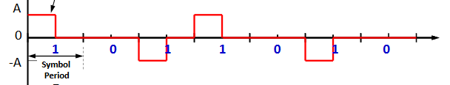

**Advantages:**

* It is simple.
* No low-frequency components are present.
* Occupies low bandwidth than unipolar and polar NRZ schemes.
* This technique is suitable for transmission over AC coupled lines, as signal drooping doesn’t occur here.
* A single error detection capability is present in this.

**Disadvantages:**

* No clocking component to synchronize to at receiver
* Limited error correction capability.

**Uni-Polar NRZ**

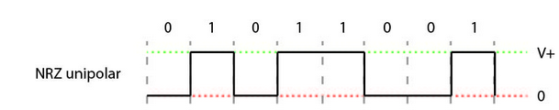

**Advantages:**

* It is simple.
* A lesser bandwidth is required.

**Disadvantages:**

* No error correction done.
* Presence of low frequency components may cause the signal droop.
* No clock is present.
* Loss of synchronization is likely to occur (especially for long strings of **1s** and **0s**).

**POWER SPECTRAL Density**

AS shown in the figure the power spectral density of Manshester is the biggest power as it have the bigger band width