Paint – User Guide

Main user interface:

The interface is really simple and straight forward. You can draw almost all geometrical shapes.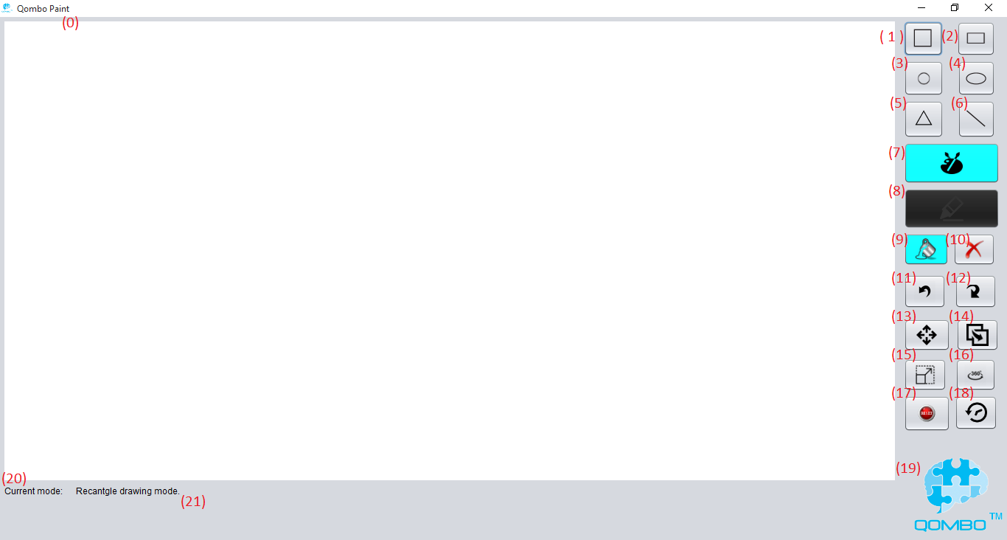

Figure 1

1. **Canvas**: the white drawing space that you will be creating your amazing shapes in.

Draw buttons:

1. **Square**: click the button and drag the mouse on the canvas to draw your square. (This shape will be rationalized to a square no matter how you drag it).
2. **Rectangle**: click the button and drag the mouse on the canvas to draw your rectangle.
3. **Circle**: click the button and drag the mouse on the canvas to draw your circle. (This shape will be rationalized to a perfect circle no matter how you drag it).
4. **Ellipse**: click the button and drag the mouse on the canvas to draw your ellipse.
5. **Triangle**: click the button and click the mouse in three different points on the canvas, these mouse clicks will be defined as the vertices of the triangle. After the third click, the triangle will appear magically on the canvas.
6. **Line**: click the button and draw the mouse on the canvas to draw your line.
7. **Fill Color**: click the button, another window will appear. Choose the desired fill color for your shape.
8. **Stroke Color**: click the button, another window will appear. Choose the desired stroke color for your shape.

Edit Buttons:

1. **Edit Color**: click the button, then choose a fill and/or a stroke color and press on the desired shape to edit the fill and/or stroke color.
2. **Delete Shape**: click on the button, then click on the shape you desire to delete.
3. **Undo**: will set you one step back.
4. **Redo**: will set you one step forward.
5. **Move**: click on the button, then drag the shape you desire to change its location.
6. **Copy**: click on the button, then drag the shape you desire to copy, it will make a new instance of this shape.
7. **Resize**: click on the button, then drag one corner of the shape you desire to resize. (please notice that the rotated shapes will not be resized)
8. **Rotate**: click on the button, then drag and rotate the shape you desire to change its orientation.
9. **Reset**: will give you a brand new canvas, and resets your history. (Use it under your own responsibility)
10. **Show History**: will display all the actions you have performed. You can return to certain step.
11. **Credits**: will display the credits. It is the logo of our team. (and a hidden feature ;) )
12. **Current Mode**: is the mode you selected.
13. **Helper Pane**: displays a help message, showing which mode you selected.

To exit the program, use the default close operation; which is clicking the x – button.

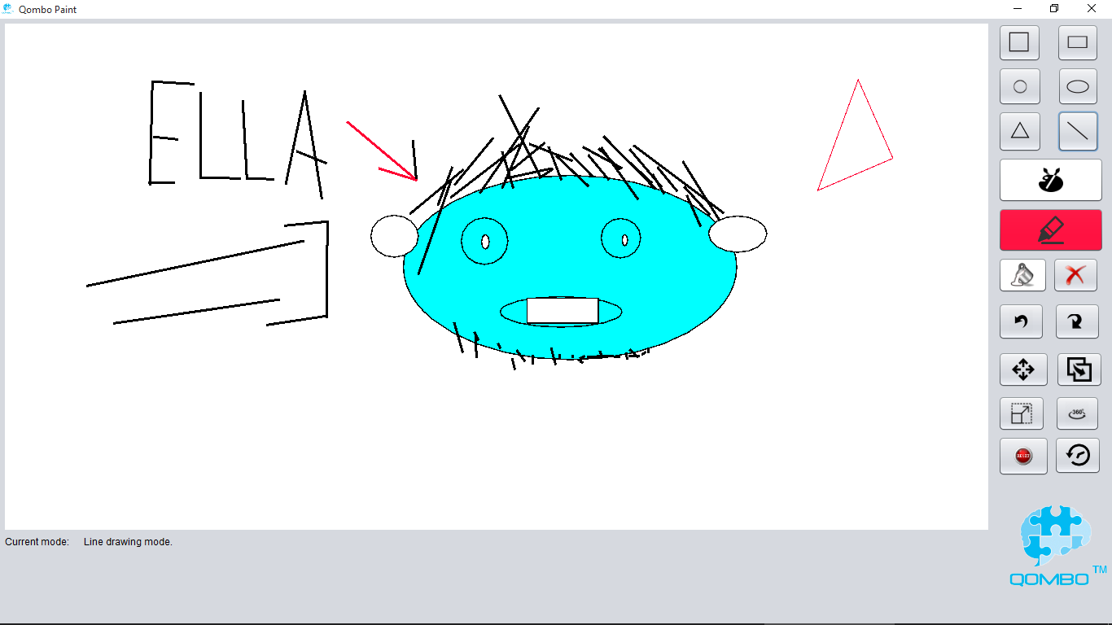

Figure 2 – “Ella” a wonderful character created by my 7 – year- old-nephew