Install module homepagecategorie
By Prestashop.

Go to the module tabs on click on « add a module »
Choose file homepagecategorie.zip and submit the form.
Look for « other modules » tabs and select the module and click on install.

By FTP :
Connect your Computer to your ftp server by a software like filezila.
On your desktop, unzip file homepagecategorie.zip
after that, take the folder homepagecategorie and put this on your modules folder on your FTP
Look for « other modules » tabs and select the module and click on install.
If the logo don't appear, please check the chmod of homepagecategorie folder and verify if there are in 755.

Configuration du module :
In the options, you 'll find 2 input, the first can define products nomber to display the second, the products category to display.

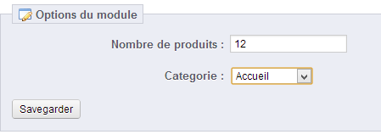
Click on Save

take a look on the front office;)
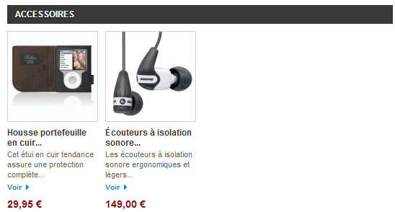
create by cookie-web.fr
enjoy;)

