Chapter 12: How to work with tables
HTML5 and CSS3 (4th edition)

MULTIPLE CHOICE

1. An HTML table can include all but one of these elements:
table, tr, th, td, thead, tbody, tdata, tfoot
Which one is it?
a. | table | c. | tbody
b. | td | d. | tdata

2. The data in an HTML table is defined by the
a. | tr element | c. | td element
b. | th element | d. | tdata element

3. To remove the space between the borders of adjacent cells, you use a CSS style rule that sets the border-collapse property
a. | for the table to collapse
b. | for the table to on
c. | for each row and column to collapse
d. | for each row and column to on

4. In the table that follows, CSS has been used to format
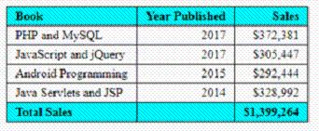
a. | background colors
b. | borders and background colors
c. | borders, alignment, and background colors
d. | borders, alignment, background colors, and border collapse

5. The main reason for dividing a table into header, body, and footer is to
a. | apply automatic formatting to those components
b. | make it easier to format those components with CSS
c. | provide automatic merging of the cells in those components
d. | make it easier to merge cells without using CSS

6. The CSS that follows
th.left, td.left { text-align: left; }
left aligns the text in the
a. | all header and data cells
b. | all header and data cells that have a class attribute set to “left”
c. | all header and data cells that have an id attribute set to “left”
d. | all header and data cells in the rows with a class attribute set to “left”

7. You can use the CSS3 structural pseudo-classes to format a table without using
a. | ids | c. | ids or classes
b. | classes | d. | element types

8. What does the following style rule?
tbody tr:nth-child(2n) {
background-color: gray;
}
a. | Sets the background color of every other row in the table, starting with the first row.
b. | Sets the background color of every other row in the table, starting with the second row.
c. | Sets the background color of the second column in each row of the table.
d. | Sets the background color of every other column in the second row of the table.

9. The best way to identify a table on a page is to
a. | use the caption element
b. | treat the table as a figure and use the caption element
c. | use the figcaption element
d. | treat the table as a figure and use the figcaption element

10. In the table that follows
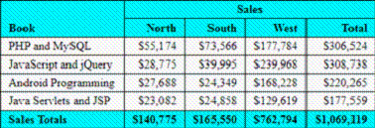
a. | the first cell in the first row spans two columns and two rows
b. | the second cell in the first row spans four columns
c. | the first cell in the last row spans two columns
d. | the first cell in the first row spans two rows

11. For accessibility, you can indicate that a cell is associated with a column or row by using a
a. | caption attribute | c. | headers attribute
b. | scope attribute | d. | figcaption attribute

12. To nest one table within another, you code the inner table within which element of the outer table?
a. | table | c. | tr
b. | th | d. | td

13. If a table doesn’t fit in the browser window, the data in the columns of a table
a. | wraps by default
b. | doesn’t wrap
c. | wraps if the white-space property is set to wrap
d. | doesn’t wrap if the white-space property is set wrap

14. One way to make a table responsive is to use a media query to
a. | display the th and td elements as inline elements
b. | display the tr and td elements as inline elements
c. | display the th and td elements as block elements
d. | display the tr and td elements as block elements

