Chapter 10: How to use Grid Layout for page layout and RWD
HTML5 and CSS3 (4th edition)

MULTIPLE CHOICE

1. A grid container consists of grid items
a. | that consist of one or more grid cells
b. | that consist of one or more columns
c. | that consist of one or more rows
d. | that consist of one or more grid tracks

2. A grid track is made up of
a. | a column within a grid container
b. | a row within a grid container
c. | a column or row within a grid container

3. The lines on each side of a grid column or row are called
a. | grid lines | c. | column lines
b. | track lines | d. | row lines

4. Two or more grid cells that form a rectangle can be combined into
a. | a grid track | c. | a grid container
b. | a grid area | d. | a grid cell

5. Unless you specify otherwise, grid items are laid out within a grid container
a. | from top to bottom and left to right
b. | from top to bottom and right to left
c. | from left to right and top to bottom
d. | from left to right and bottom to top

Code example 10-1
<main>
<div>Div 1</div>
<div>Div 2</div>
<div>Div 3</div>
<div>Div 4</div>
</main>

6. (Refer to code example 10-1) What CSS code would you use to lay out the div elements as follows?
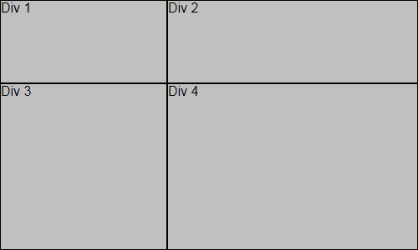
a. | main {  display: grid;  grid-template: 100px 200px / 200px 300px;  }
b. | main {  display: grid;  grid-template: 200px 300px / 100px 200px;  }
c. | main {  display: grid;  grid-template: 100px 200px, 200px 300px;  }
d. | main {  display: grid;  grid-template: 200px 300px, 100px 200px;  }

Code example 10-1
<main>
<div>Div 1</div>
<div>Div 2</div>
<div>Div 3</div>
<div>Div 4</div>
</main>

7. (Refer to code example 10-1) What CSS code could you use to add gaps between the div elements as follows?
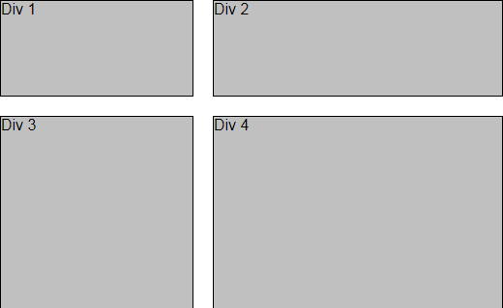
a. | grid-row-gap: 20px;  grid-column-gap: 20px;
b. | grid-gap: 20px 20px;
c. | grid-gap: 20px;
d. | all of the above

8. (Refer to code example 10-1) What CSS code could you use to lay out the div elements as follows?
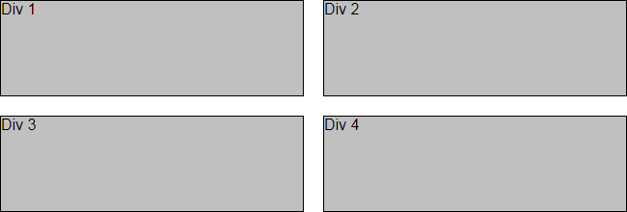
a. | grid-template-rows: repeat(2: 100px);  grid-template-columns: repeat(2: 1fr);
b. | grid-template-rows: repeat(2 100px);  grid-template-columns: repeat(2 1fr);
c. | grid-template: repeat(2, 100px) / repeat(2, 1fr);
d. | grid-template: repeat(2 100px) / repeat(2 1fr);

Code example 10-1
<main>
<div>Div 1</div>
<div>Div 2</div>
<div>Div 3</div>
<div>Div 4</div>
</main>

9. (Refer to code example 10-1) What CSS code could you use to lay out the div elements as follows?
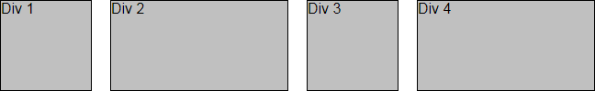
a. | grid-template: 100px / repeat(2, 100px 1fr);
b. | grid-template: 100px / repeat(2 (100px 1fr));
c. | grid-template: 100px / repeat(2, 100px / 1fr);
d. | grid-template: 100px / repeat(2 (100px, 1fr));

10. (Refer to code example 10-1) Given the CSS that follows, how many div elements will be displayed when the container is 300 pixels wide?
main {
display: grid;
grid-template: repeat(2, 50px) / repeat(auto-fit, minmax(100px, 1fr));
}
a. | 1 | c. | 3
b. | 2 | d. | 4

11. (Refer to code example 10-1) Given the CSS that follows, at what point will the grid items roll over to the next row track?
main {
display: grid;
grid-template: repeat(2, 50px) / repeat(auto-fit, minmax(100px, 1fr));
}
a. | when the container becomes narrower than 100 pixels
b. | when the container becomes narrower than 200 pixels
c. | when the container becomes narrower than 400 pixels
d. | never

12. The fr unit of measure represents
a. | a fraction of all of the space within a container
b. | a fraction of the available space within a container
c. | a fraction of all of the space within a grid track
d. | a fraction of the available space within a grid track

13. You typically use the fr unit when building
a. | fluid layouts
b. | responsive layouts
c. | fluid layouts or layouts with a combination of fixed and fluid tracks
d. | responsive layouts or layouts with a combination of fixed and fluid tracks

14. The minmax() function specifies
a. | the minimum and maximum sizes of a container
b. | the minimum and maximum sizes of a single track
c. | the minimum and maximum sizes of one or more tracks
d. | the minimum and maximum sizes of a grid area

15. When you use the auto-fit and auto-fill keywords on a repeat() function, as many grid items as will fit in the available space
a. | within a track will be placed in the track
b. | within a container will be placed in the container
c. | within a grid area will be placed in the grid area

16. You can align the row tracks within a container vertically
a. | if the row tracks are less than the width of the container
b. | if the column tracks are less than the width of the container
c. | if the row tracks are less than the height of the container
d. | if the column tracks are less than the height of the container

17. The default for both horizontal and vertical alignment of grid tracks is
a. | start | c. | center
b. | end | d. | stretch

Code example 10-2
<body>
<nav>
<div>Company Logo</div>
<div>Navigation</div>
</nav>
<section>
<div>Image</div>
</section>
<main>
<aside>Sidebar</aside>
<article>Article</article>
</main>
<footer>
<p>Copyright Notice</p>
</footer>
</body>

18. (Refer to code example 10-2) Given the CSS that follows, what CSS would you use to align the navigation menu at the bottom of the nav element?
nav {
display: grid;
width: 100%;
grid-template: 100px / 150px 1fr;
grid-gap: 25px;
}
a. | nav div:nth-of-type(2) { justify-self: bottom; }
b. | nav div:nth-of-type(2) { justify-self: end; }
c. | nav div:nth-of-type(2) { align-self: bottom; }
d. | nav div:nth-of-type(2) { align-self: end; }

Code example 10-2
<body>
<nav>
<div>Company Logo</div>
<div>Navigation</div>
</nav>
<section>
<div>Image</div>
</section>
<main>
<aside>Sidebar</aside>
<article>Article</article>
</main>
<footer>
<p>Copyright Notice</p>
</footer>
</body>

19. (Refer to code example 10-2) Given the CSS that follows, what CSS would you use to center the <p> element horizontally and vertically in the footer?
footer {
display: grid;
grid-template: 50px / 100%;
}
a. | footer {  align-content: center;  justify-content: center:  }
b. | footer {  align-items: center;  justify-items: center:  }
c. | p {  align-content: center;  justify-content: center:  }
d. | p {  align-items: center;  justify-items: center:  }

20. You use the grid-row and grid-column properties to define grid areas when you use
a. | numbered lines | c. | template areas
b. | named lines | d. | named or numbered lines

21. You use the grid-area property to place an element within a grid area when you use
a. | numbered lines | c. | template areas
b. | named lines | d. | named or numbered lines

22. Which of the following CSS style rules positions a section element in row tracks 2 through 4 and column tracks 2 and 3 of a grid container?
a. | section {  grid-row: 2 / 5;  grid-column: 2 / 4;  }
b. | section {  grid-row: 2 5;  grid-column: 2 4;  }
c. | section {  grid-row: 2 / 4;  grid-column: 2 / 3;  }
d. | section {  grid-row: 2 4;  grid-column: 2 3;  }

23. When you define grid areas for a grid with grid gaps, the gaps
a. | are added between each grid cell
b. | are added between each column and row gap
c. | are added between the grid areas
d. | aren’t added

24. When you use numbered lines to layout the elements in a grid container, you use the grid-row and grid-column properties to specify
a. | the template area for each element in the container
b. | the grid area for each element in the container
c. | the rows and columns for the grid areas in the container
d. | the rows and columns for the template areas in the container

25. When you use template names for page layout,
a. | you first define the grid areas and then assign elements to those areas
b. | you first define the template areas and then assign elements to those areas
c. | each element gets assigned to one template area
d. | each template area becomes one grid area

26. If you don’t want to assign a name to a cell when you use grid template areas, what do you code on the grid-template-areas property as a placeholder?
a. | ? | c. | #
b. | - | d. | .

27. To implement the 12-column grid concept, you use
a. | numbered lines | c. | template areas
b. | named lines

28. Which style rule is equivalent to the style rule that follows?
section {
grid-row: 3 / 5;
grid-column: 5 / 13;
}
a. | section {  grid-row: 3 / 5;  grid-column: 5 / span 9;  } | c. | section {  grid-row: 3 / span 3;  grid-column: 5 / span 9;  }
b. | section {  grid-row: 3 / span 3;  grid-column: 5 / 13;  } | d. | section {  grid-row: 3 / 5;  grid-column: 5 / span 8;  }

