Our Plain text for this assignment was: “This is our SeCrEt MeSsAgE!!! This message may not be much, but it is ours.”

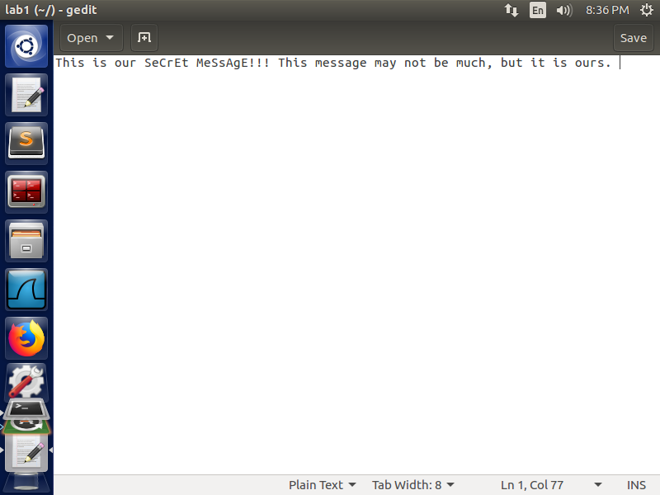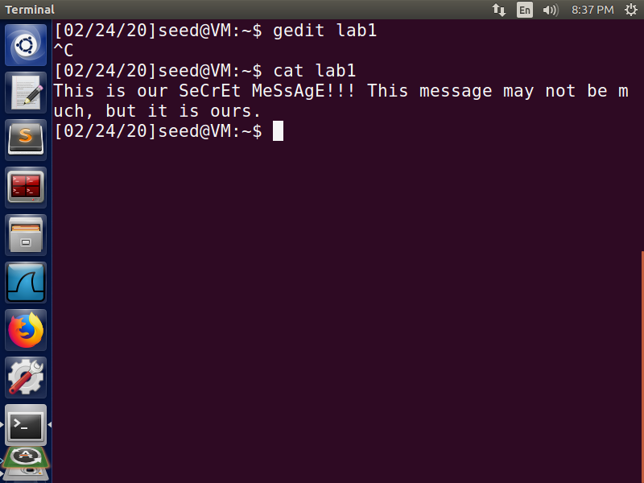

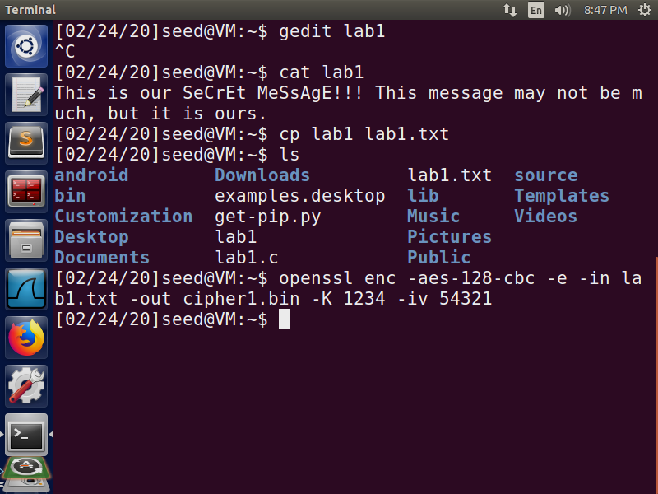

For the first cipher, we used our message, aes-128-cbc, a key of “1234”, and an IV of “54321”

The ciphertext was (hex):

0000000 64d9 5f5b c677 71ec a438 2323 9f30 71c4

0000010 7161 e7d1 8a97 7ae8 edc9 8b40 53f8 0df9

0000020 26a3 91d7 8824 4e00 f70e 9a69 7e1b 88cf

0000030 3830 4d92 cba7 6316 bcc1 dd26 352f 40a2

0000040 7a32 3c4f 56ec c74b ed98 1799 43b5 9129

0000050

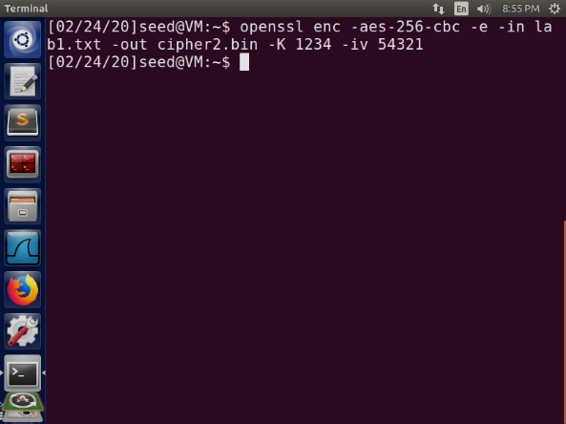

For our next cipher, we chose to use aes-256-cbc, the same key and IV.

Our ciphertext was (hex):

0000000 c55d 7830 c5cd e5cb fe56 66c9 ea15 f740

0000010 8c64 05f5 b574 7155 ec04 1145 9fe1 c5aa

0000020 ceb4 6abe 3ad2 290b 076b 2d49 6506 87dd

0000030 71f0 841b 1ba4 07e3 67ec f637 ee3a 6cd2

0000040 c396 0270 8bec 2051 ae5d fb85 54f2 7599

0000050

And lastly, we chose to use des-cbc, the same key and IV.

Our ciphertext was (hex):

0000000 daba bbcd e23a f515 3b85 86b2 b45e 32ad

0000010 2578 c1f5 204b 8cfd b850 3b56 0e72 9cc8

0000020 dc38 a3cb f424 245a 5dcc 1dce 1837 bbbf

0000030 af6a bad6 db13 5e3b f541 3ef0 e18b 2829

0000040 7655 8b6b 8edc 9e21 a4dd 1692 d8de 5918

0000050

The decryption worked as well:

