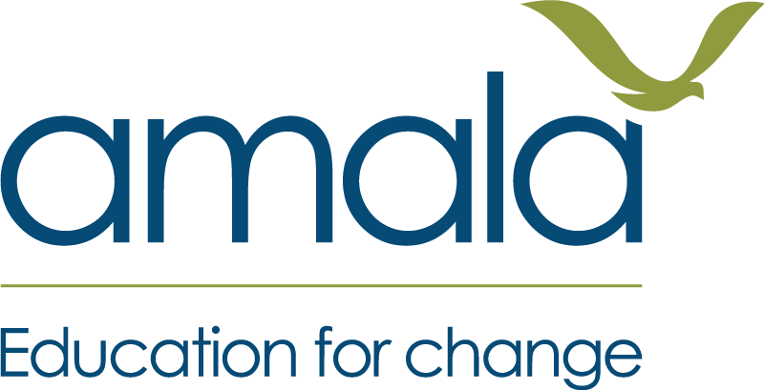
My Learning Book
Agency in Learning
My name: ________________________________________
My place: ________________________________________
You do not have to write. You can draw, colour, and say your answers.

Week 1 You can grow
Draw a time you got better at something that was hard at first.
draw here
I got better at: ________________________________________
What helped me: ________________________________________

Week 1 What I am good at
Draw or mark what you are good at as a learner.
I am good at...
What I want to grow
I want to grow...

Week 1 How I learn best
Mark when you learn best, and who and what helps you.
When I learn best (mark the times): morning · midday · evening · night
Where I learn best, and who helps me — draw here
What helps me learn: ________________________________________
What gets in my way: ________________________________________

Week 2 My goal
Draw the thing you want to be able to do.
draw your goal here
I want to be able to: ________________________________________
It matters to me because: ________________________________________

Week 2 My steps
Draw your steps. Colour the first step you can reach.
My goal (top)
step 3
step 2
step 1 — colour this one — I can reach it this week

Week 2 My first step
Draw or write the one small step you will take this week.
draw or write here
I will do it on (day): ________________________________________
☐ I said my goal and my first step out loud to my partner.

