
THE ENGLISH CHECK
Baseline
Sit this in the first session, before any teaching.
One per learner. Write each learner’s own name into it beforehand, everywhere the page says [learner’s name] — three tasks depend on it. This paper contains no answers.

The English Check — BASELINE
Take this in the first session, before any teaching. The endline paper is the same tasks in the same order with different content — see ENGLISH-ASSESSMENT-ENDLINE.md.
Answers and mark schemes are at the end and print separately. They never go in a learner's paper.
Learner name __________________ Block ____ Date ____ Facilitator __________ Say this before you start, in the language you share: "This is not an exam. Nobody passes and nobody fails. It shows me what to teach you. Some parts will be too hard — leave those and go on. You can stop whenever you like."
Most learners will not finish every part. That is expected.

PART 1 — READING
About 28 minutes. Read every instruction aloud in the language you share. Do not translate the questions themselves.

1.1 — Circle the letter you hear (10 marks)
Facilitator: say each sound, not the letter name. Say each one twice. "Circle the letter that says /s/."
 | S | m | a | T | o
 | n | L | u | c | t

Order to say: /s/ · /m/ · /a/ · /t/ ("the big one") · /o/ · /n/ · /l/ · /u/ · /k/ · /t/ ("the small one")

1.2 — Circle your name (1 mark)
Facilitator: write the learner's own name in the first box before the session.
[learner's name] | Rashid | Anwara | Jubair

1.3 — Circle the word you hear (5 marks)
Say each word twice, in this order: am · like · I · from · [learner's name]
1. | in | am | on | an
2. | look | live | like | lake
3. | I | a | it | is
4. | for | from | form | four
5. | [learner's name] | Rashid | Anwara | Jubair

1.4 — Circle the word that is written correctly (3 marks)
Picture
 | mat | tam | mta
 | nac | can | acn
 | uns | snu | sun

1.5 — Words and pictures (4 marks)
Draw a line from each word to its picture. There are two pictures you will not use.
Words: sun · man · sock · nut
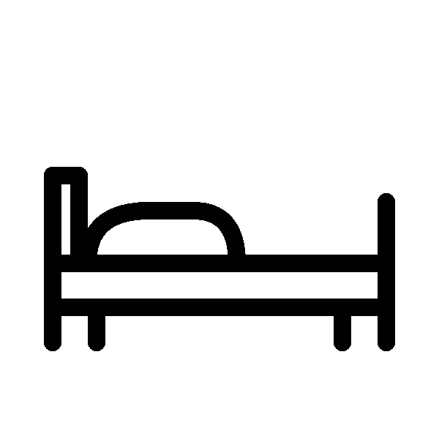 |  |  |  |  | 
1 | 2 | 3 | 4 | 5 | 6

1.6 — Signs (3 marks)
Write the letter of the correct meaning next to each sign. There are two meanings you will not use.
Sign | Meaning
1. OPEN 9 – 4 _ | A. You can get water here.
2. NO ENTRY _ | B. Do not go in.
3. WATER HERE _ | C. This place is open in the day.
 | D. Wash your hands.
 | E. Wait outside.

1.7 — Choose the word (4 marks)
Write one word from the box in each gap. There are three words you will not use. go · eat · drink · sleep · read · help · wash
1. Every morning I ________ water. 2. I ________ to the learning centre at eight o'clock. 3. At night I ________ for eight hours. 4. I ________ my hands before I eat.

1.8 — About Sokina (2 marks)
My name is Sokina. I am seventeen years old. I live in Block C with my mother and my two brothers. I come to the learning centre every day. I like English and drawing.
1. How old is Sokina? ________ 2. Who does Sokina live with? ________________________

1.9 — A message (3 marks)
Hi Anwara. I am going to the market at 3 o'clock today. Can you come with me? My sister is coming too. Please tell me. — Jannat
1. Who wrote this message? ________ 2. What time is Jannat going? ________ 3. Who else is coming? ________

1.10 — A notice (4 marks)
LEARNING CENTRE — NOTICE The learning centre is open from Saturday to Wednesday. Classes start at 9 o'clock in the morning and finish at 12 o'clock. On Thursday the centre is closed. English class is on Saturday and Monday. If you cannot come, please tell your teacher. In the rainy season, classes may start late. Please wait at the gate.
1. What time do classes start? ________ 2. Which day is the centre closed? ________
3. English class is on: A) Saturday and Monday B) every day C) Thursday D) Sunday
4. In the rainy season, classes may: A) finish early B) start late C) move to Thursday D) stop

1.11 — A timetable (3 marks)
 | 9 – 10 | 10 – 11 | 11 – 12
Saturday | English | Maths | Life Skills
Sunday | Maths | English | Drawing
Monday | English | Life Skills | Maths
Tuesday | Life Skills | English | Maths
Wednesday | Maths | Life Skills | English
1. How many days is there an English class? ________ 2. What is the class on Sunday at 11 – 12? ________ 3. You want English and Drawing on the same day. Which day? ________

1.12 — Nur's group (3 marks)
This part is harder. If it is too hard, leave it and go on to Part 2. Nur Begum is twenty and lives in Camp 12. Two years ago she joined an English class, but she noticed that many of her friends stopped coming after a few weeks. When she asked them why, most said the same thing: they were too shy to speak in front of a big group. So Nur tried something small. Every Friday she invited four neighbours to sit outside her shelter and practise English for one hour. There was no teacher and no book. They simply asked each other questions and helped each other find words. At first the group was quiet. After a month the four women were talking easily, and two of them went back to the class. Others asked to join, so Nur now runs two groups. She says the important thing is not the English. It is that nobody laughs when someone makes a mistake.
1. What is the text mainly about? A) why English classes are difficult B) how Nur made a small, safe place to practise English C) how much it costs to learn English D) why teachers are important
2. Why did Nur's friends stop coming to the class? ____________________________________
3. Find one word in the text that means "afraid to speak in front of other people". ______

PART 2 — WRITING
About 22 minutes.

2.1 — Write your name (3 marks)
___________________________

2.2 — Copy this and finish it (4 marks)
Like this: I am Nur. or I like rice.
I am ___________

2.3 — Fill in the form (6 marks)
Name
Age
Female / Male
Block
Learning centre
Languages you speak
A phone number we can use
Today's date

2.4 — Five sentences about you (4 marks)
Like this: I am Nur. I am 16. I like rice. I live in Block C. I come to the learning centre.
Write five true sentences about yourself. You choose what to write.
1. ________________________________________ 2. ________________________________________ 3. ________________________________________ 4. ________________________________________ 5. ________________________________________

2.5 — A note to your teacher (6 marks)
Tomorrow you cannot come to class. Write a note to your teacher. Write about 40 words.
Say three things: that you cannot come · why · when you will come back.
(Six ruled lines)

2.6 — A letter (7 marks)
This part is harder. If it is too hard, leave it.
Write a letter to a friend about something you learned to do. It can be anything — a skill, a subject, cooking, a repair, a language.
Say three things: what you learned · who or what helped you · how you felt when you could do it.
Write 100–120 words.
(Fourteen ruled lines)

PART 3 — SPEAKING
Optional. Six minutes, one learner at a time, in a quiet corner. Same-gender pairing where it matters. The learner may pass on anything.
 | What you say | Time
Warm-up (not scored) | "Hello. My name is _. What is your name?" | 30s
1. About you | your name · your age, or how long you have been here · who you live with. Do not ask where they are from. | 90s
2. The picture | "What can you see? Tell me about this picture." | 90s
3. Questions | "What do you do in the morning?" · "What do you like?" · "What is the weather like today?" | 90s
4. Tell me more (only if 3 was easy) | "Tell me about something you want to do after this course." Then once: "Why?" | 60s
5. Close (not scored) | "Thank you. You spoke English with me today." | 15s
The baseline picture:


---

