
THE ENGLISH CHECK
Endline
Sit this in the final week of the course.
Same tasks in the same order as the baseline, with different content, so nobody sits the same questions twice. One per learner. This paper contains no answers.

The English Check — ENDLINE
Take this in the final week of the course. The baseline paper is the same tasks in the same order with different content — see ENGLISH-ASSESSMENT-BASELINE.md.
Answers and mark schemes are at the end and print separately. They never go in a learner's paper.
Learner name __________________ Block ____ Date ____ Facilitator __________ Say this before you start, in the language you share: "This is not an exam. Nobody passes and nobody fails. It shows me what you have learned. Some parts will be too hard — leave those and go on. You can stop whenever you like."
Most learners will not finish every part. That is expected.

PART 1 — READING
About 28 minutes. Read every instruction aloud in the language you share. Do not translate the questions themselves.

1.1 — Circle the letter you hear (10 marks)
Facilitator: say each sound, not the letter name. Say each one twice. "Circle the letter that says /s/."
 | m | o | S | u | a
 | n | T | L | c | t

Order to say: /m/ · /o/ · /s/ · /u/ · /a/ · /n/ · /t/ ("the big one") · /l/ · /k/ · /t/ ("the small one")

1.2 — Circle your name (1 mark)
Facilitator: write the learner's own name in the first box before the session.
[learner's name] | Rashid | Anwara | Jubair

1.3 — Circle the word you hear (5 marks)
Say each word twice, in this order: like · from · am · I · [learner's name]
1. | lake | look | like | live
2. | form | four | for | from
3. | an | on | am | in
4. | is | it | a | I
5. | [learner's name] | Rashid | Anwara | Jubair

1.4 — Circle the word that is written correctly (3 marks)
Picture
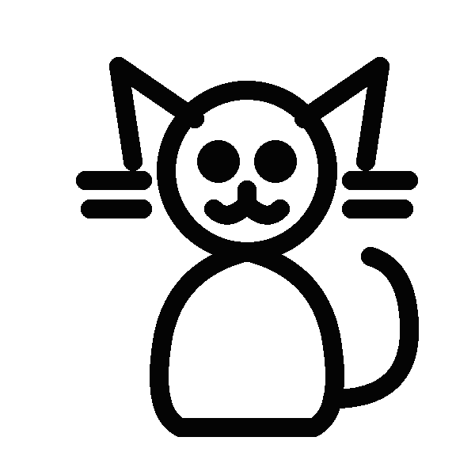 | tac | cat | cta
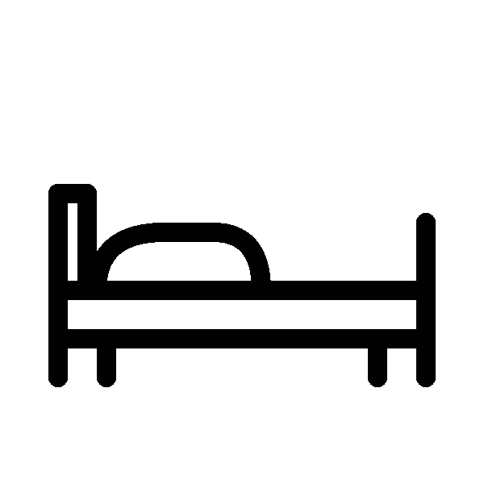 | toc | cto | cot
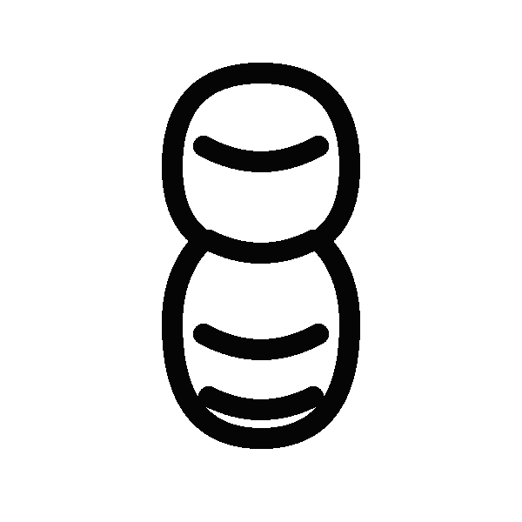 | tun | nut | nun

1.5 — Words and pictures (4 marks)
Draw a line from each word to its picture. There are two pictures you will not use.
Words: cat · mat · cot · can
 |  |  |  |  | 
1 | 2 | 3 | 4 | 5 | 6

1.6 — Signs (3 marks)
Write the letter of the correct meaning next to each sign. There are two meanings you will not use.
Sign | Meaning
1. CLOSED TODAY _ | A. Clean your hands here.
2. WASH YOUR HANDS _ | B. Stand in a line.
3. QUEUE HERE _ | C. Do not come in today.
 | D. You can buy food here.
 | E. Go quickly.

1.7 — Choose the word (4 marks)
Write one word from the box in each gap. There are three words you will not use. help · cook · study · walk · buy · listen · wait
1. In the afternoon I ________ my mother at home. 2. I ________ to the market with my sister. 3. In the evening I ________ my English book. 4. We ________ rice on the fire.

1.8 — About Karim (2 marks)
My name is Karim. I am nineteen years old. I live in Camp 4 with my father and my sister. I go to the learning centre in the morning. I like football and English.
1. How old is Karim? ________ 2. Who does Karim live with? ________________________

1.9 — A message (3 marks)
Hello Karim. I am going to the health post at 10 o'clock tomorrow. Can you come with me? My brother is busy. Please answer me. — Ayub
1. Who wrote this message? ________ 2. What time is Ayub going? ________ 3. Who is busy? ________

1.10 — A notice (4 marks)
LEARNING CENTRE — NOTICE The centre is open from Sunday to Thursday. Classes begin at 8 o'clock in the morning and end at 11 o'clock. The centre is closed on Friday. Maths class is on Sunday and Tuesday. If you are ill, please send a message to your teacher. When the wind is strong, classes may finish early. Please do not wait inside.
1. What time do classes begin? ________ 2. Which day is the centre closed? ________
3. Maths class is on: A) Sunday and Tuesday B) every day C) Friday D) Thursday
4. When the wind is strong, classes may: A) begin late B) finish early C) move to Friday D) stop

1.11 — A timetable (3 marks)
 | 9 – 10 | 10 – 11 | 11 – 12
Sunday | Maths | English | Life Skills
Monday | English | Drawing | Maths
Tuesday | Life Skills | Maths | English
Wednesday | English | Maths | Life Skills
Thursday | Maths | English | Life Skills
1. How many days is there an English class? ________ 2. What is the class on Monday at 11 – 12? ________ 3. You want English and Drawing on the same day. Which day? ________

1.12 — Ayub's card (3 marks)
This part is harder. If it is too hard, leave it and go on to Part 2. Ayub Hossain is twenty-two and lives in Camp 9. Three years ago he learned to repair mobile phones from an older neighbour. He was good at it, but he had one set of tools, and three other young men in his block had learned the same skill and needed the same tools. At first they argued about whose turn it was. Then Ayub suggested something simple. They wrote the days of the week on a card and hung it outside his shelter. Each person took two days. The arguing stopped. Because the four of them were no longer working against each other, they passed customers to whoever was free, and all four are now busier than before. Ayub says the card is not really about tools. It is about four people deciding they were not competing.
1. What is the text mainly about? A) how to repair mobile phones B) how a simple arrangement stopped four people competing C) why tools are expensive D) why Camp 9 has many phone repairers
2. Why did the four men argue at first? ____________________________________
3. Find one word in the text that means "trying to beat each other". ______

PART 2 — WRITING
About 22 minutes.

2.1 — Write your name (3 marks)
___________________________

2.2 — Copy this and finish it (4 marks)
Like this: I am Nur. or I like rice.
I am ___________

2.3 — Fill in the form (6 marks)
Name
Age
Female / Male
Block
Learning centre
Languages you speak
A phone number we can use
Today's date

2.4 — Five sentences about you (4 marks)
Like this: I am Karim. I am 19. I like football. I live in Camp 4. I go to the learning centre.
Write five true sentences about yourself. You choose what to write.
1. ________________________________________ 2. ________________________________________ 3. ________________________________________ 4. ________________________________________ 5. ________________________________________

2.5 — A note to your teacher (6 marks)
Your friend was not at class today. Write a note to your friend. Write about 40 words.
Say three things: what you did in class · what the homework is · when you will see them.
(Six ruled lines)

2.6 — A letter (7 marks)
This part is harder. If it is too hard, leave it.
Write a letter to a friend about a time you helped someone, or a time someone helped you.
Say three things: what happened · what you did · how you felt afterwards.
Write 100–120 words.
(Fourteen ruled lines)

PART 3 — SPEAKING
Optional. Six minutes, one learner at a time, in a quiet corner. Same-gender pairing where it matters. The learner may pass on anything.
 | What you say | Time
Warm-up (not scored) | "Hello. My name is _. What is your name?" | 30s
1. About you | your name · your age, or how long you have been here · who you live with. Do not ask where they are from. | 90s
2. The picture | "What can you see? Tell me about this picture." | 90s
3. Questions | "What do you do in the evening?" · "What food do you like?" · "Tell me about your friend." | 90s
4. Tell me more (only if 3 was easy) | "Tell me about something you would like to learn." Then once: "Why?" | 60s
5. Close (not scored) | "Thank you. You spoke English with me today." | 15s
The endline picture:




