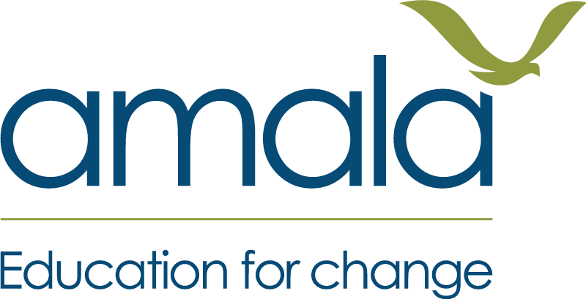
THE ENGLISH CHECK
What I can do in English
The learner’s own sheet.
One per learner, given to them at the end of the course. Read it through together — most learners at this level cannot read it alone, and that is fine.

What I can do in English
Name __________________ Date ____
Read this through with your facilitator and tick together. It is fine if some are not ticked — you will keep growing.

Sounds and letters
- I can hear the first sound in a word.
- I know some letters.
- I can find my own name.

Reading
- I can read the words I · am · from · like.
- I can sound out short words.
- I can match a word to a picture.
- I can read a short sentence about someone.
- I can find what I need on a notice or a timetable.
- I can read a longer story and understand the main idea.

Writing
- I can write my own name.
- I can copy a sentence.
- I can fill in a form with my name and my age.
- I can write true sentences about myself.
- I can write a short note to somebody.
- I can write a letter about something that happened.

Speaking
- I can say my name in English.
- I can say who I live with.
- I can say what I like.
- I can talk about a picture.
- I can answer questions about my day.
- I can talk about what I want to do next.

My growth
At the start I could __________________________________________
Now I can also ______________________________________________
One thing I want to get better at is __________________________
I feel __________________ about learning English.

Facilitator: fill the first two lines from the learner's own two papers, in their own words — "at the start you could write your name; now you can also write five sentences." Never show a learner a CEFR level. It means nothing to them and can only discourage.

