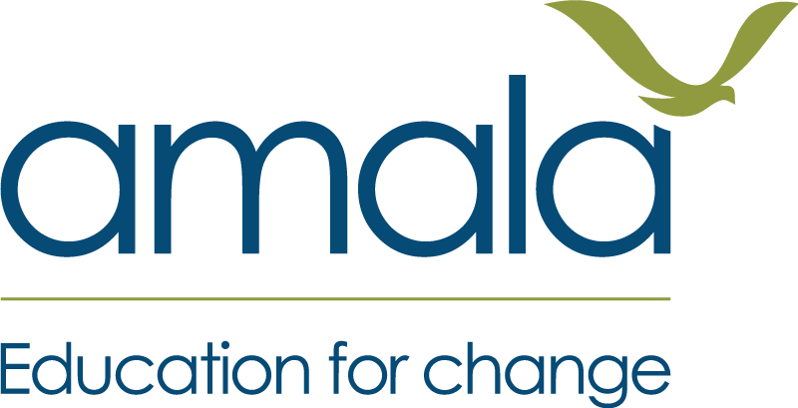
Learning Bridge+ (Cox's Bazar)
What Might You See or Hear?
An educator guide to assessing FSI1 and FSL2
This guide sits alongside the Competency Assessment Record. For each competency and each level, it gives examples of what a learner at that level might do or say. Use it to help you decide which level to circle, and to write a clear reason in the "Why this level?" box.

Three things to remember
These are examples, not a checklist. "Two interviews plus one article" does not equal Practitioner. The question is always: does the evidence match the level description?
Spoken evidence counts fully. A learner who explains their thinking to you in a conversation, or who you watch doing the work, meets the level just as much as one who writes it down. Record what you saw or heard on the sheet.
Assess the learner, not the product. A neat poster or report is not the evidence. What the learner did, and how they explain it, is.
FOUR LEVELS, NOT FIVE
Expert Practitioner is not used on Learning Bridge+, as it is not achievable within the programme timeframe.

FSI1 Investigate Real World Issues
The learner can conduct primary and secondary research into challenges affecting people and the planet to develop actionable insights.
USEFUL TERMS
Primary research: Finding out new information first-hand: talking to community members, asking a group the same questions, watching and counting (for example, how many people queue at a water point), mapping an area, or taking photos.
Secondary research: Using information someone else has gathered: asking a knowledgeable person what is already known, using a printed report, leaflet or poster, a radio programme, or material the educator brings in.
An actionable insight: A finding that points to something someone could do. "Girls miss school" is a finding. "Girls in our block miss about three days a month because there is no private latrine near the learning centre, so a screened latrine could help" is an actionable insight.
Level | You might see or hear
No level awarded  Has no plan for how to research a challenge. | • The learner names a problem but cannot say how they would find out more about it.  • They say "I would ask someone" but cannot say who, what they would ask, or why.
Theorist  Can explain how they would research a challenge using primary and secondary research. | • A plan that names a challenge, a question, and at least one primary and one secondary way of finding out.  • A reason for those choices, for example: "I will ask shop owners because they know why prices went up. I will ask the camp health worker what is already known."  • No research has happened yet, or only a small start.
Practitioner (Pass)  Has done primary and secondary research into a challenge and can explain why they chose those methods. | • Signs that research actually happened: interview notes or drawings, a tally from observing, photos, or the learner telling you clearly who they spoke to and what they found.  • Both primary and secondary research used, even if one is small.  • The learner can explain why they chose those people, questions or sources.  • They try to say what they found, but it may be a general statement ("many people have no work") rather than something someone could act on.
Reflective Practitioner  Has used their research to reach an insight someone could act on, and can say what worked, what did not and what they would change in how they researched. | • At least one insight that is specific, comes from their own research, and points to a possible action.  • The learner can show where the insight came from: "Seven of the ten women I spoke to said…"  • They reflect on how they researched, not on the topic. For example: "I only spoke to men because they were at the market, so I missed what women think. Next time I would go to the clinic in the morning."  • Their reflection points to something real from their own research, not a general comment like "I could have done more."
WATCH OUT
Doing the research is Practitioner. To reach Reflective Practitioner, the learner needs an insight someone could act on and a reflection on their research approach. A learner who did lots of research but ends with a description of the problem is still a Practitioner.

FSL2 Set and Pursue Goals
The learner can establish clear objectives for learning and growth and take deliberate steps to make progress towards them.
USEFUL TERMS
A clear goal: Says what the learner wants to achieve, by when, and how they will know. "Improve my English" is not clear. "Be able to introduce myself and my project in English at the showcase" is clear.
Deliberate steps: Actions the learner chose because they lead towards the goal: practising ten new words each evening with a sibling, asking the educator to listen to a practice, setting aside time each week.
Progress: A visible change from where the learner started, even if they have not fully reached the goal.
Level | You might see or hear
No level awarded  Cannot name a goal or how to work towards it. | • The learner cannot name something they want to achieve.  • They name a wish ("I want a good life") with no idea how to move towards it.
Theorist  Has set a goal and can explain the steps they would take. | • A goal that is fairly clear, and a plan of steps, for example: "I want to read a short story in English by the end of the course. I will practise every night and ask my cousin to test me."  • The learner can explain why those steps would help.  • No real action yet, or one start that was not followed up.
Practitioner (Pass)  Has set a goal, taken steps towards it, and can explain why they chose those steps. | • The learner set a goal earlier and can still tell you what it is.  • Signs of action: a simple tracker or tally, you or a peer seeing them practise, regular attendance at the activity they planned.  • They can explain why they chose those steps.  • Progress may be patchy, the goal may still be vague, or the steps may have drifted away from the goal.
Reflective Practitioner  Has made clear progress towards a clear goal, and can say what worked, what did not and what they would change in how they pursued it. | • A clear goal and real progress against it: "In Week 2 I could say my name. Now I can talk for one minute."  • They reflect on how they set and worked towards the goal, for example: "My goal was too big, so I stopped when I fell behind. I should have set a small target each week." "Practising with my friend worked better than practising alone."  • Their reflection is backed by something specific from what they did.
WATCH OUT
Progress, not perfection. A learner can reach Reflective Practitioner without fully reaching their goal, if the goal was clear and they made real progress. Do not reward easy goals over ambitious ones.
Reflection on the goal, not on themselves. "I learnt I am a hard worker" is about the learner, not about how they pursued the goal. On its own it does not show Reflective Practitioner.

Writing the record

Writing the "Why this level?" box
Write what you saw or heard, not a judgement. The learner and the moderator should both be able to read it and understand the level.
Not useful | Useful
Good effort, worked hard. | Interviewed 5 neighbours about water access and used the NGO leaflet. Explained why she chose them. Findings still general: "water is a problem".
Reflected well. | Said his goal was too big and he stopped practising in Week 4. Now sets a weekly target. Can introduce himself in English for one minute (I observed this).

Writing the "Next step" line
The next step is the part of the sheet most useful to the learner. A good next step:
- Is one action, not a list.
- Moves them towards the next level. Read the next column on the sheet and ask: what is the one thing missing?
- Is something they can actually do with what they have: no internet, no special materials.
- Uses words they can remember when you say it to them out loud.
Level now | Not useful | Useful
FSI1 Theorist | Do more research. | Talk to three people affected by the problem and ask each of them the same two questions.
FSI1 Practitioner | Make your findings better. | Look at what people told you and finish this sentence: "Because of what I found, someone could…"
FSI1 Reflective Practitioner | Keep it up. | Next time you investigate a problem, fix the thing you said went wrong: speak to women as well as men.
FSL2 Theorist | Work on your goal. | This week, do the first step of your plan (practise ten words each evening) and tick it off each day.
FSL2 Practitioner | Be more reflective. | At the end of each week, tell a friend one thing that helped you practise and one thing that stopped you.
FSL2 Reflective Practitioner | Set a harder goal. | Set your next goal using what you learnt: a small target each week, with a practice partner.
LEARNERS ALREADY AT REFLECTIVE PRACTITIONER
Reflective Practitioner is the top level on Learning Bridge+, but the next step still matters. Point them to using their own improvement in a new situation: a new problem to investigate, or a new goal. This is how learners grow beyond the course.
When you give the sheet to the learner, talk it through with them in the language they understand best. Tell them their level, why, and their next step.

