
THE ENGLISH CHECK
Form A
The booklet each learner works in at the start of the course.
Print one per learner. Write each learner’s own name into it before the sitting, everywhere the page says [learner’s name]. This booklet contains no answers.

English Reading, Writing and Speaking Check — Form A
Baseline form. Written against ENGLISH-ASSESSMENT-BLUEPRINT.md, slot for slot. Form B fills the same slots with different content. Keys and mark schemes are at the end and print separately — they never go in the learner booklet.
Learner name __________________ Block ____ Date ____ Facilitator __________

Part 0 — Foundations
One to one. 8 minutes. Optional — if the one-to-one time is not there, use Part 0G below instead, and use the same mode again at endline.
Say before you start, in the language you share: "This is not an exam. It shows me what to teach you. We can stop whenever you like." Do not correct during the task. Do not help. Mark on the record sheet, not on the learner's page.

F0 — Warm-up (not scored)
Point to the picture of the sun. (If the learner cannot, note it and continue.)


F1 — Sounds and letters (10 marks)
Show the letter card. Say each sound, not the letter name. "Point to the letter that says /s/."
 | S | m | a | T | o
 | n | L | u | c | t

Order to say: /s/ · /m/ · /a/ · /t/ ("the big one") · /o/ · /n/ · /l/ · /u/ · /k/ · /t/ ("the small one")
Only taught sounds appear. The plosive pairs (p/b, t/d, k/g) come last in the phonics sequence, so they are not tested at baseline — and the /k/ sound is asked once, spelled c, because c, k and ck are met as one sound, not three rules.

F2 — Your name (1 mark)
Write the learner's own name on the card before the session. Add three names that do not start with the same letter. "Point to your name."
[learner's name] | Rashid | Anwara | Jubair

F3 — Reading words (5 marks)
"Read these out loud."
I am from like [learner's name]

F4 — Words and pictures (4 marks)
"Draw a line from each word to its picture." (Six pictures, four words.)
Words: sun · man · sock · nut
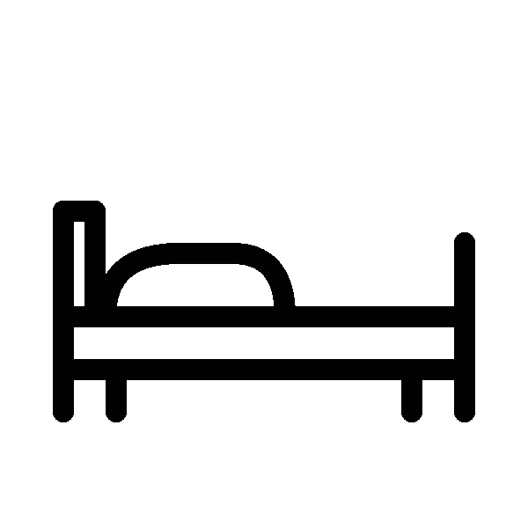 |  |  |  |  | 
1 | 2 | 3 | 4 | 5 | 6

F5 — Sounding out (3 marks)
"Say each word slowly. You can sound it out."
mat can cut

F6 — Write your name (3 marks)
"Write your name here."
___________________________

F7 — Copy and finish (4 marks)
Worked example, shown first: I am Nur. or I like rice.
"Copy this, and put your own word at the end."
I am ___________ STOP. Score Part 0 now. Reading 18 or more and F5 at least 2 → go to Part 1. Otherwise the learner stops here and goes to Part 3. Thank them warmly either way.

Part 0G — Foundations, group mode
Whole group, 10 minutes. Use instead of Part 0 when there is no one-to-one time. Everything is the same except F3 and F5, which become circling instead of reading aloud. Group-mode scores use their own conversion table and are never compared with one-to-one scores.
F1, F2, F4, F6, F7 — as printed above, except that the facilitator says each sound or word to the whole class and every learner marks their own sheet. Write each learner's name on their sheet before the session.

F3G — Circle the word you hear (5 marks)
Say each word twice, in this order: am · like · I · from · [learner's name]
1. | in | am | on | an
2. | look | live | like | lake
3. | I | a | it | is
4. | for | from | form | four
5. | [learner's name] | Rashid | Anwara | Jubair

F5G — Circle the right word (3 marks)
Beside each picture, circle the word that is written correctly.
Picture
 | mat | tam | mta
 | nac | can | acn
 | uns | snu | sun

STOP. Note "0G" on the record sheet — the mode must match at endline. Everyone now goes on to Part 1. Do not mark these sheets now.

Part 1 — Core
Whole group. 12 minutes. Read the instructions aloud in the language you share. Do not translate the questions.

Example (not scored — do this together)
Draw a line from the word to its picture.


C1–C4 · Words and pictures (4 marks)
Draw a line from each word to its picture. There are two pictures you will not use.
Words: water · school · house · phone
 |  |  |  |  | 
1 | 2 | 3 | 4 | 5 | 6

C5–C7 · Signs (3 marks)
Write the letter of the correct meaning next to each sign. There are two meanings you will not use.
Sign | Meaning
5. OPEN 9 – 4 _ | A. You can get water here.
6. NO ENTRY _ | B. Do not go in.
7. WATER HERE _ | C. This place is open in the day.
 | D. Wash your hands.
 | E. Wait outside.

C8–C11 · Choose the word (4 marks)
Write one word from the box in each gap. There are three words you will not use. go · eat · drink · sleep · read · help · wash
8. Every morning I ________ water. 9. I ________ to the learning centre at eight o'clock. 10. At night I ________ for eight hours. 11. I ________ my hands before I eat.

C12–C13 · About Sokina (2 marks)
My name is Sokina. I am seventeen years old. I live in Block C with my mother and my two brothers. I come to the learning centre every day. I like English and drawing.
12. How old is Sokina? ________ 13. Who does Sokina live with? ________________________

C14–C17 · A notice (4 marks)
LEARNING CENTRE — NOTICE The learning centre is open from Saturday to Wednesday. Classes start at 9 o'clock in the morning and finish at 12 o'clock. On Thursday the centre is closed. English class is on Saturday and Monday. If you cannot come, please tell your teacher. In the rainy season, classes may start late. Please wait at the gate.
14. What time do classes start? ________ 15. Which day is the centre closed? ________
16. English class is on: A) Saturday and Monday B) every day C) Thursday D) Sunday
17. In the rainy season, classes may: A) finish early B) start late C) move to Thursday D) stop

C18–C20 · Rashid (3 marks)
Rashid finished a six-month training course in tailoring last year. At first he found it difficult to get customers, because many people in his block already used another tailor. Instead of giving up, he began repairing clothes for a lower price. Slowly, people started to trust his work, and now he is busy most days.
18. What is the text mainly about? A) How Rashid learned to sew B) How Rashid built up his work after a difficult start C) Why there are too many tailors D) The price of repairing clothes
19. Why was it hard for Rashid at first? ____________________________________
20. Find two words in the text that mean "stopping trying". ________________ STOP. Everyone now does Part 2A. Do not mark Part 1 now. Mark it after the session; any learner scoring 15 or more and at least 2 on C18–C20 sits Part 2B on another day.

Part 2A — Lower booklet
18 minutes.

Reading

L1–L3 · A message (3 marks)
Hi Anwara. I am going to the market at 3 o'clock today. Can you come with me? My sister is coming too. Please tell me. — Jannat
1. Who wrote this message? ________ 2. What time is Jannat going? ________ 3. Who else is coming? ________

L4–L6 · Health post (3 marks)
HEALTH POST — BLOCK D Open: Saturday – Thursday, 8:00 – 2:00 Friday: closed At night, for an emergency, go to the main clinic near the market.
4. What time does the health post open? ________ 5. Which day is it closed? ________ 6. Where do you go at night in an emergency? ________________________

L7–L10 · Timetable (4 marks)
 | 9 – 10 | 10 – 11 | 11 – 12
Saturday | English | Maths | Life Skills
Sunday | Maths | English | Drawing
Monday | English | Life Skills | Maths
Tuesday | Life Skills | English | Maths
Wednesday | Maths | Life Skills | English
7. How many days is there an English class? ________ 8. What is the class on Sunday at 11 – 12? ________ 9. On which day is the first class Life Skills at 9 – 10? ________ 10. You want English and Drawing on the same day. Which day? ________

Writing

L11 · Fill in the form (6 marks)
Name
Age
Female / Male
Block
Learning centre
Languages you speak
A phone number we can use
Today's date

L12 · Five sentences about you (4 marks)
Example: I am Nur. I am 16. I like rice. I live in Block C. I come to the learning centre.
Write five true sentences about yourself. You choose what to write.
1. ________________________________________ 2. ________________________________________ 3. ________________________________________ 4. ________________________________________ 5. ________________________________________

L13 · A note to your teacher (6 marks)
Tomorrow you cannot come to class. Write a note to your teacher. Write about 40 words.
Say three things: that you cannot come · why · when you will come back.

Part 2B — Reach booklet
20 minutes. Nur Begum is twenty years old and lives in Camp 12. Two years ago she joined an English class at her learning centre. She enjoyed it, but she noticed that many of her friends stopped coming after a few weeks. When she asked them why, most said the same thing: they were too shy to speak in front of a big group, and they were afraid of making mistakes. Nur decided to try something small. Every Friday afternoon, she invited four of her neighbours to sit together outside her shelter and practise English for one hour. There was no teacher and no book. They simply asked each other simple questions and helped each other find words. At first the group was quiet. After a month, though, the four women were talking easily, and two of them went back to the class at the centre. Others heard about the group and asked to join, so Nur now runs two groups instead of one. She says the most important thing is not the English. It is that nobody in the group laughs when someone makes a mistake.

Reading (10 marks)
1. How often does the group meet? ________ 2. How many people did Nur invite at the beginning? ________
3. The text is mainly about: A) why English classes are difficult B) how Nur made a small, safe place to practise English C) how much it costs to learn English D) why teachers are important
4. Why did Nur's friends stop coming to the class? ____________________________________ 5. What in the text shows that Nur's group worked? ____________________________________ 6. Find one word in the text that means "afraid to speak in front of other people". ______
7–10. Write the number of the paragraph (1, 2, 3 or 4) next to each sentence. There is one sentence you will not use.
 | Paragraph
A problem is explained. | _
A new idea is described. | _
The results are given. | _
What matters most is explained. | _
The cost is described. | _

Writing (12 marks)
11. Write a letter to a friend about something you learned to do. It can be anything — a skill, a subject, cooking, a repair, a language.
Say three things: what you learned · who or what helped you · how you felt when you could do it.
Write 100–120 words.

Part 3 — Oral check
One to one. 6 minutes. Optional, and the last thing to drop. If there is not time for everyone, assess a random sample of at least 10 learners or 40% of the class, chosen before the baseline, and assess the same learners at endline.
Same-gender pairing where it matters. The learner may pass on anything. Nothing is recorded unless the learner agrees.
 | What you say | Time
1. Warm-up (not scored) | "Hello. My name is _. What is your name?" | 30s
2. Personal information | Ask, wait, and ask once more in simpler words if needed: your name · your age, or how long you have been here · who you live with. Do not ask where they are from. | 90s
3. Picture | Show the Form A picture — people outside a learning centre. "What can you see? Tell me about this picture." | 90s
4. Questions | Ask all three: "What do you do in the morning?" · "What do you like?" · "What is the weather like today?" | 90s
5. Extended turn (only if 4 was easy) | "Tell me about something you want to do after this course." Then once: "Why?" | 60s
6. Close (not scored) | "Thank you. You spoke English with me today." | 15s
The Form A picture prompt:


---

