
THE ENGLISH CHECK
Form B
The booklet each learner works in in the final week.
Same tasks, same order, different content - so nobody sits the same paper twice. Six slots are deliberately identical to Form A. This booklet contains no answers.

English Reading, Writing and Speaking Check — Form B
Learner name __________________ Block ____ Date ____ Facilitator __________ Mode at baseline: ☐ Part 0 (1:1) ☐ Part 0G (group) — use the same mode again

Part 0 — Foundations
One to one. 8 minutes. Optional — use Part 0G if the one-to-one time is not there. Say first, in the language you share: "This is not an exam. It shows me what you have learned. We can stop whenever you like." Do not correct. Do not help.

F0 — Warm-up (not scored)
Point to the picture of the cat.


F1 — Sounds and letters (10 marks)
 | m | o | S | u | a
 | n | T | L | c | t

Order to say: /m/ · /o/ · /s/ · /u/ · /a/ · /n/ · /t/ ("the big one") · /l/ · /k/ · /t/ ("the small one")

F2 — Your name (1 mark)
[learner's name] | Rashid | Anwara | Jubair

F3 — Reading words (5 marks)
"Read these out loud."
like from I am [learner's name]

F4 — Words and pictures (4 marks)
Words: cat · mat · cot · can
 | 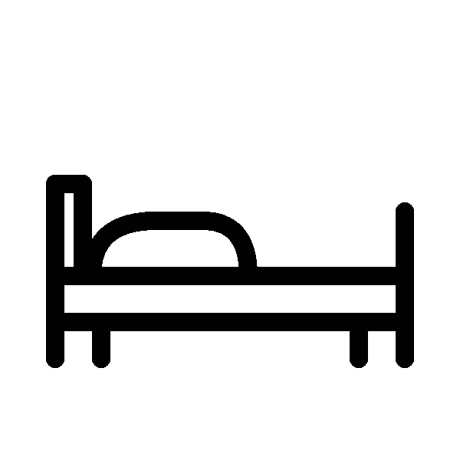 |  |  |  | 
1 | 2 | 3 | 4 | 5 | 6

F5 — Sounding out (3 marks)
sat lot nut

F6 — Write your name (3 marks)
___________________________

F7 — Copy and finish (4 marks)
Worked example: I am Nur. or I like rice.
I am ___________ STOP. Reading 18 or more and F5 at least 2 → Part 1. Otherwise stop here and go to Part 3.

Part 0G — Foundations, group mode
Use instead of Part 0, and only if the learner sat 0G at baseline too.
F1, F2, F4, F6, F7 — as above, read aloud to the whole class.

F3G — Circle the word you hear (5 marks)
Say each word twice: like · from · am · I · [learner's name]
1. | lake | look | like | live
2. | form | four | for | from
3. | an | on | am | in
4. | is | it | a | I
5. | Rashid | [learner's name] | Anwara | Jubair

F5G — Circle the right word (3 marks)
Picture
 | tac | cat | cta
 | sun | uns | snu
 | toc | cto | cot

Part 1 — Core

Example (not scored)
Draw a line from the word to its picture.


C1–C4 · Words and pictures (4 marks)
Draw a line from each word to its picture. There are two pictures you will not use.
Words: water · school · road · bag
 |  |  | 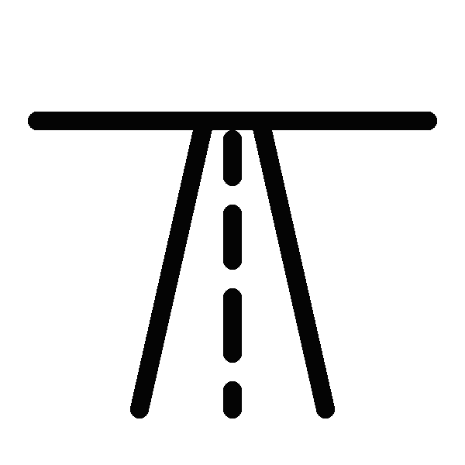 |  | 
1 | 2 | 3 | 4 | 5 | 6

C5–C7 · Signs (3 marks)
Sign | Meaning
5. CLOSED TODAY _ | A. Clean your hands here.
6. WASH YOUR HANDS _ | B. Stand in a line.
7. QUEUE HERE _ | C. Do not come in today.
 | D. You can buy food here.
 | E. Go quickly.

C8–C11 · Choose the word (4 marks)
Write one word from the box in each gap. There are three words you will not use. help · cook · study · walk · buy · listen · wait
8. In the afternoon I ________ my mother at home. 9. I ________ to the market with my sister. 10. In the evening I ________ my English book. 11. We ________ rice on the fire.

C12–C13 · About Karim (2 marks)
My name is Karim. I am nineteen years old. I live in Camp 4 with my father and my sister. I go to the learning centre in the morning. I like football and English.
12. How old is Karim? ________ 13. Who does Karim live with? ________________________

C14–C17 · A notice (4 marks)
LEARNING CENTRE — NOTICE The centre is open from Sunday to Thursday. Classes begin at 8 o'clock in the morning and end at 11 o'clock. The centre is closed on Friday. Maths class is on Sunday and Tuesday. If you are ill, please send a message to your teacher. When the wind is strong, classes may finish early. Please do not wait inside.
14. What time do classes begin? ________ 15. Which day is the centre closed? ________
16. Maths class is on: A) Sunday and Tuesday B) every day C) Friday D) Thursday
17. When the wind is strong, classes may: A) begin late B) finish early C) move to Friday D) stop

C18–C20 · Anwara (3 marks)
Anwara completed a three-month course in solar repair two years ago. At the beginning, few people in her block believed a young woman could fix their lights. Rather than argue, she offered to repair the first one free. Word spread quickly after that, and she now trains two other women in the same skill.
18. What is the text mainly about? A) How solar lights work B) How Anwara won people's trust and built up her work C) Why courses are too short D) The price of repairs
19. Why was it hard for Anwara at the beginning? ____________________________________
20. Find two words in the text that mean "instead of". ________________ STOP. Everyone now does Part 2A. Do not mark Part 1 now. Mark it after the session; any learner scoring 15 or more and at least 2 on C18–C20 sits Part 2B on another day.

Part 2A — Lower booklet

Reading

L1–L3 · A message (3 marks)
Hello Karim. I am going to the health post at 10 o'clock tomorrow. Can you come with me? My brother is busy. Please answer me. — Ayub
1. Who wrote this message? ________ 2. What time is Ayub going? ________ 3. Who is busy? ________

L4–L6 · Health post (3 marks)
HEALTH POST — BLOCK F Open: Sunday – Friday, 9:00 – 3:00 Saturday: closed At night, for an emergency, go to the big clinic beside the school.
4. What time does the health post open? ________ 5. Which day is it closed? ________ 6. Where do you go at night in an emergency? ________________________

L7–L10 · Timetable (4 marks)
 | 9 – 10 | 10 – 11 | 11 – 12
Sunday | Maths | English | Life Skills
Monday | English | Drawing | Maths
Tuesday | Life Skills | Maths | English
Wednesday | English | Maths | Life Skills
Thursday | Maths | English | Life Skills
7. How many days is there an English class? ________ 8. What is the class on Monday at 11 – 12? ________ 9. On which day is the first class Life Skills at 9 – 10? ________ 10. You want English and Drawing on the same day. Which day? ________

Writing

L11 · Fill in the form (6 marks)
Name
Age
Female / Male
Block
Learning centre
Languages you speak
A phone number we can use
Today's date

L12 · Five sentences about you (4 marks)
Example: I am Karim. I am 19. I like football. I live in Camp 4. I go to the learning centre.
Write five true sentences about yourself. You choose what to write.
1. ________________________________________ 2. ________________________________________ 3. ________________________________________ 4. ________________________________________ 5. ________________________________________

L13 · A note to your friend (6 marks)
Your friend was not at class today. Write a note to your friend. Write about 40 words.
Say three things: what you did in class · what the homework is · when you will see them.

Part 2B — Reach booklet
Ayub Hossain is twenty-two and lives in Camp 9. Three years ago he learned to repair mobile phones from an older neighbour. He was good at it, but he had a problem: he owned only one set of tools, and three other young men in his block had learned the same skill and needed the same tools. At first they argued about whose turn it was. Then Ayub suggested something simple. They wrote the days of the week on a piece of card and hung it outside his shelter. Each person took two days, and on the seventh day the tools stayed where they were, so that anyone with an urgent job could use them. The arguing stopped almost immediately. Because the four of them were no longer working against each other, they began passing customers to whoever was free, and all four are now busier than any of them had been alone. Ayub says the card outside his shelter is not really about tools. It is about four people deciding that they were not competing.

Reading (10 marks)
1. How many days did each person take? ________ 2. How did Ayub learn to repair phones? ________________________
3. The text is mainly about: A) how to repair mobile phones B) how a simple arrangement stopped four people competing C) why tools are expensive D) why Camp 9 has many phone repairers
4. Why did the four men argue at first? ____________________________________ 5. What in the text shows that the arrangement worked? ____________________________________ 6. Find one word in the text that means "trying to beat each other". ________
7–10. Write the number of the paragraph (1, 2, 3 or 4) next to each sentence. There is one sentence you will not use.
 | Paragraph
A problem is explained. | _
A new idea is described. | _
The results are given. | _
What matters most is explained. | _
The cost is described. | _

Writing (12 marks)
11. Write a letter to a friend about a time you helped someone, or a time someone helped you.
Say three things: what happened · what you did · how you felt afterwards.
Write 100–120 words.

Part 3 — Oral check
One to one. 6 minutes. Optional, and the last thing to drop. If sampled, it must be the same learners who were sampled at baseline.
 | What you say | Time
1. Warm-up (not scored) | "Hello. My name is _. What is your name?" | 30s
2. Personal information | your name · your age, or how long you have been here · who you live with. Do not ask where they are from. | 90s
3. Picture | Show the Form B picture — people at a small shop. "What can you see? Tell me about this picture." | 90s
4. Questions | "What do you do in the evening?" · "What food do you like?" · "Tell me about your friend." | 90s
5. Extended turn (only if 4 was easy) | "Tell me about something you would like to learn." Then once: "Why?" | 60s
6. Close (not scored) | "Thank you. You spoke English with me today." | 15s
The Form B picture prompt:




