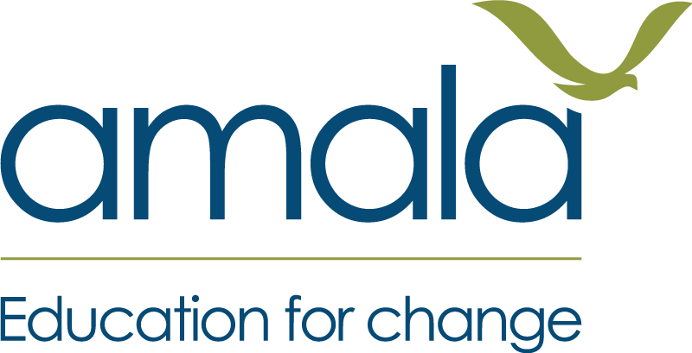
MODERATION PROTOCOL · THE SESSION WITH AMALA
Learning Bridge+ (Cox's Bazar)
The protocol for the online moderation session between a member of the Amala Education Programmes team and the master educators, in each assessment period. The master educators' templates are the material. The session checks that the level descriptions are being read the same way across every centre and every master educator, and that what the master educators take back to educators is right. Amala moderates the moderation: it does not regrade learners.

1. What the session is for
- A shared reading of the level descriptions across every centre and every master educator.
- A check on the master educators' moderation - how each discussion ran, as well as where it landed.
- Clear messages for the master educators to take back to every educator.
- What the templates show about the programme itself - where learners do not get a fair chance to show a competency.
Role | What they do
Amala moderator | A member of the Amala Education Programmes team. Reads every template beforehand, runs the session, holds the protocol, and writes the session summary.
Master educators | Send their templates ahead. In the session, present their cases - the educator's level and rationale, and their own - and ask questions about each other's.
Note-taker (optional) | A second Amala person, where possible, so the moderator can listen. Otherwise the moderator notes as they go.
The session
When | After the moderation discussions and before the rest of the learners are assessed, so what it changes still reaches every educator in time. At the summative period, always before results are confirmed.
How | Online: a video call with all the master educators together and a member of the Amala Education Programmes team. Join from somewhere quiet with a reliable connection, and have your templates in front of you. Send your templates - a clear photo of each page is fine, including handwritten ones - at least two days ahead, so Amala can read them all. The session is spent on a selection - the biggest differences, the lowest confidence, a strong example - and on what came up across the templates. If the connection will not hold video, the session carries on as a voice call over templates everyone already has. The full running order is in the moderation protocol.

2. Before the session
- Templates arrive at least two days before the session. Most will be handwritten and photographed - check every page is readable, and ask again for any that are not. Chase any that are missing; a centre with no template is a gap in the sample.
- Send the video-call link with the session time, and agree a fall-back - a voice call - if a connection drops.
- Read every template. For each, note whether the educator and master educator agreed, the educator's confidence, and where any difference came from.
- Look across them. Are some centres or master educators placing most learners at one level? Is one level description being read in different ways? One template is not a pattern; three may be.
- Choose four to six cases for the session - the biggest differences, the lowest confidence, a case that shows a shared misreading, and one strong example of a discussion done well.
- Prepare one question for each chosen case, from the question bank below.
- Send the master educators the list of chosen cases the day before, so whoever presents each one is ready.

3. Running the session
About 40 minutes of fixed time, plus about 15 minutes for each case. Four to six cases makes a session of about 100 minutes to 130 minutes.
Step | Time | What happens
Open | 5 min | What the session is for, and the two rules: differences are settled against the level descriptions, not by seniority; and changing your mind is the system working.
What the templates show | 10 min | The moderator's overview: how many templates, from which centres and competencies, how often educator and master educator agreed, and the patterns noticed. No names attached to patterns about harshness or generosity - those need more cases.
Present a case | 5 min per case | The master educator presents the case, uninterrupted: the learner's story, the context and opportunity, the evidence, the educator's level and rationale, their own level and why, and how the discussion with the educator went.
Questions | 6 min per case | The moderator asks the prepared question first, then the other master educators ask theirs. Which words in the level description does the evidence match? What in the next level has not been seen? Was it seen or reported?
Amala's view | 4 min per case | The moderator gives their own reading of the case and why. Where it differs, explore why - the evidence, the opportunity, or reading the level description differently. Nobody has to end up agreeing. Close on what the master educator takes back to the educator.
Across the cases | 15 min | What came up more than once - a level description read differently, a kind of evidence being missed or over-weighted, an opportunity the programme does not give learners. Put each into a sentence every master educator can repeat to educators.
Actions and close | 10 min | Each master educator says what they will take back, to whom, and by when. Note any changes to learners' records, and anything for the programme.

The question bank
One prepared question per case, and these to draw on as the discussion goes.
- Which words in the level description does this evidence match?
- What in the next level's description has not been seen?
- Did the learner have a session that was built to draw out this competency, or did the evidence come from somewhere else?
- Was this seen by the educator, or reported by the learner?
- How confident was the educator - and what did they say when asked why?
- Is the difference about the evidence, the opportunity, or how the level description is read?
- Was the level set to push or encourage the learner, rather than to describe what they can do now?
- Would you place a learner who said this the same as one who wrote it?
- How did the discussion with the educator go - who did most of the talking?

4. Holding the session
- Hold the conversation, not the verdict. It is case-based, not consensus-based: your reading is a view to be explored against the level descriptions, not a ruling, and the session does not have to end in agreement.
- Let the master educator present the whole case before anyone asks anything.
- Check the moderation, not the educator. The question is whether the master educator's discussion reached a sound reading - and whether they will take the right message back.
- Do not regrade learners. Where a case is read differently, the master educator takes it back to the educator, who changes the record.
- One case is not a pattern. Track levels across more templates and periods before concluding that anyone is harsh or generous.
- Keep it to time. Cases not discussed still get a written comment in the session summary.
WHEN THE SESSION READS A CASE DIFFERENTLY
If the session reads a case differently, take that back to the educator, one-to-one, before the follow-up session. The level stays their judgement: they decide whether to revise it, and if they do, they check any other learners they judged the same way. Then share what was learned with every educator. Amala does not regrade learners.

5. After the session
- Within two working days, send the session summary to every master educator and the coordinator.
- Master educators hold a follow-up session with the educators at each centre before the rest of the learners are assessed, and make sure changed records are updated. The summary should give them what they need for it - the agreed messages in plain sentences.
- Give a short written comment on every template not discussed in the session.
- Keep the templates and summaries for the period. Look at them again at the summative period, to see whether the readings held and whether any pattern has become real.
- Pass anything about the programme - for example a competency learners have little chance to show before Week 6 - to whoever owns the curriculum.

Session summary
One per moderation session, written by the Amala moderator and sent to every master educator and the coordinator within two working days.
The session
Amala moderator
Assessment period | Formative Summative
Date
Master educators present
1. Templates received How many, from which centres, for which competency. Any centre with none.
2. Cases discussed For each - master educator, centre, competency, the educator's level, the master educator's level, the moderator's reading, and what goes back to the educator.
3. Across the templates What came up more than once.
4. Agreed readings Each in a sentence a master educator can repeat to educators.
5. Actions What, who, by when - including records to change.
6. For the programme Anything the templates showed about the curriculum or the assessment design.
7. Templates not discussed A short comment on each.
Part of the Learning Bridge+ (Cox's Bazar) pack. Editable. Not for redistribution outside the programme.

