Optimisation of Machine Learning Algorithms for Memory Constrained Edge Devices
Louie Bisset

Summary
This report presents the design, implementation and evaluation of a low power machine learning system deployed on the Seeed Studio XIAO nRF54L15 microcontroller. The project addressed the challenge of running neural networks on a resource constrained device while minimising energy consumption. To investigate this problem, two independent on device machine learning (TinyML) case studies were developed: keyword spotting using the integrated digital microphone (PDM) and gesture recognition using the integrated six axis motion sensor (IMU). For keyword spotting, three model approaches were compared. A raw audio neural network (1D CNN) achieved 75% accuracy, a network using compact spectral audio features (MFCC 2D CNN) achieved 96%, and an Edge Impulse model achieved 98% with the lowest energy consumption of 6.36 millijoules (mJ) per inference cycle. For gesture recognition across five classes, a baseline neural network achieved 94% accuracy, a deeper model achieved 98%, and an Edge Impulse model achieved 100%, also with the lowest energy consumption of 12.98 mJ per cycle. Collectively, these case studies demonstrated that a system level optimisation approach covering model architecture, feature extraction, quantisation, and firmware scheduling can deliver accurate and energy efficient inference across different applications on a single platform. To the author's knowledge, this work represents the first publicly documented deployment of TinyML on the XIAO nRF54L15 platform. Under a 15 second duty cycle, estimated operational lifetimes on a 1,200 mAh battery reached 416 days for keyword spotting and 131 days for gesture recognition, demonstrating the feasibility of long-term deployment.

Supervised by Dr Roshan Weerasekera

School of Electrical, Electronic, and Mechanical Engineering
University of Bristol
2026

Declaration
This project report is submitted towards an application for a degree at the University of Bristol. The report is based upon independent work by the candidate. All contributions from others have been acknowledged and the supervisor is identified on the front page. The views expressed within the report are those of the author and not of the University of Bristol.
I hereby assert my right to be identified as the author of this report. I give permission to the University of Bristol Library to add this report to its stock and to make it available for consultation in the library, and for inter-library lending for use in another library. It may be copied in full or in part for any bona fide library or research worker on the understanding that users are made aware of their obligations under copyright legislation.
I hereby declare that the above statements are true.

© Copyright, Louie Bisset, 2026
Certification of ownership of the copyright in a dissertation presented as part of and in accordance with the requirements for the relevant degree at the University of Bristol.
This report is the property of the University of Bristol Library and may only be used with due regard to the author. Bibliographical references may be noted but no part may be copied for use or quotation in any published work without prior permission of the author. In addition, due acknowledgement for any use must be made.

Contents
1 Introduction 4
1.1 Project Objectives 4
2 Literature Review 5
3 System Design and Methodology 8
4 Implementing Audio Keyword Spotting 9
4.1 Recording Audio with nRF54L15 9
4.2 Creating a Dataset. 9
4.3 Keyword Spotting Machine Learning Models 10
4.4 Edge Impulse 12
4.5 Continuous Keyword Spotting 12
5 Gesture Recognition using IMU Data 12
5.1 Gesture Recording Methods 12
5.2 Feature Extraction 13
5.3 Datasets 13
5.4 Machine Learning Models 14
6 Embedded Deployment 14
6.1 Converting to TinyML 14
6.2 Optimisation 15
6.3 Memory and Ram Analysis 15
6.4 Bluetooth Optimisation 16
6.5 Battery Monitoring 16
7 Results 16
7.1 Power Measurement Setup 16
7.2 Evaluation Metrics 16
7.3 Keyword Spotting Model Results 17
7.4 Gesture Recognition Models Results 18
7.5 Bluetooth Energy Consumption 19
8 Discussion 19
8.1 Keyword Spotting Model Analysis 19
8.2 Gesture Recognition Model Analysis 20
8.3 Memory and Ram Analysis 21
8.4 Battery Life 22
8.5 Broader Implications 22
8.6 Solar Machine Learning Feasibility 22
8.7 Limitations 23
9 Conclusion 24
9.1 Future Work 24

1 Introduction
Machine Learning (ML) is embedded in almost every aspect of modern life, from voice assistants and medical diagnostics to autonomous vehicles and industrial automation. Despite impressive advances within the ML field, the computational infrastructure required to support modern ML has introduced significant energy challenges. Large scale models are deployed in data centres that represent the predominant electricity consumers in the AI field. The electricity consumption is rapidly rising, the International Energy Agency reported that the global data centre energy usage was approximately 460 TWh in 2022 and is projected to increase to 1050 TWh by 2026 [1]. This increase is driven by the demand for AI workloads.
Conventional Internet of Things (IoT) architectures rely on constant streaming of raw data to data centres for centralised processing. This approach introduces communication latency, increases energy consumption due to wireless transmission and raises privacy concerns as sensitive data leaves the device [2] [3].
Tiny Machine Learning (TinyML) addresses these challenges by enabling ML models to be run directly on constrained microcontrollers, while operating with low power and memory limits. This allows data to be processed locally, eliminating the need for continuous data communication. Thereby reducing latency, energy consumption and improving data privacy [3]. As a result, TinyML represents a key approach to creating energy efficient systems [2], [4].
Most published TinyML studies focus on single application benchmarks [2], [4], typically keyword spotting or gesture recognition in isolation, without examining how model architecture, feature extraction, quantisation and firmware optimisation work together to determine the overall energy efficiency [4]. Much of the existing work also focuses on established platforms such as the Arduino Nano 33 BLE Sense or the ESP32, leaving newer, low power microcontrollers unexplored. Achieving energy efficient machine learning on constrained hardware remains an open research question, both for understanding TinyML design trade-offs and for enabling practical applications such as remote monitoring, wearable health devices and battery powered smart sensors.
This project investigated the feasibility of deploying TinyML on the Seeed Studio XIAO nRF54L15 Sense microcontroller. Two complementary case studies were designed: keyword spotting using the onboard PDM microphone and gesture recognition using the inertial measurement unit (IMU). These were chosen to cover different data types, preprocessing methods and inference profiles. Together they served to answer a single research challenge:
How can TinyML inference be made as energy efficient as possible on a constrained microcontroller without sacrificing accuracy?
Unlike previous TinyML studies, this work focuses on the complete energy characteristics rather than model accuracy alone. By measuring every phase of operation (idle, data collection, preprocessing, inference and wireless output) across two different applications on the same hardware, the project identified where energy was consumed and where optimisation had the most impact. At the time of writing, no published implementations of TinyML on the Seeed Studio XIAO nRF54L15 Sense have been identified in the academic or technical literature, making this the first documented deployment of both keyword spotting and gesture recognition on this specific platform.
The project adopted an energy aware system design that focused on optimising multiple aspects such as the model architecture, quantisation, firmware scheduling and wireless communication. Using the Nordic Power Profiler Kit 2 (PPK2) the energy consumption of the microcontroller was evaluated to assess the feasibility of solar harvesting for long term operation.

1.1 Project Objectives
The research objectives of this project are:
- To investigate the feasibility and energy efficiency of deploying TinyML models on a memory and power constrained microcontroller.
- To evaluate how model architecture, feature extraction, quantisation and firmware optimisation impact accuracy, memory usage and energy consumption.
- To assess the potential for long term autonomous operation using battery and solar energy harvesting.
The two case studies were selected not only for their technical complementarity but also for their relevance to wider societal and environmental challenges. Keyword spotting and gesture recognition are foundational components of assistive technologies, wearable health monitoring and remote sensing systems, applications that directly serve diverse user populations including those with physical disabilities or those with limited access to centralised infrastructure. By demonstrating that accurate inference is achievable within a sub milliwatt idle power budget, this work contributes to the feasibility of sustainably powered embedded AI devices that reduce dependence on battery replacement and minimise electronic waste. The system's local processing architecture also addresses data privacy concerns inherent to cloud dependent IoT deployments, as no raw sensor data leaves the device at any point during operation.

2 Literature Review

2.1 Tiny Machine Learning
The term TinyML refers to the deployment of machine learning on microcontrollers and other resource constrained devices that typically operate with less than 1 MB of memory and consume milliwatts of power [3]. TinyML has been growing significantly since 2019, this has been caused by major advances in model compression techniques and the widespread availability of affordable microcontrollers [2].
Warden and Situnayake [3] provides a comprehensive introduction to the TinyML framework, explaining its usefulness to shift away from the large data centre driven AI and towards on device inference. The key advantage of this approach is reduced latency, since data does not need to be transmitted to a server this lowers energy consumption by reducing the model’s complexity and increased data privacy due to the data remaining on the device.
The primary challenge of TinyML is fitting the models within the severe memory and computational constraints of microcontrollers. Modern deep learning models trained in TensorFlow can contain millions of 32-bit floating point parameters [2], which far exceed the limits of flash memory on small microcontrollers. To reduce the memory, multiple model compression techniques have been developed [5]. The most widely adopted is post training quantisation, which converts 32-bit floating point weights to 8-bit integers, reducing the model size by approximately a factor of four, with minimal reduction in accuracy [6], [7]. Additional techniques include pruning, which removes less important weights from the neural network and knowledge distillation, which trains smaller models to replicate larger ones [2].
TensorFlow Lite for Microcontroller is the main framework used in this project. It provides a runtime environment capable of executing quantised models on microcontrollers and helps export models as C header files containing the weights as an array of bytes, allowing direct integration between the neural network and the microcontroller [8]. While TensorFlow Lite is the most widely adopted framework for on device inference, alternatives exist. CMSIS-NN provides optimised neural network kernels specifically for ARM cortex-M processors capable of achieving up to 4.6 times lower inference latency [9]. MicroTVM takes a compiler approach that can generate optimised code for a range of targets [10]. TensorFlow Lite was selected for the project due to its broader model compatibility and the availability of well documented conversion tools despite the potential latency advantage of platform specific frameworks.

2.2 Edge Impulse
Edge Impulse is an end-to-end TinyML development platform that simplifies data collection, feature extraction, model training and deployment for embedded systems [11]. This platform works by allowing the user to select signal processing and learning blocks. Once the model has been created, the inbuilt EON compiler automatically optimises the model architecture and quantisation for the selected target device. This reduces both memory usage and inference latency.
A key advantage of Edge Impulse is its ability to simplify many of the complexities involved in embedded machine learning, making it easier to move from experimentation to deployment on microcontrollers. However, this comes with a trade-off. The EON compiler operates as a black box, making it difficult to understand or modify the optimisations applied to the model. Additionally, Edge Impulse’s free model restricts dataset size which can limit its use in larger scale deployment [11].

2.3 Keyword Spotting
Keyword spotting (KWS) is a specific form of speech recognition in which a system continuously monitors an audio input and triggers a response upon detecting the target word. This is the first stage of voice assistants such as Amazon Alexa or Apple Siri, which use a lightweight detection system to listen for the target word before sending the audio data to the cloud for further processing [12]. While this approach achieves high accuracy, it requires a vast amount of wireless communication which increases latency and raises privacy concerns. Deploying KWS on a local microcontroller eliminates these issues.
When using KWS, the most widely used feature extraction method is Mel Frequency Cepstral Coefficient (MFCC). MFCCs convert raw audio data into a compact spectral representation through four main stages. The first stage consists of a short time Fourier transform that converts the signal into the frequency domain. The output is then mapped onto the Mel scale to approximate human auditory perception, next it is logarithmically compressed to reduce the dynamic range and finally a discrete cosine transform produces the final set of coefficients [12]. This significantly reduces the inputs compared to raw data. For a one second audio segment sampled at 16 kHz, the standard sampling rate for audio [13], [14], MFCC reduces the 16,000 input values into a compact two dimensional feature map, significantly reducing the computational cost of the neural network.
Alternative feature extraction methods have also been explored for embedded KWS. Mel spectrograms retain more spectral detail than MFCCs but produce larger feature maps, increasing the total memory requirements [12]. Raw waveform approaches using SincNet or learnable filterbanks have shown promise on larger devices but are generally too computationally expensive for microcontrollers with limited RAM [12]. MFCCs remains the most common choice for TinyML keyword spotting due to their compact output and well understood computational requirements.
For the model architecture, 1D convolution neural networks are well suited for processing raw time domain audio as they can detect short temporal patterns from the waveform [15]. When MFCC are applied to the raw dataset, they produce a two dimensional output, meaning 2D CNNs are more suited, as they can detect patterns across both the frequency and time axes simultaneously [14].

2.4 IMU Based Gesture Recognition
Inertial measurement unit (IMU) based gesture recognition is a well established application for TinyML. An IMU combines a three axis accelerometer and a three axis gyroscope to provide both linear acceleration and angular velocity of the device during a gesture. This data is less complex compared to camera based gesture recognition, making it well suited for lightweight neural networks deployed on microcontrollers [16].
The use of 1D convolutional neural networks (CNN) for classification on IMU data has been proven to be effective. Lattanzi et al. [17] demonstrated that on device inference using 1D CNNs is both feasible and energy efficient. The 1D CNN processes the full window of IMU samples and uses convolutional layers to detect the patterns across all sensor inputs simultaneously, making it well suited for gesture recognition. A sample rate of 50 Hz is widely used in gesture recognition [16] as it fully captures typical human hand gestures, while remaining low enough to limit memory and processing requirements [17].
Other architectures have been considered for IMU based gesture recognition. Recurrent neural networks (RNNs) and long short-term memory (LSTM) networks can learn patterns over longer time periods, but they need to store information from each step in the sequence, resulting in significantly higher memory usage [16]. This makes them impractical for deployment on constrained microcontrollers. Random forests and support vector machines (SVMs) offer lower computational cost for IMU classification but typically achieve reduced accuracy on multi-class gesture tasks compared to CNNs [16]. The 1D CNN was therefore selected for this work, as it provides the best balance between classification performance and resource efficiency on memory constrained hardware.
The six raw sensors axes provide accelerometer and gyroscope data from which derived features such as total acceleration and gyroscope magnitudes can be computed. These magnitude features have been shown to improve classification performance. These magnitudes capture the overall intensity of motion independent of the gesture's orientation, providing additional information useful for distinguishing gestures with similar directional profiles [16].
Preprocessing is vital for IMU based systems. Standardisation of both accelerometer and gyroscope separately, with zero mean and unit variance normalises the data, improving the neural network’s training stability.

2.5 Hardware Selection
Selecting the appropriate microcontroller is critical to the success of TinyML deployment. The primary considerations are flash memory for storing the model, RAM for running the model, processing speed and power consumption.
The Arduino Nano 33 BLE Sense is one of the most widely adopted platforms for TinyML projects due to its integration with the Arduino IDE and extensive community support [2]. However, even with all non-essential peripherals disabled, the board's minimum standby current is approximately 0.9 mA [18], limiting its suitability for long term battery powered deployment. The ESP32 offers Wi-Fi connectivity and dual core processing but its active current consumption ranges from 20 mA to 68 mA depending on CPU speed [19], compared to 2.4 mA of the XIAO nRF54L15 [20]. Neither platform matches the nRF54L15's combination of ultra-low sleep current, integrated sensors and on chip power management.
The Seeed Studio XIAO nRF54L15 Sense was selected for this project for several reasons. Its ARM Cortex M33 core operating at 128 MHz provides sufficient processing power for this project while its 1.5 MB flash and 256 kB RAM exceed the minimum requirements for the quantised models used in this project [20]. Critically, unlike the Arduino Nano 33 BLE Sense and the ESP32, the nRF54L15 is designed for ultra-low power operation with multiple sleep states that can reduce consumption to the microamp range [20]. The integrated PDM microphone, a six axis IMU and a BLE radio on a single board, eliminates the need for external sensor modules and reduces system complexity and power usage, making it well suited for this application.

2.6 Energy Efficient Embedded ML Systems
The energy consumption of an embedded ML system can be split into three main components, the idle current, data collection current and the active inference current, during model’s execution. For a battery powered TinyML application all three must be carefully managed and reduced. Some ways to reduce this include firmware scheduling, sensor duty cycling and the removal of unnecessary peripherals [3]. These methods help reduce energy consumption.
At the hardware level, Nordic Semiconductor's nRF54L15 is specifically designed for ultra-low power operation. It combines an ARM Cortex-M33 processor with a dedicated low power processor, an integrated power management system, and multiple configurable sleep modes [20]. Its on device peripherals include a PDM microphone interface and an I²C sensor interface, removing the need for external components that would otherwise add to the system power budget. The integrated battery management circuitry, including the TPS22916CYFPR load switch, makes it particularly suited to battery and energy harvesting powered applications [20].
Model quantisation directly impacts energy consumption in addition to reducing memory footprint. INT8 representations require fewer memory accesses and execute faster than FP32 equivalents, reducing both the active current draw and the duration of the inference window [6].

2.7 Solar Energy Harvesting for TinyML
Battery powered TinyML systems deployed in remote locations have limited operational lifetimes. This can be extended by reducing system power consumption or harvesting ambient energy. Power reduction through duty cycling or model compression eventually hits a limit as idle current and minimum inference rates cannot be reduced further. Energy harvesting offers an alternative by continuously recharging the battery during deployment.
Four main energy sources are available for TinyML applications, thermal, vibration, RF, and solar harvesting. Thermal energy harvesting uses temperature gradients to generate power through the Seebeck effect, but typically produces only 10 to 200 µW in indoor environments [21], which is not enough for systems that need milliwatts during inference. Vibration harvesting converts mechanical vibrations into electricity using piezoelectric materials. While outputs ranging from microwatts to milliwatts are achievable depending on vibration amplitude [22], the power output is highly dependent on environmental factors, making it unsuitable for applications that require constant inference. RF harvesting captures energy from ambient wireless signals such as Wi-Fi or cellular networks, and while this is viable in dense urban environments, it delivers unpredictable sub milliwatt power [23]. Solar harvesting provides 1 to 4 mW [24] from small panels under both indoor and outdoor conditions, which matches the power requirements of optimised TinyML systems and offers predictable daily cycles that align well with duty cycled operation.
Solar powered systems can operate in two configurations: harvest and use, where the panel connects directly to the device, or harvest store and use, where a battery is added. The harvest and use approach minimises cost but restricts operation to periods when light is available, as the system cannot sustain inference when light levels fall or when brief active current spikes exceed panel output. Adding a battery addresses this problem by storing energy when light is available and supplying energy when it is not, enabling continuous operation through lowlight periods and night. The Texas Instruments BQ25570 implements this approach using maximum power point tracking (MPPT), boost conversion to charge a LiPo buffer, and undervoltage protection [25].
Solar operation is only feasible when the energy harvested during daylight, calculated as panel power output multiplied by available sun hours, exceeds the total energy consumed across the full 24-hour duty cycle. Any shortfall results in continuous battery drain that the panel cannot recover from. The nRF54L15's low power sleep states and milliwatt inference current suggest it is capable of meeting this condition. This report evaluates whether the keyword spotting and gesture recognition workloads remain within the PowerFilm DEV-BASIC kit's capacity across indoor, partial sun, and full sun conditions.

3 System Design and Methodology
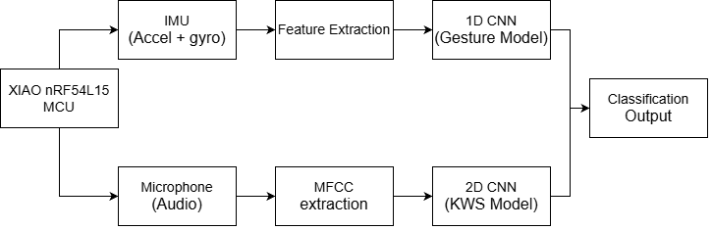
The system is built around the Seeed Studio XIAO nRF54L15 Sense [20], powered by a 1,200 mAh LiPo battery connected through the rear battery input pins. These pins route power through the nRF54L15’s internal power management system. The microcontroller integrates all sensing and communication on a single board, including the PDM microphone MSM261DGT006 for audio capture, a six axis IMU LSM6DS3TR-C for motion sensing, and a BLE radio for wireless output. Solar energy harvesting using the PowerFilm development kit [24] was investigated separately as a possible route to autonomous operation. The overall system is shown in Figure 1.

Figure 1: Dual Case Study System Architecture

Two complementary TinyML case studies were developed on this platform. The keyword spotting system captured one second audio segments at 16 kHz from the PDM microphone, processed them through different methods, and classified whether the target keyword was spoken. The gesture recognition system recorded three second gesture samples at 50 Hz from the IMU then classified the gesture using a 1D CNN. Both applications were triggered by a button press, with the classification result broadcast via a short BLE advertising burst.
Both case studies followed the same development methodology. Sensor data was collected on the nRF54L15 and transmitted to a host computer via USB serial for dataset creation. Models were trained in TensorFlow or Edge Impulse, quantised to INT8, exported as C header files and deployed on the microcontroller using TensorFlow Lite for Microcontrollers. The firmware was developed using the nRF Connect SDK (NCS) built on Zephyr RTOS, which provided the device runtime power management and hardware abstraction used throughout the project [26].
The Nordic Power Profiler Kit 2 was used throughout development to measure the energy consumption of each operational state. These measurements guided the firmware optimisations and were used to evaluate model efficiency and assess battery life and the feasibility of solar harvesting.
The project was developed using the NCS v3.1.1 within Visual Studio Code, with the firmware built on the Zephyr RTOS which provided built in power management and a flexible software framework for embedded deployment. A significant integration challenge arose from the nRF54L15 being a recently released platform. Although NCS v3.1.1 includes a TensorFlow Lite Micro module. It was not fully compatible with XIAO nRF54L15 at the time of development. To resolve this, three source files were added directly to the module: flatbuffer_conversions.cc, error_reporter.cc, and flatbuffer_conversions_bridge.cc, as these were absent from the default build and caused compilation failures without them. The CMakeLists.txt was then configured to reference the modified module, with additional modifications to the prj.conf file required to enable C++ support, as NCS defaults to C. This was necessary because TensorFlow Lite Micro is written in C++ and the model inference API, including interpreter instantiation and tensor allocation, cannot be accessed from a C-only build environment. At the time of writing, no prior documented example of this integration existed for the nRF54L15 platform, making this a non-trivial development overhead that was necessary before any TensorFlow Lite model deployment could take place.

4 Implementing Audio Keyword Spotting

4.1 Recording Audio with nRF54L15
Accurate audio capture is fundamental to reliable keyword spotting. The Seeed Studio XIAO nRF54L15 integrates a digital MEMS microphone, the MSM261DGT006, which operates using pulse density modulation (PDM) [20]. In a PDM system the microphone outputs a high frequency one bit data stream, where the density of 1s represents the amplitude of the acoustic sample.
This PDM bitstream is processed by the nRF54L15’s hardware and converted into 16-bit PCM samples at a sampling rate of 16 kHz. This sampling rate provides sufficient audio quality for speech recognition [13] while still maintaining manageable memory for the nRF54L15.

4.1.1 Serial Transmission to Host Computer
Once a recording was completed, the buffered PCM samples were transmitted to a host computer via Universal Asynchronous Receiver Transmitter (UART). The transmission baud rate was 1 Mbps, which is maximum standard for the nRF54L15 [20]. The data was also formatted using ASCII integers with added start and end markers to make transmission more reliable. Each sample was transmitted using the code: printk("%d\n", sample_value).
Although ASCII transmission is less bandwidth efficient than binary streaming, it significantly simplified debugging and allowed the use of a serial terminal to inspect the output. As the baud rate was so high, a small delay of 50 ms was added every 1000 samples to prevent any transmission issues, which improved stability.

4.1.2 Python Data Logging
A Python script was developed using the pyserial library to collect the transmitted audio data. The script connected to the microcontroller using the COM port and baud rate of the device. The script received 16000 different values between -32768 and +32767, corresponding to the 16-bit PCM mentioned before. Each set of samples were saved into individual CSV, removing the start and end markers. Every CSV file had a corresponding WAV file for audio verification, confirming that the data had been transmitted correctly.

4.2 Creating a Dataset.
The performance of supervised machine learning models is strongly dependent on the dataset quality, diversity and label accuracy [13]. For this project a binary classification was used, consisting of two classes: ‘Hello’ and Noise. The first class ‘Hello’ represented the keyword and the second class included multiple samples of silence, random words and phonetically similar words to hello. A total of 200 samples were collected, 100 for each class. The dataset was then split 80:20 into training and validation data to evaluate the performance.
To increase the robustness of the dataset and improve the generalisation of the model, several techniques were implemented. Firstly, the target word was recorded under various acoustic conditions, including multiple speaking distances, different volume intensities and slight pronunciation variations. This prevented the model from overfitting to a single acoustic profile and encouraged extraction of different acoustic features. Secondly, the Noise class included phonetically similar words such as “help”, “hollow” and “pillow”. This forced the model to learn to distinguish patterns rather than relying on simple amplitude or spectral similarities. Finally, recording were collected over multiple times and locations to vary background noise, helping improve generalisation and reflect real world conditions.
It should be noted that all recordings were produced by a single speaker. Although several techniques exist to increase vocal diversity in a practical deployment, multiple speakers would be required to ensure robustness across variations in accent, pitch and speaking style [13].
During early data collection, a noticeable ‘pop’ was observed in the beginning of each recording. This effect happened across all captured samples implying there was a hardware related issue rather than just coincidence. Two examples of the ‘pop’ are shown in Figure 2.

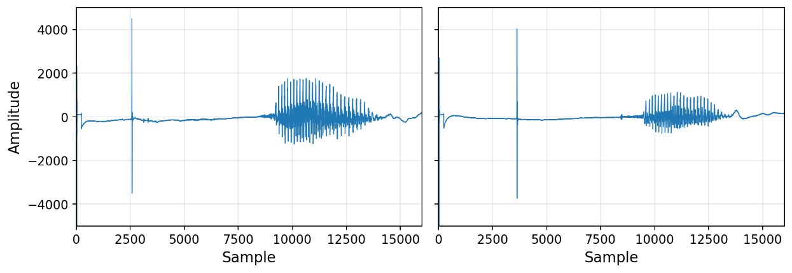

Figure 2: Two Hello Samples With ‘POP’
The short, high amplitude spikes within the first 5,000 samples shown in Figure 2 were likely caused by the initialisation of the microphone and the PDM peripheral. During this time the internal circuitry stabilised and then reached a steady state. Because the pop occurred at similar times at the beginning of the sample it can be removed easily as shown in Figure 3.
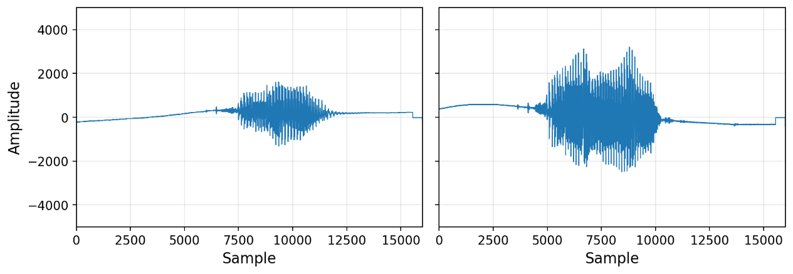

Figure 3: Two Hello Samples Without 'POP'
If the pop was not removed, it could have had an adverse effect on the model training, causing it to try and distinguish similar pops between two classes. This would have overall reduced the generalisation performance.
To mitigate this issue the total recording was increased to 1.5 seconds. The first 0.5 seconds were removed which gave ample time for the microphone to stabilise. An LED was added to alert the user when the one second recording was happening to reduce misspoken samples. The remaining one second segment was then used in the final dataset to improve the quality of the data.

4.3 Keyword Spotting Machine Learning Models
The objective of the machine learning models was to detect the presence of the spoken word ‘Hello’ within the audio data. The models were designed specifically for deployment on the resource limited microcontroller, meaning the complexity and memory usage had to both be carefully considered.

4.3.1 Models using Raw Audio Data
The initial approach to keyword spotting utilised the raw audio waveforms as inputs. The audio was sampled at 16 kHz, meaning that the one second recording used for training the model corresponded to 16,000 input values. Before being passed into the model, the data was normalised to the range -1,1. This was done by dividing the signed 16-bit data by 32768. Normalisation improved the neural networks training and ensured the data is kept within a constant range. After normalisation the dataset was divided into training and testing subsets using an 80/20 split. For the raw audio data 1D convolution neural networks (CNN) were chosen. 1D CNNs are well suited for time series data due to their ability to detect short temporal patterns in the waveform [15].

4.3.2 Model Architecture for Raw Data
The raw audio model was designed to progressively reduce temporal resolution while extracting features at each layer. With 16,000 samples at the input, a four block 1D CNN was implemented, as shown in Figure 4. Each convolutional block was followed by a max pooling layer with a value of 4 (removed from the diagram for clarity), which reduced temporal resolution by a quarter.
Figure 4: Raw Data ML Model

As shown in Figure 4, the first convolutional layer is the most critical design choice. A stride of 8 was applied to immediately reduce the temporal resolution by a factor of eight, which was necessary to keep the activation maps within the RAM budget of the microcontroller. Subsequent layers used smaller kernels of size 5 and 3, which operated on progressively smaller input size. A GlobalMaxPooling layer then collapsed the temporal dimension. The resulting vector was fed into a single neuron dense layer with sigmoid activation producing the binary classification.
The model was trained using the Adam optimiser [27] with binary cross entropy loss over 50 epochs, achieving a validation accuracy of approximately 75%. This result established a baseline and motivated the MFCC based approach described next.

4.3.3 Models using MFCCs
To improve the classification performance, the raw audio signals were transformed into Mel Frequency Cepstral Coefficients (MFCC) before being used as inputs to the neural network. MFCCs are used in speech recognition as they provide a compact representation of the spectral characteristics of audio signals.
The MFCC extraction process was described in the Literature Review. For this project, thirteen MFCC coefficients were extracted from each input with a hop length of 512 samples, chosen to balance accuracy and computational cost. This resulted in a two dimensional feature map of 13 × 32 for each sample, reducing the input from 16,000 values by a factor of approximately 38. The feature map was standardised to have a zero mean and unit variance.
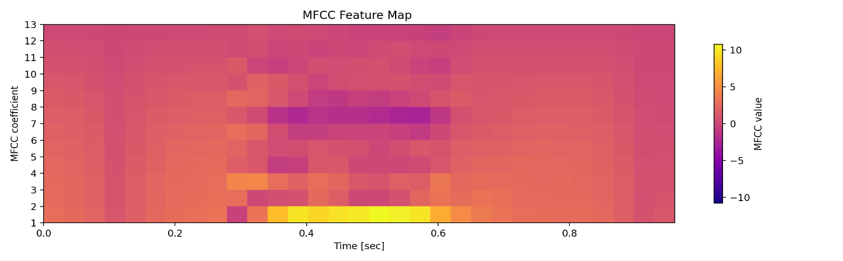
Figure 5 presents the MFCC feature map generated from a one second audio sample. It converts raw audio into a compact 2D representation, where the X axis shows time, the Y axis shows the MFCC coefficients, and the colour scale shows coefficient magnitude. This representation reduces the input size and makes the data suitable for 2D CNN classification.
Figure 5: MFCC Feature Map of a Hello Sample

4.3.4 Model for MFCC Features
When MFCCs are applied, the output is two dimensional, so a 2D CNN was used. This treats the input as an image, allowing the model to detect patterns across both the frequency and time axes. The model used for this application is shown in Figure 6.
Figure 6: MFCC ML Model
As shown in Figure 6, the first convolutional block applied eight 3×3 filters with ReLU activation and the same padding, extracting local time frequency patterns. A 2×2 max pooling layer, omitted from the diagram, halved both spatial dimensions. The second block doubled the filter count to 16, enabling the network to extract more complex patterns within the image, again followed by 2×2 max pooling. The pooled maps were flattened and passed through a 16 neuron fully connected layer with ReLU activation, followed by a dropout layer with a rate of 0.2 to mitigate overfitting on the 200-sample dataset [28]. A single neuron dense layer with a sigmoid activation output produced the binary classification.
The model was trained using the same optimiser and loss as the raw audio model, achieving 96% validation accuracy with an input approximately 38 times smaller than the raw waveform.

4.4 Edge Impulse
Edge Impulse was an alternative development approach to compare a manually designed model against an automatic one. This platform provides an end to end pipeline that integrates data processing, feature extraction, model training and quantisation, making it very useful for embedded systems. The initial implementation utilised the standard Edge Impulse system and integrated MFCC feature extraction and a convolutional neural network. The model was trained using the Edge Impulse EON compiler which helps optimise the hardware to reduce both memory and inference latency. After the optimisation of this model, it occupied approximately 30.4 kB of flash memory and 15.4 kB of RAM. This made it highly suitable for the deployment on the nRF54L15 microcontroller.
Evaluation results showed that the model achieved a validation accuracy of 98% by only having one misclassification between the two classes. However, with test data it received 100% accuracy by correctly classifying the 40 test samples. These accuracies were identical to the INT8 quantised model which demonstrated its effectiveness for embedded keyword spotting.
One main advantage of Edge Impulse was the ease of integration of the full system as with a single call of the function: run_classifier() it performed the MFCC extraction, feature scaling and the classification. This significantly reduced the complexity of the code compared to the TensorFlow Lite implementation.

4.5 Continuous Keyword Spotting
The final keyword spotting system implemented was a continuous inference pipeline, which enabled persistent monitoring of the target word without the user’s interaction. The PDM microphone was configured once at the start of initialisation and remained active throughout the operation, continuously streaming audio data into a fixed size buffer. This avoided repeated peripheral initiation and reduced latency. A short section of data was removed at the beginning to discard the pop effect of the data.
The audio was processed using a sliding window approach to detect all spoken keywords, even between consecutive windows. Each inference cycle operated on a one second window with 16,000 samples. However, to reduce the chance of missing the beginning or end of the keyword a 0.5 second cycle was introduced, that shifted the second half of the data into the first and then appended 0.5 seconds of new data. Using this method allowed no audio data to be discarded between cycles and maintained constant coverage of the incoming audio stream.
Each full window was passed to the Edge Impulse model to perform the inference. When a confidence score of over 0.90 was received it triggered the detection event. The detection event was handled using non blocking work mechanisms to avoid interfering with data collection.
This approach enabled continuous keyword detection with guaranteed coverage across different windows and provided a practical implementation for a constrained embedded deployment.

5 Gesture Recognition using IMU Data

5.1 Gesture Recording Methods
A dedicated collection code was developed using a button triggered buffer and dump approach. When the user pressed the onboard button, the firmware recorded the IMU data into a buffer. An LED indicated when the recording was active, allowing the user to perform the gesture during the correct time window. Each recording lasted 3 seconds, producing 150 samples $(50Hz ×3)$. Each sample contained six sensor values, $a_{x}$, $a_{y}$, $a_{z}$ for the accelerometer and $g_{x}$, $g_{y}$, $g_{z}$ for the gyroscope. This resulted in each gesture containing 900 individual measurements. These measurements were stored as signed 16-bit integers, giving a theoretical range of -32,768 to +32,767.
Once the recording was completed the buffered samples were transmitted to a host computer via USB serial using ASCII integers with start and end markers. A Python script using pyserial library passed the transmitted data and created individual CSV files for each gesture.

5.2 Feature Extraction
In addition to the six raw sensor inputs from the accelerometer and the gyroscope, two additional inputs were computed to improve the model’s performance. These two additional inputs were the magnitude of the accelerometer and the gyroscope vectors. These describe the overall motion of the device [16].
They were calculated using the equations 1 and 2.
$$\left\|a\right\|= \sqrt{{a_{x}}^{2}+{a_{y}}^{2}+{a_{z}}^{2} }$$ | (1)
$$\left\|g\right\|= \sqrt{{g_{x}}^{2}+{g_{y}}^{2}+{g_{z}}^{2} }$$ | (2)

5.3 Datasets
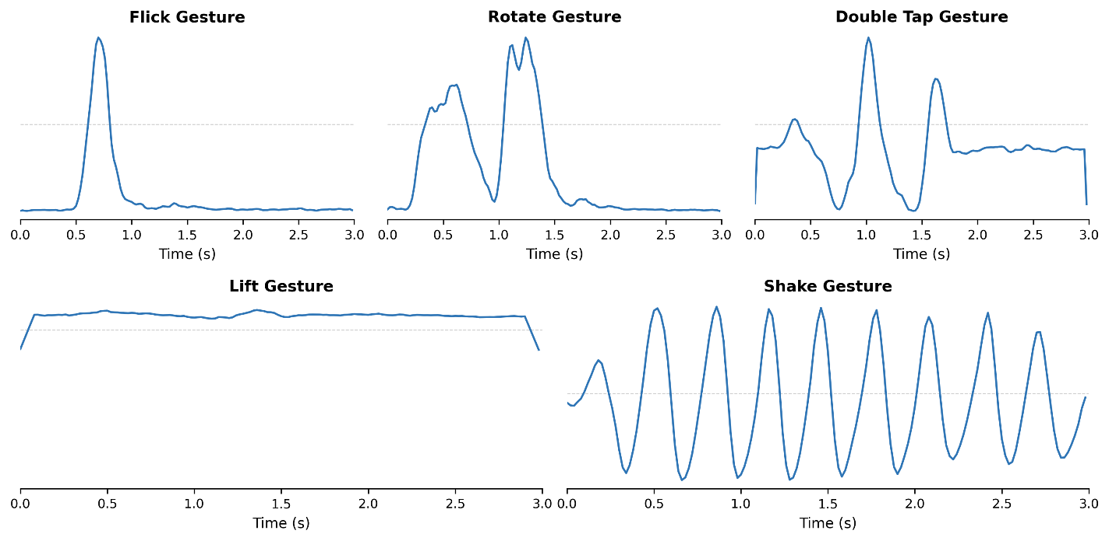
Five gestures were selected for classification: lift, rotate, shake, double tap and flick. These were chosen due to their distinct motion patterns which produce clearly distinguishable signatures across the accelerometer and gyroscope channels. A total of 250 samples were collected, with 50 recordings per gesture class. With an 80/20 split across training and validation data. All five gestures are shown in Figure 7.
Figure 7: All Gesture Kinematic Profiles
Figure 7 illustrates the unique kinematic profiles and defining attributes of all five gesture classes. Each motion produced a highly distinguishable signature across the sensor channels: the flick gesture exhibited a single, sharp transient peak in the gyroscope magnitude, while the shake gesture displayed a clear sinusoidal pattern along the accelerometer's X axis. The double tap is characterised by two distinct, sequential spikes in the acceleration magnitude. Similarly, the rotate gesture produced two pronounced peaks, but these occur within the gyroscope magnitude. Finally, the lift gesture resulted in a sustained shift along the accelerometer's Z axis as the device's orientation changed relative to gravity.

5.3.1 Data Preprocessing
Before training the model, the data needed to be prepared, for this application standardisation was applied using the standardscaler algorithm [29]. The accelerometer and the gyroscope were treated differently due to operating on different numerical ranges, each sensor’s features were transformed using the equation:
$$X_{new}= \frac{x-μ}{σ}$$ | (3)
Where $x$ represents the raw sensor data, $μ$ represents the mean of the sensor’s dataset and $σ$represents the standard deviation. Using this scale meant that each feature had a mean of zero and unit variance, improving neural network training stability. The mean and standard deviation for each feature was saved and later used with the microcontroller to ensure the same preprocessing was applied during real time implementation.

5.4 Machine Learning Models
Two model architectures were developed and compared. The first was a lightweight baseline model and the second was a deeper model designed to increase accuracy. Both models used 1D CNNs which are well suited for time series classification [15].

5.4.1 Baseline Model
The baseline gesture model was designed to have a minimal architecture, through only using a single CNN layer shown in Figure 8.
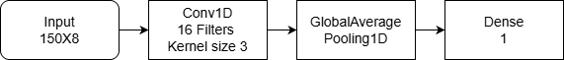
Figure 8: Baseline ML Model
The input to the neural network was 150 X 8, representing 150 time steps across the eight features: three accelerometer axes, three gyroscope axes, and the two magnitudes. The 1D CNN layer applied 16 filters across a kernel size of 3 to detect short motion patterns within the data. Global average pooling flattened the data to prepare for the final dense layer with SoftMax activation to produce the final classification across the five gesture classes.

5.4.2 Deep Model
The deep gesture model extended upon the baseline architecture with a second larger convolutional layer, aiming to improve accuracy at the cost of additional parameters. The architecture is shown in Figure 9.
Figure 9: Deep ML Model
The first Conv1D layer applied 32 filters with a kernel size of 3 and same padding, followed by batch normalisation and a max pooling layer with a factor of 2. Batch normalisation stabilised training by normalising activations at each step, allowing higher learning rates and reducing sensitivity to weight initialisation [30]. The max pooling layer halved the temporal resolution. A second Conv1D layer with 64 filters then extracted higher level features by combining the short patterns identified in the first block. A global average pooling layer reduced the output to prepare the data for a 32-neuron dense layer with ReLU activation before a 5-neuron dense SoftMax output produced the final classification.

5.4.3 Model Training
Both models were compiled with Adam optimiser [27] and categorical cross entropy loss. Training was performed for 30 epochs with a batch size of 16. The models achieved accuracies of 94 and 98% respectively.

5.4.4 Edge Impulse
To contrast the two manual TinyML models, an Edge Impulse model was created using the EON tuner that automatically found the best inputs and hyperparameters to minimise ram, rom and latency. It achieved an accuracy of 100% by using spectral analysis and classification block.

5.4.5 Continuous Gesture Recognition
A continuous gesture recognition system was implemented using the LSM6DS3TR’s built in wake up detection. Instead of requiring a button press, the system monitored the IMU’s accelerometer and triggered when the motion exceeded the programmed threshold. This threshold was configured to have minimum sensitivity (0.063g) to detect even slight movements. Once triggered the system recorded a three second of IMU movement and ran Edge Impulse classification on it. After classification, if the microcontroller remained stationary, it automatically returned to sleep mode until the next movement was detected.

6 Embedded Deployment

6.1 Converting to TinyML
Models trained on TensorFlow typically use 32-bit floating point (FP32) parameters. These require significant memory resources. To allow the model to run efficiently on the nRF54L15, the parameters were converted from the 32-bit numbers to INT8. This change reduced the memory by approximately a factor of four. To ensure the model could handle the different input, a representative dataset was provided to the converter. This allowed each layer to scale properly to the change of inputs. The final model was then exported as a C header file containing the model’s weights stored as a byte array. The header file can be directly executed with TensorFlow Lite.

6.2 Optimisation
The Seeed Studio XIAO nRF54L15 is an ultra-low power microcontroller and highly customisable. Reducing the system’s overall power consumption required multiple optimisations throughout the development process.
During the initial development phase, the system used the Seeed Studio XIAO expansion board to display the operational state and classification results on the integrated OLED screen. While this was valuable for prototyping and visual debugging, the display consumed significant RAM, ROM and several milliamps of continuous current. Removing the OLED display was the first major optimisation.
When the system was transitioned to battery power using the rear battery pins of the nRF54L15, it was discovered that the expansion board was not powered through this path. The battery input connected to the nRF54L15’s internal power management system which accepted voltages between 3.0 V and 4.2 V from a LiPo battery but did not route power to the expansion board’s voltage regulator. This confirmed that the expansion board was not viable for battery powered deployment.
Following the removal of the display, the system still consumed approximately 8 mA in steady state. The main source of this excess current was identified as the UART serial console and printk logging. Disabling UART reduced the average current by approximately 6.5 mA. For the final deployment, all serial output was removed, leaving only the core processing and inference code active during each cycle.
The sensor peripherals were managed using Zephyr’s device runtime power management. The IMU was powered down between gesture recordings by writing zero to the accelerometer and gyroscope control registers and releasing the I²C bus with pm_device_runtime_put. The PDM microphone was only powered during the recording window using the same mechanism. The main loop blocked on a kernel semaphore (K_FOREVER) until a button interrupt fired, ensuring the processor entered its lowest sleep state between events.

6.3 Memory and Ram Analysis
Efficient memory usage is critical for TinyML deployment on the XIAO nRF54L15. The RAM requirements of a TensorFlow model are determined by the tensor arena, this is a single static buffer that is allocated at the beginning of the code. This buffer needs to be enough to handle the entire model and all resolvers. Different resolvers are needed for different models and are critical for telling the firmware what the model does. Unlike conventional computing where the total memory usage scales directly with the size of the script, TensorFlow Lite executes the model layer by layer and reuses memory between layers. During inference only the current layers input and output layers is stored. This means that the arena size is determined by the two biggest consecutive layers, not by the total number of layers.
To investigate this behaviour, a firmware was developed on the nRF54L15. This firmware loads a model, allocates the huge tensor arena, reports the number of byte the model uses with the arena and measures the inference latency of the model.
A series of models were created using a first Conv1D layer with 8 filters and a stride of 4, followed by an additional Conv1D layer with 8 filters.
Number of layers in neural network | RAM (bytes) | ROM (bytes) | Latency (ms)
1 layer | 65652 | 5256 | 486.2
2 layers | 66036 | 7008 | 869.4
4 layers | 66804 | 10640 | 1641
6 layers | 67572 | 14272 | 2415
8 layers | 68340 | 17904 | 3182
Table 1: Comparing RAM, ROM and Latency

The results of Table 1 show a contrast between how RAM, ROM and inference time scale with model depth. The ROM and latency increase linearly from the 2nd layer with the ROM increasing by roughly 1800 bytes and the latency 385 ms per layer. This is the complete opposite to the recorded RAM hardly increased between increasing layers.
This finding has practical implications for any RAM limited microcontrollers like the XIAO nRF54L15. Model accuracy can be improved by adding more depth to the model without increasing total ram. The constraint moves on therefore to the ROM and inference time. For the nRF54L15 with 1.5 MB there is sufficient space for deeper architectures.

6.4 Bluetooth Optimisation
With the display and the UART removed, Bluetooth Low Energy (BLE) was used to output classification results, this would be used if the data on the chip was required by a device not connected to the chip. To reduce the energy consumption a non connectable implementation was chosen. This broadcasts three bytes, where the first two are the manufacture data field, which was useful so that the user can see where the data is coming from and the last byte was used to show the models output. This advertising takes place after the inference takes place and lasts for 600 ms, after each 100 ms the three bytes are advertised. This allowed six attempts for the host to receive the data, as if it was just once, its unlikely to be picked up. This was very energy efficient as it doesn’t need to get a connection with the device, saving energy constantly advertising when not in use.

6.5 Battery Monitoring
The Seeed Studio XIAO nRF54L15 featured an integrated power management designed to efficiently monitor the voltage of a connected battery while minimising passive current drain. This system utilised a TPS22916CYFPR intelligent load switch connected to a voltage divider circuit. To conserve energy, the TPS22916CYFPR acted as an on-demand gate and remained closed during standard operation to prevent the voltage divider from drawing continuous current. When a battery measurement was required, the firmware briefly triggered the load switch, allowing the nRF54L15’s internal Analog to Digital Converter (ADC) to sample the divided battery voltage before immediately disconnecting the circuit again.
To translate this raw ADC voltage reading into the battery percentage a simplified linear approximation model was utilised. The system maps the measured voltage $V_{bat}$ linearly between a fully charged state of 4.2 V and a safe discharge cut off threshold of 3.0 V using the following equation:
$$C =\frac{V_{bat}-3.0}{4.2-3.0}×100$$ | (4)
Where C represents the estimated battery capacity percentage. It is important to acknowledge that this was an estimation and in reality LiPo experience nonlinear discharge curve. However, for this system it was a practical and resource efficient estimate for tracking the battery percentage.

7 Results

7.1 Power Measurement Setup
To evaluate the energy consumption of the system, all measurements were taken using the Nordic Power Profiler Kit 2 (PPK2). The supply voltage was set to 3.7 V to represent the nominal output of a single lithium polymer (LiPo) battery, which was the intended power source for the final deployment. The PPK2 was connected directly to the battery input pins on the rear of the XIAO nRF54L15 to replicate the configuration in the final system.
All reported current values represent the mean of five independent measurements, each recorded over the full duration of the corresponding operational state, with the system restarted between measurements to ensure independence. UART logging and all unnecessary peripherals were disabled prior to measurement to ensure that reported currents reflect only the core application pipeline, including sensor operation, data processing, and model inference. The PPK2 carries a manufacturer specified measurement uncertainty of ±10% [31], introducing a small systematic offset into the absolute energy and battery life figures; the relative comparisons between models and configurations are unaffected by this.
Three power states were measured for each model. The first was the idle state, this represents the current draw when the device was powered but not performing any active tasks. The second was data collection state, this represented the current during the microphone recording or the IMU sampling. The last was the inference state this was the current during the preprocessing and neural networks execution.

7.2 Evaluation Metrics
To enable a comprehensive evaluation of the model’s performance on the embedded hardware, multiple metrics were considered. Classification accuracy measures the ratio of correctly classified samples and provided an indicator of the model performance. RAM usage represents the memory required to execute the model in real time. ROM usage represents the size of the model and represents the number of bytes the header file uses. Inference time is the duration of a single cycle including preprocessing and neural networks execution and measured in milliseconds. Energy consumption in milliamps represents the current draw of the microcontroller during each operational phase at the 3.7 V.
In addition to these measured metrics, the total energy per inference was calculated to allow direct comparison of the overall energy usage of each model. This was computed using the equation:
$$E_{cycle}=(I_{collect}×t_{collect}+ I_{active}× t_{inference})×V$$ | (5)
Where $I_{collect}$ is the current during data acquisition, $t_{collect}$is the recording duration, $I_{active}$ is the average current during the active processing phase, $t_{inference}$ is the inference duration and V is the supply voltage of 3.7 V.

7.3 Keyword Spotting Model Results
The three keyword spotting models were evaluated and created on the same 200 samples. Each model received the same one second of audio input recorded at 16 kHz from the same onboard PDM microphone. The results from all three models are shown in Table 2.
Model | Accuracy (%) | Inference Time (ms) | $$I_{collect}$$  (mA) | $$I_{active}$$  (mA) | $$I_{idle}$$  (µA) | RAM (bytes) | ROM (bytes) | $$E_{cycle}$$  (mJ)
Raw 1D CNN | 75 | 865 | 1.05 | 2.01 | 11.6 | 51,476 | 14,272 | 12.26
MFCC 2D CNN | 96 | 127 | 1.05 | 2.14 | 11.6 | 15,928 | 8,080 | 6.83
Edge Impulse | 98 | 65 | 1.05 | 2.20 | 11.6 | 15,400 | 30,400 | 6.36
Table 2: Comparing Three Keyword Spotting Models
Figure 10 shows the power profile of the raw data keyword spotting during a single inference cycle captured by the Nordic PPK2. The traces show three distinct phases: the 1.5 seconds of microphone recording showing high spikes of current, the model inference shown by the smooth block at the end and the idle current either side of the inference. The sharp transition back into idle shows that the Zephyr power management is effective at enabling and disabling the PDM microphone.
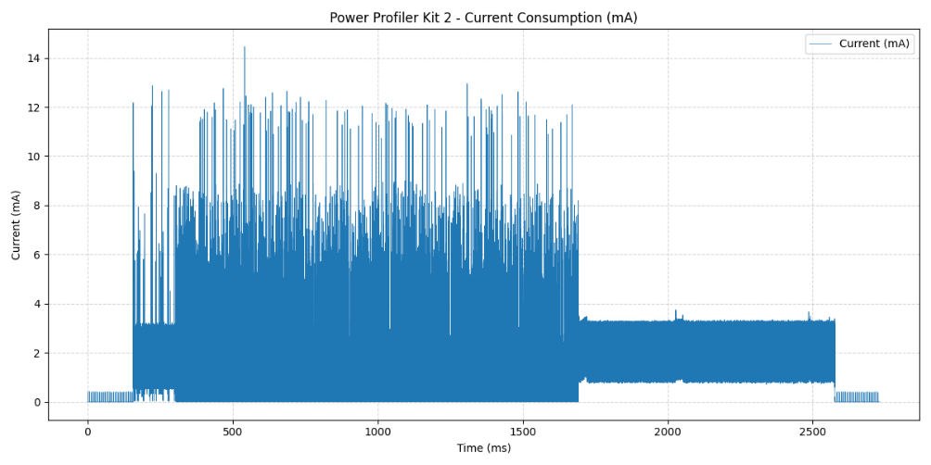

Figure 10: Power Profiler of Raw Data Keyword Spotting Model
The raw audio model achieved the lowest accuracy of 75%, with the longest inference time of 865 ms and the highest RAM usage of 51,476 bytes. The MFCC model significantly improved accuracy to 96% while reducing inference time to 127 ms and RAM to 15,928 bytes. The Edge Impulse model achieved the highest accuracy of 98% with the shortest inference time of 65 ms and the lowest energy per cycle of 6.36 millijoules (mJ). The Edge Impulse model’s larger ROM of 30,400 bytes was due to the bundled SDK rather than a larger neural network.

7.3.1 Continuous Keyword Spotting Results
The continuous keyword spotting system was measured using the PPK2 over multiple cycles with the microphone permanently active and the inference running every 0.5 seconds. The system consumed on average 1.67 mA, this was constant as there was no idle state for this code. The energy consumption per inference is 3.09 mJ calculated using: $1.67 mA ×0.5 s ×3.7 V$.

7.4 Gesture Recognition Models Results
The three gesture models were evaluated using the five gesture classes: lift, rotate, shake, double tap and flick. Each gesture class had 50 samples and lasted 3 seconds with a sampling rate of 50 Hz. The results are summarised in Table 3.
Table 3: Comparing Three Gesture Recognition Models
Model | Accuracy (%) | Inference Time (ms) | $$I_{collect}$$  (mA) | $$I_{active}$$  (mA) | $$I_{idle}$$  (µA) | RAM (bytes) | ROM (bytes) | $$E_{cycle}$$  (mJ)
Baseline | 94 | 75 | 1.15 | 2.25 | 180 | 5925 | 4500 | 13.39
Optimised | 98 | 707 | 1.15 | 2.27 | 180 | 12436 | 19768 | 18.70
Edge Impulse | 100 | 24 | 1.15 | 2.46 | 180 | 11900 | 42800 | 12.98
Figure 11 shows the power profile of the optimised gesture recognition model during a single inference. The three second recording phase is visible from the spikes spaced at 20 ms apart, followed by the inference block lasting around 700 ms. The idle current is visible on either side of the cycle and is visibly higher than the idle current in the keyword spotting Figure 10.
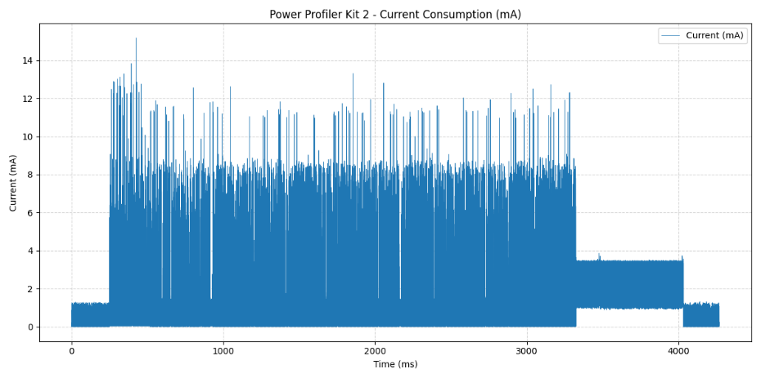

Figure 11: Power Profile of Optimised Gesture Recognition Model
To further evaluate the classification performance of the models, confusion matrices were generated for the baseline and optimises models shown in Figure 12A and B.
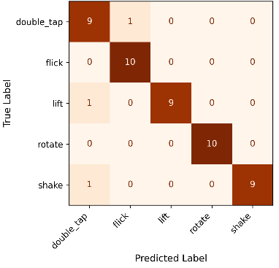
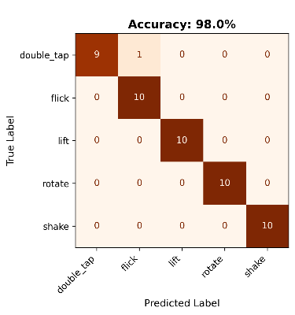

Figure 12:A) Baseline Model Confusion Matrix B) Optimised Model Confusion Matrix
The baseline model correctly classified 47 out of 50 samples, misclassifying one lift, shake and double tap. While the optimised model only had one error of double tap misclassified as flick. Edge Impulse correctly identified all test data.

7.4.1 Continuous Gesture Recognition
The continuous gesture recognition system was measured in two states, the first state was idle when the accelerometer was running at reduced frequency for motion detection this consumed 308 µA. This was higher than the 180 µA measured for the other gesture systems due to the accelerometer still being awake. The second state started when motion was detected, causing the system to start recording. It used the same system as the Edge Impulse model meaning the energy consumption is also the same, consuming the same 12.98 mJ. The key advantage to this system is that it only runs the TinyML model when there is movement therefore reducing the total energy consumption over a long period of time if gestures are infrequent.

7.5 Bluetooth Energy Consumption
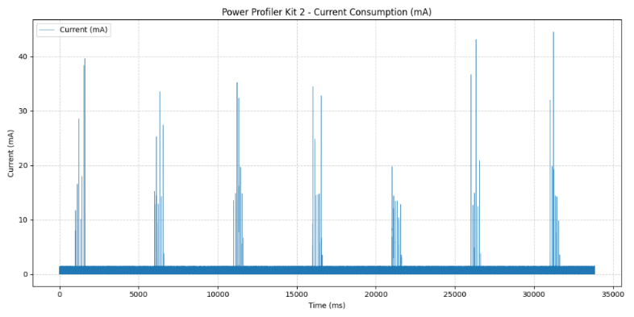
To precisely measure the energy footprint of Bluetooth transmission, a firmware application was developed that strictly replicated the BLE advertising used in the final deployment, while removing all the neural network inference. The microcontroller was configured to broadcast in 600 ms bursts at 5 second intervals shown in Figure 13.

Figure 13: Power Profile for Bluetooth Advertisement
To accurately calculate the average energy consumption of the radio during these bursts, the idle current ($I_{Idle})$must be subtracted from the total average current ($I_{avg}$) recorded over the time T. The BLE advertisement energy was derived using the equation:
$$E_{burst}=\frac{(I_{avg}-I_{Idle})×V×T}{N}$$ | (6)
Where V represents the system’s voltage (3.7 V) and N represents the total number of bursts over time T. Using Equation (6), $E_{burst}$ was calculated to be 0.16 mJ. This demonstrates that non connectable BLE advertising was a highly efficient for wirelessly outputting TinyML classification results.

8 Discussion

8.1 Keyword Spotting Model Analysis
The keyword spotting results demonstrate a clear progression in both accuracy and efficiency as the feature extraction pipeline becomes more sophisticated. The raw audio model represents the most direct approach, feeding the raw waveform into the neural network and relying on the convolutional layers to extract spectral features. This approach achieved the lowest accuracy of 75% while consuming the most memory and energy. This is due to the large input of 16,000 values forcing the first convolutional layer to use a stride of 8, which threw away fine temporal detail before the network had a chance to learn useful features. With such aggressive compression in the first layer, the model had very limited capacity to distinguish between similar sounding words. This is a common limitation of raw waveform models on constrained devices, where the network must learn both feature extraction and classification within a very small parameter budget.
The transition from raw audio to MFCC features represents the most impactful design decision in the keyword spotting pipeline. By transforming the 16000 audio samples into a 13 × 32 spectral representation, the input dimensionality is reduced by a factor of approximately 38. This allowed the model to focus on learning patterns in the frequency domain rather than attempting to derive them from the raw waveform. The MFCC model increased accuracy to 96% while also decreasing the model size and inference time. These changes led to a 44% reduction in energy consumption per cycle, showing that preprocessing and feature extraction are not just about improving accuracy, but are fundamental to reducing energy usage on constrained devices. By reducing the input size, the model needs fewer operations and less memory, which directly translates to less energy per inference.
The Edge Impulse model used the same MFCC feature extraction approach but benefitted from the EON compiler optimisation. This model increased accuracy to 98% and halved the inference time from 127 ms to 65 ms, suggesting that the EON compiler identified a more efficient network layout for the classification task than the manually designed architecture. The trade-off is a significantly larger ROM of 30,400 bytes compared to 8,080 bytes for the MFCC model. However, this increase is due to the bundled SDK rather than a larger neural network and given the nRF54L15’s 1.5 MB of available flash, it is insignificant in practice.
For a practical deployment, both the MFCC model and the Edge Impulse model are viable solutions. The MFCC model offers a similar memory footprint and allows full customisation of both the model architecture and preprocessing, making it preferable for applications requiring further optimisation. The Edge Impulse model offers superior accuracy, inference speed and significantly simpler firmware integrations, making it the better choice when development time is constrained.

8.1.1 Keyword Spotting Energy Comparison
Comparing the button triggered and continuous keyword spotting deployments revealed an important trade-off between responsiveness and battery life. The button triggered system at a 15 second duty cycle consumed only 0.12 mA on average, giving an estimated battery life of 416 days. At a 5 second duty cycle this increased to 0.35 mA and 143 days. In both cases the system spent most of its time in a deep sleep state at 11.6 µA, with brief active windows for recording and inference.
The continuous system eliminated the possibility of missing a keyword by keeping the microphone permanently active, but at the cost of a constant 1.67 mA draw. This limited the battery life to approximately 30 days. However, the energy per individual inference cycle was only 3.09 mJ compared to 6.36 mJ for the button triggered mode. This is because the sliding window approach reused half of the previous audio buffer and removed the 0.5 second microphone stabilisation overhead, meaning each cycle only needs 0.5 seconds of new recording instead of 1.5 seconds. This shows that for TinyML systems, keeping a peripheral continuously active can reduce per inference energy by avoiding repeated peripheral startups.
The choice between these modes depends on the application requirements. For applications where keywords may be spoken at unpredictable times and every instance must be captured, the continuous system is the appropriate choice despite its shorter battery life. For applications where keyword detection is periodic or can tolerate occasional missed events, the button triggered system with a longer duty cycle provides substantially longer operation from the same battery.

8.2 Gesture Recognition Model Analysis
The gesture recognition results present a different set of design considerations compared to keyword spotting. The most notable finding was that energy consumption was dominated by the data collection phase rather than the model’s inference. For all models the three second IMU recording at 1.15 mA consumed most of the total cycle energy with a value of 12.77 mJ. The baseline model’s inference added only 0.62 mJ over 75 ms, while the deep model’s 707 ms inference contributed 5.94 mJ. Even for the deep model, the inference accounts for only 31.8% of the total cycle energy.
This has important implications beyond just this platform. For any TinyML application where data collection takes multiple seconds, optimising the model architecture alone will have limited impact on overall energy. The bigger savings come from reducing the recording window or sampling rate, provided accuracy can be maintained. This highlights why it is important to profile the full system pipeline rather than focusing only on model level metrics.
The baseline model achieved 94% accuracy across the five gesture classes, which is a strong result for such a minimal architecture. However, its confusion matrix reveals that the single convolutional layer lacked the depth to reliably separate gestures with subtle kinematic differences, resulting in one misclassification each of lift, shake, and double tap. The deep model resolved these issues by increasing accuracy to 98%, with only one remaining error of double tap misclassified as flick. This improvement came at the cost of a 707 ms inference time due to the increased computational complexity of the second convolutional layer and the larger filter counts, totalling 96 across both layers.
The Edge Impulse model achieved perfect 100% accuracy on the test set with an inference time of only 24 ms, the fastest of all three gesture models. The EON compiler’s use of spectral analysis features likely provided a more useful representation of the gesture dynamics than the raw time domain input used in the manual models. The 24 ms inference time meant the model’s energy contribution to each cycle was negligible compared to the 3 second recording window by only adding 0.22 mJ.
The idle current of 180 µA for the button triggered gesture models was significantly higher than the 11.6 µA measured for keyword spotting. This is because the PDM microphone interface can be fully powered down between recordings, using Zephyr’s device runtime power management, while the IMU communicated over I²C, which retains a small residual current draw even when the sensor registers are set to power down mode. This shows that for a TinyML system design, the choice of sensor interface (PDM vs I²C vs SPI) has a significant effect on idle power and should be considered during hardware selection.
The continuous gesture system increased the idle current further to 308 µA by using the IMU’s hardware wake up detection. In this configuration the accelerometer ran at 12.5 Hz in a low power mode with the gyroscope completely disabled. Although 308 µA was higher than the button triggered idle of 180 µA, the continuous system provided automatic gesture detection without user interaction. The slight increase in idle current was attributable to the accelerometer remaining active rather than being fully powered down. This trade off was justified because it eliminated the need for a physical button press, making the system practical for wearable applications.

8.3 Memory and Ram Analysis
The Seeed Studio XIAO nRF54L15 is constrained to 256 kB of RAM and 1.5 MB of Flash. To evaluate the viability of each approach, the total memory footprint of both the keyword spotting (KWS) and gesture recognition systems was measured. The results are summarised in Table 4.
Model | Total RAM (kB) | Total ROM (kB)
Raw data KWS | 155.91 | 147.1
MFCC KWS | 116.16 | 262.19
Edge Impulse KWS | 105.82 | 164.30
Continuous KWS | 124.79 | 280.04
Baseline gesture | 63.18 | 140.84
Optimised gesture | 83.18 | 155.91
Edge Impulse gesture | 50.67 | 203.53
Continuous gesture | 38.88 | 177.91
Table 4: All Systems RAM and ROM
The KWS configurations exhibited the highest RAM demands across all implementations. The Raw Data KWS model consumed 155.91 kB of RAM which was over 60% of available RAM. This was driven by the large PCM sample buffer required to store raw 16-bit audio and the correspondingly large tensor arena demanded by the 16,000 input values. Transitioning to the MFCC KWS model reduced this by approximately 25% to 116.16 kB, as the compressed 13 × 32 feature map required a substantially smaller tensor arena. The Edge Impulse KWS model achieved the lowest footprint of the button triggered configurations at 105.82 kB through the EON compiler's automated memory optimisations. The Continuous KWS system increased slightly to 124.79 kB, as the overhead of maintaining the active sliding 32 kB audio buffer and associated hardware states offset the efficiency gains of the Edge Impulse model core.
The gesture recognition models used considerably less RAM than their KWS counterparts, reflecting the much smaller IMU input buffer of 2,400 bytes (150 samples across 8 axes) compared to the audio buffers required for speech processing. The Baseline Gesture model required only 63.18 kB due to its reduced tensor arena. The Optimised Gesture model increased RAM usage to 83.18 kB due to its deeper architecture requiring a larger tensor arena. The Edge Impulse Gesture model remained highly optimised at 50.67 kB, while the Continuous Gesture system achieved the lowest RAM of all tested systems at 38.88 kB.
Throughout all implementations, a consistent RAM and ROM trade off was observed because of feature extraction and compiler optimisation. The MFCC KWS model provided the clearest example. Whilst preprocessing reduced RAM requirements, it increased ROM to 262.19 kB, approximately 78% larger than the raw audio model. This increase came from the storage requirements of the MFCC preprocessing pipeline, specifically the Fast Fourier Transform lookup tables used for quick spectral computation and the precalculated Mel filter bank coefficients required to replicate the Python trained ML model on the device.
Beyond feature extraction, automated optimisations also introduced ROM overhead. Edge Impulse implementations produced a higher ROM footprint compared to equivalent manual TensorFlow Lite deployments, as seen with the Edge Impulse Gesture model at 203.53 kB. This arises because the EON compiler aggressively minimises runtime RAM by bundling necessary SDK libraries that increase the baseline flash allocation. Given the nRF54L15's 1.5 MB of available Flash, these ROM increases represent an acceptable trade-off for the substantial reductions in RAM and inference latency.

8.4 Battery Life
A 1,200 mAh LiPo battery was selected for the final deployment. To estimate operational lifetime, the average current consumption was calculated for each application under two duty cycling scenarios using the equation:
$$I_{average }=\frac{(I_{collect}×t_{collect}+ I_{active}× t_{inference}+ I_{idle}×t_{idle})}{t_{cycle}}$$ | (7)
For the keyword spotting system using the Edge Impulse model, the active phase consisted of 1.5 seconds of microphone recording at 1.05 mA followed by 65 ms of inference at 2.20 mA. The idle current was 11.6 µA. At a 5 second duty cycle the average current was 0.35 mA, giving an estimated battery life of approximately 143 days. At a 15 second duty cycle the average current dropped to 0.12 mA, extending the battery life to approximately 416 days. The continuous KWS system with its constant 1.67 mA draw would last approximately 30 days.
For the gesture recognition system using the Edge Impulse model, the active phase consisted of 3 seconds of IMU recording at 1.15 mA, followed by 24 ms of inference at 2.46 mA. The button triggered idle current was 180 µA. At a 5 second duty cycle the average current was 0.77 mA, giving an estimated battery life of approximately 64 days. At a 15 second duty cycle the average current dropped to 0.38 mA, extending the battery life to approximately 131 days. The continuous gesture system with its 308 µA idle current would achieve significantly longer battery life when gestures are infrequent, as the system only draws active current during actual gesture events rather than on a fixed duty cycle.
Application | Duty Cycle (s) | $I_{average }$ (mA) | $P_{average }$ (mW) | Battery Life (days)
KWS | 5 | 0.35 | 1.30 | 143
KWS | 15 | 0.12 | 0.44 | 416
Gesture | 5 | 0.77 | 2.86 | 64
Gesture | 15 | 0.38 | 1.41 | 131
Table 5: Comparing Battery Life
The keyword spotting system demonstrated excellent battery efficiency due to its very low idle current of 11.6 µA. Even at the more responsive 5 second duty cycle, the system would operate for nearly five months on a single charge. The gesture recognition system has shorter battery life primarily due to the longer 3 second recording window and the higher idle current from the I²C bus. However, 64 days at a 5 second cycle is still a practical operational lifetime for many embedded applications.
These calculations assume a constant supply voltage of 3.7 V. In practice the battery voltage varies from 4.2 V to approximately 3.0 V during discharge, which affects current draw. The actual battery life may differ from these estimates, however the relative comparison between models and configurations remains valid.

8.5 Broader Implications
Beyond the direct performance results, several broader considerations are relevant to this work. The single-speaker and single user datasets represent a practical limitation on generalisation, as models trained on consistent data may achieve reduced accuracy for users with different accents, speech patterns, or motor variability. The 416 day battery lifetime at a 15 second duty cycle substantially reduces the frequency of battery replacement compared to conventional IoT deployments, which is relevant at sensor network scale where maintenance overhead is a practical constraint. The on device processing architecture means that no raw audio or motion data leaves the device at any point, directly addressing the privacy concerns associated with cloud dependent IoT systems. The solar feasibility analysis further suggests that energy neutral autonomous operation is achievable with a modest change to the voltage regulation configuration, which would bring average power consumption within the capacity of the available outdoor panels.

8.6 Solar Machine Learning Feasibility
Solar feasibility testing used the PowerFilm DEV-BASIC kit configured to deliver a regulated 3.0 V output to the nRF54L15 through the BQ25570 energy harvesting power management IC [25]. A 60 mAh LiPo cell served as an energy buffer. All measurements were taken using the Nordic PPK2 at 3.0 V supply. The measured power consumption is presented in Table 6.
Model | Idle Current (µA) | Idle Power (mW) | Average Current Over Full Cycle (mA) | Total Cycle Time (s) | Power Of Full Cycle (mW)
KWS | 465 | 1.40 | 1.2 | 2.36 | 3.6
Gesture | 730 | 2.19 | 1.34 | 4.03 | 4.02
Table 6: System Power Profile at 3.0 V
Table 6 shows the current consumption at idle and the average current over the full inference cycle including data collection, inference, and Bluetooth advertising. The idle current at 3.0 V was significantly higher than the 11.6 µA and 180 µA measured at 3.7 V in the battery life analysis. This increase is likely due to the voltage dependent efficiency of the nRF54L15's internal DC-DC converters. At lower input voltages, the power management circuit must draw higher current to maintain stable voltages, reducing overall system efficiency.
The PowerFilm DEV-BASIC kit includes two solar panels: a LL200-3-37 indoor panel and an ONP1.2-12x24 outdoor panel. The manufacturer specified performance characteristics [24] are shown in Table 7.
Panel | Voltage (V) | Current (mA) | Power (mW)
Inside 200 Lux | 2.1 | 0.166 | 0.348
Inside 1000 Lux | 2.6 | 0.419 | 1.089
Classic 25% Sun | 1.2 | 0.7 | 0.84
Classic 100% Sun | 1.2 | 3.33 | 4
Table 7: Panel Specifications Power out of Different Solar Panels

Comparing Table 6 and Table 7 reveals the fundamental challenge for solar powered operation. The idle power consumption alone (1.40 mW for keyword spotting, 2.19 mW for gesture recognition) exceeded the available solar power under all conditions except the outdoor panel at full sun. This means that even when the system is not performing inference, the baseline power draw from maintaining the 3.0 V regulated output exceeds what the indoor panel can provide.
For the outdoor panel at full sun, which provides 4.0 mW, the keyword spotting model operating on a 5 second duty cycle would consume an average of 2.44 mW, while the gesture recognition model would consume 3.66 mW. Although both values fall below the instantaneous panel output, they represent continuous power consumption across the full 24 hour period, not just during daylight. For autonomous overnight operation, the system must generate sufficient surplus energy during daylight hours to sustain operation when the panel is not producing.
The keyword spotting model consuming 2.44 mW continuously over 24 hours requires 210.8 J. With the outdoor panel producing 4.0 mW for approximately 6 hours of sunshine per day, the available daily energy produced is 86.4 J, representing a deficit of 124.4 J per day. Achieving energy neutrality would require approximately 14.6 hours of full sun daily, which is not achievable under any practical outdoor deployment scenario. The gesture recognition model requires 22 hours of full sun per day, making solar operation even less viable for that application.
For solar operation to be feasible with the available panels, the average system power consumption would need to be reduced to approximately 1.0 mW. This is not achievable under the 3.0 V regulated output due to the higher idle current. By contrast, the battery powered measurements at 3.7 V achieved idle currents of 11.6 µA by allowing the microcontroller to operate closer to its native voltage range, which minimised power conversion losses. An alternative configuration that charges the battery directly to 3.7 V, rather than regulating the output to 3.0 V, would reduce the keyword spotting model's idle power consumption to only 0.043 mW, bringing the average cycle power within the outdoor panel's capacity at moderate duty cycles. Connecting multiple panels in parallel to increase available current would represent a further route to viability, though this could not be tested within the scope of this project.
This analysis suggests that the barrier to solar powered TinyML operation is not the inference energy itself, but the baseline power required to maintain regulated voltage. Direct battery charging with minimal voltage conversion, as demonstrated by the 3.7 V measurements, would likely enable successful solar operation with the same panels without requiring any change to the ML pipeline.

8.7 Limitations
Several limitations of this study should be acknowledged. The keyword spotting dataset was collected from a single speaker, which could have limited the model’s ability to generalise across different voices, accents and styles of speaking. For actual production, the deployment would require multiple speakers to diversify the dataset. The dataset of 200 samples is relatively small compared to established benchmarks such as Google Speech Command’s dataset, which contains over 100,000 samples [13].
The gesture recognition dataset was also collected from a single user. Variation in the different user’s movement of the device could impact classification accuracy. The five gestures used were selected due to being distinct, meaning that the model’s accuracy may decrease with different similar gestures.
The energy measurements were taken at a fixed supply voltage of 3.7 V. In practice the battery voltage would vary from 4.2 V to approximately 3 V, affecting the current draw. This may cause the battery life to differ from the calculated estimates.
Battery lifetime estimates were derived analytically from measured current values rather than validated through long term discharge testing. Nonlinear LiPo discharge and temperature dependant capacity loss means actual operational lifetimes may differ from the calculated figures.

9 Conclusion
This work investigated the feasibility of deploying TinyML on the Seeed Studio XIAO nRF54L15 through three research objectives. Objective one confirmed that deployment on this memory and power constrained platform is both feasible and energy efficient, with both applications achieving high accuracy within the 256 kB RAM and 1.5 MB flash constraints. Objective two revealed that system level optimisation across model architecture, feature extraction, quantisation, and firmware management was essential, with MFCC preprocessing improving accuracy while reducing energy consumption, and firmware changes that removed unnecessary peripherals reduced idle current. Critically, for sensor driven applications, data collection duration dominated total cycle energy over inference cost. Objective three demonstrated that long term autonomous operation is achievable through battery power, reaching 416 days for keyword spotting at a 15 second duty cycle, while solar harvested operation is viable under full outdoor illumination, though indoor and partial sun conditions remain infeasible due to idle power exceeding available panel output at 3 V.
At the time of writing, no prior published deployments of TinyML on the XIAO nRF54L15 have been identified, making this the first documented implementation of both keyword spotting and gesture recognition on this platform. The findings demonstrate that effective TinyML deployment requires optimisation across the full system, encompassing feature extraction, model architecture, firmware scheduling, and power management, rather than model compression alone. These results are expected to generalise to other ultra-low power microcontrollers with similar resource constraints and provide a documented reference for future TinyML work on the nRF54L15 platform.

9.1 Future Work
Several directions for future work have been identified:
- Expand the keyword spotting dataset with multiple speakers to represent real word condition and improve generalisation.
- Investigate the minimum window length and sampling rate that still achieves acceptable accuracy for gesture recognition.
- Characterise the full energy profile of the system across the complete battery discharge curve from 4.2 V to 3.0 V.
- Further investigate the feasibility of solar harvesting to sustain TinyML inference autonomously.
- Test alternative sensor interfaces to reduce energy consumption during data acquisition.
- Benchmark the two case studies on alternative ultra-low power microcontrollers to identify the most energy efficient platform for this class of workload.
- Extend the keyword spotting to support multi keyword classification and investigate the memory and energy overhead of scaling beyond binary detection.

References

[1] | International Energy Agency, “Electricity 2024 - Analysis and Forecast to 2026,” IEA, 2024.
[2] | Y. Abadade, A. Temouden, H. Bamoumen, N. Benamar, Y. Chtouki and A. S. Hafid, “A Comprehensive Survey on TinyML,” IEEE Access, vol. 11, 2023.
[3] | P. Warden and D. Situnayake, TinyML: Machine Learning with TensorFlow Lite on Arduino and Ultra-Low-Power Microcontrollers, O'Reilly Media, 2020.
[4] | J. Lin, W.-M. Chen, Y. Lin, J. Cohn, C. Gan and S. Han, “Tiny Machine Learning: Progress and Futures,” IEEE Circuits and Systems Magazine, vol. 23, no. 3, pp. 8-34, 2023.
[5] | J. Lin, W.-M. Chen, Y. Lin, J. Cohn, C. Gan and S. Han, “MCUNet: Tiny Deep Learning on IoT Devices,” in Advances in Neural Information Processing Systems (NeurIPS), 2020.
[6] | B. Jacob, S. Kligys, B. Chen, M. Zhu, M. Tang, A. Howard, H. Adam and D. Kalenichenko, “Quantization and Training of Neural Networks for Efficient Integer-Arithmetic-Only Inference,” in Proceedings of the IEEE Conference on Computer Vision and Pattern Recognition (CVPR), 2018.
[7] | P.-E. Novac, G. Boukli Hacene, A. Pegatoquet, B. Miramond and V. Gripon, “Quantization and Deployment of Deep Neural Networks on Microcontrollers,” Sensors, vol. 21, no. 9, p. 2984, 2021.
[8] | R. David, J. Duke, A. Jain, V. Janapa Reddi, N. Jeffries, J. Li, N. Kreeger, I. Nappier, M. Natraj, S. Regev, R. Rhodes, T. Wang and P. Warden, “TensorFlow Lite Micro: Embedded Machine Learning for TinyML Systems,” in Proceedings of Machine Learning and Systems (MLSys), 2021.
[9] | L. Lai, N. Suda and V. Chandra, “CMSIS-NN: Efficient Neural Network Kernels for Arm Cortex-M CPUs,” CoRR, vol. abs/1801.06601, 2018.
[10] | T. Chen, T. Moreau, Z. Jiang, L. Zheng, E. Yan, H. Shen, M. Cowan, L. Wang, Y. Hu, L. Ceze, C. Guestrin and A. Krishnamurthy, “TVM: An Automated End-to-End Optimizing Compiler for Deep Learning,” in 13th USENIX Symposium on Operating Systems Design and Implementation, Carlsbad, CA, USA, 2018.
[11] | Edge Impulse, “Edge Impulse Documentation,” 2025. [Online]. Available: https://docs.edgeimpulse.com/. [Accessed 17 March 2026].
[12] | I. López-Espejo, Z.-H. Tan, J. H. L. Hansen and J. Jensen, “Deep Spoken Keyword Spotting: An Overview,” IEEE Access, vol. 10, pp. 4169 - 4199, 2022.
[13] | P. Warden, “Speech Commands: A Dataset for Limited-Vocabulary Speech Recognition,” CoRR, 2018.
[14] | Y. Zhang, N. Suda, L. Lai and V. Chandra, “Hello Edge: Keyword Spotting on Microcontrollers,” arXiv, 2018.
[15] | S. Kiranyaz, O. Avci, O. Abdeljaber, T. Ince, M. Gabbouj and D. J. Inman, “1D Convolutional Neural Networks and Applications: A Survey,” Mechanical Systems and Signal Processing, vol. 151, 2021.
[16] | C. A. Ronao and S.-B. Cho, “Human activity recognition with smartphone sensors using deep learning neural networks,” Expert Systems with Applications, vol. 59, pp. 235-244, 2016.
[17] | E. Lattanzi, M. Donati and V. Freschi, “Exploring Artificial Neural Networks Efficiency in Tiny Wearable Devices for Human Activity Recognition,” Sensors, vol. 22, no. 7, p. 2637, 2022.
[18] | Arduino, “How to reduce power consumption on the Nano 33 BLE,” Arduino Help Center, 2022.
[19] | Espressif Systems, “ESP32 Series Datasheet,” Espressif Systems, Shanghai, 2024.
[20] | Seeed Studio, “XIAO nRF54L15 (Sense) Wiki,” 2025. [Online]. Available: https://wiki.seeedstudio.com/xiao_nrf54l15_sense_getting_started/. [Accessed 10 April 2026].
[21] | H. Xiao, N. Qi, Y. Yin, S. Yu, X. Sun, G. Xuan, J. Liu, S. Xiao, Y. Li and Y. Li, “Investigation of Self-Powered IoT Sensor Nodes for Harvesting Hybrid Indoor Ambient Light and Heat Energy,” Sensors, vol. 23, no. 8, p. 3796, 2023.
[22] | M. Safaei, H. A. Sodano and S. R. Anton, “A review of energy harvesting using piezoelectric materials: state-of-the-art a decade later (2008–2018),” Smart Materials and Structures, vol. 28, no. 11, p. 113001, 2019.
[23] | K. K. P. Churchill, H. Ramiah, G. Chong, Y. Chen, P.-I. Mak and R. P. Martins, “A Fully-Integrated Ambient RF Energy Harvesting System with 423-μW Output Power,” Sensors, vol. 22, no. 12, p. 4415, 2022.
[24] | PowerFilm Solar, “Solar Development Kit (DEV-BASIC),” 2024. [Online]. Available: https://www.powerfilmsolar.com/products/development-kits/solar-development-kit. [Accessed 9 April 2026].
[25] | Texas Instruments, “Bq25570 Nano Power Boost Charger and Buck Converter,” Texas Instruments, Texas, 2019.
[26] | Zephyr Project, “Zephyr RTOS Documentation,” 2025. [Online]. Available: https://docs.zephyrproject.org/. [Accessed 11 April 2026].
[27] | D. P. Kingma and J. Ba, “Adam: A Method for Stochastic Optimization,” in Proceedings of the 3rd International Conference on Learning Representations (ICLR), 2015.
[28] | N. Srivastava, G. Hinton, A. Krizhevsky, I. Sutskever and R. Salakhutdinov, “Dropout: A Simple Way to Prevent Neural Networks from Overfitting,” Journal of Machine Learning Research, vol. 15, no. 1, pp. 1928-1958, 2014.
[29] | F. Pedregosa, G. Varoquaux, A. Gramfort, V. Michel, B. Thirion, O. Grisel, M. Blondel, P. Prettenhofer, R. Weiss, V. Dubourg, J. Vanderplas, A. Passos, D. Cournapeau, M. Brucher, M. Perrot and É. Duchesnay, “Scikit-learn: Machine Learning in Python,” Journal of Machine Learning Research, vol. 12, pp. 2825-2830, 2011.
[30] | S. Ioffe and C. Szegedy, “Batch Normalization: Accelerating Deep Network Training by Reducing Internal Covariate Shift,” in Proceedings of the 32nd International Conference on Machine Learning (ICML), 2015.
[31] | Nordic Semiconductor ASA, “Power Profiler Kit II User Guide,” May 2025. [Online]. Available: https://docs.nordicsemi.com/bundle/ug_ppk2/page/UG/ppk/ppk_measure_accuracy.html. [Accessed 6 April 2026].

