**CERTIFICATION**

**APPROVAL**

**DEDICATION**

**ACKNOWLEDGEMENT**

**ABSTRACT**

This project is a web based information exchange platform that will enable Farmers cooperatives to easily divulge information regarding their meetings, new events, etc. amongst their members and also allow different Farmers cooperatives to network with each other. It also enables Farmer cooperatives to have access to vital information concerning agriculture from institutions and organizations that deal with agriculture and also, it helps Farmer cooperatives manage their financial activities. This project analyses the design of three existing web based platform for cooperatives and uses ideas gathered to design a new and better information exchange platform. The research methodology used in this project is the exploratory case study. The IDE used in designing this system is JetBrains PyCharm on a windows 10 system using Python Django Framework, HTML, CSS and Java script. In conclusion, this project is to enable the unity of cooperatives and easy dissemination of information across every member of a farmers’ cooperation and to increase the awareness of farmers’ cooperatives and their various activities in the country. This would indirectly lead to an economic boost in the country.

**CHAPTER 1**

**INTRODUCTION**

**1.0 Introduction**

According to [1], an agricultural cooperative is a legal act of farmers working together to purchase farm inputs, produce and market farm products. They can decide to pool funds together to enable them access loans at cheaper interests, buy farm machineries and use among the said cooperative, buy or produce fertilizers for crops or buy a lorry that will help transport their goods. The benefit of farmer cooperatives is so much. Apart from the farm inputs listed previously, information could also be a form of farm inputs for farmers; therefore the sharing of information among farmers is vital to farmer cooperatives. In addition to that, vital information from professionals such as information about environment conditions like climatic conditions, new diseases and how to prevent them or fight them, topographic conditions etc. are beneficial to farmers.

This project therefore aims to integrate all the said needed services into a web based information exchange platform. Connection to the internet is really necessary to access this platform, this though may pose some problems for some farmers who have very little or no access to the internet, this then calls for awareness and provision of internet by the government or NGOs to such communities, but according to [2], most farmers now own an android phone or even a tablet since 2013, this implies that a good percentage of farmers can be beneficiaries of this proposed platform.

Some cooperatives suffer from poor management of membership and financial services due to illiteracy, corruption, lackadaisical attitude of members, poor funding etc. The platform seeks to help manage members and help record financial activities to get rid of the above mentioned problems. Also, from the research it was found that cooperatives at the brink of extinction can become strong again if they should have an alliance with another cooperative, this can only be fruitful if there is transparency among this cooperatives. This project also seeks to bring the government closer to farmer cooperatives.

Agricultural cooperatives are sets of groups of farmers who come together to help solve different problems ranging from obtaining loans, accessing farm machinery, farm inputs etc. They invest together to solve each other’s problems, the farmers in theses cooperatives are independent farmers who want to boost their business one way or the other. A successful agricultural cooperative therefore consist of successful farmers. A collaboration of Agricultural cooperatives will enable successful and unsuccessful agricultural cooperatives meet and help each other in diverse ways. The product of this collaboration will yield a whole bunch of successful cooperatives because the successful ones will influence the unsuccessful ones through dissemination of information, knowledge is power. This will in turn promote the agricultural sector of a country. In Nigeria, most agricultural goods and products are imported, that can be eliminated if the collaboration of all cooperatives is achieved and a social network is created among all cooperatives, the government and institutions concerned with agriculture. In unity we stand, divided we fall.

There are some existing online platforms that unify cooperatives and help them manage their financial activities, but these platforms don’t allow for the inter-communication of different cooperatives neither are they bringing cooperatives closer to the government or institutions that can help the cooperatives. Also, these platforms are not for a specific type of cooperative. This proposed project is specially made for farmer cooperatives. This project work aims to collect ideas from different existing platforms to enable the production of a platform with a new concept.

**1.1 Statement of the problem**

1. Information sharing among some Farmers co-operatives is mostly among themselves, Very few or no inter – cooperative information sharing platform for farmer cooperatives exist in Nigeria.
2. The liquidation of poor performing cooperatives due to under-capitalization.
3. Online platforms that enforce collaboration of farmer cooperatives with tertiary institutions and agricultural organizations do not exist in Nigeria.
4. Corruption due to poorly managed ledger or no ledger

**1.2 Aim of the project**

The aim of this study is to develop a web based information exchange platform that will allow intra and inter communication among farmer co-operatives and professionals, organizations that deal in agriculture and the government. It also aims to manage loan acquisition/savings.

**1.3 Specific Objectives**

1. To enable all users to make posts and make cooperative posts viewable to only to cooperative members.
2. To incorporate the management of cooperative members which include adding and deleting members and also the updating of members’ information
3. To enable the logging in and signing out of all users of the platform
4. To facilitate proper account documentation of loans and investments.

**1.4 Significance of the research**

The major beneficiaries of this project are majorly the members of farmer cooperatives, the government.

This platform will aid farmers’ cooperatives to easily receive and give information to their members and members of other cooperatives. Also, farmer cooperatives can also get quality information from professionals and various institutions that join the platform as partners. Every Farmers cooperative specialize in one or more of the following activities; growing crops and harvesting crops, rearing animals, production of animal Feed, producing farm inputs such as fertilizers, transportation of agricultural products, storage of agricultural products, food processing, distribution and sale of agricultural products. This platform will enable Farmers cooperatives to know about each other, this is called networking. It could lead to the collaboration of cooperatives which result into a tremendous economic growth in the nation. For example; if cooperative A finds out that the waste products of cooperative B is relevant to them, they utilize it, that way, a proper utilization of resources occurs which is good for a nation. According to [3], a cooperative that wants to stop its operation due to undercapitalization can due to this platform find another cooperative of similar interest and have a strong alliance with them, yet still being cooperatives themselves i.e. they don’t liquidate. This alliance can be fruitful if transparency exists between them.

The government is also a beneficiary of this proposed project. This project aims to bring all farmer cooperatives into one decentralized unit. This platform will enable the government to know what is trending in agriculture in the nation from the platform through posts and comments from different cooperatives and partners. With this information, the government can be able to know the challenges facing farmer cooperatives and communicate back to the farmer cooperatives. This project in this way brings the government closer to the farmer cooperatives through the two way communication that is been provided by the platform; this will have a positive impact on the economic development of the nation.

**1.6 Scope of the project**

This platform is developed for farmers cooperatives in Nigeria. This platform majorly covers information dissemination among Farmer cooperatives, inter-communication between farmer cooperatives, agricultural institutions/organizations, professionals in the field of agriculture. It equally allows the registration of new members, management of members and management of loans/savings transactions for farmer cooperatives. This is majorly an information exchange platform.

**CHAPTER 2**

**LITERATURE REVIEW**

**2.0 Introduction**

There are some web based platforms in Nigeria that house cooperatives and automate their services, but many of these platforms majorly focus on managing the financial activities of cooperatives, others manage the e-market section of the cooperatives activity, even though few of them contain an information sharing platform, they only allow cooperatives to relay information to their members only. Farmers tend to have higher yields when they have access to information regarding products, inputs, climate conditions, market etc., such information can be gotten if partnership between agricultural professionals in governmental organization, tertiary institutions and other non-governmental organizations is achieved in the platform.

**2.1 Theoretical Background**

According to [3], a cooperative is a business that is owned and controlled by a group of people. This people invest collectively to achieve surplus incomes in the long run. A cooperative is not motivated by profit, they converge to serve themselves and make things easy for them. Their members are usually independent i.e. they are already business owners. They converge to make things easier for them. In the case of farmer cooperatives, the members are mostly farmers. Farmer cooperatives are formed to enable farmers to pool funds together to help each other get in puts from the government or obtain credit facilities and other services.

According to the seven Rochdale Principles, a cooperative must have an open and voluntary membership, every member must have a say in decision making, cooperatives must participate actively in economic activities, every member of a cooperative should be independent i.e. in as much as the cooperative is a group of people who come together to achieve an aim, a member should be established on his/her own but uses the cooperative as a boost in his/her endeavors, members of the cooperative should receive adequate information in form of education and trainings, there should be cooperation among members and other cooperatives, and lastly there should be concern for the community where the cooperative is sited i.e. whatever activity the cooperative is involved in, the implications of their activities on the environment should be considered.[4][5].

According to [6], cooperatives face the problems of illiteracy, corruption, poor management, overdue loans, lack of commitment of members etc. The problem of illiteracy is caused by lack of proper education or training of members. The problem of corruption is brought about by dishonesty on the part of the committee and/or the managers due to lack of transparency in managing financial accounts. The problem of poor management is caused by putting non educated members as managers and committee members. The problem of overdue loans is as a result of poor management and the problem of members exhibiting lackadaisical attitude towards the affairs of the cooperative society simply because it is non-profit oriented.

The problems listed above can be taken care of by integrating into this proposed project, functions that can combat each one of the problems. The problem of illiteracy can be solved by enabling the government, NGOs and tertiary institution organize events and trainings both online and offline and also upload educative materials for all users to read. If the problem of illiteracy is solved, it can aid members in other areas of their involvement with their cooperative society and that is what this platform is all about. The problem of corruption can be solved if the proposed platform houses functions that will accurately manage every transactions made in the cooperative society, also each transaction can viewed by all the members for transparency sake. The problem of lack of commitment by members can be stopped if each and every member is assigned a role to play in the cooperative society therefore entrusting each member with responsibilities.

A web based platform is software that processes some functions which might take inputs from a user over the internet and return webpages. It can be accessed from a web browser in any device ranging from mobile devices to laptops. It comprises of two parts the front-end and the back-end. The front-end is the part of the software that is shown to the user. It is made with HTML Hypertext Markup Language), CSS (Cascading Style Sheet), Java script etc.[7].while the back-end is the part of the software that takes user input and either manipulates it and returns a value back to the front-end or stores data gotten from user through the frontend (database). The backend is usually written with programming languages like PHP (scripting language), python, etc. A web platform help digitalize services by processing them over the internet. That is why most businesses have put their businesses on web platform to easily manage their services and attract customers using so many online marketing strategies.

Economic Activities undergone by Farmers cooperatives include the following; activities that increase the production of crops and livestock, and credit facilities such as loans, savings etc. [9]. Activities that increase the production of crops and livestock are tied to ICT and proper cooperation. Farmers can have bountiful increase of crops and livestock if they have easy access to quality information such as climatic information, information on new markets etc. All these been said, the web platform should be able to manage the financial activities of farmers cooperatives such as accessing loans and saving money [10]. The web platform should also ensure that accurate information is fed to the members of the Farmers cooperatives who are farmers in different levels and different specializations to help them in their endeavors. This information can only be gotten from partnering with professionals in the field of agriculture.

Collaboration is also required for the success of cooperatives. When cooperatives collaborate with themselves, suppliers, universities and other organization, it leads to the access of quality information, investment opportunities and cost reduction [2]. Inter collaboration of cooperatives is important in the world of economics. This could lead to Complementarity. Complementarity is a cooperative situation where two cooperatives benefit mutually in a complementary way. For example; if cooperative A deals in livestock and cooperative B deals in crop cultivation, complementarity occurs if cooperative A uses straw from cooperative B while cooperative B uses manure from cooperative A, both wastes are successfully utilized [11]. This alone has leads to cost reduction on both sides. A web platform that causes the collaboration of cooperatives has lots of social benefits such as strengthening social ties and enhancing idea sharing among cooperatives [11]. The web platform should not just unite cooperatives but also unite all cooperatives with professionals in the field of agriculture, engineering and other fields that will be beneficial to the Farmers cooperatives. This collaboration would enable the platform contain quality information from this professionals. According to [10], the Information can take the forms of short message services, voice messages, training videos, audio messages etc. This information would be vital to the farmers and empower them in their endeavors. Knowledge is power.

**2.2 Review of Related Literature**

This project is a web based information exchange platform for Farmers cooperatives, it incorporates information dissemination between cooperatives. It also manages cooperative membership and their activities. It also allows information to be shared by professions in the field of agriculture in different institutions and organizations in the country to the members of all the Farmers cooperatives for the advancement of agriculture in the nation. United cooperative platform UCP is a web platform for all cooperatives (no specification) that automates cooperatives’ activities which includes membership management, managing account records, posting information by members and for members and allowing comments to be made, but it does not give room for external information sharing i.e. Information sharing from professionals in the different fields of study in relation to the area of specialization of its cooperatives. The later cannot be done because the type of cooperative is not specific, so information sharing of this sort is thereby made difficult [12].

Riby is another web platform for not only cooperatives, but also companies, groups, associations. It manages their financial activities such as saving, lending, loan management, payments etc. It also allows individuals to save money on their platform. It automates their financial services through the use of technologies such as USSD technology, Web technology, Mobile technology and QR technology, Chat bot technologies etc. It is not responsible for the management of cooperatives members or information dissemination of any kind or information sharing [13].

Micheno is another web based platform for entrepreneurs to pool funds together, obtain loans, obtain credit facilities, engage in entrepreneurial trainings, marketing of goods and services etc. It is a web platform for a cooperative i.e. it is not a unification platform neither is it an information sharing platform [14].

Farmers Exchange Coop is an online platform that allows farmers to view information on agriculture. They are able to view crop prices, market information and weather information. The weather information can be gotten on any city. The platform also has a section where market prices of goods are futuristically predicted. The platform also has another section where news can be read, news on agriculture, financial news etc. The website also contains farmer’s quotes. The platform is purely an informative platform for farmers, but it is a one way communication i.e. information is supplied by the creator of the platform only. The platform also enables farmers to sign up and receive notifications on agricultural details [15].

Procoop Nigeria is an online platform that enables the e-marketing and e-commerce for its members. They also allow loan management and membership management [16]. All these platforms do one or more of the following; membership management, information sharing, e-marketing, e-commerce etc. Farmer cooperative societies indulge in all these services, but there is no existing platform for only Farmers cooperatives, the narrower the type of cooperative the more powerful the focus of the information.

**CHAPTER 3**

**SYSTEM ANALYSIS AND DESIGN**

**3.0 Introduction**

The research methodology used in this project research is the exploratory case study research methodology. This method is a condensed case study and the purpose is to gather basic, in-depth study about an individual, a group of persons or an organization. This study aided in finding information on how Farmers cooperatives operate and the actors involved in a farmers cooperative society. The information was gotten by doing a background study and conducting an interview on cooperative societies. The Background study involves studying textbooks, journals and articles online and offline. The Interview was by phone. A staff in a Farmers cooperative society was interviewed to get first-hand information.

**3.1 Description of the existing systems**

The existing system has one or more of the following features;

1. Incorporates only membership management and savings/loan management.
2. It is not targeted at a specific type of cooperative.
3. Information sharing is basically between cooperative members.
4. Information is displayed to users but users cannot add any information to the system.

**3.2 Analysis of the existing system**

After careful analysis, the following deficiencies were found in the existing systems;

1. The unification of all cooperatives is a problem, information sharing among specifically targeted cooperatives is better because information sharing will now be more specific.
2. A platform for NGOs, Tertiary institutions, governmental organization etc. to share vital information with cooperatives does not exist. Collaboration should not just be with cooperatives only, but also with professionals in the area of specialization of the cooperatives.
3. Internal free riders problem which is a situation in a cooperative society where members who did not participate in bringing about a goal benefit from that goal, will be taken care of by ensuring that all cooperatives, new and old are made to pay for what will be of benefit to its members.
4. Allowing a two way communication between cooperatives should be allowed so that both global and local news can reach every farmer at any point in time. Even if it has to be a one way communication where information can only be viewed by users, comments should be allowed so that users can meet each other.

The actors in the system are the floor cooperative members, the admin cooperative members, partners and the admin. The use case diagram below shows the actions of each actor in the system,

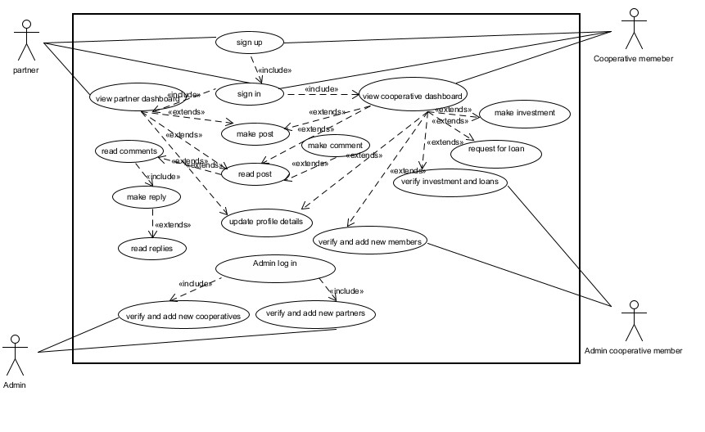

**Figure 1: Use case diagram**

**Design of the proposed system**

The database management used is Sqlite. Python Django frame work makes use of Model classes to represent database entities The Models classes used are as follows Cooperative, User, Member, Post, Comment, Wallet, Needs, Loan, Debtor, Document, Attachment, Partner and Investment. The database tables are shown below:

**Table 1 : Collateral table**

|  |  |  |  |
| --- | --- | --- | --- |
| **Column** | **Type** | **Null** | **Default** |
| ***id*** | int(11) | No |  |
| title | varchar(255) | No |  |
| document | varchar(100) | No |  |
| verified | tinyint(1) | No |  |
| Loan_id | int(11) | No |  |

**Table 2: Cooperative Table**

|  |  |  |  |
| --- | --- | --- | --- |
| **Column** | **Type** | **Null** | **Default** |
| ***Id*** | int(11) | No |  |
| Name | varchar(255) | No |  |
| Location | varchar(255) | No |  |
| Area_of_Specialization | varchar(255) | No |  |
| Icon | varchar(100) | No |  |
| Website | varchar(200) | No |  |
| Email | varchar(254) | No |  |
| About | longtext | No |  |
| address | Varchar(255) | No |  |
| account_name | varchar(255) | No |  |
| account_number | varchar(255) | No |  |
| Bank | varchar(255) | No |  |
| Motto | varchar(255) | No |  |
| Phone | varchar(50) | No |  |
| reg_no | varchar(100) | No |  |

**Table 3: Document Table**

|  |  |  |  |
| --- | --- | --- | --- |
| **Column** | **Type** | **Null** | **Default** |
| ***id*** | int(11) | No |  |
| desc | varchar(255) | No |  |
| file | varchar(100) | No |  |
| cooperative_id | int(11) | No |  |

**Table 4: Investment Table**

|  |  |  |  |
| --- | --- | --- | --- |
| **Column** | **Type** | **Null** | **Default** |
| ***id*** | int(11) | No |  |
| time | datetime(6) | No |  |
| amount | decimal(50,2) | No |  |
| payment_proof | varchar(100) | No |  |
| verified | tinyint(1) | No |  |
| investor_id | int(11) | No |  |
| need_id | int(11) | No |  |
| cooperative_id | int(11) | No |  |

**Table 5: Loan Table**

|  |  |  |  |
| --- | --- | --- | --- |
| **Column** | **Type** | **Null** | **Default** |
| ***Id*** | int(11) | No |  |
| Amount | decimal(50,2) | No |  |
| Paid | tinyint(1) | No |  |
| time_asked | datetime(6) | No |  |
| time_granted | datetime(6) | No |  |
| time_to_pay | datetime(6) | No |  |
| percentage_of_interest | decimal(50,2) | No |  |
| borrower_id | int(11) | No |  |
| Status | varchar(10) | No |  |

**Table 6: Member Table**

|  |  |  |  |
| --- | --- | --- | --- |
| **Column** | **Type** | **Null** | **Default** |
| ***user_id*** | int(11) | No |  |
| time_of_request | datetime(6) | No |  |
| date_of_admission | datetime(6) | No |  |
| cooperative_id | int(11) | No |  |
| Role | varchar(10) | No |  |

**Table 7: Membership Request Table**

|  |  |  |  |
| --- | --- | --- | --- |
| **Column** | **Type** | **Null** | **Default** |
| ***Id*** | int(11) | No |  |
| sender_id | int(10) | No |  |
| Name | varchar(255) | No |  |
| Email | varchar(254) | No |  |
| time_of_request | datetime(6) | No |  |
| cooperative_id | int(11) | No |  |

**Table 8: Need Table**

|  |  |  |  |
| --- | --- | --- | --- |
| **Column** | **Type** | **Null** | **Default** |
| ***Id*** | int(11) | No |  |
| Title | varchar(255) | No |  |
| Body | Longtext | No |  |
| Amount | decimal(50,2) | No |  |
| Time | datetime(6) | No |  |
| cooperative_id | int(11) | No |  |

**Table 9: User Table**

|  |  |  |  |
| --- | --- | --- | --- |
| **Column** | **Type** | **Null** | **Default** |
| ***Id*** | int(11) | No |  |
| Password | varchar(128) | No |  |
| last_login | datetime(6) | Yes | NULL |
| is_superuser | tinyint(1) | No |  |
| **Username** | varchar(150) | No |  |
| first_name | varchar(30) | No |  |
| last_name | varchar(150) | No |  |
| Email | varchar(254) | No |  |
| is_staff | tinyint(1) | No |  |
| is_active | tinyint(1) | No |  |
| date_joined | datetime(6) | No |  |
| is_cooperative_member | tinyint(1) | No |  |
| is_partner | tinyint(1) | No |  |
| is_admin | tinyint(1) | No |  |
| Image | varchar(100) | No |  |
| phone_no | varchar(20) | No |  |
| Specialization | varchar(255) | No |  |
| Bank | varchar(255) | No |  |
| account_number | varchar(50) | No |  |
| Gender | varchar(1) | No |  |
| date_of_birth | date | No |  |
| Location | varchar(20) | No |  |
| account_name | varchar(255) | No |  |

**Table 16: Partner Table**

|  |  |  |  |
| --- | --- | --- | --- |
| **Column** | **Type** | **Null** | **Default** |
| ***user_id*** | int(11) | No |  |
| Icon | varchar(100) | No |  |
| position | Varchar(125) | No | Staff |
| institution | varchar(255) | No |  |
| biography | Longtext | No |  |
| Verified | tinyint(1) | No |  |
| specialization | varchar(255) | No |  |
| Website | varchar(200) | No |  |

**Table 17: Attachment Table**

|  |  |  |  |
| --- | --- | --- | --- |
| **Column** | **Type** | **Null** | **Default** |
| ***Id*** | int(11) | No |  |
| File | varchar(100) | No |  |
| post_id | int(11) | No |  |

**Table 18: Comment Table**

|  |  |  |  |
| --- | --- | --- | --- |
| **Column** | **Type** | **Null** | **Default** |
| ***Id*** | int(11) | No |  |
| author_id | int(11) | No |  |
| author_status | Varchar(255) | No |  |
| Content | longtext | No |  |
| date_posted | datetime(6) | No |  |
| post_id | int(11) | No |  |

**Table 19: Post Table**

|  |  |  |  |
| --- | --- | --- | --- |
| **Column** | **Type** | **Null** | **Default** |
| ***Id*** | int(11) | No |  |
| author_id | int(11) | No |  |
| date_posted | datetime(6) | No |  |
| author_status | Varchar(255) | No |  |
| Title | varchar(255) | No |  |
| Image | varchar(100) | No |  |
| Video | varchar(200) | No |  |
| Tag | varchar(255) | No |  |
| Audio | varchar(200) | No |  |
| for_cooperative | tinyint(1) | No |  |
| cooperative_name | varchar(255) | No |  |
| Content | longtext | No |  |

**Table 20: Reaction Table**

|  |  |  |  |
| --- | --- | --- | --- |
| **Column** | **Type** | **Null** | **Default** |
| ***Id*** | int(11) | No |  |
| Reaction | varchar(7) | No |  |
| message_type | varchar(8) | No |  |
| message_id | int(11) | No |  |
| reactor_id | int(11) | No |  |

**Table 21: Reply Table**

|  |  |  |  |
| --- | --- | --- | --- |
| **Column** | **Type** | **Null** | **Default** |
| ***Id*** | int(11) | No |  |
| author_id | int(11) | No |  |
| author_status | Varchar(255) | No |  |
| Content | longtext | No |  |
| date_posted | datetime(6) | No |  |
| comment_id | int(11) | No |  |

Top of Form

**Database Entity Relationship**

A database consists of different entities. These entities have different attributes. Therefore the entities are represented as tables with different fields. So a table consists of the records of different entities. For example if Animal were to be a table, sample records might be dog, cat, rat etc. Just like in real life, different entities relate one way or the other for example a student can be an entity and school can be another entity, every student must belong to a school. Therefore I can say that school id relates student entity to school entity. Therefore every student is identified by his/her school id. The entity relationship between the above database tables is illustrated with the entity relationship diagram below.

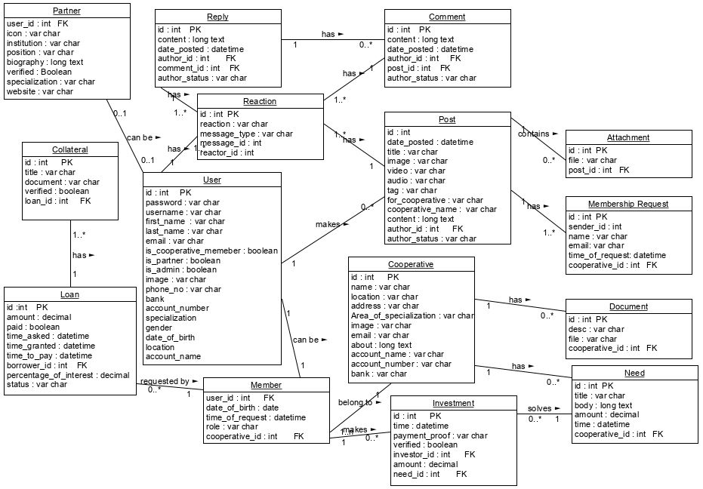

**Figure 2: Entity Relationship Diagram**

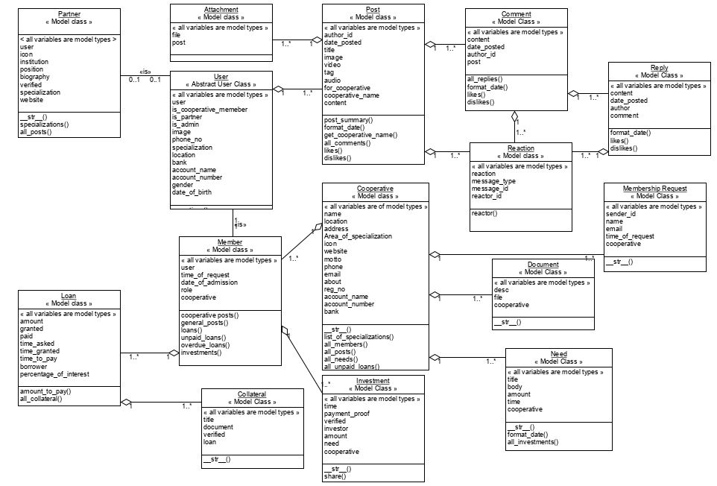

**Figure 3: UML Class Diagram**

**System Architecture**

The proposed system is a website. A website consists of two parts; a front end and the back end. The front end which is the presentation tier consists of blocks of HTML codes, CSS and java script. It is the user interface. The back end which is the server consist of two tiers the middle tier and the data tier. The middle tier is the part that connects the front end to the data tier. In this system, the middle tier is python code, Using Django framework. Data is stored in the data tier. The data tier consists of the database management system used to store all the data in the system. In this system, the data is stored in SQLITE database. The system architecture is illustrated using this diagram below

**Server (Python Django Frame work)**

**Presentation Tier**

**Data Tier**

**Middle Tier**

**SQLite DATABASE**

**PYTHON CODE**

**HTML**

**Figure 4: System Architecture**

**CHAPTER 4**

**SYSTEM IMPLEMENTATION**

**4.0 Introduction**

The implementation of this web based information exchange platform is basically with the python Django framework. The platform is hosted on a local server (local host: 8080). The web based platform can be accessed from the URL which is located in the urls.py file, which contains all the URL paths, and then the URL calls on the views. The views are functions that makes use of the model classes (database tables) and variables from a POST or a GET request, they can either return a HTTP (Hypertext transfer protocol) response, JSON ( Response or a template (HTML page), the views are contained in the views.py file. The responses can be returned in the templates. Also in the templates, some HTML components can be manipulated with Jinja language (A Django language for manipulating templates). This is how the python Django framework works.

**4.1 Choice of development Environment**

The system used in developing this platform is Windows 10. The integrated development environment (IDE) used to develop this web platform is JetBrains PyCharm. PyCharm was used because of how of the boiler plates it generates when typing the program codes, therefore it makes programming easier and faster. The choice of programming language used is python scripting language with the Python Django web framework. Django web Framework was used because it makes web development easier and faster. It also has a professional, production ready administrative interactive interface.

**4.2 Implementation Architecture**

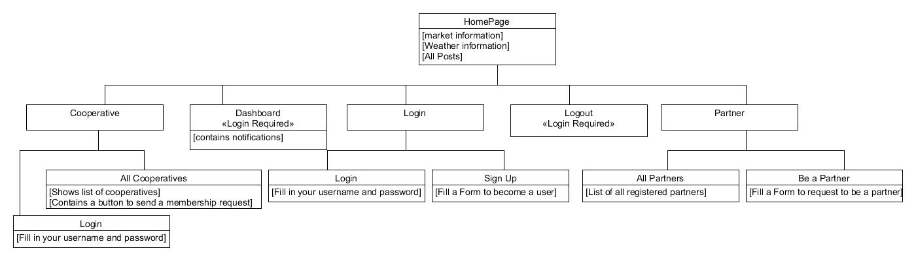

**Figure 1: Home Architectural view**

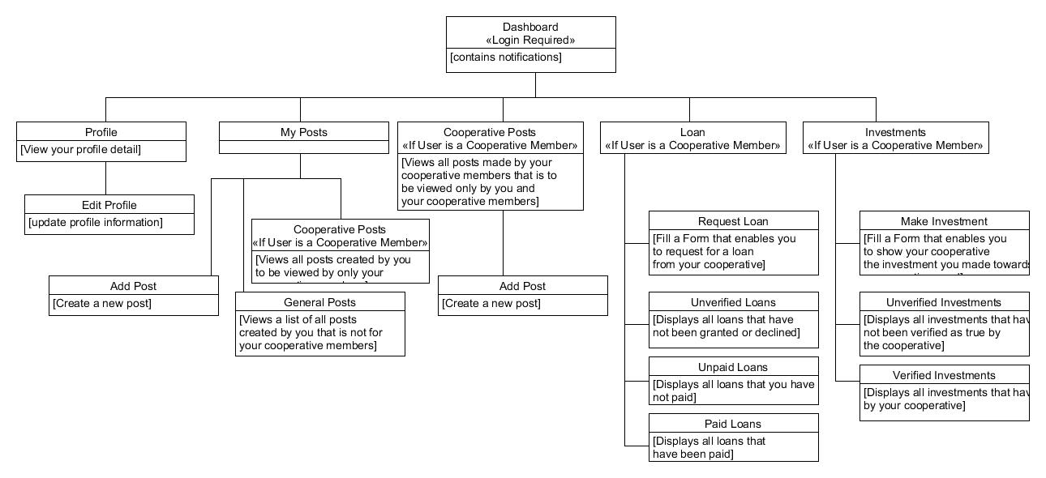

**‘Figure 2: Dashboard Architectural View**

**4.3 Software Testing**

**4.4 Documentation**

**4.5**

**CHAPTER 5**

**SUMMARY AND CONCLUSION**

* 1. **Summary**
  2. **Conclusion**
  3. **Recommendation**

# References

[1] Agricultural Cooperatives. *Agriculture for Impact.* [Online] 2019. [Cited: February 19, 2019.] https://ag4impact.org/sid/socio-economic-intensification/building-social-capital/agricultural-cooperatives.

[2] **Philippe, David, et al., et al.** *Agricultural Cooperatives and Digital Technology. What are the impacts? What are the challenges?* s.l. : PWC, 2016.

[3] *Agricultural Cooperatives I: History, Theory and Problems.* **Robert P, King and Gerald F, Ortmann.** s.l. : Agrekon, 2007. 10.1080/03031853.2007.9523760.

[4] **Wikipedia Contributors.** Cooperatives. *Wikipedia.* [Online] January 30, 2019. [Cited: February 20, 2019.] https://en.wikipedia.org/wiki/Cooperative.

[5] **Nations, Food and Agriculture Organization of the United.** Understanding Cooperatives. *Agricultural Cooperative Developement (a manual for trainers).* Rome : Food and Agriculture Organization of the United Nations, 2001, pp. 5-6.

[6] **Eric, Arthur.** Problems and Prospects of Cooperative Societies in Nigeria. *InfoGuide Nigeria.* [Online] October 31, 2016. [Cited: March 9, 2019.] https://infoguidenigeria.com/problems-and-prospects-of-cooperative-societies/.

[7] *Characteristics of Web applications that affect usability: A review.* **Bruno, Vince, Tam, Audrey and Thom, James.** Canberra, Australia : OZOCHI, 2005. 10.1145/1108368.1108445.

[8] **Food and Agriculture Organization of The United Nations.** Communication. [book auth.] Food and Agriculture Organization of The United Nations. *Agricultural Cooperative Development (a manual for trainers).* Rome : Food and Agriculture Organization of The United Nations, 2001, p. 3.

[9] *Roles of Farmers’ Cooperatives in Agricultural Development In Sabuwa Local Government Area of Katsina State, Nigeria .* **Adefila, James and Madaki, Joshua.** 2014, Journal of Economics and Sustainable Development , p. 80.

[10] **FAO, IFPRI and OECD.** *Information and Communication Technology in Agriculture.* Rome : Food and Agriculture Organisation of the United Nations, 2017.

[11] **Susanne, Jarret, et al., et al.** *Literature Review on Farming Collaboration.* 2015.

[12]Benefits of UCP. *Unified Cooperative Platform.* [Online] 2018. [Cited: February 20, 2019.] https://www.cooplatform.com.ng.

[13] A Unified Finance Platform. *Riby.* [Online] 2017. [Cited: February 20, 2019.] https://www.riby.me.

[14] About Us. *Micheno.* [Online] 2018. [Cited: February 20, 2019.] https://www.michenocoop.com.

[15] **Barchart.com.** Home Page. *Farmers Exchange Coop.* [Online] 2019. [Cited: 3 20, 2019.] https://www.farmersexchangecoop.com/.

[16] PROCOOP Nigeria. *The Progressive Mobile Employees Multipurpose Cooperative Society.* [Online] 2018. [Cited: February 20, 2019.]