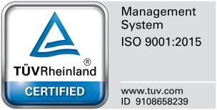


Republic of the Philippines
BOHOL ISLAND STATE UNIVERSITY
Poblacion Norte, Clarin, 6330, Bohol, Philippines
Office of the Instruction

Balance I Integrity I Stewardship I Uprightness

Midterm Project

SOFTWARE ENGINEERING 2

Software Project Documents

BARANGAY PROJECT TRACKER
SYSTEM

Members

Louie Jay M. Lacbayo(BSCS 2B)
Joever A. Sapungay(BSCS 2B)
Jade Marion G. Tapic(BSCS 2B)

Entity Relationship Diagram
ER DIAGRAM:
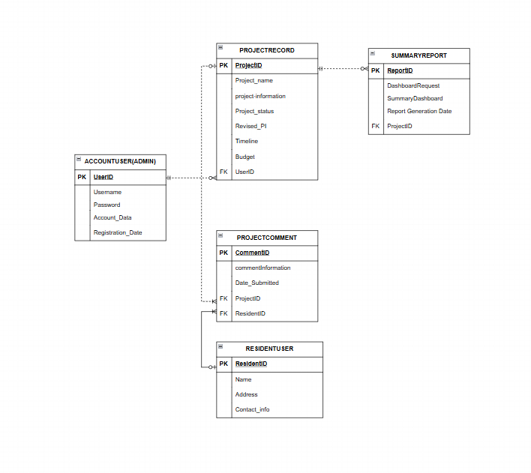
Discussion of Entities and Relationships:
The Account User (Admin) entity stores login and registration details of barangay officials. Each account user can manage multiple project records, establishing a one-to-many relationship between Account User and Project Record.
The Project Record entity contains all essential information about barangay projects, including name, status, budget, timeline, and revised details. A single project record can generate multiple summary reports and can also receive multiple resident comments, making it central to the system’s data flow.
The Project Comment entity captures feedback from residents. Each comment is linked to one project record and one resident user, forming many-to-one relationships with both Project Record and Resident User.
The Resident User entity holds personal information of community members. A resident can submit multiple comments, but each comment belongs to a single resident, creating a one-to-many relationship.
The Summary Report entity consolidates project information into dashboards and reports. Each report is tied to a single project record, but a project can generate multiple reports, forming a one-to-many relationship.

