10 talking points about
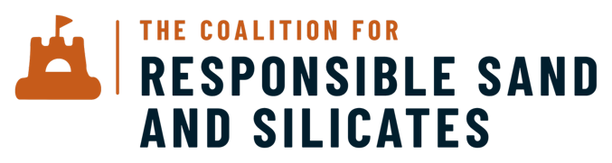

V 21 July 2026 | These are prompts to say in your own words, not lines to read out
- What these materials are, and why we don’t see them. Sand and silicates are what we build the modern world from. Sand is the second most used material on earth after water, underpinning construction, glass, electronics and the energy transition. We depend on them for almost everything, yet rarely ask where they come from. They are the most used solid materials on earth, and among the least examined.
- The scale. The flows here are roughly seventy thousand times larger than the materials the responsible minerals world has focused on so far. The stakes, and the opportunity, are big.
- The harm is coming into view. As people look more closely, the costs are becoming clear, across human rights, the environment and the security of supply. The costs were always there. We are only now beginning to see them.
- Responsible sourcing is necessary, not optional. We should use less, and we should innovate in how we meet these needs. Both matter enormously. But at the scale the world demands, and with little substitution available, we will keep sourcing these materials in vast quantities. How they are produced, used and sourced is something we can act on now.
- The call to action already exists. The OECD's 2026 study on due diligence in sand and silicate supply chains drew on more than four hundred sources across more than a hundred countries, and set out clearly why responsible sourcing of these materials matters. The Coalition grew directly out of that work. We are the practical response to a call the international system has already made.
- What the Coalition is. We are the dedicated knowledge and practice platform for this material family. We are not a standards body. We work alongside them, and with the people who source, produce, regulate and depend on these materials every day. We build the shared knowledge infrastructure. We give members a credible commitment signal they can stand behind. And we act as a process partner to existing standards, so responsible action gets recognised.
- We are genuinely multistakeholder. Civil society, research and industry sit at the table as equals. Our Founders include IKEA, Roca Group, WWF, the University of Queensland and Gilbane, with the OECD and UNEP as supporting partners.
- How we think about responsibility. Responsibility is not a threshold to cross. It is a direction of travel. It begins with doing less harm, and reaches for doing better. We want responsible actors to win.
- Where this is heading. We want sand and silicates to become a normal, expected part of responsible minerals, shaping the frameworks from within rather than sitting in a category of their own. The line we use is, replace invisibility with regard.
- How to engage with us. Anyone who joins in 2026, our founding year, comes in as a Founder, with a real hand in shaping what responsible looks like. Those who engage now shape the field, those who wait respond to definitions written by others. You do not have to be a member to work with us either. We also offer advisory and technical support, the same shared knowledge applied to your situation, with fees that keep the knowledge base open for the wider field.

