1a.

function hw3p1a

noiseImg = randn(256, 256);

[U, V] = meshgrid(-127:1:128, -127:1:128);

tf = (U.^2 + V.^2); %get filter

tf = 1 ./ tf;

tf(128, 128) = 0; %set where x,y = 0 to 0

dft = fft2(noiseImg); %translate image to frequency domain

dft = fftshift(dft);

fi = dft .\* tf; %apply filter

fi = fftshift(fi);

fi = ifft2(fi); %translate back to spatial domain

fi = real(fi);

subplot(1,2,1);

imagesc(fi);

colormap('gray');

title('Filtered Image');

subplot(1,2,2);

imagesc(noiseImg);

truesize;

colormap('gray');

title('Original Image');

end

1b.

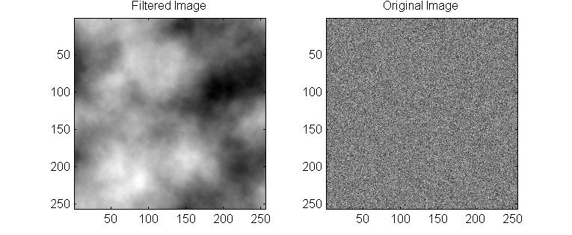

The statistics of natural images vs. images of manmade objects are that the natural images are a lot more noisy and random in pixels compared to images of manmade objects.

2a.

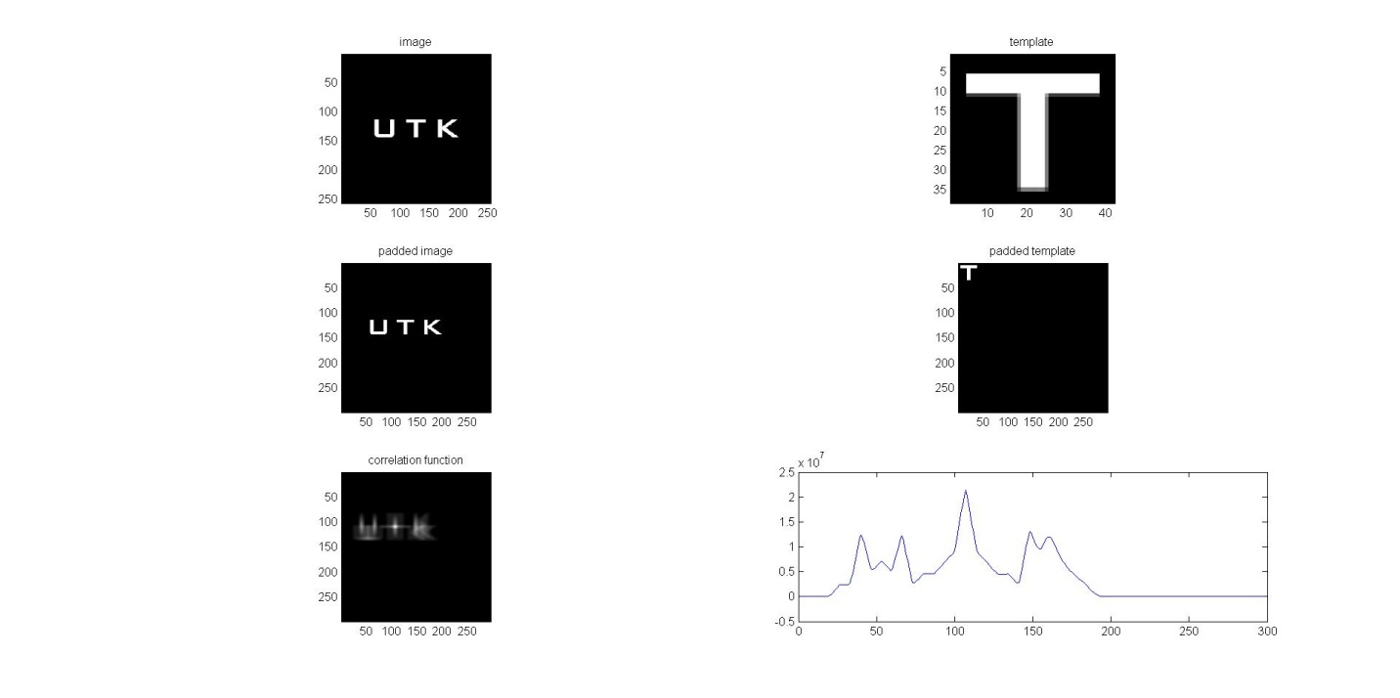

2b.

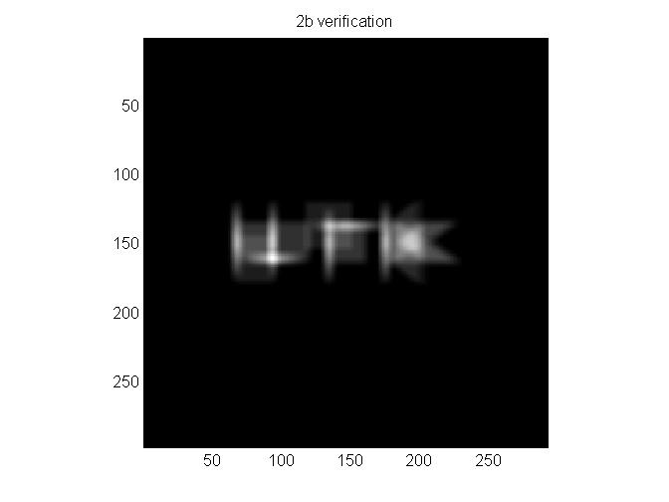

function hw3p2a

image = imread('Fig4.41(a).jpg');

template = imread('Fig4.41(b).jpg');

figure;

subplot(3,2,1);

imagesc(image); %show the original image

colormap('gray');

axis image;

title('image');

subplot(3,2,2);

imagesc(template); %show the template

colormap('gray');

axis image;

title('template');

padImg = padarray(image, [298-size(image,1) 298-size(image,2)], 'post'); %pad images to 298 x 298

padTemplate = padarray(template, [298-size(template,1) 298-size(template,2)], 'post');

subplot(3,2,3);

imagesc(padImg);

colormap('gray');

axis image;

title('padded image');

subplot(3,2,4);

imagesc(padTemplate);

colormap('gray');

axis image;

title('padded template');

fimage = fft2(padImg);

ftemp = fft2(padTemplate);

ftemp = conj(ftemp); %find the complex conjugate for the template

corr = fimage .\* ftemp;

corr = ifft2(corr);

corr = real(corr);

subplot(3,2,5);

imagesc((corr));

colormap('gray');

axis image;

title('correlation function');

%find the highest value row

max = intmin;

row = 0;

for i=1:size(corr,1)

for j=1:size(corr,2)

if(corr(i,j) > max)

max = corr(i,j);

row = i;

end

end

end

subplot(3,2,6);

plot(corr(row,:));

%2b

rotatetemp = rot90(template);

spatial = conv2(rotatetemp, image, 'full');

figure;

imagesc(spatial);

colormap('gray');

axis image;

title('2b verification');

end