The grid-constrained load optimiser
What the model is, what it includes, who it is for, how the linear programme works, and where it goes next — September 2026

1. What the model is
A large electrical load has to be continuously powered. For large numbers a lack of available grid connection and a multi-year queue is a bottleneck for development in the UK.
The model takes a load of a stated size at a stated GB coordinate, a set of power assets the user is prepared to consider, and a year of half-hourly weather, grid carbon and grid price data for that site. It returns the cheapest, or the lowest-carbon, combination of installed capacities that keeps the facility running — together with the exact half-hourly dispatch that achieves it, and the full trade-off curve between the two objectives.
It is built as a linear programme: an optimisation problem in which every cost and every physical relationship is proportional to the quantities being chosen. That property matters for a practical reason — it is what lets the model size the assets and schedule them at the same time, over a full year, and return an answer that is provably the best one rather than the best one a search happened to find.
Underneath it sit two layers that supply the numbers:
- A life-cycle inventory built in Brightway on ecoinvent 3.9.1, which supplies every carbon coefficient. “Life-cycle” here means the carbon counted is not only what comes out of the chimney but what it took to make the equipment — the steel in a turbine, the platinum in an electrolyser, the cells in a battery.
- A cost layer drawn from DESNZ/Arup 2024, NESO’s Future Energy Scenarios 2025, and NESO/Elexon tariff data, including the UK’s own network charges (BSUoS, DUoS bands, TNUoS zones).
Every coefficient the optimiser uses is produced by a standalone, self-checking module in optimisation/, with its provenance graded in SOURCES.md. The Streamlit page is only a view over them.

1.1 Why it is no longer only about data centres
The model was built for data centres, and the data centre remains the reference case. But nothing in the mathematics is specific to servers. What the model actually solves is a more general problem:
A large, steady, network-connected load wants power. The connection it can get is smaller, later, or more expensive than the one it needs. What should it build on site, how should it run it, and what does that choice cost in money and in carbon?
That description fits an electric arc furnace, a semiconductor fab, a port with shore-power berths, a truck depot, a green hydrogen plant and a battery gigafactory as readily as it fits a data centre. The load shape differs; the decision does not. The companion commercial brief sets out which of these segments are worth pursuing and why.
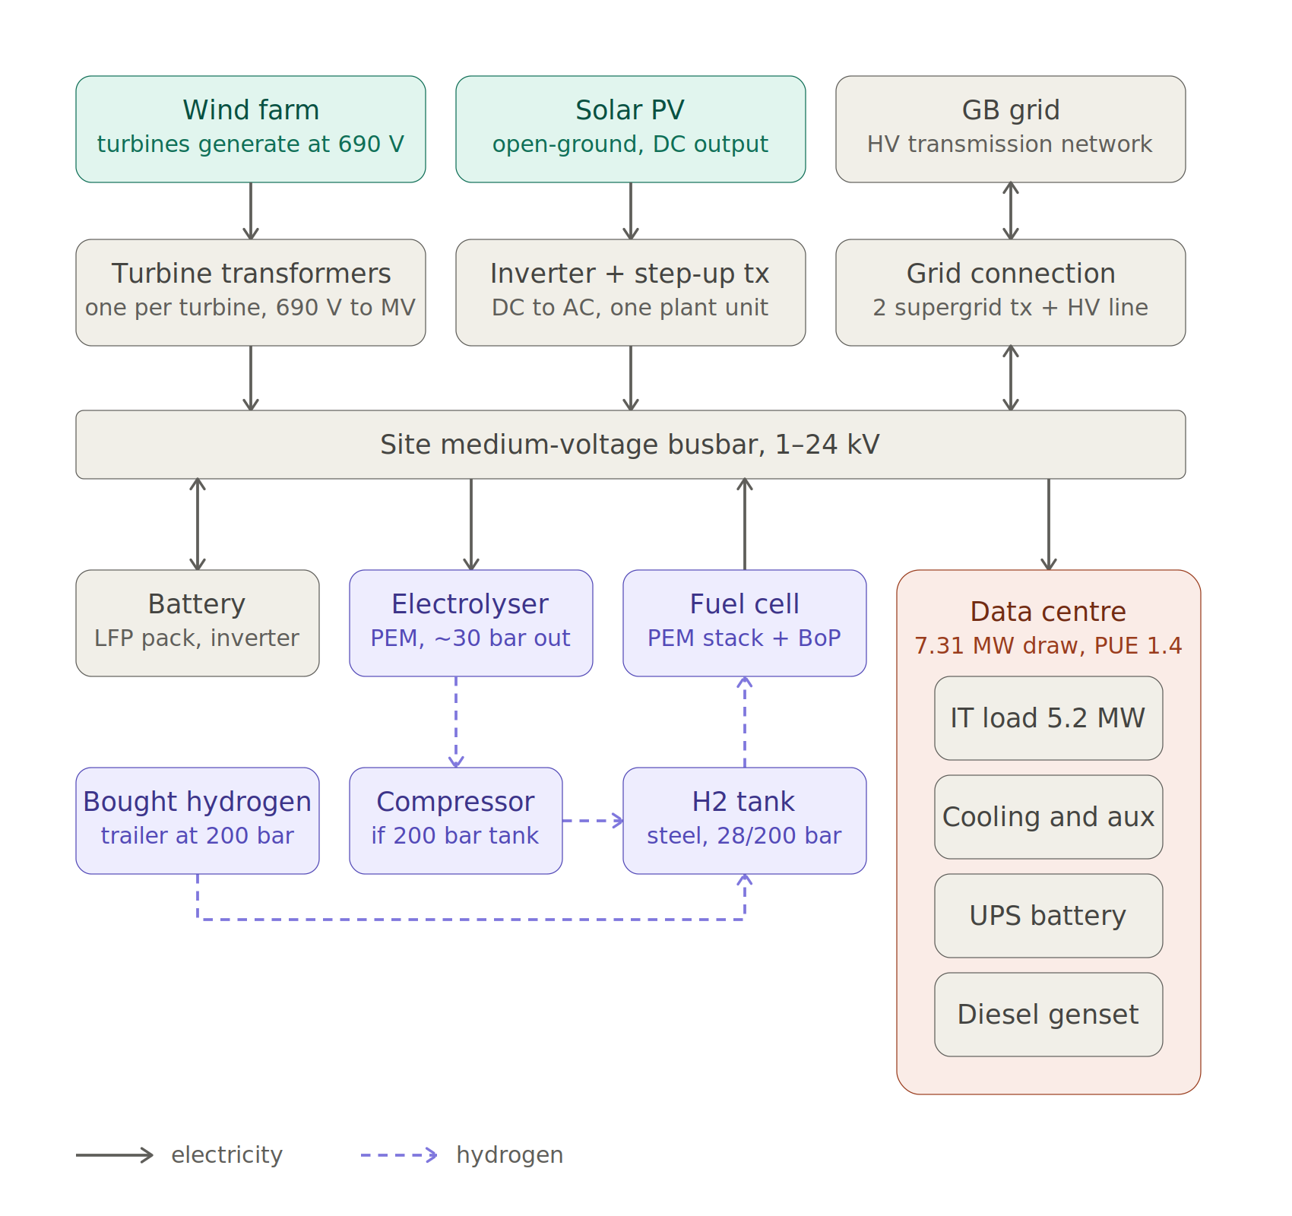
The reference system. The optimiser chooses how much of each box to build — including whether to build it at all — and how to run it in every half-hour of the year. A data centre is shown as the load; any large network-connected load substitutes directly.

2. Scope — what is in, what is out, and why
The nine things the optimiser may build are the grid connection, onshore wind, offshore wind, solar PV, a lithium-ion (LFP) battery, an electrolyser (PEM, alkaline or SOEC), a hydrogen tank, a PEM fuel cell, and bought hydrogen by colour (grey, blue, turquoise, green — up to two supply contracts at once).
Every asset is an upper bound, never a requirement. The solver sets an unlocked asset to zero when it is not worth building, and that is itself a result: it tells you the conditions under which an option fails, not merely that it did.
The accounting boundary is cradle-to-gate, attributional, IPCC 2021 GWP100, with grid electricity scored at the regional average intensity of the Carbon Intensity API mix against ecoinvent. Deliberate exclusions, each recorded in ASSUMPTIONS.md with what it costs you:
- End-of-life on every asset. No decommissioning burden and no recycling credit, so all options are compared on the same cradle-to-gate footing.
- Hydrogen haulage. Hydrogen made on site is co-located; hydrogen bought in is compressed to trailer pressure at the seller’s gate but not driven anywhere, because the distance is unknowable without a named seller.
- The facility’s diesel standby generator. Backup is a decision variable here — fuel cell, battery, larger connection, or an allowance for unserved load — so charging the genset as well would bill every architecture twice for the same resilience.
- Load flexibility. The load draws flat at its rated demand, so storage is sized against supply variability alone. This is conservative for renewables-plus-storage, and it is the assumption most worth relaxing for non-data-centre loads, many of which are genuinely interruptible.
- Unit commitment and an internal network. The site is a single copper-plate node and minimum loads are relaxed, which is what keeps the problem linear (§5.6).

3. Who uses it, and what they get
The user is a developer, investor, industrial operator or policy analyst facing the question “should we go on-site renewables, hydrogen, battery, or simply a bigger grid connection — and at what carbon price does the answer change?”
What they get is a justified limit:
- the exact trade-off curve between annualised cost and annual CO₂e, and the knee of that curve;
- the cost of meeting a stated carbon target, read directly off the curve;
- for hydrogen — which no grid-connected case currently builds — the tipping-point price at which it would enter;
- the dispatch behind every point, so the answer can be interrogated rather than believed.
Because every result names its assumptions, its foresight bound (§5.6) and its data gaps, it is usable in a board paper, an investment committee submission or a planning application, not only as an exploration tool.

4. Inputs and outputs
Inputs | Outputs
Load. Rated draw (MW), power usage effectiveness or equivalent overhead factor, horizon (years), unserved-energy allowance (%) | Capacities. MW of each asset built, MWh of battery, kg of tank, MW of grid connection — and the annual energy through each
Site. Latitude and longitude, or a preset. The Carbon Intensity region, TNUoS zone and weather all follow from the coordinate; optional connection cap | Totals. £/yr and kg CO₂e/yr, split embodied against operational and by asset, so it is visible whether an option is genuinely cleaner or has merely moved its burden upstream
Window. Any date range. Grid series are built on demand; Renewables.ninja profiles fetched and cached | Trade-off curve. Minimum-cost and minimum-carbon anchors plus an exact sweep between them; knee, carbon-price and maximum-curvature points
Kit to consider. Tick-boxes over the nine assets, electrolyser technology, running strategy (baseload / flexible / free), hydrogen colour(s), green-hydrogen grid share | Dispatch. Half-hourly served demand by source, battery and tank state of charge; a myopic merit-order re-dispatch of the same build brackets what an operator without foresight would achieve
Economics. Cost case (low / central / high), carbon price, solar embodied basis | Diagnostics. Which bound was pressed, degenerate fronts, hydrogen tipping-point price by bisection

5. The underlying structure: a joint sizing-and-dispatch linear programme

5.1 Notation
Both objectives are linear in the same variables. The decision variables are the installed capacities of each asset, and a half-hourly flow for each energy stream. Multi-letter names have been avoided deliberately: the symbols are terse so the equations stay readable, and the table below is the key.
Symbol | Meaning
$K_{j}$ | installed capacity of asset $j$: $K_{w}$ onshore wind, $K_{o}$ offshore wind, $K_{s}$ solar, $K_{e}$ electrolyser, $K_{f}$ fuel cell, $K_{h}$ hydrogen tank, $K_{g}$ grid connection
$K_{b}^{P}, K_{b}^{E}$ | battery power rating (MW) and energy capacity (MWh), sized separately
$p_{t}^{w}, p_{t}^{o}, p_{t}^{s}$ | onshore wind, offshore wind and solar output in period $t$ (MW)
$f_{t}^{w}, f_{t}^{o}, f_{t}^{s}$ | capacity factors for the same three, from the site’s weather
$q_{t}^{c}, q_{t}^{d}, S_{t}$ | battery charge, discharge and state of charge
$p_{t}^{e}, p_{t}^{f}, M_{t}$ | electrolyser draw, fuel-cell output, hydrogen inventory in the tank (kg)
$m_{k,t}$ | hydrogen bought under contract $k$ (kg)
$i_{t}, x_{t}, u_{t}$ | grid import, grid export, unserved load
$D_{t}$ | facility demand — rated draw times overhead factor
$π_{t}$ | wholesale price plus volumetric network charges (£/MWh)
$φ_{t}$ | regional grid carbon intensity (kg CO₂e/MWh)
$c_{j}, g_{j}$ | annualised cost and annualised embodied carbon per unit of capacity
$A_{j}, F_{j}, r_{j}, L_{j}$ | capital cost, fixed operating cost, discount rate and life of asset $j$
$ρ_{k}, γ_{k}$ | price and gate-level carbon burden of bought hydrogen colour $k$
$κ_{e}, κ_{f}$ | kilograms of hydrogen made per MWh, and consumed per MWh
$η, λ_{b}, λ_{h}$ | one-way battery efficiency, battery standing loss, tank leakage
$C_{0}, G_{0}$ | fixed connection charges, and the facility’s own embodied burden
$V, α$ | value of lost load, and the permitted unserved fraction
$n_{s}, n_{p}$ | stack and balance-of-plant replacement rate (MW of kit replaced per year)
$T, L_{p}, H_{s}, H_{p}$ | study horizon; balance-of-plant calendar life; stack and balance-of-plant duty-hour lives
$E_{f}$ | annual energy through the fuel cell (MWh)
$Δt=0.5 \text{h}$ | settlement period length
$s=8760/H$ | scale factor annualising a window of $H$ hours

5.2 The two objectives
Annualised cost:
min C = j​cj Kj + cs ns + C0 + st​πtit−xtΔt + k​ρk mk,t + VutΔt
Annual life-cycle carbon:
min G = j​gj Kj + gp np + gs ns + G0 + st​φt it Δt + k​γk mk,t + γe κe pteΔt + gf ptfΔt
The coefficients $c_{j}$ and $g_{j}$ are annualised £ per MW-year and kg CO₂e per MW-year. Costs are capital expenditure plus fixed operating cost at each technology’s own hurdle rate; embodied carbon is amortised over the asset’s life. The annualised cost of an asset is the standard capital recovery factor applied to its capital cost:
$$c_{j} = A_{j}⋅\frac{r_{j}{\left(1+r_{j}\right)}^{L_{j}}}{{\left(1+r_{j}\right)}^{L_{j}}−1} + F_{j}$$
with $r_{j}$ the technology’s discount rate and $L_{j}$ its life in years. $ρ_{k}$ and $γ_{k}$ are the price and gate-level carbon burden of bought hydrogen colour $k$; $C_{0}$ and $G_{0}$ carry the connection’s fixed charges and the facility’s own embodied burden; $V$ is the penalty on unserved energy. The capacity sum j​gjKj includes the step-up transformers, charged on capacity rather than output, because a transformer is sized to the peak it must pass and does not care how many hours a year that happens.

5.3 Constraints
(1) Energy balance at the site busbar, in every period. One node, no internal network:
$$p_{t}^{w}+p_{t}^{o}+p_{t}^{s}+q_{t}^{d}+p_{t}^{f}+i_{t}+u_{t} − q_{t}^{c} − p_{t}^{e} − x_{t} = D_{t} ∀ t$$
Generation that is not consumed is curtailed, because (2) is an inequality rather than an equality.
(2) Resource availability. Output cannot exceed what the weather allows:
$$p_{t}^{w}≤f_{t}^{w} K_{w}, p_{t}^{o}≤f_{t}^{o} K_{o}, p_{t}^{s}≤f_{t}^{s} K_{s}$$
(3–5) Battery. Power and energy are sized separately, and the state of charge carries across the window:
$$q_{t}^{c}, q_{t}^{d} ≤ K_{b}^{P}, S_{t} ≤ K_{b}^{E}$$
$$S_{t} = \left(1−λ_{b}Δt\right)S_{t−1} + Δt\left(η q_{t}^{c}−\frac{q_{t}^{d}}{η}\right), η=\sqrt{η_{0}}$$
cyclic over the window, so the model cannot finance itself by draining a battery it never refills.
(6–8) Hydrogen. The electrolyser, fuel cell and tank are three separately sized assets on one mass balance:
$$p_{t}^{e}≤K_{e}, p_{t}^{f}≤K_{f}, M_{t}≤K_{h}$$
Mt = 1−λhΔtMt−1 + κe pte Δt + k​mk,t − κf ptf Δt
also cyclic, with $κ_{e}$ and $κ_{f}$ the kilograms of hydrogen produced and consumed per MWh.
(9) Grid connection. The connection is itself a sized asset, bounded above by whatever the network operator will actually offer:
$$i_{t} ≤ K_{g} ≤ {\overline{K}}_{g}, x_{t} ≤ K_{g}$$
The second inequality applies only where export is permitted; otherwise $x_{t}$ is fixed at zero.
(10) Reliability. Unserved energy is capped at a stated fraction $α$ of annual demand:
t​ut Δt ≤ αt​Dt Δt
(11) Replacements. Stacks and balance-of-plant wear out on whichever comes first, calendar life or duty hours. Because the solver minimises a cost that rises with the replacement rate, a maximum of two terms can be written as a pair of inequalities and stays linear:
$$n_{s} ≥ \frac{K_{f}}{T}, n_{s} ≥ \frac{E_{f}}{H_{s}}, n_{p} ≥ \frac{K_{f}}{L_{p}}, n_{p} ≥ \frac{E_{f}}{H_{p}}$$

5.4 Tracing the trade-off curve
The two objectives are optimised against each other by the $ε$-constraint method: minimise one while holding the other below a moving bound.
$$min C s.t. G ≤ G^{max}, G^{min} ≤ G^{max} ≤ G​\left(C^{min}\right)$$
Sweeping $G^{max}$ from the lowest achievable carbon up to the carbon of the cheapest build traces the frontier exactly, point by point, rather than sampling it. Each point is a certified optimum of a convex problem, not the best result a search happened to reach. A final tie-break minimising $K_{g}$ resolves the degenerate cases where the connection is otherwise unpriced.

5.5 Running strategies as constraints
How the electrolyser is operated is imposed as extra constraints rather than chosen as a separate algorithm, so the penalty of a mode of operation can be read straight off the objective:
- Baseload — an 80 % per-period floor on electrolyser draw and an 85 % annual capacity factor.
- Flexible (islanded) — annual electrolyser energy capped at available generation minus served demand.
- Free — no additional constraint; the solver decides.

5.6 What the linear form costs you
Every one of these is a known limitation:
- Perfect foresight over the whole window. The model knows the year’s weather and prices in advance. The myopic re-dispatch is run alongside it.
- No minimum-load binaries. The electrolyser may run at 1 % of rating. Adding unit commitment would make the problem a mixed-integer one and cost the exactness of the frontier.
- One node. No internal network, no transmission limits within the site.
- A value of lost load of £100,000/MWh, which is a diagnostic penalty that makes infeasibility legible, not a market number.

5.7 Scale and solver
Roughly 17,500 half-hourly steps per year, solved with HiGHS through linopy. Full chronology is kept deliberately: sampled “representative day” files are refused by profiles.py, because a dispatch that carries battery and tank state cannot use them. This matters more than it sounds — representative days break the inter-day and seasonal linkage that a hydrogen tank exists to exploit, and would systematically undervalue it (Poncelet et al., 2016).

6. Where the carbon numbers come from
This is the part that distinguishes the model from a conventional energy design tool, and it is worth stating plainly.
Most design tools compute emissions as emission factor $×$ energy: a number per kWh of grid import, and perhaps one per litre of fuel. Nothing is counted for building the equipment. On that basis a wind farm and a battery are free of carbon, which is the wrong answer to the question a developer is actually asking.
Here, every carbon coefficient is produced by a life-cycle inventory in Brightway on ecoinvent 3.9.1, decomposed out of ecoinvent’s per-kWh activities into a per-MW-installed embodied burden that the optimiser can attach to a capacity variable. The result is that the objective $G$ contains both terms — what the kit cost to build, amortised over its life, and what it emits in operation — and the output splits them, so it is visible whether an option is genuinely cleaner or has merely moved its burden upstream into a supply chain.
The coefficients are checked. Each module re-reads its values from Brightway and compares them against the figures pinned in the code; the renewables decomposition is re-amortised back to ecoinvent’s own published per-kWh score; scenario cases are checked for monotonicity. These checks have caught real errors, including a case-pairing bug inherited from the DESNZ reports’ own scenario convention.

7. What has been validated
tests/ covers the model’s internal invariants — energy balances close, storage stays bounded, hydrogen mass is conserved. optimisation/validate.py asks the harder question: do the answers agree with things established independently of the linear programme? Nine benchmarks, all currently passing:
Benchmark | What it guards | Result
Electrolyser embodied carbon | The decomposition every hydrogen result depends on | Three inventories reconstruct the foreground’s own figure; worst relative error 2.3 × 10⁻⁵
Hydrogen round-trip efficiency | Chain-wide sanity on efficiencies and unit conversions | 29.3 % — 54.0 kWh in per kg, 15.8 kWh out
Grid-only reproduces the standalone baseline | Two unrelated routes to the same number | 16,014 t/yr both ways — 0.003 % apart
Frontier ordering | The defining property of the two anchors | Cheapest £4.90 m / 6,605 t; cleanest £10.98 m / 3,019 t
Grid-charged hydrogen arbitrage | An analytic prediction the solver can contradict | Round-trip penalty 3.41×, grid carbon spread 3.11×, electrolyser built: none
Islanded with no generation | A degenerate case must fail loudly, not crash | 100 % of demand surfaced as unserved
Free zero-carbon grid | The opposite degenerate case | Nothing built; largest capacity 0.00
Delivered cost per MWh | Units and annualisation smell test | £76.49/MWh to IT load, against £103.09/MWh grid-only
Superset control is no worse | The architectures must agree on bounds and coefficients | Control £4.898 m equals the best sub-architecture
The run behind these figures is Central London, 2025, 7.31 MW draw. Two of them are worth reading twice: the cheapest build delivers power at £76.49/MWh against £103.09/MWh for grid-only, and at 6,605 tCO₂e/yr against a 16,014 t grid-only baseline. On this site and this year, the optimised build is cheaper and substantially cleaner than simply buying a bigger connection — which is the commercial argument in a single line.
What the benchmarks do not cover is equally important, and is recorded in VALIDATION.md: perfect foresight is untested against a myopic operator for a full configuration; fuel-cell and vessel capital costs carry spreads of 4.5× and 2× with no UK source; only the London grid series is cached, so other regions’ results are not yet meaningful; and there is no unit commitment.

8. Future direction: forecasting
Every coefficient is a 2023-real-price snapshot and every answer is a single year, while a facility designed now runs into the 2050s. Nothing below is committed — these are the options for turning that snapshot into a forecast.
Option | What it would change, and the data behind it
Forward grid carbon and price | Imports scored against the grid the facility will actually see. NESO FES 2025: 118 gCO₂/kWh in 2024, −37 to +26 by 2050 across four pathways. DESNZ traded carbon values run £29/tCO₂e in 2025 to £235 in 2050.
Falling equipment costs | Answers when to build, not only whether. Learning rates per doubling: solar 23 %, wind 12 %, Li-ion 16 %, alkaline 18 %, PEM 32 % — contested, and none published for tanks, so a band not a point.
Forward-dated inventories | Embodied carbon falls as the factories making the kit decarbonise. premise rewrites ecoinvent for a future year, free and built on Brightway.
Marginal rather than average grid carbon | Changes what avoiding an import is worth. Hawkes: GB long-run marginal 0.26–0.53 kgCO₂/kWh now, near zero by 2035, against 0.69 short-run.
The first changes the most and is the cheapest to build: a system sized against a 250 gCO₂/kWh grid is over-built for one heading toward zero, and h2_prices.py already parses the FES workbook.

9. The immediate worklist
Ahead of the dynamic work, the near-term list (TODO.md) closes the inputs on which the hydrogen cost axis still turns, so the dynamic outlook is built on a defensible static base:
- Fuel cell capital cost, and a per-replacement stack cost. Until this closes, the cost axis of every hydrogen architecture carries a roughly 4× range with a known-direction bias, and cost-optimal builds over-run the fuel cell for free.
- SOEC capital and operating cost, currently a PEM multiple with no source. Carbon-only SOEC results are a defensible partial result meanwhile; cost-optimal SOEC is not.
- Electrolyser consumables. SOEC’s external heat and water demand are charged in carbon and free in cost, so the cost objective prefers SOEC partly for a reason that does not exist.
- Sweep the two storage loss terms. Battery standing loss and tank leakage are both pinned at zero and push in opposite directions, so the hydrogen-versus-battery seasonal result is currently unbounded rather than conservative.
- Report the two large assumed scalars as bands rather than points — the green-hydrogen grid share and the transmission-connected flag. The transmission/distribution threshold alone swings the network bill from £270k to £4.67m a year.

10. References
DESNZ. Traded carbon values used for modelling purposes, 2025; Energy and emissions projections: 2024 to 2050; Fossil fuel price assumptions.
Galletti, A. et al. (2025). Learning in green hydrogen production: Insights from a novel European dataset. International Journal of Hydrogen Energy, 148, 149812.
Hawkes, A. D. (2014). Long-run marginal CO₂ emissions factors in national electricity systems. Applied Energy, 125, 197–205.
Mutel, C. (2017). Brightway: An open source framework for Life Cycle Assessment. Journal of Open Source Software, 2(12), 236.
NESO (2025). Future Energy Scenarios 2025 and FES 2025 Data Workbook.
Nordhaus, W. D. (2014). The perils of the learning model for modeling endogenous technological change. The Energy Journal, 35(1), 1–13.
Poncelet, K. et al. (2016). Impact of the level of temporal and operational detail in energy-system planning models. Applied Energy, 162, 631–643.
Rubin, E. S. et al. (2015). A review of learning rates for electricity supply technologies. Energy Policy, 86, 198–218.
Sacchi, R. et al. (2022). PRospective EnvironMental Impact asSEment (premise). Renewable and Sustainable Energy Reviews, 160, 112311.
Schmidt, O. et al. (2017). The future cost of electrical energy storage based on experience rates. Nature Energy, 2, 17110.
Way, R., Ives, M. C., Mealy, P. & Farmer, J. D. (2022). Empirically grounded technology forecasts and the energy transition. Joule, 6(9), 2057–2082.

