Team: TeamName (kuolintsai)

In the excel file, there’s no cost of the product. So in this case, we can’t take cost of the product into concern. To optimize the profit, first, we check the data of quantity and price of a product. By input all the data into a diagram, then use linear regression to model the relationship between the quantity and price of a product. After the linear approach to the selling( pricing model), we can achieve a trendline(regression line). As figure:

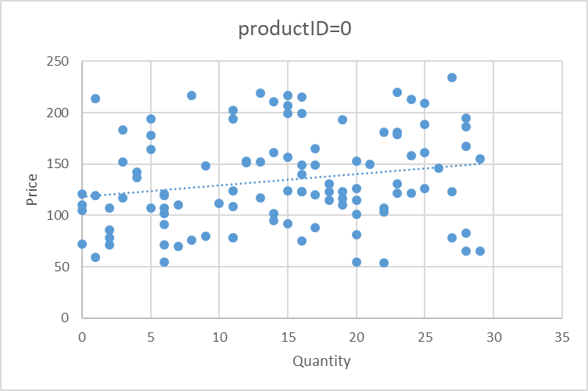

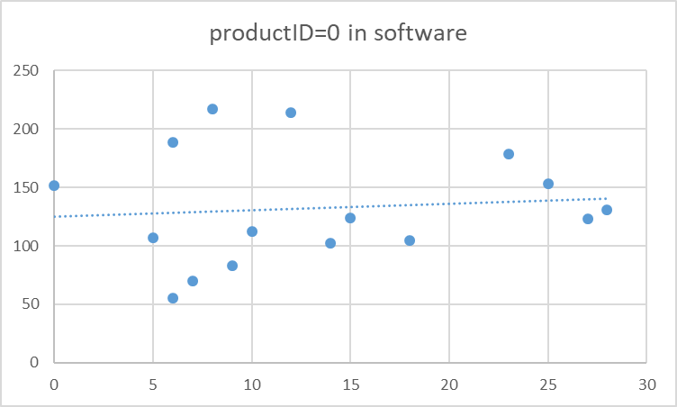

See the figure carefully, we can find that the trendline is going upward, which is weird because this is not similar to a normal q-p diagram. This shows that the number of selling quantity vs. price is too random that we cannot view this as a normal case.

So we’ll deal with this with an unconventional way. As we see, sometimes the product can sell even more than usual at an abnormally high price. Some are at a pretty low price but only sell a little. To improve this problem, we will adjust all the dot below the trendline, drag it closer to the trendline, which mean it might still sell the same quantity at a higher price. As for the dot above the trendling, we only change it a little bit, because it’s already sell higher than expected. After modifying all the prices in different field of the same product, we can find an average sell price, which should be higher than the original target price, then find the average of the price. After achieving the average of the price, compare it to the original target price. If it’s higher or lower than 5 %, we’ll set it to 5% higher( as required) . This can optimize our profits.

**Procedure:**

First, we use excel to calculate the average price of each prices, create a P-Q diagram, then generate a trendline (as the figure above) and its formula. After achieve the trendline,

For those dot higher than the trendline, we prefer not to move it. Because although the price of the product might seem too high, it still sell higher than expected (trendline ). For the dot below the trendline more than two standard deviation (which can also be generated by excel), we move up two standard deviation of the dot (if we move too much, the price may seem too high). For the dot higher than two standard deviation of the trendline, we move it down only one standard deviation. After achieving these numbers, we can calculate the avg. price of a product after modification.

NOTE: Most of the procedure above is done by excel, because in this assignment, the target is to modify the price and quantity that are **ALREADY EXIST!** In my opinion, there is no need to spend extra storage and efficiency to show the result of the appi. We can calculate these numbers without spending extra space and without causing a higher time complexity of the application.