Warehouse

Truck

Staff

Radio base

Fish ship

Coming message

storage

Load truck

Working message

Unloading message

Full capacity message

unloading

Fish ship: send_coming_message (output); send_fish (output); get_unload_message (input)

Radio base: get_coming_message (input); send_working_message (output)

Staff: get_working_message (input); send_unload_message (output); get_fish(input); send_fish_to_truck (output); get_full_capacity_message (input)

Truck: get_fish_to_truck (input); send_fish_to_warehouse (output); send_full_capacity_message (output)

Warehouse: get_fish_to_warehouse (input)

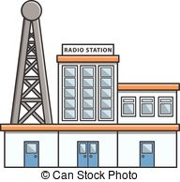

Coming message

Working message

   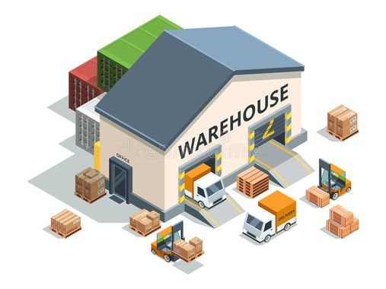

storage

Full capacity message

Load truck

unloading

Unloading message

1. When the fish ship coming it sent a coming message to radio base
2. When the radio base received the coming message, it sent the working message to staff
3. When the staff received the working message, they sent the unloading message to ship
4. The staff unload the ship that mean the staff take fish until the boat is empty
5. The staff load the truck until it will be full (until the staff receive the full capacity message)
6. When the truck was full it sent a message to staff
7. When the truck was full it went to the warehouse