Louis Andrada
Born in 2002 in Mossoró, Brazil
Resides and works in Toronto, Canada
Contact Information
Portfolio: www.louisandrada.com
Email: louis.andrada@outlook.com
Instagram: www.instagram.com/viiii13iixv

Exhibitions
2026 — Group Exhibition — Pancakes and Booze — Toronto, Canada
2024-2025 — Works on Display — The Chess Gallery — Toronto, Canada

Press & Publications
2026 — Featured Artworks — ArtLaunch — Canada/Online

Collections
Private:
Athens, Greece
Rapid City, USA
Suncheon, South Korea
Toronto, Canada

Artistic Practice

Acrylic painting practice rooted in fear, dark emotion, and internal imagery. Visual language developed through analog photographic processes translated into paint: tonal fragmentation, simulated grain, and controlled image degradation. Work drawn from horror, folklore, and occult visual traditions.
Technical Background
Analog film photography (foundation); Darkroom printing processes (conceptual and technical influence); Application of photographic structures and exposure logic within acrylic painting.

Louis Andrada — Description of Practice
Since I was a kid, I have been drawn to fear. Not as spectacle but as the most honest feeling I know. Horror, folklore, occult imagery were never escapes for me, they were the only places that told the truth about what living inside my own head actually felt like. That is where this practice comes from.
My technical foundation is in analog film photography and darkroom production. That training established how I think about images, in grain, tonal contrast, chemical disruption, forms that develop slowly and resist full resolution. I do not produce photographs anymore but those processes live inside how I paint. Surfaces are built through sequential acrylic layering that simulates exposure, degradation, and controlled deterioration. Figures emerge gradually, caught between visibility and collapse.
Painting functions as containment for me. Internal images tied to fear, unease, and disturbance would otherwise stay formless and intrusive. The canvas fixes them into a physical state and holds them there. Each work is less an invention than an extraction, taking what already exists internally and forcing it into visibility.
Works are wall-mounted acrylics on canvas, developed across multiple sessions with controlled drying between layers. Scale varies. No complex installation requirements.

Louis Andrada — Support Material – Digital Images (10 Works)
- A Man Mourning Its Lack of Purpose, 2026
39 x 26 in
Acrylic on canvas
- A Lover’s Gasp, 2026
61 × 45 in
Acrylic on canvas
- Another Lost One, 2026
28 × 62 in
Acrylic on canvas
- Ballad of Lost Dreams, 2026
62 × 47 in
Acrylic on canvas
- Despair, 2026
71 × 43 in
Acrylic on canvas
- Jogo da Forca, 2026
30 × 40 in
Acrylic on canvas
- Blood Path, 2026
24 × 12 in
Acrylic on canvas with wood frame
- Subject N.5, 2026
71 × 43 in
Acrylic on canvas
- Subject N.2, 2026
28 × 22 in
Acrylic on canvas
- Card N.XV, 2025
36 × 24 in
Mixed media on cardboard
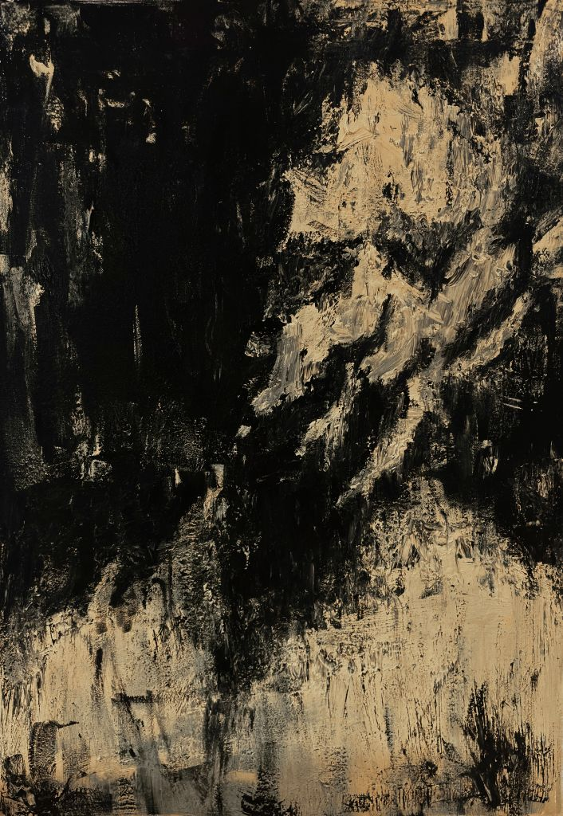
A Man Mourning Its Lack of Purpose, 2026 I
39 x 26 in
Acrylic on canvas
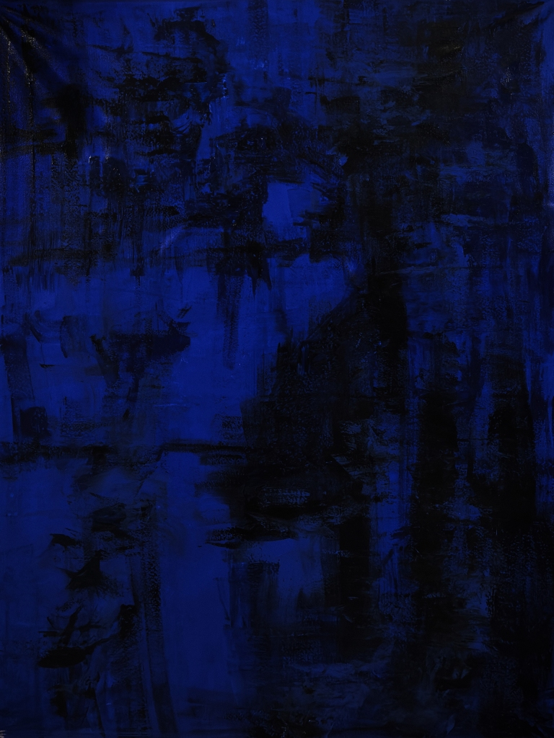
A Lover’s Gasp, 2026 II
61 × 45 in
Acrylic on canvas
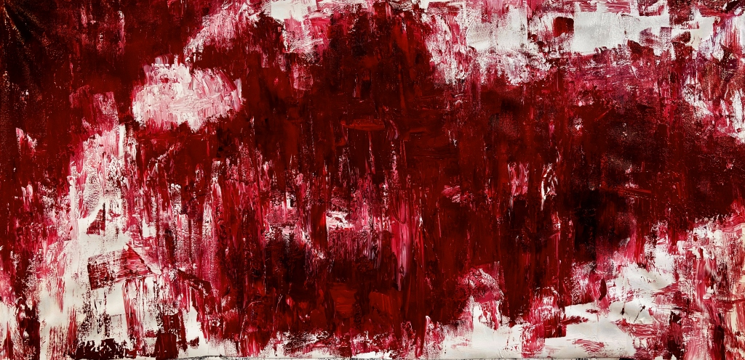
Another Lost One, 2026 III
28 × 62 in
Acrylic on canvas

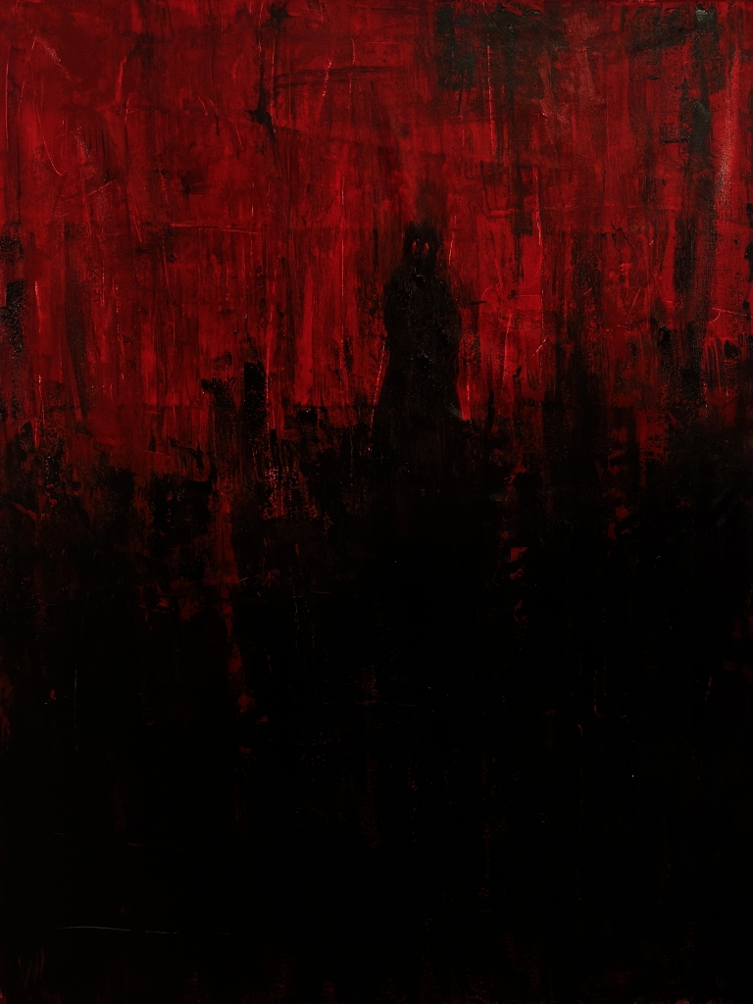
Ballad of Lost Dreams, 2026 IV
62 × 47 in
Acrylic on canvas
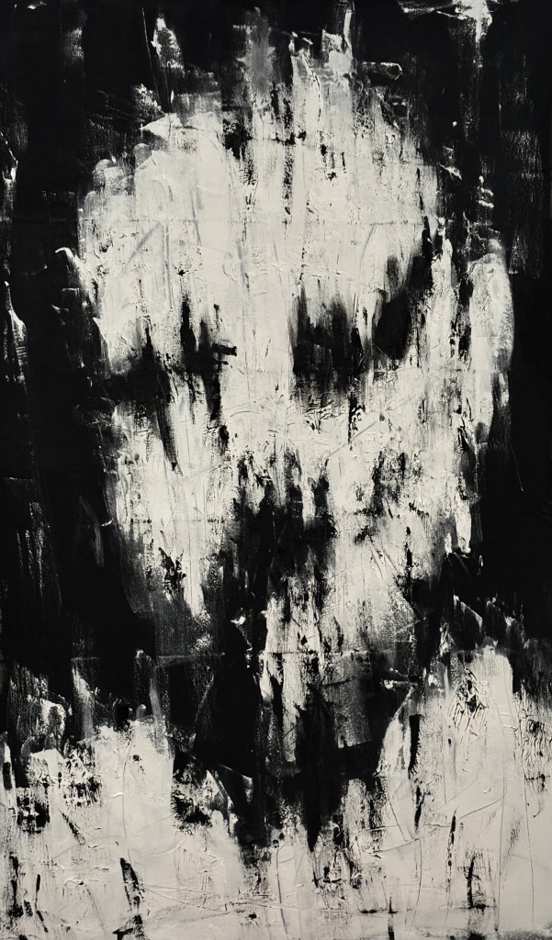
Despair, 2026 V
71 × 43 in
Acrylic on canvas
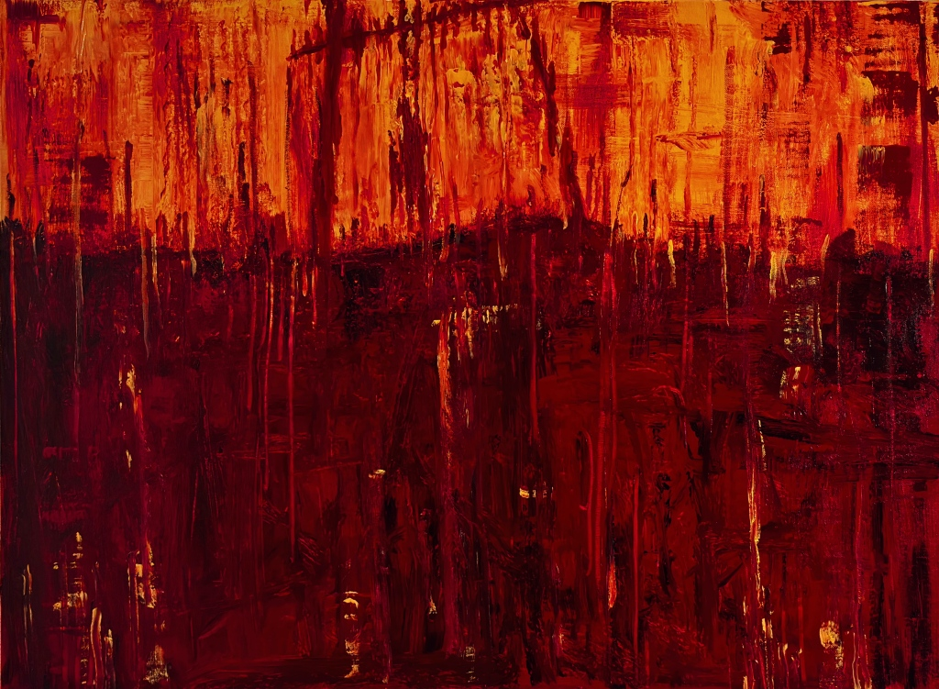
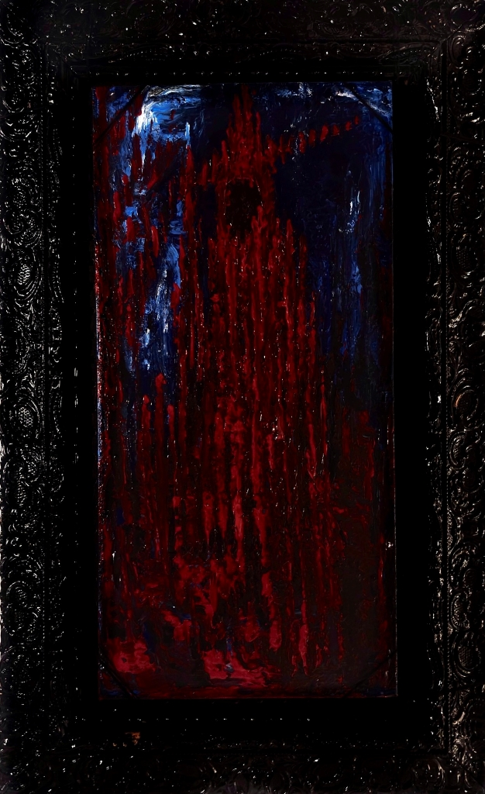
Jogo da Forca, 2026 VI
30 × 40 in
Acrylic on canvas
Blood Path, 2026 VII
24 × 12 in
Acrylic on canvas with wood frame
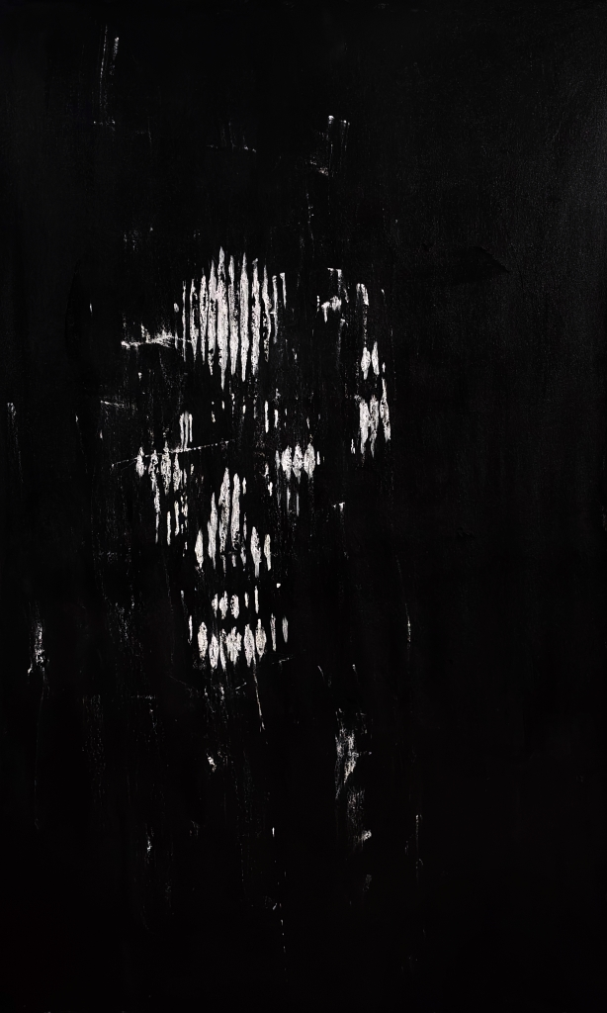
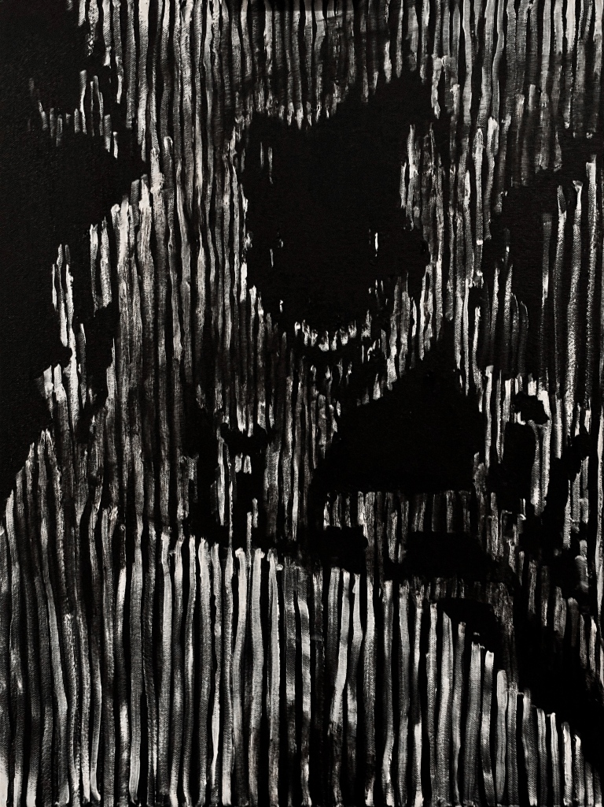
Subject N.5, 2026 VIII
71 × 43 in
Acrylic on canvas
Subject N.2, 2026 IX
28 × 22 in
Acrylic on canvas
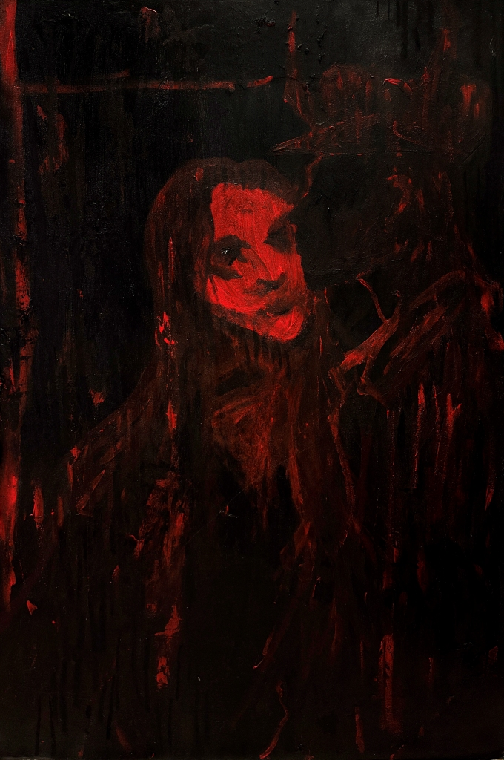
Card N.XV, 2025 X
36 × 24 in
Mixed media on cardboard

