Android Tutorials: Services Example
As this is a beginners’ Android tutorial, we have used the most basic example of a Service, i.e. Music Player.
Here are the code and snapshots for playing and stopping a song using a Service:
Follow the steps described in this Android Tutorial:

Step 1: Create a new Android Project with the class name MainActivity.
Step 2: Add two buttons in layout and name them as play and stop.
Step 3: Set the onClick Listeners of both buttons inside the MainActivity.
Step 4: Create a new class “MyService” and extends it to Service Class
Step 5: Make a new folder named as “raw” inside the “res” directory, and copy a song inside it.
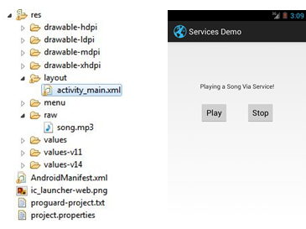
Tag to add in Manifest:
<service
android:name=“.MyService”
android:enabled=“true” >
</service>

Code : MainActivity.java
public class MainActivity extends Activity {
@Override
protected void onCreate(Bundle savedInstanceState) {
super.onCreate(savedInstanceState);
setContentView(R.layout.activity_main);
Button play, stop;
play = (Button) findViewById(R.id.button1);
stop = (Button) findViewById(R.id.button2);
play.setOnClickListener(new View.OnClickListener() {

