**Lakes and streams**

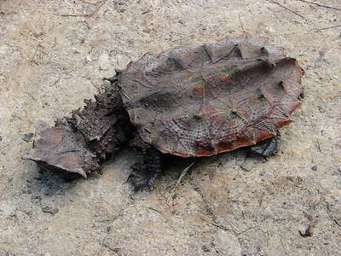

Common name: Matamata turtle

Species: *Chelus fimbriatus*

Range: Amazon basin and Northern South America

Fun facts:

* Matamatas have poor eyesight, but bumps on the head and barbels on the chin contain nerves that help the turtle sense vibrations in the water.
* The strange shape and coloration of the turtle seem to disguise it as a piece of floating bark.
* The Matamata eggs have an extremely long incubation period of 200 days.
* Matamatas are bottom feeders that suck up worms and invertebrates like a vacuum cleaner.

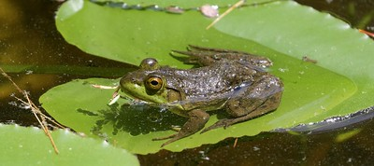 or 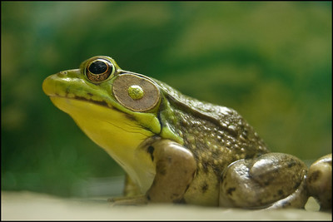

Common name: American Bullfrog

Species: *Lithobates catesbeianus*

Range: Eastern Mexico, Canada, and US

(less) Fun facts:

* Bullfrogs are extremely aggressive, and will eat almost anything they can fit in their mouths. This includes scorpions, small mammals, turtles, birds, and each other.
* The frogs were brought to Europe for food and as pets, but their extreme aggression and adaptability has allowed them to become an invasive species in many parts of Europe and the western United States.
* Bullfrog tadpoles do not taste good to many would-be predators, such that the predators will spit the tadpoles back out.
* Bullfrogs are thought to be one potential carrier of the chytrid fungus, which has decimated amphibian populations worldwide.

**Islands and Oceans**

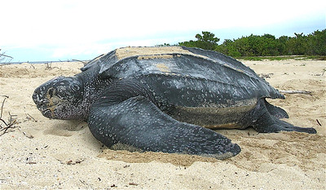

Common name: Leatherback turtle

Species: *Dermochelys coriacea*

Range: All tropical and subtropical oceans

Fun facts:

* The leatherback is the largest of all turtles, weighing over 2,000 pounds and growing up to 6 feet long.
* The leatherback is the only turtle species that lack scales and a hard shell, instead they are covered in rubbery skin.
* The leatherbacks migrate long distances each year, with some traveling over 10,000 miles. They can also dive to a depth of nearly 4,000 feet.
* Female leatherbacks come ashore at night to dig deep nests in which they lay about 100 eggs.

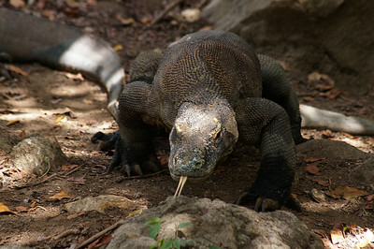

Common name: Komodo dragon

Species: *Varanus komodoensis*

Range: Southern Indonesian Islands

Fun facts:

* Komodo dragons are the largest lizards, and will eat large prey such as goats, monkeys, boars, deer, and each other.
* The Komodo dragon’s mouth contains over 50 species of bacteria, at least 7 of which are septic. These dangerous bacteria, along with the dragon’s own venom, will slowly kill prey that the dragon has bitten. The venom keeps blood from clotting, leading to massive blood loss. It can take four days for the animal to die, during which time the dragon continually tracks its quarry.
* A dragon can eat up to 80% of its own body weight in a single meal. If threatened, the dragon will throw up its food to allow it to quickly run away.
* To avoid being cannibalized by older dragons, the young will roll themselves in fecal material to stay undetected.

**Tropical Rainforest**

You already have the picture for this one.

Common name: Spiny bush viper

Species: *Atheris hispida*

Range: Central and East Africa

Fun facts:

* These snakes eat birds, lizards, and small mammals, and hunt by ambushing their prey in the tree tops. They prefer to wait in the terminal leaves and flowers of smaller trees.
* Their venom is a potent neurotoxic, which damages internal organs and can be fatal to humans.
* The snakes are small, growing no longer than 30 inches.
* Because of their elusiveness and the remoteness of their home range, little is known about their population size or life-span.

**Mountains**

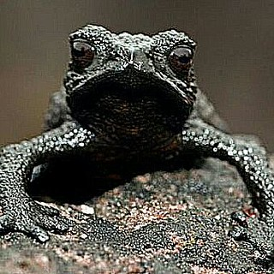

Common name: Pebble toad

Species: *Oreophrynella nigra*

Range: Venezuala

Fun facts:

* When confronted by a predator, the toad will tense its muscles, going stiff. Due to its mountainous habitat, it will usually be on an incline when this happens, so it can roll down the mountain to safety.
* The frogs are no more than a few centimeters long, so they can roll and bounce down the mountain without injury.
* The frog has not evolved to excel at jumping, so it can only hop about an inch.

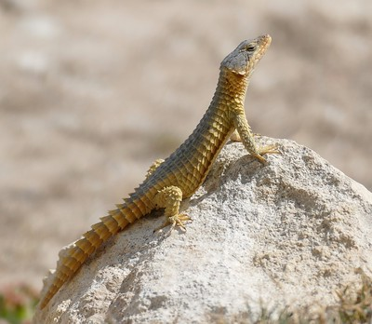

Common name: Cape girdled lizard

Species: *Cordylus cordylus*

Range: Southern Africa

Fun facts:

* These lizards live in colonies on mountain summits and rocky outcrops.
* When threatened, the lizards will wedge themselves into holes and cracks in the rocks, and cover their faces with their thorny tails.
* They rush and pounce to catch their prey, which consists primarily of insects.

**Temperate forest**

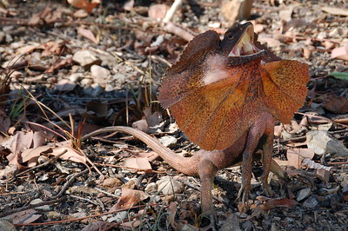

Common name: Frilled lizard

Species: *Chlamydosaurus kingii*

Range: Northern Australia

Fun facts:

* When threatened, the lizard will raise its frill and hiss. If this doesn’t work, it has long claws that help it quickly scale trees.
* The lizard can reach speeds of 30 mph over short distances. They are nicknamed bicycle lizards due to their bipedal running form.
* The lizards also raise or lower their frill to control their body temperature.
* They are ambush hunters, and eat insects and small mammals.
* Contrary to popular belief, the lizards are not venomous, and do not spit at their predators.