1. purposes for repeated-measures designs: examine trends across time; increase power to detect treatment effects by comparing the performance of the same subjects across treatment conditions [when time/treatment is the within-subjects factor]).

2. advantages: assess performance across time; tends to be more powerful than between-subjects designs thus requiring fewer participants to attain the same power (increased precision and economy of subjects)  
We block on each participant. variability among the subjects due to individual differences is completely removed from the error term.

3. disadvantages: order effects, carry-over effects, differential attrition.  
Counterbalancing the order is an effective method of minimizing order effects. (randomly assigning one third of the subjects to each of the following sequences). Counterbalance = all possible orders of treatments are administered: 3 Treatments = 3! = 3 * 2 * 1 = 6 possible orders.  
Carryover effects refer to the impact of a previous trial: Allowing an adequate amount of time.

4. MSw vs MSb. MSb= SSb/(k-1)  
MSw = SSw/(N-k), SSw = SSbl + SSres where SSbl = sum of squares for blocks and SSres = sum of squares residual. SSbl = k∑(MeanPerPerson - GrandMean)

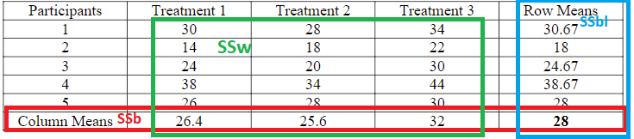

Total: variation of individual scores around the grand mean, SSb(between-subjects variation): variation of the subjects’ means pooled across the repeated measures around the grand mean, between-trial variation: variation of the trial means around the grand mean, error variation: remaining variation of the individual scores around the grand mean that could not be accounted for by between-subject and between-trial variation.

5. Epsilon: The extent to which the covariance matrix deviates from sphericity. To adjust for the positive bias, Greenhouse and Geisser suggest altering the degrees of freedom: df x Epsilon (don’t do this when it’s over 0.7).

6. Sphericity requires that the variances of the differences for all pairs of repeated measures are equal. When sphericity is not met, the F ratio/test in the univariate approach is positively biased (falsely rejecting the null too often). When sphericity is not met, Epsilon can be used to adjust the degrees of freedom for the F test. When sphericity is met, Epsilon = 1. The lowest value that epsilon (ε) can take is called the lower-bound estimate.

7. 1B, 1W repeated design:  
W: is the average weight for all 40 subjects different at the 3 points in time?  
Inter: Is the difference in means between the therapy and control groups the same or different across time? (we expect the two groups to have similar weight at time 1, but different average weight at times 2 and 3 (due to the therapy).   
B: Is there an overall weight difference between the family therapy and control group in the population (averaging across the three time points)  
Simple Effects I: Do participants in the family therapy group/control group differ across time?  
Simple Effects II: Do family therapy and control groups differ at time 1,2,3?  
There was a significant main effect of therapy group, F(1, 38) = 39.45, p< .001, which was a large effect (η = .51).   
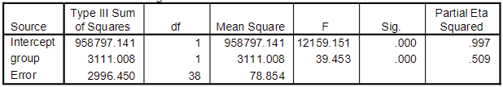  
Participants in the therapy group gained significantly more weight than participants in the control group. The Greenhouse-Geisser adjusted F tests were used when interpreting effects involving the within-subjects factor of time and are reported with adjusted degrees of freedom rounded to the nearest whole number. There was a significant main effect of time, F (2, 75) = 166.10, p< .001, which was a large effect (η = .81).   
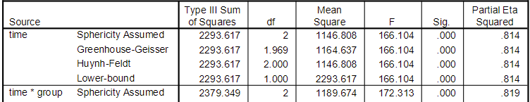 Post hoc tests using the Bonferroni adjustment indicate that participants weighed significantly more at 12 weeks than at   
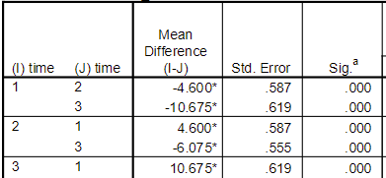the beginning of the intervention and weighed significantly more at 24 weeks than at 12 weeks. Both main effects are dependent upon the other, as indicated by the significant interaction between therapy group and time, F (2, 75) = 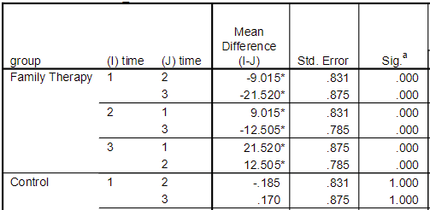172.31, p < .001, which was a large effect (2pη = .82). Post hoc comparisons using the Bonferroni adjustment indicated that average weight increased significantly across time for participants in the family group, but remained fairly constant for participants in the control group.  
  
Assumptions:  
1. Multivariate normality (inspect the distribution of scores in each cell). The histograms and the descriptive statistics indicated negligible skew and some kurtosis (all values less than 3). The K-S test supports normality whereas the Shapiro-Wilk indicates nonnormality in the control group at time 3. Nonetheless, the absolute value of the kurtosis estimate associated with the control group was less than 2X its corresponding standard error (i.e., 1.009 >2*1.232). The kurtosis values, while indicating platykurtic distributions, are not extreme enough to warrant concern with non-normality. Thus, you could go ahead and assume normality.  
2. Independence of observations. usually be guaranteed by randomly assigning participants and testing participants individually). Just make sure participants did not interact with others either in a group or a dyad.  
3. Sphericity  
4. Between-groups equality of variance (use Levene’s test; examine standard deviations for each group): robust when cell sizes are equal, as is in this study.

1. advantages: reduce error variance and allow for increased power in detecting treatment effects; detection of interaction between the covariate and treatment; adjust for initial group differences. (Systematic bias: Groups differ systematically on some variable that is related to the dependent variable; Random assignment takes care of systematic bias, but we are not always able to randomly assign participants to groups.) (ex: Reduce bias when comparing intact or self-selected groups (e.g., males vs. females); Adjust the posttest means on the dependent variable for any initial differences.

2. ATI: used when the treatment and covariate interact. describe how the effectiveness of the treatment varies across the range of the covariate.

3. Covariate: Variables should correlate with the dependent variable; Variables have been shown to correlate with similar types of participants; but low correlations with other covariates; Limit the number of covariates to satisfy the following relationship:

4. Purpose  
2. Reduction of within group or error variance: we have smaller error variance (MSw)   
▪ The amount of variance on the dependent variable that is accounted for by the covariate is the squared value of the correlation between the two variables ( rxy^2 ). The within group variance in ANCOVA has removed the portion due to the covariate: MSw – Mswrxy^2 = MSw (1-rxy^2 ).

5. Assumptions. no measurement error in the covariate. **linearity** between the covariate and dependent variable in each group can be assessed by examining scatterplots; **equal regression slopes** in ANCOVA can be assessed by examining the test for the increment in R2.(The slopes look similar across three groups, but check this using a model with the interaction term between covariate and group)   
Null Hypothesis: H0 = u1* = u2* = u3* (the adjusted population means are equal)  
If **reliability** is low, use alternative technique. Low reliability results in biased treatment effects. The population **variance** of the errors (the differences between the outcome measurements and the linear prediction line) is constant across the J groups  
▪ Test the increment in R2 that is due to adding the interaction term(s) to a model containing the treatment variable(s) and the covariate. If this increase is statistically significant, conduct an ATI analysis.   
5. Sums of Squares Within (error)  
SSw* = (1- r xy(w)^2 )SSw (same for total)   
SSb* = SSt* - SSw*   
F* = (SSb* /(k -1)) / SSw* /(N -k -C) = MSb* / MSw* , and C is the number of covariates.

the interaction is not statistically significant (p > .05). This indicates that the regression slopes (regression aptitude on posttest) are the same across group.  
The overall treatment main effect was statistically significant. Follow-up comparisons using the Bonferroni adjustment procedure indicate that TTT was significantly higher, after adjusting for initial reading aptitude level, when BBB than no questions were presented.  
There is a significant effect of covariate (aptitude) on post-test (reading score). This indicates that ANCOVA model is appropriate to be used. The covariate explains post-test scores significantly.

F* = (182.86/2) /45.86/ (18 – 3 – 1) = 27.87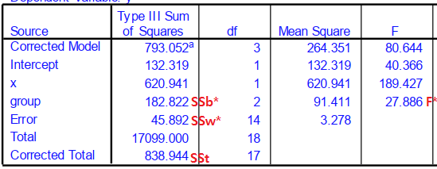

Calc adjusted mean for each group. yi*= yi - b(xi - x): group means after controlling for the influence of the CV

