Contents

1. Background 1

1.1 IE 1

1.2 R1 Strategies 1

2. PSS 1

2.1 Magnusson’s Method (Bayesian Framework) 1

2.1.1 data structure 1

2.2.2 algorithm 1

2.2 Principal Score Method 1

2.2.1 data structure 1

2.2.2 algorithm 1

3. AdACE 2

4. Result Comparison 2

4.1 Simulation intro 2

4.2 Comparison result (1 scenario example) 2

### Background

#### 1.1 Intercurrent Events (IE)

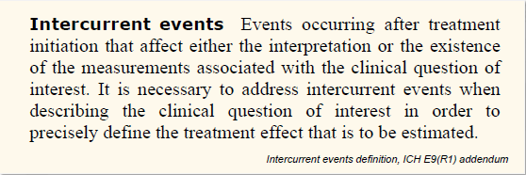

#### 1.2 Strategies to Address IE

The ICH E9(R1) Addendum introduces five strategies that can be used alone or in combination to address different intercurrent events.

* Treatment Policy [ignoring IE]
* Hypothetical [imputed from model]
* Composite [imputed by incorporating the IE result]
* While-on-Treatment [using last result before IE]
* Principal Stratum Strategy (PSS) **[stratifying population based on potential IE outcome]**

### 2. PSS

#### 2.0 Overview of Three Methods

Step 1. predict strata membership – using the observed S(Z) and potential/predicted S(1-Z)

Step 2. Compute ACE within each stratum – using the observed Y(Z) and potential/predicted Y(1-Z)

The 2nd step is similar across 3 methods. The 1st step, the estimand of each method is defined by its own indicator variable S(Z), it could be indicator of IE, indicator of Adherence, or indicator of the actual treatment received. To compare the estimand ACE of different methods, we first define the matching relationship of all the indicator variables.A screenshot of a computer
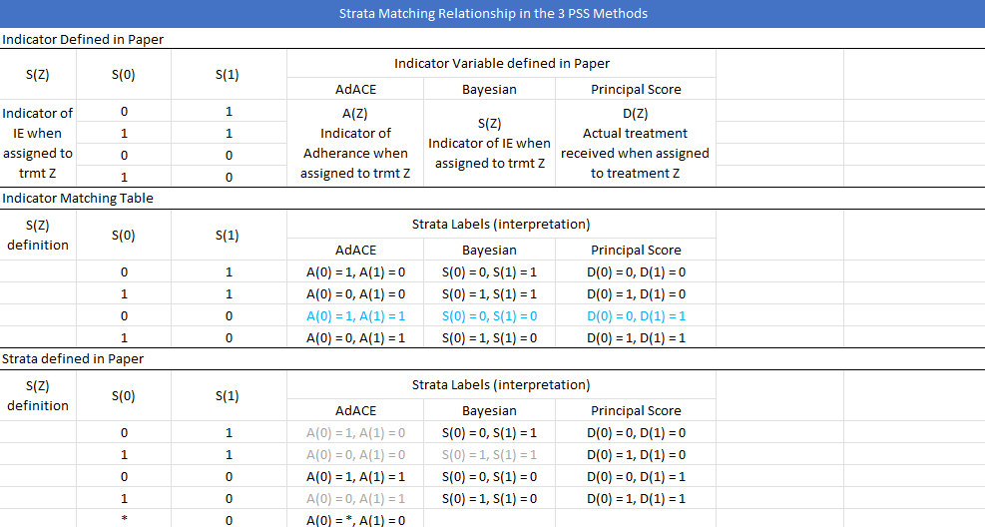

#### 2.1 Magnusson’s Method (Bayesian Framework)

##### 2.1.1 method from paper

(a) essentials (from notes)

S(0) S(1) Stratum

0 1 Harmed (H)

1 1 Doomed (D)

0 0 Immune (I)

1 0 Benefiters (B)

Model Y:

$Y_{iz}\sim N\left(μ_{iz},1\right),$ where $μ_{iz}$ is a mixture of two normal means, defined as follows:

|  |  |  |
| --- | --- | --- |
|  | $$μ_{i0} mix$$ | $$μ_{i1} mix$$ |
| $$If\left(S_{i},Z_{i}\right)=\left(0,0\right), then subject i∈\left\{I,H\right\} →$$ | $$μ_{i0}=\frac{π_{iI,x}}{π_{iI,x}+π_{iH,x}}μ_{iI,x}\left(0\right)+\frac{π_{iH,x}}{π_{iI,x}+π_{iH,x}}μ_{iH,x}\left(0\right)$$ | $$μ_{i1}=\frac{π_{iI,x}}{π_{iI,x}+π_{iH,x}}μ_{iI,x}(1)+\frac{π_{iH,x}}{π_{iI,x}+π_{iH,x}}μ_{iH,x}(1)$$ |
| $$If \left(S_{i},Z_{i}\right)=\left(0,1\right), then subject i∈\{I,B\} →$$ | $$μ_{i0}=\frac{π_{iI,x}}{π_{iI,x}+π_{iB,x}}μ_{iI,x}\left(0\right)+\frac{π_{iB,x}}{π_{iI,x}+π_{iB,x} }μ_{iB,x}\left(0\right)$$ | $$μ_{i1}=\frac{π_{iI,x}}{π_{iI,x}+π_{iB,x}}μ_{iI,x}(1)+\frac{π_{iB,x}}{π_{iI,x}+π_{iB,x} }μ_{iB,x}(1)$$ |
| $$If \left(S_{i},Z_{i}\right)=\left(1,0\right), then subject i∈\{D,B\} →$$ | $$μ_{i0}=\frac{π_{iD,x}}{π_{iD,x}+π_{iB,x}}μ_{iD,x}\left(0\right)+\frac{π_{iB,x}}{π_{iD,x}+π_{iB,x} }μ_{iB,x}\left(0\right)$$ | $$μ_{i1}=\frac{π_{iD,x}}{π_{iD,x}+π_{iB,x}}μ_{iD,x}(1)+\frac{π_{iB,x}}{π_{iD,x}+π_{iB,x} }μ_{iB,x}(1)$$ |
| $$If \left(S_{i},Z_{i}\right)=\left(1,1\right), then subject i∈\{D,H\} →$$ | $$μ_{i0}=\frac{π_{iD,x}}{π_{iD,x}+π_{iH,x}}μ_{iD,x}\left(0\right)+\frac{π_{iH,x}}{π_{iD,x}+π_{iH,x} }μ_{iH,x}\left(0\right)$$ | $$, μ_{i1}=\frac{π_{iD,x}}{π_{iD,x}+π_{iH,x}}μ_{iD,x}(1)+\frac{π_{iH,x}}{π_{iD,x}+π_{iH,x} }μ_{iH,x}(1)$$ |
| Code notation | mu0_mix | mu1_mix |

In the table above $μ_{ij,x}\left(0\right)=\left(1,X_{i1}, X_{i2}, X_{i3}\right)\left[\begin{aligned}\begin{matrix}β_{1j} \\ β_{2j} \\ β_{3j}\end{matrix} \\ β_{4j}\end{aligned}\right] , μ_{ij,x}\left(1\right)=μ_{ij,x}\left(0\right)+Δ_{j}, , π_{ij,x}=\frac{\exp\left(α_{ij,x}\right)}{\sum_{j=1}^{J}{\exp\left(α_{ij,x}\right)}},$ $j∈\{H,D,I,B\}$. Namely:

|  |  |  |
| --- | --- | --- |
| $$μ_{ij,x}\left(z\right)→$$ | $$μ_{iH,x}\left(0\right)=\left(1,X_{i1}, X_{i2}, X_{i3}\right)\left[\begin{aligned}\begin{matrix}β_{1H} \\ β_{2H} \\ β_{3H}\end{matrix} \\ β_{4H}\end{aligned}\right],$$ $μ_{iD,x}(0)=\left(1,X_{i1}, X_{i2}, X_{i3}\right)\left[\begin{aligned}\begin{matrix}β_{1D} \\ β_{2D} \\ β_{3D}\end{matrix} \\ β_{4D}\end{aligned}\right],$ $μ_{iI,x}\left(0\right)=\left(1,X_{i1}, X_{i2}, X_{i3}\right)\left[\begin{aligned}\begin{matrix}β_{1I} \\ β_{2I} \\ β_{3I}\end{matrix} \\ β_{4I}\end{aligned}\right],$ $$μ_{iB,x}(0)=\left(1,X_{i1}, X_{i2}, X_{i3}\right)\left[\begin{aligned}\begin{matrix}β_{1B} \\ β_{2B} \\ β_{3B}\end{matrix} \\ β_{4B}\end{aligned}\right]$$ | $$μ_{iH,x}\left(1\right)=μ_{iH,x}\left(0\right)+Δ_{H}$$ $$μ_{iD,x}\left(1\right)=μ_{iD,x}\left(0\right)+Δ_{D}$$ $$μ_{iI,x}\left(1\right)=μ_{iI,x}\left(0\right)+Δ_{I}$$ $$μ_{iB,x}\left(1\right)=μ_{iB,x}\left(0\right)+Δ_{B}$$ |
| Code notation: | mu0[i,j] | mu1[i,j] |

|  |  |  |  |  |
| --- | --- | --- | --- | --- |
|  | where $$α_{iH,x}=(1,X_{i1}, X_{i2}, X_{i3})\left[\begin{aligned}\begin{matrix}η_{1H} \\ η_{2H} \\ η_{3H}\end{matrix} \\ η_{4H}\end{aligned}\right]$$ | $$π_{iD,x}=\frac{exp⁡(α_{iD,x})}{\sum_{j=1}^{J}{exp⁡(α_{ij,x})}}$$ where $$α_{iD,x}=\left(1,X_{i1}, X_{i2}, X_{i3}\right)\left[\begin{aligned}\begin{matrix}η_{1D} \\ η_{2D} \\ η_{3D}\end{matrix} \\ η_{4D}\end{aligned}\right]$$ | $$π_{iI,x}=\frac{exp⁡(α_{iI,x})}{\sum_{j=1}^{J}{exp⁡(α_{ij,x})}}$$ where $$α_{iI,x}=(1,X_{i1}, X_{i2}, X_{i3})\left[\begin{aligned}\begin{matrix}η_{1I} \\ η_{2I} \\ η_{3I}\end{matrix} \\ η_{4I}\end{aligned}\right]$$ | $$π_{iB,x}=\frac{exp⁡(α_{iB,x})}{\sum_{j=1}^{J}{exp⁡(α_{ij,x})}}$$ where $$α_{iB,x}=\left(1,X_{i1}, X_{i2}, X_{i3}\right)\left[\begin{aligned}\begin{matrix}η_{1B} \\ η_{2B} \\ η_{3B}\end{matrix} \\ η_{4B}\end{aligned}\right]$$ |
| Code notation: | pi1[i] | pi2[i] | pi3[i] | pi4[i] |

Model S:

For each subject i:

|  |  |
| --- | --- |
|  | Code notation : |
|  | p1[i] = pi1[i] + pi2[i] |
|  | P0[i] = pi2[i] + pi4[i] |

ACE Calculation

|  |  |  |  |  |  |
| --- | --- | --- | --- | --- | --- |
|  | $$S_{i}(0)$$ | $$S_{i}(1)$$ | $$Y_{i}(0)$$ | $$Y_{i}(1)$$ | ACE Calculation |
| $$If\left(S_{i},Z_{i}\right)=\left(0,0\right)$$ | observed | S1[i] ~ dbern(p1[i]) | observed | Y1[i] ~ dnorm(mu1_mix[i], sigma2) | Strata Membership defined by $$S_{i}\left(0\right), S_{i}(1)$$ Within each stratum, compute the mean of $ITT_{i}=Y_{i}\left(1\right)-Y_{i}(0)$ |
| $$If \left(S_{i},Z_{i}\right)=\left(0,1\right)$$ | observed | S1[i] ~ dbern(p1[i]) | Y0[i] ~ dnorm(mu0_mix[i], sigma2) | observed |
| $$If \left(S_{i},Z_{i}\right)=\left(1,0\right)$$ | S0[i] ~ dbern(p0[i]) | Observed | observed | Y1[i] ~ dnorm(mu1_mix[i], sigma2) |
| $$If \left(S_{i},Z_{i}\right)=\left(1,1\right)$$ | S0[i] ~ dbern(p0[i]) | Observed | Y0[i] ~ dnorm(mu0_mix[i], sigma2) | observed |

##### 2.1.2 data structure

#### 2.2 Principal Score Method

##### 2.2.1 data structure

##### 2.2.2 algorithm

(a) essentials (from notes)

(b) updated part

### 3. AdACE

### 4. Result Comparison

#### 4.1 Simulation intro

#### 4.2 Comparison result (1 scenario example)