B2 : Tableau de route R1, R2, R3

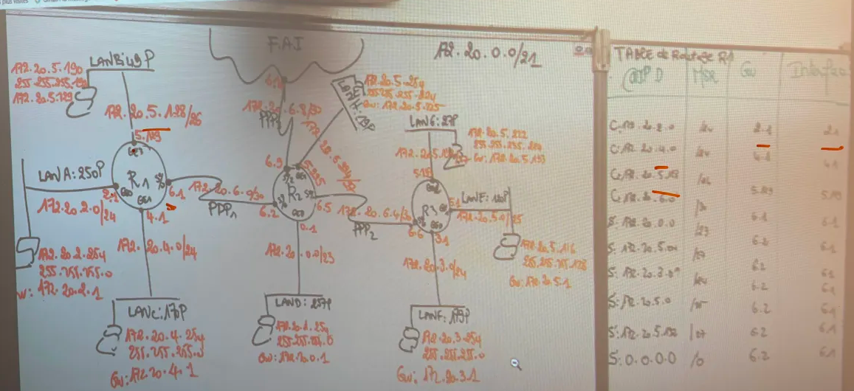

R2

IP | MASK | GUAITEWAY | INTERFACE
170.20.5.0 | /24 | 6.2 | 6.2
170.20. | /24 | 6.6 | 6.2
 | / | 6.6 | 6.2
 |  | 6.6 | 6.2
 |  | 6.6 | 6.2

