Nature Communications
Supplementary Information
for
Spatial redistribution of a globally constant marine biological carbon pump
L. Delaigue^{1,2}, R. Sauzède³, O. Sulpis⁴, P. W. Boyd⁵, Lynne. D. Talley⁶, H. Claustre², G-J. Reichart^{1,7} and M. P. Humphreys¹

¹Department of Ocean Systems (OCS), NIOZ Royal Netherlands Institute for Sea Research, PO Box 59, 1790 AB Den Burg (Texel), the Netherlands
²Sorbonne Université, CNRS, Laboratoire d’Océanographie de Villefranche, Villefranche-Sur-Mer, France
³Sorbonne Université, CNRS, Institut de la Mer de Villefranche, Villefranche-Sur-Mer, France
⁴CEREGE, Aix Marseille Univ, CNRS, IRD, INRAE, Collège de France, Aix-en-Provence, France
⁵Institute for Marine and Antarctic Studies, University of Tasmania, Hobart, Tasmania, Australia
⁶Scripps Institution of Oceanography, University of California San Diego, La Jolla, CA, USA
⁷Department of Earth Sciences, Utrecht University, Utrecht, the Netherlands

Corresponding author: Louise Delaigue (louise.delaigue@imev-mer.fr)

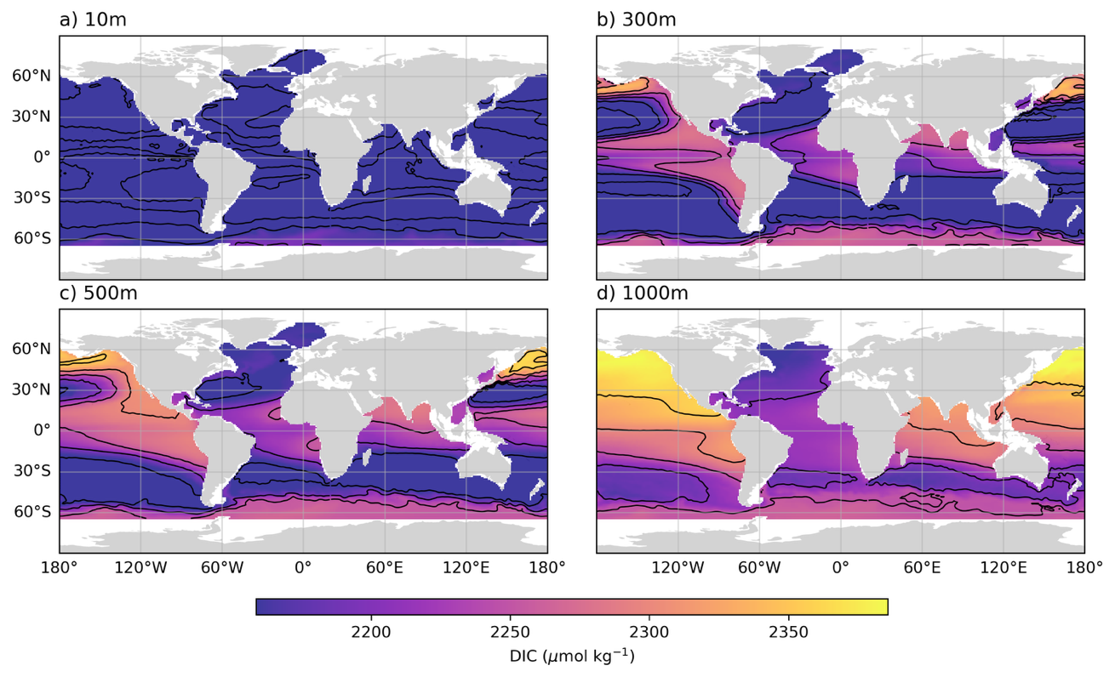Figure S1. Annual mean DIC concentration from GCC-DIC. Four depth levels are shown: a) 10m, b) 300m, c) 500m, and d) 1000m. Black contour lines are drawn every 50 μmol kg⁻¹.

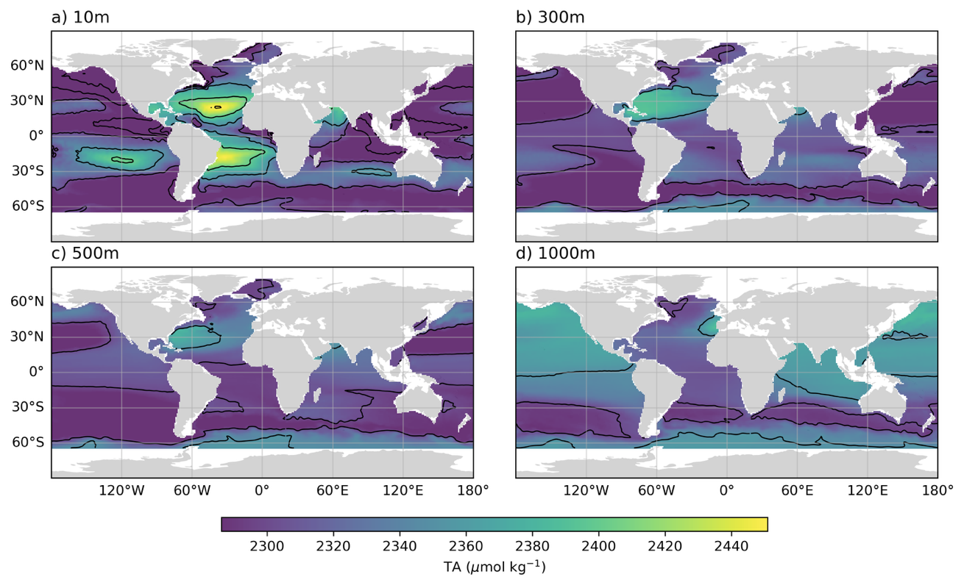
Figure S2. Annual mean TA concentration from GCC-DIC. Four depth levels are shown: a) 10m, b) 300m, c) 500m, and d) 1000m. Black contour lines are drawn every 50 μmol kg⁻¹.

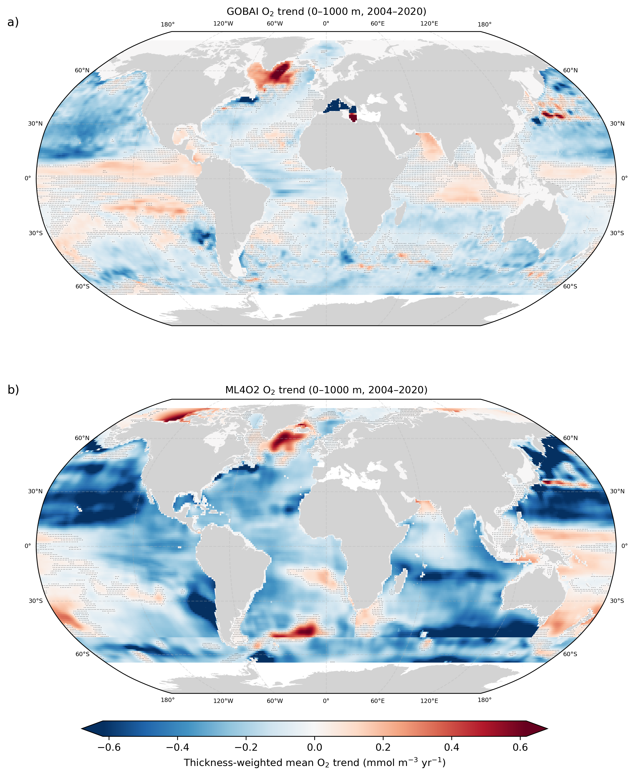
Figure S3. Thickness-weighted mean O₂ trends over the 0–1000 m depth range for the 2004–2020 period derived from (a) the GOBAI-O₂ v2.3 reconstruction and (b) the ML4O₂ product. Both datasets show broadly consistent basin-scale patterns of oxygen change despite relying on different gap-filling approaches. Stippling indicates regions where the local O₂ trend is not significantly different from zero in each product (p ≥ 0.05). This highlights areas where the inferred trends are less robust and helps distinguish coherent large-scale signals from regions of weak or uncertain change. Color shading denotes thickness-weighted mean O₂ trends (mmol m⁻³ yr⁻¹).

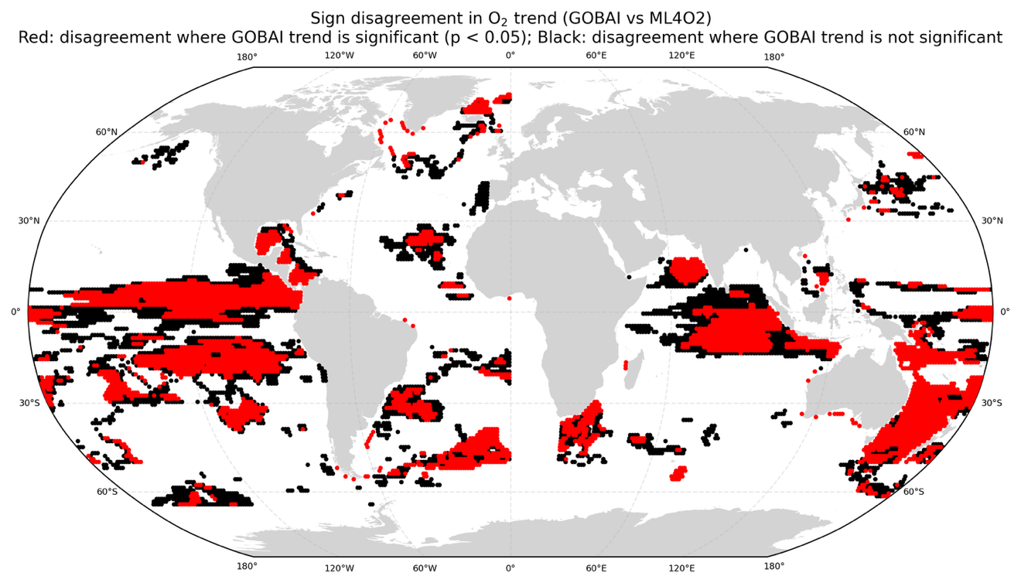
Figure S4. Map of grid points where the sign of the thickness-weighted mean O₂ trend (0–1000 m, 2004–2020) differs between the GOBAI-O₂ and ML4O₂ reconstructions. Red indicates disagreement in regions where the GOBAI- O₂ trend is significantly different from zero (p < 0.05), whereas black indicates disagreement where the GOBAI- O₂ trend is not significantly different from zero.

Text S1
We evaluated the sensitivity of inferred large-scale oxygen trend patterns to oxygen product choice using the independent ML₄O₂ reconstruction (Ito et al., 2024). GOBAI-O₂ was retained as the primary oxygen product because it provides monthly global oxygen fields on a 1° × 1° grid from 2004 onward, extends from the surface to 2 km on 58 pressure levels, and is embedded in a framework with co-located temperature and salinity fields required for the CONTENT and CANYON-B calculations used in the GCC-DIC reconstruction. In addition, GOBAI- O₂ provides a gridded uncertainty framework that can be propagated through the downstream analysis. By contrast, ML₄O₂ was used here as an independent oxygen-only sensitivity test because it does not provide the corresponding hydrographic fields or directly comparable gridded uncertainty fields needed to reproduce the full workflow.
Over the common 2004–2020 period and the 0–1000 m depth range, GOBAI- O₂ and ML₄O₂ show broadly similar basin-scale patterns in thickness-weighted mean O₂ trends despite substantial methodological differences (Fig. S3). In both products, negative oxygen trends dominate large parts of the Pacific, Atlantic, and Southern oceans, while positive trends appear in more localized regions, particularly in parts of the subpolar North Atlantic and the northwestern Pacific. This broad agreement indicates that the large-scale pattern of contemporary oxygen redistribution is not tied to a single mapping methodology.
At the same time, localized differences are evident (Fig. S4). Grid cells where the sign of the thickness-weighted mean O₂ trend differs between GOBAI- O₂ and ML₄O₂ account for 15.10% of valid ocean grid cells globally, corresponding to 84.90% sign agreement. These disagreement regions are spatially structured rather than basin-wide, occurring notably in parts of the equatorial Pacific, tropical Indian Ocean, Southern Ocean, and selected mid-latitude frontal regions. This pattern suggests that disagreement is concentrated in dynamically complex regions where mapping choices and data constraints can have a stronger influence on the inferred local trend.
Such localized differences are expected given the methodological contrasts between the two reconstructions. GOBAI- O₂ is trained on post-2004 quality-controlled GLODAP and BGC-Argo oxygen observations and uses overlapping regional feed-forward neural-network and random-forest regressions applied to gridded temperature and salinity fields from the Argo array. Its uncertainty framework combines measurement, gridding, and algorithm components. ML₄O₂, in contrast, combines historical shipboard observations from WOD18 with Argo- O₂ data over a longer training period beginning in 1965 and constructs an ensemble of machine-learning reconstructions using different predictor sets, hyperparameters, and decadal cross-validation. Differences in training data, temporal coverage, predictor choice, ensemble construction, and regionalization strategy therefore provide a plausible explanation for the observed local mismatches in trend amplitude and, in some cases, trend sign.
To assess whether disagreement tends to occur preferentially where GOBAI- O₂ trends are weakly constrained, we further separated sign-disagreement pixels according to whether the GOBAI- O₂ trend was statistically distinguishable from zero. Of all disagreement pixels, 52.33% occur where the GOBAI- O₂ trend is significant at p < 0.05, whereas 47.67% occur where the GOBAI- O₂ trend is not significant (Fig. S4). Thus, disagreement is not confined to regions where GOBAI- O₂ shows weak or insignificant trends, but also occurs where GOBAI-O2 indicates a statistically robust oxygen change. This implies that differences between the products reflect structural differences in reconstruction behavior in specific dynamical regimes, rather than arising only from weakly constrained regions in GOBAI- O₂.
Because ML₄O₂ does not provide co-located temperature and salinity fields in a framework consistent with GOBAI- O₂, the intercomparison was carried out directly on oxygen trends rather than on derived AOU fields. This comparison is nevertheless informative for the present study because the biologically driven carbon signal diagnosed here is derived from oxygen through the AOU framework and Redfield stoichiometry. Consistency in large-scale oxygen trend patterns across the two reconstructions therefore supports the robustness of the inferred spatial redistribution of biologically respired carbon.
Taken together, the broad agreement in large-scale oxygen trend patterns across two independent reconstructions indicates that the inferred oxygen redistribution underlying our DIC_{soft} analysis is unlikely to be an artefact of a single oxygen product or mapping methodology, while the localized disagreement highlights the sensitivity of regional trend estimates in observationally sparse or dynamically complex regions.

Time-series site | Location | Time range | Temporal resolution | Bottom depth
ALOHA | 22.8°N – 15.0°W | 1988 – 2019 | Monthly | 4750m
BATS | 31.67° N – 64.17° W | 1988 – 2023 | Monthly | 5000m
CVOO | 17.6°N – 24.3°W | 2006 – 2019 | 1-3 cruises yr-1 | 3600m
Iceland Sea | 68.0°N – 12.7°W | 1985 – 2019 | Seasonal | 1850m
Irminger Sea | 64.3°N – 28.0°W | 1983 – 2019 | Seasonal | 1000m
K2 | 47.0°N – 160.0°E | 1999 – 2020 | 1-3 cruises yr-1 | 6000m
KNOT | 44.0°N – 155.0°E | 1992 – 2020 | 1-3 cruises yr-1 | 6000m

Table S1. Key metadata of selected oceanographic time-series sites from the Synthesis Product for Ocean Time Series (SPOTS) compilation (Lange et al., 2024). The Bermuda Atlantic time series (BATS), which is not part of the compilation, was added as an additional temporal validation.

Text S2

In theory, neutral density surfaces represent oceanic mixing processes that occur along isopycnal surfaces. However, adopting the neutral density dimension means forgoing a gridded product, which facilitates practical analysis of changes in DIC components across the global ocean. Thus, in our study, we determined whether vertical water mass movements, averaged over the studied period, could be adequately analyzed within the pressure dimension. This analysis was performed using GOBAI-O₂ v2.1, but since the choice between pressure and neutral density coordinates is not sensitive to oxygen product version, the conclusions carry over to the v2.3 product used in the main analysis.

To explore the differences between pressure and neutral density as analytical dimensions, pixels from various ocean basins were isolated and analyzed in both pressure and neutral density spaces (see Figure S5 of the Supplementary Information).

We then assessed the variations in pressure across different ocean basins by quantifying how the relationship between pressure and neutral density fluctuated over time. For each predefined ocean basin, we calculated the ratio of pressure (P) to neutral density (γ) for all pressure levels in the 4D synthetic product:
$${Ratio}_{P/γ}=\frac{P}{γ}$$ | (1).

Using the ratio of pressure to neutral density provides normalization across basins, enabling consistent comparison of regions with different absolute values of pressure and density. Additionally, it simplifies dimensional consistency and highlights subtle fluctuations over time, making it more sensitive to small-scale variability. By comparing these ratios to their mean values over the entire time period of GOBAI-O₂ v2.1 (2004-2022), we were able to determine residuals, which represent deviations from the mean relationship between pressure and neutral density:
$$Residuals=\frac{P}{γ}-{\left(\frac{P}{γ}\right)}_{mean}$$ | (2).

This part of the analysis revealed no significant long-term trends in the pressure/γ (gamma) ratio, indicating that pressure has remained stable with respect to neutral density over the study period. This conclusion is supported by linear regressions on the time series of mean residuals across all pressure levels, which showed no significant trends in any ocean basin (p > 0.05; Fig. S5 in the Supplementary Information, see Methods for details). To make these deviations interpretable in terms of pressure changes, we converted the residuals back into pressure variations:
$$ΔP=Residuals×\frac{P}{γ}$$ | (3).

This allowed us to quantify the minimum and maximum pressure changes at each pressure level for every basin. These extreme pressure variations provide insight into the range of variability in the relationship between pressure and neutral density across different ocean basins and time periods.
The largest deviation ($ΔP$) observed across the study period (2004 – 2022) was approximately 6 dbar, occurring in the North Atlantic (Figures S6 and S7 of the Supplementary Information). This corresponds to ~6m, a relatively small fluctuation in the context of oceanic processes. Given the absence of consistent trends in ${Ratio}_{P/γ}$ and considering that the analysis integrates over the entire pressure column, these variations appear insignificant. Therefore, the pressure dimension remains a reliable and practical choice for the continuation of this analysis (Fig. 3, Fig. S9 of the Supplementary Information).

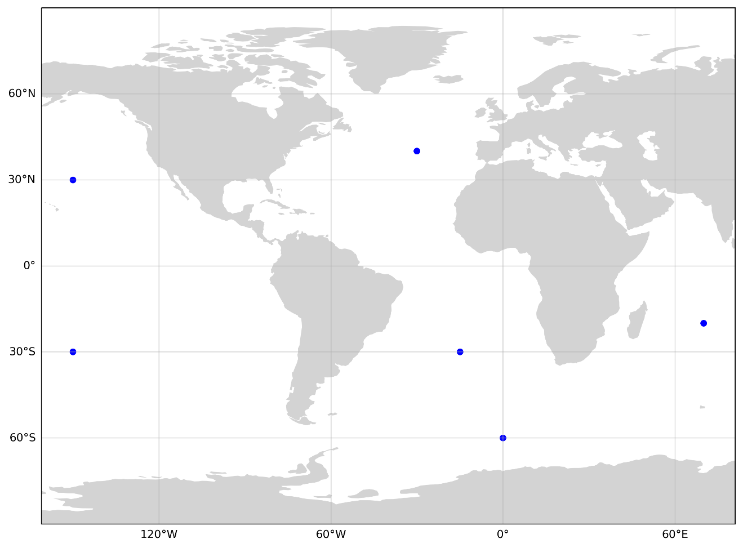
Figure S5. Locations of selected ocean basin pixels used for comparison of pressure and neutral density. Blue markers indicate representative points in the North Atlantic Ocean, South Atlantic Ocean, North Pacific Ocean, South Pacific Ocean, Indian Ocean, and Southern Ocean. These points were chosen to capture a range of oceanographic conditions across basins while keeping the analysis computationally tractable. Due to the size of the GCC-DIC dataset, it was not feasible to perform this analysis on all grid points globally; instead, representative pixels were selected to assess the pressure–neutral density relationship over time in each basin.

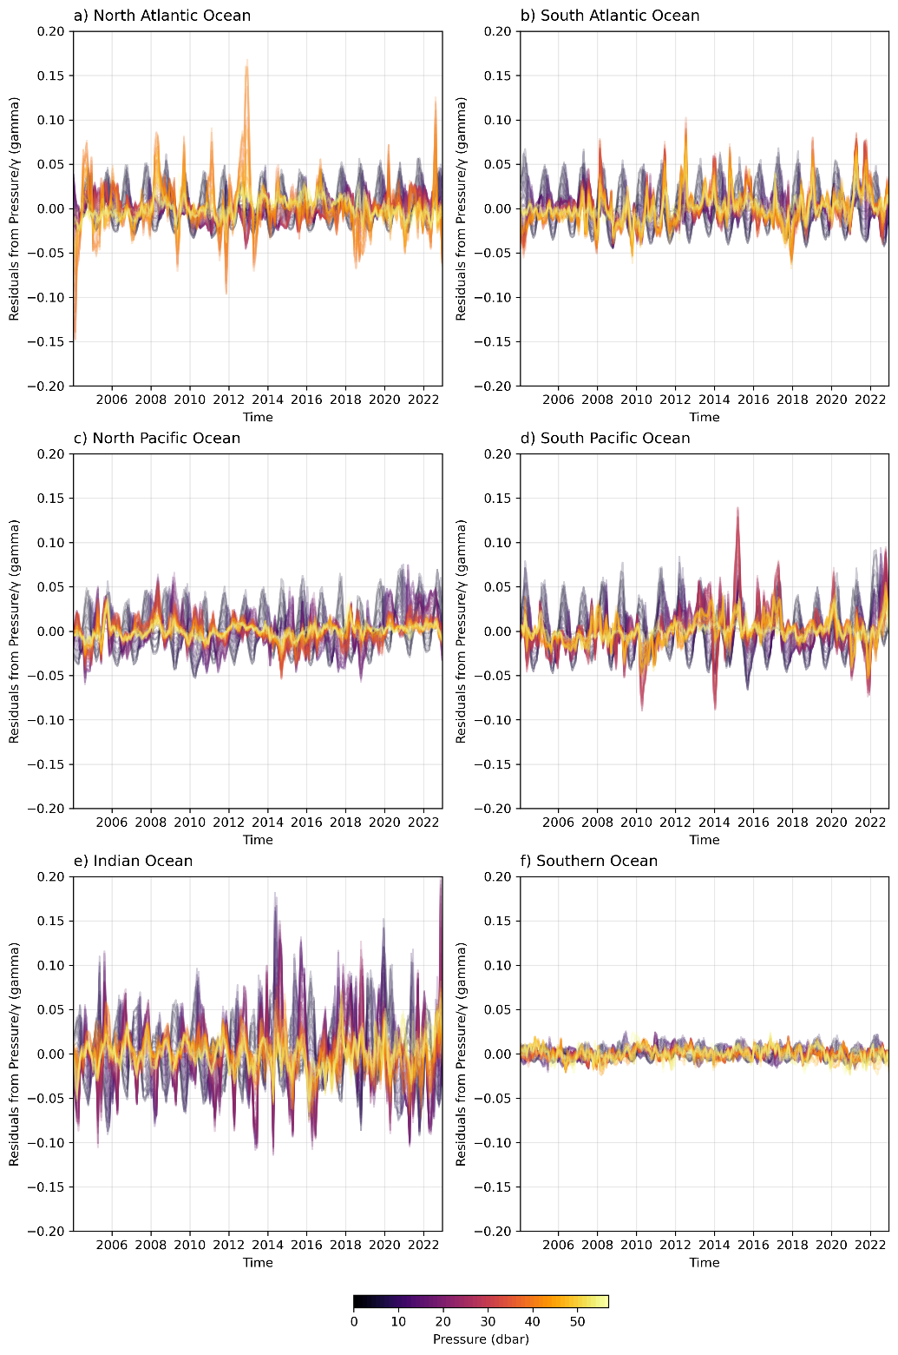

Figure S6. Residuals from the mean pressure/γ (gamma) ratio across all pressure levels from GOBAI-O₂ v2.1 over time for each ocean basin. The residuals are calculated for the North Atlantic Ocean (a), South Atlantic Ocean (b), North Pacific Ocean (c), South Pacific Ocean (d), Indian Ocean (e), and Southern Ocean (f). Each line represents the deviation of the pressure/γ (gamma) ratio from the mean ratio at a given pressure level (indicated by the color gradient) over the time series. The pressure/γ (gamma) ratio provides a normalized measure of the relationship between pressure and neutral density at each level, used here to assess whether significant shifts in water mass structure (e.g., due to heave) have occurred over time.
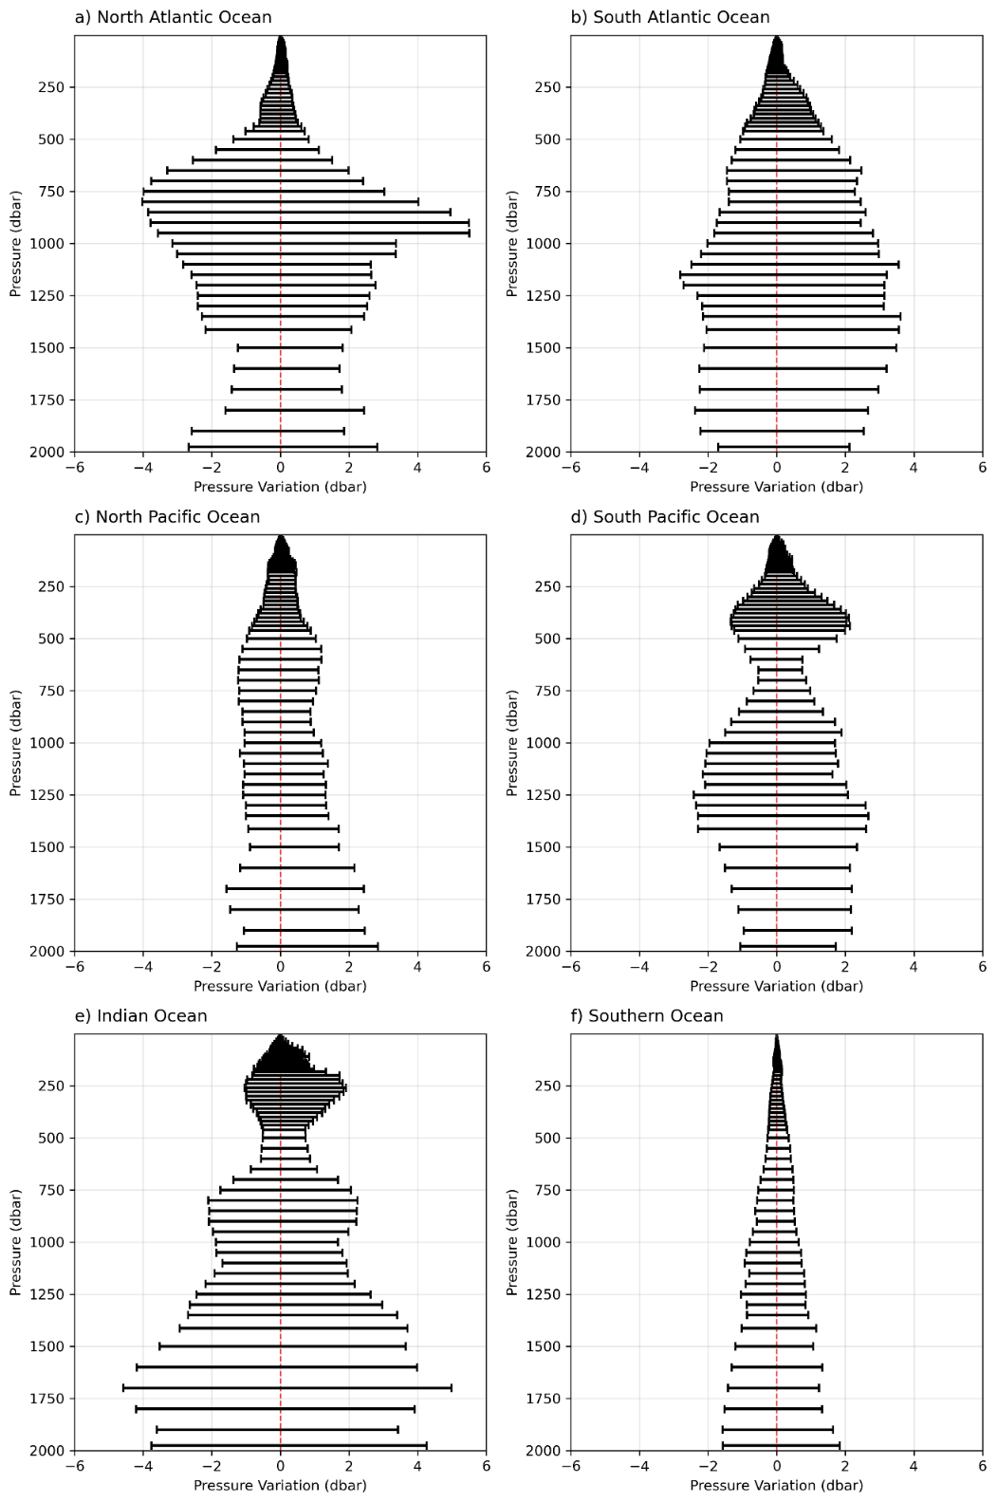

Figure S7. Range of pressure variations at each depth level across major ocean basins, derived from the GOBAI-O₂ v2.1 dataset. Each horizontal line shows the minimum and maximum pressure deviation from the long-term mean, calculated for each pressure level over the 2004–2022 period. Panels correspond to the North Atlantic (a), South Atlantic (b), North Pacific (c), South Pacific (d), Indian (e), and Southern (f) Oceans. These variations reflect how much pressure at a given depth level differs from the neutral density surface over time. The red dashed line at x = 0 indicates no deviation from the mean.
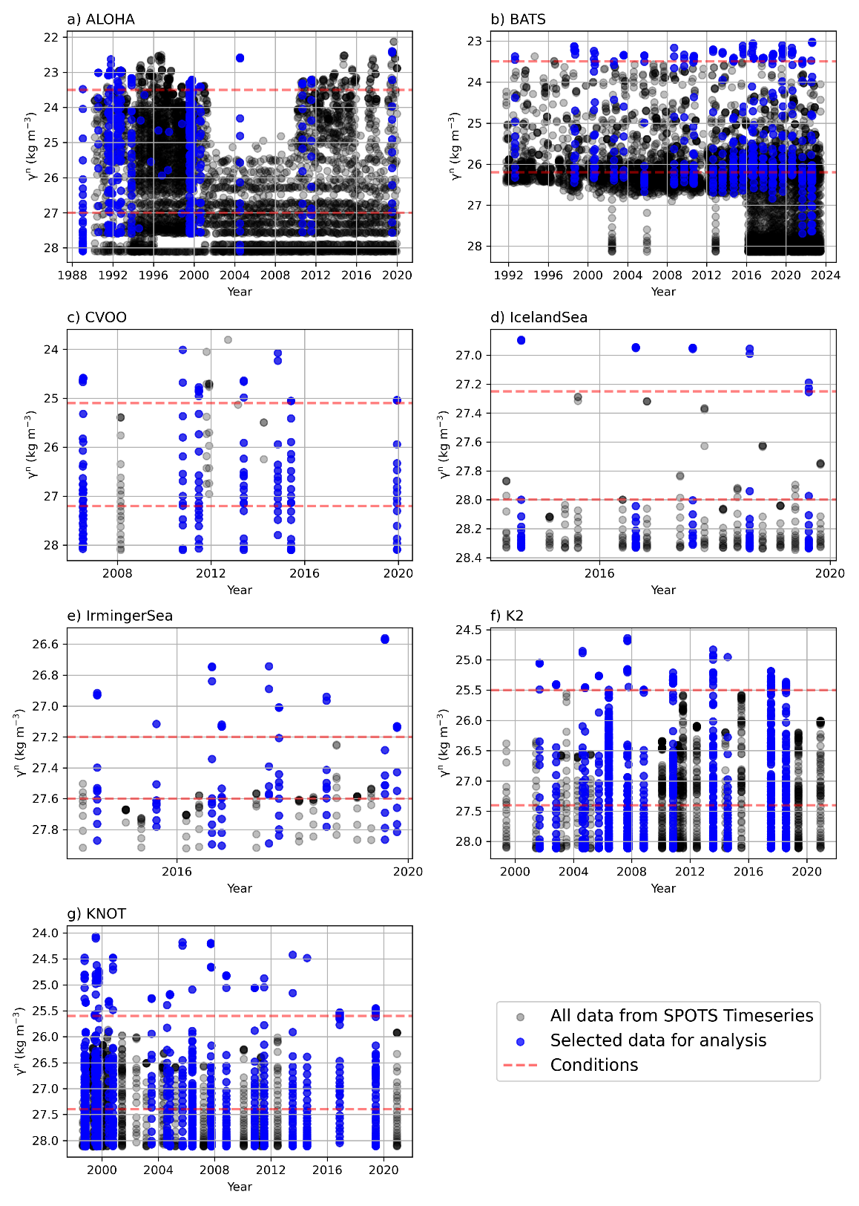
Figure S8. Independent time series analyses from the SPOTs compilation, displaying profiles through time for selected sites. Each subplot represents a unique site where profiles have been selected based on a predefined minimum and maximum neutral density. This selection criterion ensures consistent analysis across all sites for observing changes in the components DIC through time. All data are shown in black and selected data points in blue. Red dashed lines indicate the boundaries set by the minimum and maximum neutral density values. This selection ensures consistent depth coverage and temporal sampling across sites, which directly constrains the time span used in the linear regressions and therefore the robustness of the inferred rates of change.

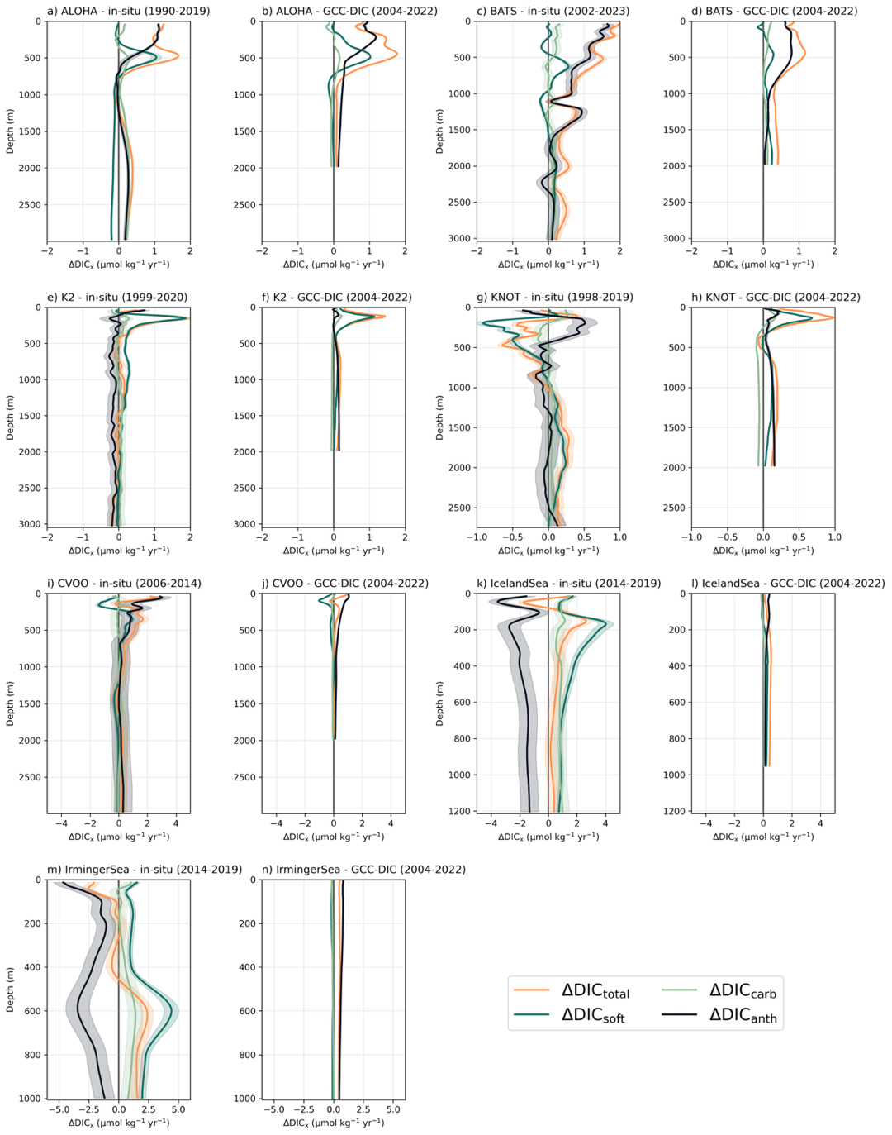
Figure S9. Changes in DIC and its components at selected independent ocean time series sites. Each subplot shows the in situ rate of change over the full observational period (black, with shading for uncertainty) and the corresponding trend from the GCC-DIC reconstruction using GOBAI-O₂ v2.1 for 2004–2022, decomposed into total DIC_{total} (orange), DIC_{soft} (green), DIC_{carb} (light green), and DICₐₙₜₕ (dark grey). Subplots are ordered from the longest to the shortest observational record. Overall, GCC-DIC aligns with the direction and structure of observed trends at most sites, though regional discrepancies exist — notably in the Irminger and Iceland Seas — which may reflect the limited duration of some time series or the timing of trend emergence (Henson et al., 2016). In the Irminger Sea, for example, the decrease in DICₛₒₒf observed in GCC-DIC is consistent with previous findings (Fröb et al., 2018), suggesting that the short in situ record may not yet capture the longer-term trend. Agreement between GCC-DIC and in situ trends varies across sites: some locations show similar sign or vertical structure, whereas others (e.g., BATS, KNOT, Iceland Sea, and Irminger Sea) exhibit notable discrepancies. Differences likely reflect regional variability, differences in sampling duration, and the distinction between local time-series observations and basin-scale reconstructed trends.
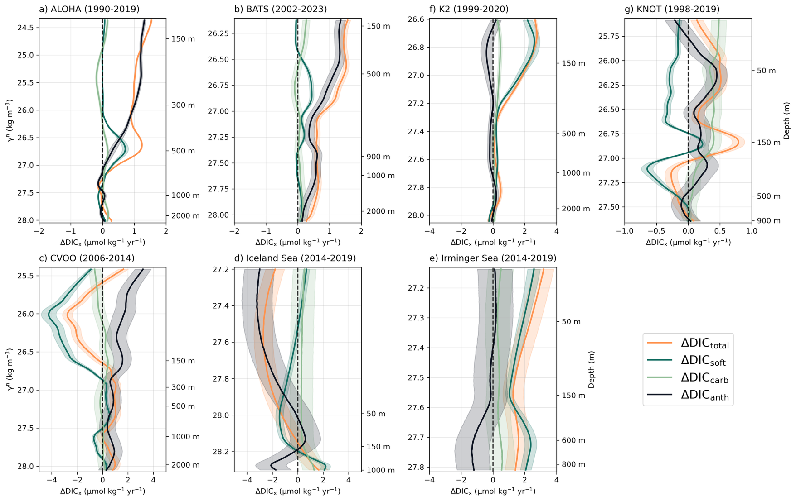
Figure S10. Same analysis as Figure S9 but in neutral density space, which more closely follows isopycnal surfaces and better accounts for water mass movement than fixed-depth coordinates. Approximate depths are shown. Subplots are ordered from the longest to the shortest observational record. While neutral density space offers a more physically consistent framework for following water mass trajectories, our parallel analysis (see Text S2, Fig. S5–S8) showed that pressure space remains a valid and practical choice, with vertical deviations due to heave remaining small (~6 dbar) and lacking long-term trends. Accordingly, pressure-based analysis (used in the main text) is sufficient for capturing decadal variability in DIC components. This analysis is shown for the in situ SPOTS time-series only, as the GCC-DIC reconstruction is defined on a fixed pressure grid and cannot be consistently remapped into neutral density space across basins without losing comparable density ranges.
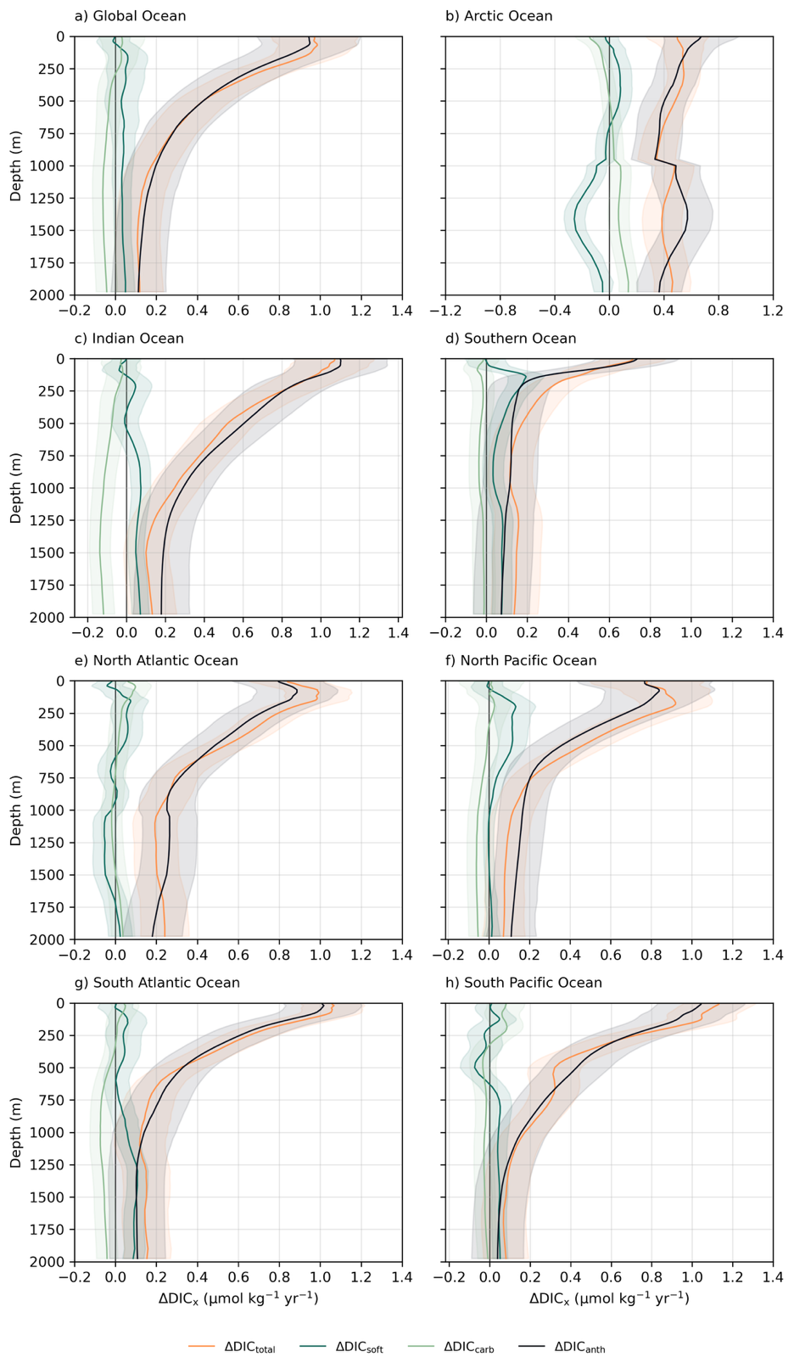
Figure S11. Basin-scale vertical rates of change in dissolved inorganic carbon (DIC) and its components from 2004–2024. Annual rates of change (µmol kg⁻¹ yr⁻¹) are shown as a function of depth for (a) the global ocean and for major ocean basins: (b) Arctic Ocean, (c) Indian Ocean, (d) Southern Ocean, (e) North Atlantic Ocean, (f) North Pacific Ocean, (g) South Atlantic Ocean, and (h) South Pacific Ocean. Trends were derived from the GCC-DIC reconstruction using ordinary least-squares regression applied to annual basin-mean profiles. Total DIC change (ΔDICₜₒₜₐₗ; orange) is decomposed into anthropogenic (ΔDICₐₙₜₕ; black), soft-tissue biological (ΔDIC_{soft}; dark green), and carbonate pump (ΔDIC_{carb}; light green) contributions. Shaded envelopes denote ±1σ uncertainties estimated from a Monte Carlo ensemble incorporating measurement errors in DIC, alkalinity, and oxygen, as well as uncertainty in Redfield stoichiometric scaling factors. Basin averages were computed using area-weighted means within ocean-basin polygons derived from the GOAS v1 ocean polygon mask (Flanders Marine Institute, 2021).

Station | Sequestration depth trend  (m year⁻¹) | Trend significance  (p-value) | Change in sequestration depth  (m) | Change significance  (p-value) | Late 50% sequestration depth  (m)
ALOHA | -0.51 ± 0.019 | < 0.05 | -13.3 ± 0.67 | < 0.05 | 1611
BATS | 1.8 ± 0.31 | < 0.05 | 24.5 ± 2.2 | < 0.05 | 1449
CVOO | -1.5 ± 1.9 | > 0.05 | -10.5 ± 9.7 | > 0.05 | 1102
Iceland Sea | -5.8 ± 0.32 | < 0.05 | -24.5 ± 1.4 | < 0.05 | 728
Irminger Sea | -8.5 ± 1.3 | < 0.05 | -30.3 ± 6.1 | < 0.05 | 739
K2 | -0.96 ± 0.20 | < 0.05 | -11.7 ± 3.1 | < 0.05 | 1432
KNOT | 1.0 ± 0.15 | < 0.05 | 11.3 ± 3.4 | < 0.05 | 1383
Table S2. Statistical trends in the depth at which 50% of DIC_{soft} is sequestered across in-situ time series stations. The slope (m year⁻¹) represents the rate of change in sequestration depth over time while the change in sequestration depth (m) quantifies the difference in sequestration depth between the mean first (Q1) and mean fourth (Q4) quartiles. The late 50% sequestration depth represents the mean 50% sequestration depth of Q4. Note that all statistics were significant except at station CVOO, likely due to too few observations. The table demonstrates that, at most long-running stations, changes in sequestration depth are detectable and significant, supporting the premise that decadal-scale vertical reorganization of biologically respired carbon is observable in independent data. This lends confidence that the redistribution signals diagnosed in GCC-DIC are physically plausible and not an artifact of the reconstruction, while acknowledging that the short duration and sparse sampling of some records (e.g., CVOO) limit detectability.

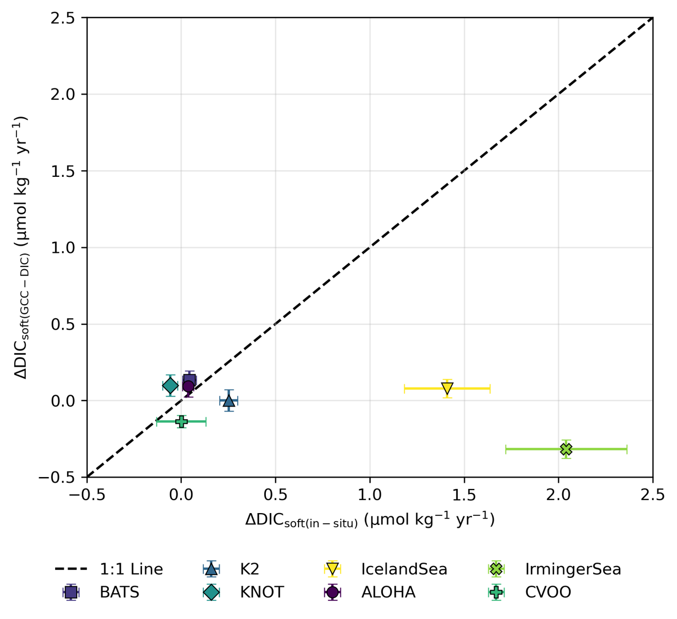
Figure S12. Comparison of in-situ time series and GCC-DIC depth-weighted changes in DIC_{soft}. Error bars represent propagated uncertainties: horizontal bars for in-situ observations and vertical bars for modeled GCC-DIC data. In some cases, the in situ time series show larger uncertainties than the reconstruction, particularly in the Irminger and Iceland Seas. This likely reflects the limited number of observations and shorter time coverage at these sites, which reduce the statistical robustness of the trend estimates compared to the gridded and temporally complete GCC-DIC product.
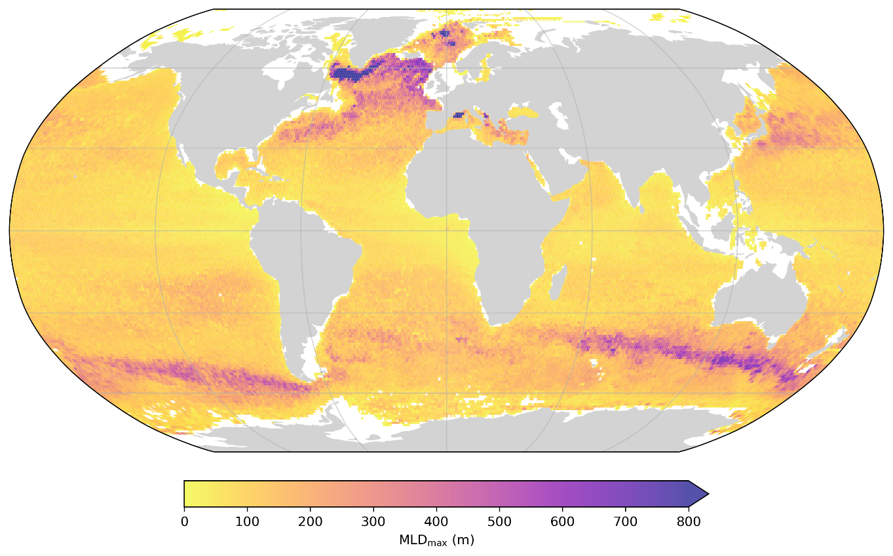

Figure S13. Spatial distribution of the maximum mixed layer depth (MLD) across the global ocean, based on the Argo mixed layer climatology developed by Holte et al. (2017). The MLD values represent the maximum monthly climatological depths determined using a hybrid density algorithm, applied to over 2.6 million Argo profiles collected between 2000 and 2021. The climatology used here is the most recent version, updated in April 2022. The maximum MLD is defined as the mean of the three deepest MLDs in each 1° × 1° grid cell. This climatology provides a physically consistent estimate of the deepest annual mixing, relevant for evaluating vertical exchange and potential carbon sequestration.
References

Lange, N., Fiedler, B., Álvarez, M., Benoit-Cattin, A., Benway, H., Buttigieg, P. L., Coppola, L., Currie, K., Flecha, S., Gerlach, D. S., Honda, M., Huertas, I. E., Lauvset, S. K., Muller-Karger, F., Körtzinger, A., O'Brien, K. M., Ólafsdóttir, S. R., Pacheco, F. C., Rueda-Roa, D., . . . Tanhua, T. (2024). Synthesis Product for Ocean Time Series (SPOTS) – a ship-based biogeochemical pilot. Earth Syst. Sci. Data, 16(4), 1901-1931. https://doi.org/10.5194/essd-16-1901-2024
Flanders Marine Institute (2021). Global Oceans and Seas, version 1. Available online at
https://www.marineregions.org/. https://doi.org/10.14284/542
Fröb, F., Olsen, A., Pérez, F. F., García-Ibáñez, M. I., Jeansson, E., Omar, A., & Lauvset, S. K. (2018). Inorganic carbon and water masses in the Irminger Sea since 1991. Biogeosciences, 15(1), 51-72. https://doi.org/10.5194/bg-15-51-2018
Henson, S. A., Beaulieu, C., & Lampitt, R. (2016). Observing climate change trends in ocean biogeochemistry: when and where. Global change biology, 22(4), 1561-1571.
Holte, J., Talley, L. D., Gilson, J., & Roemmich, D. (2017). An Argo mixed layer climatology and database. Geophysical Research Letters, 44(11), 5618-5626. https://doi.org/https://doi.org/10.1002/2017GL073426

