Spatial redistribution of a globally constant marine biological carbon pump
L. Delaigue^{1,2}, R. Sauzède³, O. Sulpis⁴, P. W. Boyd⁵, L. D. Talley⁶, G-J. Reichart^{1,7}, H. Claustre² and M. P. Humphreys¹
¹Department of Ocean Systems (OCS), NIOZ Royal Netherlands Institute for Sea Research, PO Box 59, 1790 AB Den Burg (Texel), the Netherlands
²Sorbonne Université, CNRS, Laboratoire d’Océanographie de Villefranche, Villefranche-Sur-Mer, France
³Sorbonne Université, CNRS, Institut de la Mer de Villefranche, Villefranche-Sur-Mer, France
⁴CEREGE, Aix Marseille Univ, CNRS, IRD, INRAE, Collège de France, Aix-en-Provence, France
⁵Institute for Marine and Antarctic Studies, University of Tasmania, Hobart, Tasmania, Australia
⁶Scripps Institution of Oceanography, University of California San Diego, La Jolla, CA, USA
⁷Department of Earth Sciences, Utrecht University, Utrecht, the Netherlands

Corresponding author: Louise Delaigue (louise.delaigue@imev-mer.fr)

Abstract (200 words max)
Marine dissolved inorganic carbon (DIC_{total}) is a key component of the global ocean carbon cycle. Over recent decades, DIC_{total} has increased due to rising anthropogenic CO₂, but the response from the biological carbon pump (BCP), which transfers carbon from the surface to the ocean interior, remains uncertain. Here, we reconstruct global three-dimensional DIC changes from 2004 to 2024 down to 2km and separate anthropogenic, biological, and carbonate contributions. We find that while DIC_{total} increased throughout the water column, driven primarily by anthropogenic CO₂, the global inventory of biologically respired carbon associated with the BCP remained statistically constant. This apparent stability masks pronounced regional and vertical redistribution of respired carbon within the ocean interior. In some regions, respired carbon accumulated at shallower depths, reducing its isolation from the atmosphere, whereas in others it was transported deeper, enhancing long-term storage. These contrasting patterns co-vary with changes in ocean stratification and ventilation, indicating that physical change may regulate where biologically respired carbon is retained. Although these redistributions had little net effect on the global carbon inventory over the study period, they reveal a structural reorganization of the BCP that may influence the ocean’s capacity to sequester carbon under continued climate change.

Introduction (1160 words)
The ocean is a major CO₂ reservoir and sink. It holds ~37,000 GtC of dissolved inorganic carbon (DIC)—40 times more than the atmosphere (Friedlingstein et al., 2025). Anthropogenic CO₂ emissions, projected to increase by ~50% by 2050 relative to present levels (IPCC, 2023), drove the accumulation of dissolved inorganic carbon (DIC) in seawater at a rate of ~3.2 ± 0.7 GtC per year from 2004 to 2019 (Keppler et al., 2023).

A major pathway for the long-term isolation of biologically fixed carbon in the ocean is the biological carbon pump (BCP), which transfers carbon from the surface to the ocean interior through the production, export, and remineralization of organic matter (Volk & Hoffert, 1985; Boyd et al., 2019; Frenger et al., 2024). The BCP is composed of two pumps which have opposite effects on marine CO₂ uptake from the atmosphere. The soft-tissue pump removes dissolved inorganic carbon (DIC) from the surface mixed layer through photosynthetic carbon fixation by marine phytoplankton and the export of organic carbon, both particulate (POC) and dissolved (DOC). Exported organic matter is remineralized at depth through heterotrophic respiration, returning carbon to the dissolved inorganic carbon pool as biologically regenerated DIC (DIC_{soft}; Volk & Hoffert, 1985). The respired DIC_{soft} that accumulates below the winter mixed layer constitutes the biologically sequestered carbon relevant to long-term climate regulation. The residence time of respired DIC_{soft} governs the BCP’s impact on climate, as deeper remineralization generally leads to longer isolation from the atmosphere (Kwon et al., 2009; Riebesell et al., 2009; Hain et al., 2014; Schlunegger et al., 2019; Frenger et al., 2024).

In parallel to the soft-tissue pump, the carbonate counter-pump is coupled to organic matter export through the production, sinking, and dissolution of calcium carbonate. The carbonate counter-pump influences DIC through calcium carbonate formation in surface waters, which emits CO₂ by reducing alkalinity (Volk & Hoffert, 1985). As calcium carbonate particles sink and dissolve at depth, they release DIC_{carb} and alkalinity, which increases the buffering capacity of seawater and offsets surface CO₂ release (Feely et al., 2004; Sulpis et al., 2021). The carbonate counter-pump therefore opposes the soft tissue pump in its effect on marine CO₂ uptake from the atmosphere (Riebesell et al., 2009). Through the combined action of organic carbon export, remineralization, and carbonate cycling, the BCP reduces atmospheric CO₂ by at least 163 ppm relative to a world without it (Tjiputra et al., 2025). The efficiency of long-term carbon sequestration by the BCP depends mainly on the fraction of exported carbon that is remineralized at depth and retained as DIC_{soft}. This varies by region and is influenced by ecosystem structure and functioning (driven by nutrients, temperature, light, and ocean stratification; Falkowski et al., 2000; Boyd & Trull, 2007), as well as by remineralization depth and water residence time in the ocean interior, which together control carbon isolation timescales (Ricour et al., 2023).

Despite improved estimates of marine anthropogenic CO₂ uptake, uncertainties remain in its spatiotemporal variability and in the response of other DIC sources and sinks to ongoing anthropogenic climate change (Gruber et al., 2023; Keppler et al., 2023). In particular, the response of the biological carbon pump (BCP) to contemporary climate forcing is still poorly constrained and has been identified as a key research priority for improving confidence in major Earth system processes assessed by the Intergovernmental Panel on Climate Change (IPCC; Pillar et al., 2024).

Climate-driven changes in stratification, remineralization, particle dynamics, and ecosystem structure can either amplify or dampen biological carbon export and its transfer to depth, with regionally divergent outcomes (Henson et al., 2022), with implications for the sequestration of respired DIC_{soft}. Although the BCP represents a major climate-regulating service, valued at over US$900 billion per year (Berzaghi et al., 2025), observational indicators remain ambiguous: satellite records suggest recent increases in phytoplankton biomass, yet trends are uncertain and spatially heterogeneous (Zhao et al., 2025). At the same time, Earth system models diverge strongly in their projections of future POC export, particularly at deeper, climate-relevant depths (Wilson et al., 2022).
The global inventory of DIC_{soft} has been considered relatively constant over recent decades compared to DIC_{anth} (Fig. 1; Gruber et al., 2023). However, studies suggest that since the late 20th century, POC export and the efficiency of DIC_{soft} sequestration have varied regionally, driven by shifts in circulation, nutrient supply, and plankton community structure (Humphreys et al., 2016; Fröb et al., 2018; Keppler et al., 2023; Delaigue et al., 2024). Recent reconstructions show increasing total DIC primarily driven by anthropogenic CO₂ accumulation, while the residual signal suggests substantial internal redistributions of natural DIC (C_{nat}), from the mid-latitudes to the tropics and from the surface to below ~200 m, without a detectable net global gain or loss in C_{nat} over the study period (Keppler et al., 2023). Climate-driven changes in circulation, nutrient supply, and plankton community composition may have led to regionally contrasting patterns in organic carbon export and in the sequestration of remineralized DIC_{soft} at depth, shifting the geographic pattern of DIC_{soft} storage hotspots (Ciais et al., 2014; Henley et al., 2020; Lønborg et al., 2020; Bonino et al., 2021; Chaabane et al., 2024). This suggests that while no statistically detectable change in long-term global BCP-driven carbon sequestration emerges over the study period, compensating changes in productivity, remineralization, and circulation are reshaping its regional expression and the depth and residence time of respired carbon storage.

Until now, it has been unclear whether this spatial reorganization of sequestered DIC_{soft} over the last two decades reflects changes in carbon retention at depth, or redistribution driven by circulation. This has remained unsolved due to observational gaps in space and time. This uncertainty limits the ability to separate variability in DIC_{soft} sequestration from global trends and to evaluate the impact of the BCP on long-term marine carbon sequestration. One way to address this is by deriving DIC_{soft} (i.e., the respired component of the soft-tissue pump that is retained below the winter mixed layer) directly from dissolved oxygen using Redfield stoichiometry, leveraging the global, high-resolution coverage of dissolved oxygen data from ship campaigns and BioGeoChemical-Argo (BGC-Argo) to enable spatiotemporally resolved assessments of biological carbon storage and emerging sequestration patterns (Redfield, 1958; Redfield, 1963; Anderson & Sarmiento, 1994).

In this study, we estimated 3D fields of DIC across space, time, and depth by applying the CANYON-B and CONTENT algorithms (Sauzède et al., 2017; Bittig et al., 2018) to the GOBAI-O₂ v2.3 product (Sharp et al., 2023). These algorithms infer carbonate system properties, including DIC, from dissolved oxygen and hydrographic tracers using empirical relationships trained on observations from the Global Ocean Data Analysis Project (GLODAP; Olsen et al., 2020). The resulting dataset, referred to as GCC-DIC (GOBAI-O₂ CANYON-B CONTENT-DIC), provides monthly DIC values on a 1° × 1° grid from 2004 to 2024, spanning 58 depth levels spanning the upper 2 km of the water column, with higher resolution nearer the surface. We used this dataset to compute rates of total DIC change (ΔDIC_{total}), which we decomposed into its anthropogenic (ΔDIC_{anth}), biologically respired (ΔDIC_{soft}), and carbonate pump (ΔDIC_{carb}) components (see Methods). To quantify BCP-driven DIC_{soft} sequestration, we calculated the accumulation and redistribution of DIC_{soft} below the winter maximum mixed layer depth (MLD) and integrated this down to 1975 m. For validation, we applied the same decomposition approach to a compilation of independent observational time series of carbonate chemistry from Lange et al., 2024. Additionally, we determined the depth at which 50% of the DIC_{soft} inventory was stored and assessed whether it deepened or shoaled over the study period, indicating changes in the depth and isolation timescale of respired DIC_{soft}, which are relevant for centennial-scale air–sea carbon exchange. Finally, we interpret the diagnosed redistribution of DIC_{soft} in the context of changes in upper-ocean stratification and interior ventilation pathways, linking biological carbon storage to evolving physical connectivity between the surface and the ocean interior.

Global change in marine DIC (325 words)
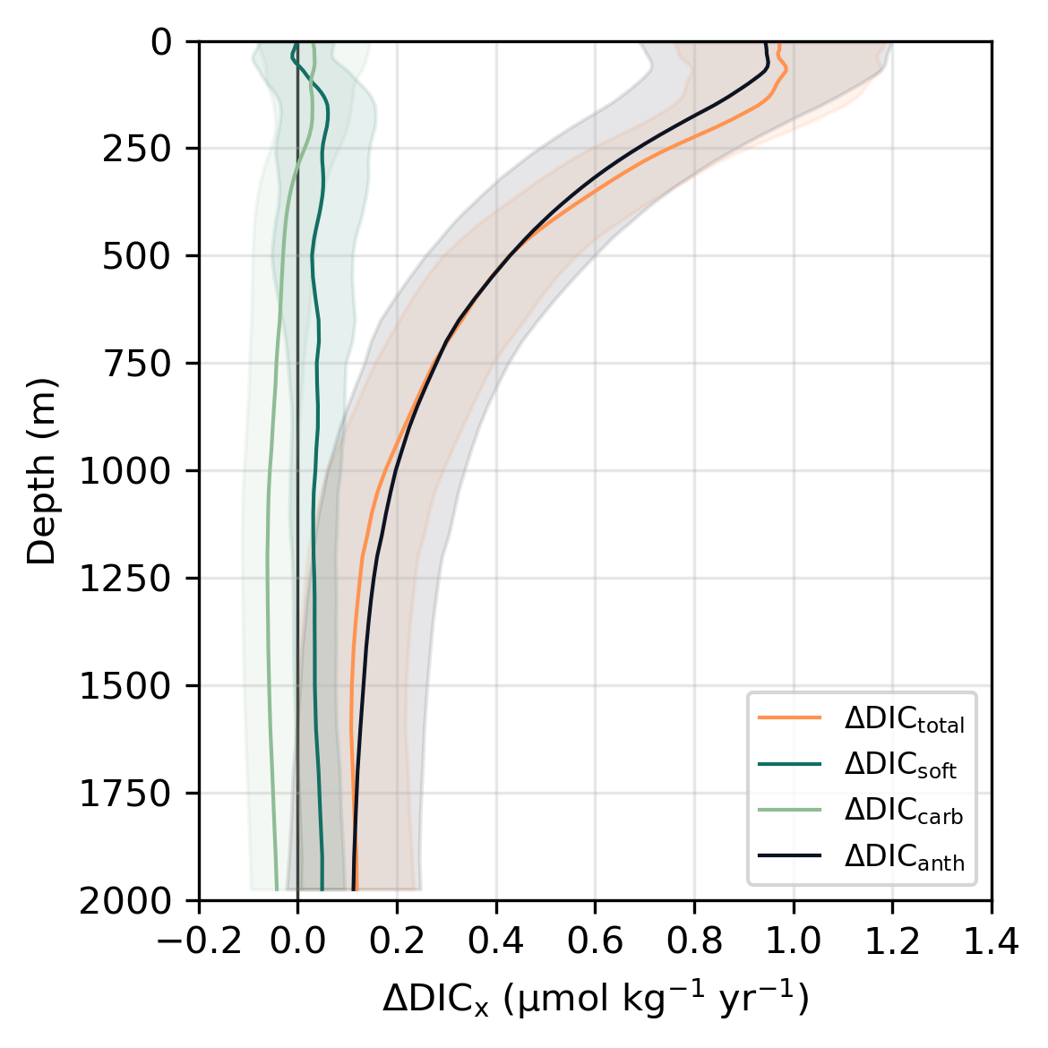
Figure 1. Global mean rates of change in each DIC component as a function of depth (m) within the upper 1975 m for the GCC-DIC dataset. Components include total DIC (DIC_{total}; orange), soft-tissue pump DIC (DIC_{soft}; green), carbonate pump DIC (DIC_{carb}; light green), and anthropogenic DIC (DIC_{anth}; black). Shaded areas indicate ±1σ uncertainty.

From 2004 to 2024, global mean ΔDIC_{total} derived from GCC-DIC in the upper 50 m was 1.0 ± 0.21 μmol kg⁻¹ yr⁻¹, consistent with previous studies (Sabine et al., 2004; Gruber et al., 2019). The rate of DIC_{total} increase attenuated with depth, reaching 0.1 ± 0.11 μmol kg⁻¹ yr⁻¹ near 2000 m (Fig. 1). Over 90% of the DIC_{total} increase in the upper 50 m during the study period (2004–2024) was attributable to ΔDIC_{anth}. This pattern reflects the dominance of anthropogenic CO₂ invasion over biological or carbonate pump processes on (multi-)decadal timescales, consistent with expectations under transient climate forcing (Keppler et al., 2023; Müller et al., 2023; Frenger et al., 2024).

The contribution of the BCP to ΔDIC_{total}, ΔDIC_{soft}, did not differ from zero within the uncertainty bounds and remained globally small, with a mean of 0.05 ± 0.08 μmol kg⁻¹ yr⁻¹ in the upper 50 m (Fig. 1). This negligible contribution is expected over the 2004–2024 period, as BCP-driven changes in global DIC inventories are constrained by circulation and residence-time scales that exceed the observational window, even though vertical redistribution ultimately underpins long-term ocean carbon uptake (Martin et al., 1987; Burd et al., 2010; Henson et al., 2011; Boyd et al., 2019). This observation is consistent with recent work emphasizing that the climatic relevance of the BCP arises not from changes in the global inventory of interior DIC, but from changes in its vertical distribution (Frenger et al., 2024). By storing remineralized ΔDIC_{soft} deeper in the water column, the BCP increases its isolation from the surface ocean and atmosphere without necessarily altering the total amount of interior DIC. As such, changes in the vertical distribution of DIC_{soft} may reflect evolving storage patterns rather than changes in its global inventory. Such redistribution matters because deeper storage of remineralized DIC_{soft} reduces its re-exposure to the surface ocean, thereby modulating surface DIC and pCO₂ and influencing air–sea CO₂ fluxes without altering the global DIC inventory.

ΔDIC_{carb} did not contribute significantly to global DIC change between 2004 and 2024, as it, like ΔDIC_{soft,} remained indistinguishable from zero at all depths, and is therefore excluded from further analysis.

Biological carbon pump redistribution (2115 words)

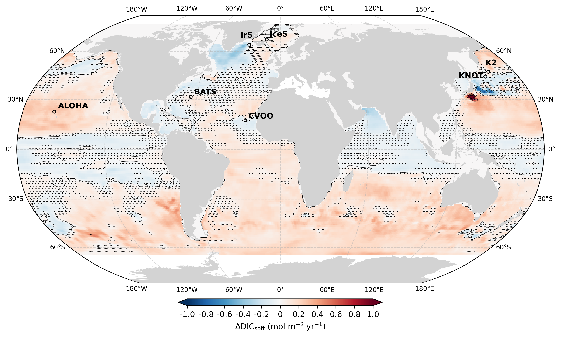

Figure 2. Spatial redistribution of biologically respired carbon. Depth-integrated (upper 2 km) rates of change in DIC_{soft}, corresponding to the vertical extent of the GCC-DIC product. Locations from the Synthesis Product for Ocean Time Series (SPOTS; Lange et al., 2024) are shown. Stippling indicates grid cells where fewer than 80% of Monte Carlo iterations (n = 1,000) yield a statistically significant trend with a consistent sign (α = 0.05). Contours are drawn every 0.5 mol m⁻² yr⁻¹.

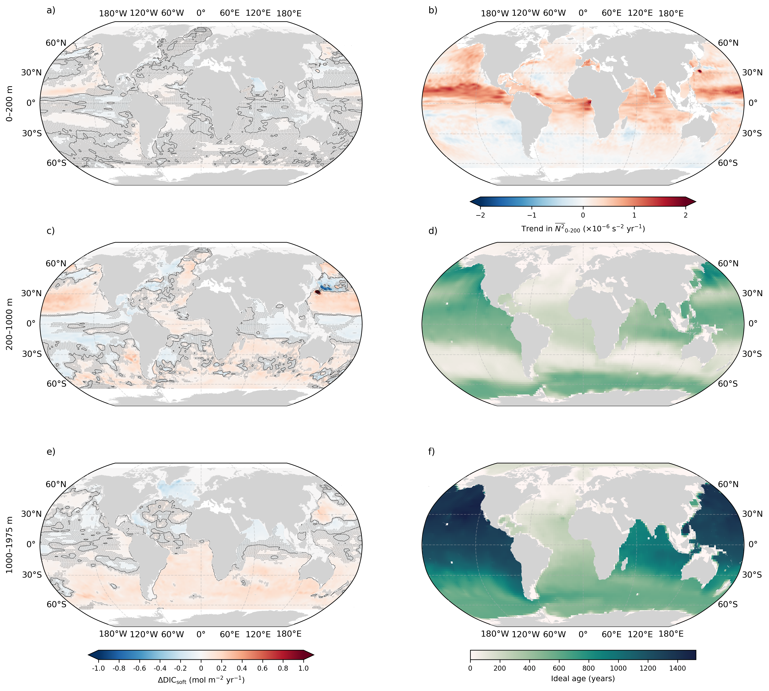
Figure 3. Physical controls on the redistribution of the biological carbon pump. Left column (a, c, e): band-integrated rates of change in biologically respired dissolved inorganic carbon (ΔDIC_{soft}; mol m⁻² yr⁻¹) over (a) 0–200 m, (c) 200–1000 m, and (e) 1000–1975 m. Stippling indicates grid cells where fewer than 80% of Monte Carlo realizations (n = 1000) yield a statistically significant trend of consistent sign (α = 0.05). Contour lines are drawn every 0.5 mol m⁻² yr⁻¹. Right column: (b) linear trend (2004–2024) in the thickness-weighted mean buoyancy frequency squared (N²₀₋₂₀₀; ×10⁻⁶ s⁻² yr⁻¹), computed over the upper 0–200 m from annual-mean hydrography, used as a proxy for upper-ocean stratification change; (d, f) climatological ideal age (years; Millet et al., 2024), shown as thickness-weighted means over (d) 200–1000 m and (f) 1000–2000 m, used as a proxy for interior ventilation timescales.

Despite no change in ΔDIC_{soft} globally (Fig. 1), significant regional shifts in DIC_{soft} storage can be observed (Fig. 2). This spatial variability reflects climate-driven shifts in physical, biogeochemical, and ecological processes that are reshaping the vertical structure and regional expression of BCP-driven carbon sequestration (Liniger et al., 2025; Zhao et al., 2025). Conceptually, this redistribution is consistent with a shoaling of the effective ventilation depth under increasing stratification, whereby ventilation and mode-water formation increasingly occupy a thinner upper layer, leaving deeper portions of the thermocline more isolated from renewal (Fig. 3d,f; Capotondi et al., 2012; Yamaguchi & Suga, 2019; Li et al., 2020; Cheng et al., 2025). Such changes can promote subsurface accumulation of DIC_{soft} without requiring an increase in biological export, highlighting physical connectivity and residence time as primary controls on long-term sequestration (Waugh et al., 2004; Khatiwala et al., 2012; Talley, 2013).

When integrated over the upper 2 km, the accumulation of remineralized DIC_{soft} has decreased across the equatorial Atlantic and parts of Indian Ocean, as well as the northern subtropical South Pacific (Fig. 2). This trend is consistent with the effects of climate-driven ocean warming (Levitus et al., 2012; Cheng et al., 2017) and with increasing upper-ocean stratification (Fig. 3b), a robust feature of ocean warming over recent decades (Li et al., 2020; Cheng et al., 2025), which reduces nutrient supply to the euphotic zone, and ultimately limits net primary production (Boyce et al., 2010; Laufkötter et al., 2016; Boyd et al., 2019; Zhao et al., 2025). In the upper ocean, however, increased stratification may both reduce vertical nutrient fluxes from below and retain nutrients within a thinner, better-lit surface layer, such that changes in productivity and export reflect a redistribution of nutrient residence time rather than a simple reduction in supply. The observed decline in depth-integrated DIC_{soft} is consistent with previously documented reduced particle export and shoaling of remineralization under enhanced stratification, reflected in weak or negative ΔDIC_{soft} trends in the upper mesopelagic layer (Fig. 3a) and the 200-1000m layer (Fig. 3c) and relatively efficient ventilation at intermediate depths (Fig. 3d), processes documented in subtropical gyres under recent climate change (Fig. 2; Waugh et al., 2004; DeVries & Primeau, 2011; Khatiwala et al., 2012). In addition, these changes are in line with the expected shoaling of POC remineralization, associated with enhanced upper-ocean stratification that favors slower-sinking particles, higher microbial respiration rates in warmer surface layers, and reduced transfer into weakly ventilated depths, reflected in a tendency toward reduced DIC_{soft} accumulation in the upper intermediate layer (Fig. 3a,c; Nowicki et al., 2022) and conceptually consistent with the sequestration depth framework of Ricour et al., 2023, though the signal at depth (1000–1975 m) remains weak and spatially heterogeneous (Fig. 3e), precluding firm conclusions about changes in long-term carbon storage in these regions. In the subpolar North Atlantic, including the Labrador Sea, reduced DIC_{soft} accumulation occurs despite recent surface cooling, consistent with changes in ventilation and overturning rather than a simple thermally driven stratification response, as indicated by young ideal ages and efficient renewal at intermediate depths (Fig. 3d,f; Waugh et al., 2004; DeVries & Primeau, 2011; Talley, 2013; Yashayaev & Loder, 2016; Caesar et al., 2018).

Most of the ocean showed an increase in depth-integrated DIC_{soft} over the upper 2 km. Across most of the Southern Ocean, relatively stronger positive trends in depth-integrated DIC_{soft}, exceeding background open-ocean variability, occur in regions where reduced sea-ice extent and enhanced vertical mixing have promoted nutrient supply and larger phytoplankton blooms (Arteaga et al., 2019; Henley et al., 2020; Sallée et al., 2021; Liniger et al., 2025). In contrast to subtropical regions, these trends arise despite generally weak or spatially heterogeneous trends in upper-ocean stratification (Fig. 3b), suggesting that documented strengthening and poleward shifts of the Southern Ocean westerlies, rather than stratification-controlled nutrient limitation, dominate the physical control on export and the transfer of respired carbon into the ocean interior (Sallée et al., 2021; Grise & Polvani, 2014; Liniger et al., 2025). Once exported below the surface, the fate of this respired carbon is governed by ventilation pathways and residence times: the accumulation of DIC_{soft} in the 200–1000 m layer is visible in parts of the Southern Ocean, though partially affected by high uncertainty (Fig. 3c), while a weaker but coherent positive signal extends into the 1000–1975 m layer (Fig. 3e), indicating that wind-driven circulation, including enhanced Ekman divergence and subduction, sustains efficient transfer and interior storage of respired carbon on interannual to decadal timescales (Boyd & Trull, 2007; DeVries et al., 2012; Talley, 2013).

Together, these patterns indicate that redistribution of DIC_{soft} is controlled less by changes in export magnitude than by changes in the depth and efficiency of physical isolation from the surface ocean, consistent with evidence that weaker upper-ocean overturning enhances interior carbon retention (DeVries & Deutsch, 2014). As stratification increases, the depth reached by ventilated circulation and mode-water subduction shoals, leaving deeper portions of the thermocline increasingly isolated from renewal and favoring the accumulation of respired carbon beneath the ventilated layer (Fig. 2; Fig. 3f), where climatologically old ideal ages indicate slow ventilation timescales that favor long-term retention of respired carbon.

The vertical redistribution of DIC_{soft} is not solely governed indirectly by nutrient-driven changes in particle export and remineralization depth, but also directly by shifts in ecosystem structure. Warming, acidification, and nutrient limitation have been associated with observed shifts toward smaller phytoplankton and reduced diatom dominance, leading to slower-sinking particles and shallower remineralization depths (i.e., more DIC_{soft} in the upper mesopelagic; Behrenfeld et al., 2006; Polovina et al., 2008; Moràn et al., 2010; Boscolo-Galazzo et al., 2021). In some subtropical gyres, weak or near-neutral trends in depth-integrated DIC_{soft} coincide with enhanced upper-ocean stratification and moderate intermediate-depth ventilation (Fig. 3b,d), as reflected in documented ecosystem shifts toward reduced transfer efficiency of particle export under warming and stratification (Behrenfeld et al., 2006; Boyd & Trull, 2007; Henson et al., 2019). The western North Pacific is a notable exception, exhibiting strong spatial heterogeneity in depth-integrated DIC_{soft} trends, with juxtaposed positive and negative anomalies and high uncertainty across much of the region (Fig. 2), reflecting the complex and regionally varying interplay between stratification, ecosystem structure, and ventilation in this transition zone. Although stratification can increase DIC_{soft} accumulation at shallower depths, consistent with the sequestration depth framework of Ricour et al., 2023, it tends to reduce long-term carbon storage by shifting remineralization upward, thereby decreasing the fraction of respired carbon that reaches the deep ocean where isolation from the atmosphere occurs on centennial timescales (Kwon et al., 2009; DeVries et al., 2012). This pattern is consistent with the separation between shallow accumulation and older, weakly ventilated interior waters revealed by the depth-dependent DIC_{soft} redistribution and ideal age structure (Fig. 3a–f). These changes not only limit the transfer of respired carbon to long-lived interior reservoirs but may also shorten sequestration timescales by increasing the likelihood of re-exposure to the surface ocean.

In the subpolar western North Pacific, near K2 and KNOT, depth-integrated ΔDIC_{soft} trends are spatially heterogeneous and largely uncertain (Fig. 2), with localized negative anomalies embedded within a broader region of mixed or weakly positive signals. This pattern is consistent with a documented decadal decline in ²³⁴Th-derived POC export flux in this region, attributed to shifts in phytoplankton community structure rather than reduced biomass ( Kawakami, 2024), and with long-term DIC and AOU increases in intermediate waters at KNOT linked to changes in ventilation and organic matter decomposition (Wakita et al., 2005; Honda et al., 2017). These trends may also reflect changes in the formation and subduction of North Pacific Intermediate Water (Yasuda, 1997; Watanabe et al., 2011), whose ventilation pathways directly regulate the residence time of respired carbon in this transition zone.

In contrast, regions typically associated with high nutrient supply and POC export—such as equatorial upwelling zones and coastal upwelling systems adjacent to eastern boundary currents—show mixed signals in depth-integrated ΔDIC_{soft} (Fig. 2), indicating that strong biological production does not necessarily translate into long-term interior storage. While some areas, including parts of the eastern tropical Pacific, show neutral or weakly positive depth-integrated ΔDIC_{soft}, others—such as the eastern tropical Atlantic (including the Cape Verde region near CVOO) and parts of the equatorial Indian Ocean exhibit weakly negative or near-neutral trends, though with considerable spatial uncertainty, despite persistent upwelling (Fig. 2). At CVOO, both in situ and reconstructed DIC trends indicate limited accumulation of respired DIC_{soft} below the upper mesopelagic, consistent with shallow remineralization and efficient ventilation that restrict long-term carbon storage (Koseki et al., 2024; Figure S9 of the Supplementary Information). This behaviour reflects a decoupling between surface export and long-term sequestration, whereby organic matter is remineralized within well-ventilated layers rather than transferred into weakly ventilated interior reservoirs. Such decoupling is expected in regions characterized by strong overturning and shallow circulation cells, where short residence times and efficient ventilation limit the retention of respired carbon in the ocean interior (Fig. 3d,f). Under these conditions, enhanced surface export may coincide with shallower remineralization driven by warming and moderate deoxygenation, limiting the fraction of respired DIC_{soft} retained at depth despite sustained productivity (Marsay et al., 2015; Weber et al., 2016; Henson et al., 2019; Frenger et al., 2024). Circulation-driven redistribution further modulates the depth-integrated signal independently of local export, as rapid renewal along young, well-ventilated circulation pathways and efficient lateral transport limit the accumulation of respired carbon in the interior (Fig. 3; DeVries et al., 2012; Siegel et al., 2016).

In the tropical Indian Ocean, these effects may be amplified by strong surface warming and frequent marine heatwaves, which enhance stratification and metabolic rates while maintaining efficient ventilation through monsoon-driven circulation. Although some deoxygenation is observed—particularly in the Arabian Sea—it rarely reaches fully anoxic conditions, limiting the extent to which reduced oxygen slows remineralization or enhances deep transfer, in contrast to regions such as the North Pacific oxygen minimum zone (Cavan et al., 2017; Oschlies et al., 2018). As a result, high surface productivity in these regions does not necessarily translate into increased long-term storage of respired carbon, and in parts of the tropical Indian Ocean is consistent with reduced interior accumulation, noting that a comparison between the GOBAI-O₂ (Sharp et al., 2023) and ML₄O₂ oxygen (Ito et al., 2024) reconstructions reveals sign disagreement across much of the tropical Indian Ocean (Figs. S3 and S4), suggesting that the inferred DIC_{soft} trends in this region, which are based on GOBAI-O₂ alone, should be interpreted with particular caution.

The subpolar North Atlantic exhibits a broadly dipolar but spatially uncertain pattern in ΔDIC_{soft}, with weakly positive or mixed values along the western subpolar boundary and downstream of Arctic–Nordic Seas overflow pathways (e.g. the East Greenland Current), but negative values in active deep-water formation regions such as the Labrador and Irminger Seas (Fig. 2). This spatial structure aligns with contrasts in ventilation regime rather than surface stratification alone, and is consistent with changes in overturning strength and ventilation efficiency that regulate the retention of respired DIC_{soft} in the interior (Fig. 3c–f), though much of the signal at intermediate and deep layers remains uncertain in this region (Fig. 3c,e). Episodic deep convection and rapid renewal in formation regions limit interior accumulation, whereas downstream overflow pathways with longer residence times favor the storage of respired carbon (Yashayaev & Loder, 2016; Caesar et al., 2018). In surface layers, anthropogenic CO₂ uptake can partially mask biologically-driven changes in the DIC_{soft} signals in this region, particularly where air–sea CO₂ fluxes are large (Gruber et al., 2023; Asselot et al., 2024; Nowicki et al., 2024). This superposition does not reflect reduced robustness of the biological signal, but rather the coexistence of anthropogenic and biological contributions, which are explicitly separated in our analysis. Consequently, the observed ΔDIC_{soft} patterns represent net biological redistribution superimposed on a strong anthropogenic background, especially in high-latitude, high-ventilation regions (Gruber et al., 2019; Nowicki et al., 2024).

Overall, the spatial variability in ΔDIC_{soft} did not signal a globally uniform weakening or strengthening of the BCP, but rather a redistribution arising from regional changes in the vertical transport and storage of respired DIC_{soft} (Frenger et al., 2024). Interpreting these emerging signals also requires careful consideration of the methodological assumptions underlying DIC_{soft} reconstructions. Oxygen-based estimates of respired carbon are subject to additional uncertainties under a changing climate, including warming-driven declines in O₂ solubility, enhanced air–sea O₂ disequilibrium during high-latitude subduction, and climate- or ecosystem-driven variability in Redfield C:O₂ remineralization ratio (Körtzinger et al., 1999; Ito et al., 2004; Körtzinger et al., 2008; Bianchi et al., 2012; DeVries & Weber, 2017; Yang et al., 2017; Lauderdale & Cael, 2021). While these effects are generally considered second order for global DIC_{soft} inventories, they may be more consequential for the subtle vertical redistribution signals examined here. Incomplete oxygen equilibration in the North Atlantic and Southern Ocean, as well as non-Redfield remineralization and oxygen cycling within oxygen minimum zones, could alias into apparent shoaling or deepening of the diagnosed sequestration depth (Palter et al., 2010; Bianchi et al., 2012; DeVries & Deutsch, 2014). These effects should therefore be viewed as regionally specific sources of uncertainty when interpreting trends in DIC_{soft} storage geometry, even if they are unlikely to dominate the global mean signal. More direct constraints on these quantities should become possible as the BGC-Argo 5-sensor array expands, enabling broader pH-based reconstructions of DIC; in the meantime, our present oxygen- and Redfield-based estimates are evaluated against regional carbon time-series observations to assess reconstruction uncertainty and provide an independent benchmark for the diagnosed redistribution signals.

Against this backdrop, regional processes linked to climate-driven changes in stratification, nutrient pathways, and ecosystem dynamics appear to offset each other at the global scale, resulting in limited net change in globally integrated DIC_{soft} over the study period, consistent with previous observational and modeling studies of BCP variability (Kwon et al., 2009; DeVries et al., 2012; Laufkötter et al., 2016). However, this apparent compensation is resolved over a relatively short, decadal observational window and may not be stationary. Continued regional redistribution of respired carbon, particularly if accompanied by further shoaling of ventilation or expansion of low-oxygen conditions, could alter the depth and residence time of interior carbon storage. Whether such compensating patterns persist or break down under continued climate forcing remains an open question.

Dynamic sequestration horizon (1312 words)

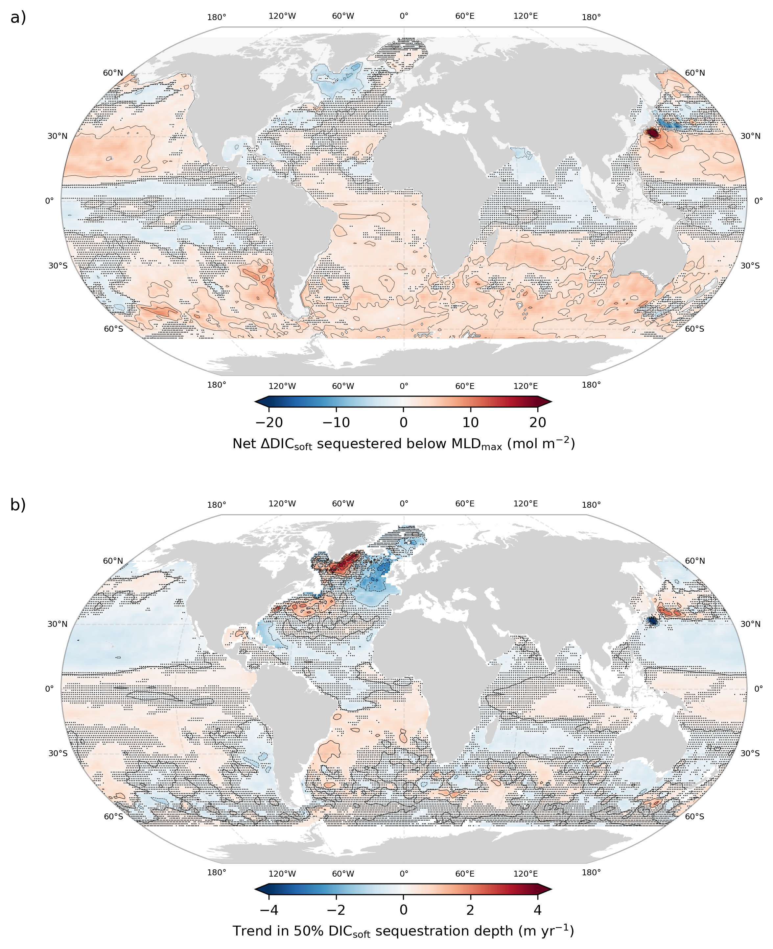

Figure 4. (a) Net accumulated ∆DIC_{soft} sequestered below the maximum climatological mixed layer depth (MLD_{max}) over 2004–2024 (mol m⁻²), derived from the GCC-DIC dataset. (b) Trend in the depth containing 50% of the DIC_{soft} inventory below MLD_{max} (m yr⁻¹) over 2004–2024. Stippling indicates grid cells where the trend is not robust across the ensemble, defined as fewer than 80% of Monte Carlo realizations yielding a statistically significant trend (p < 0.05) of the same sign. Thin black contours show isolines of the plotted fields.

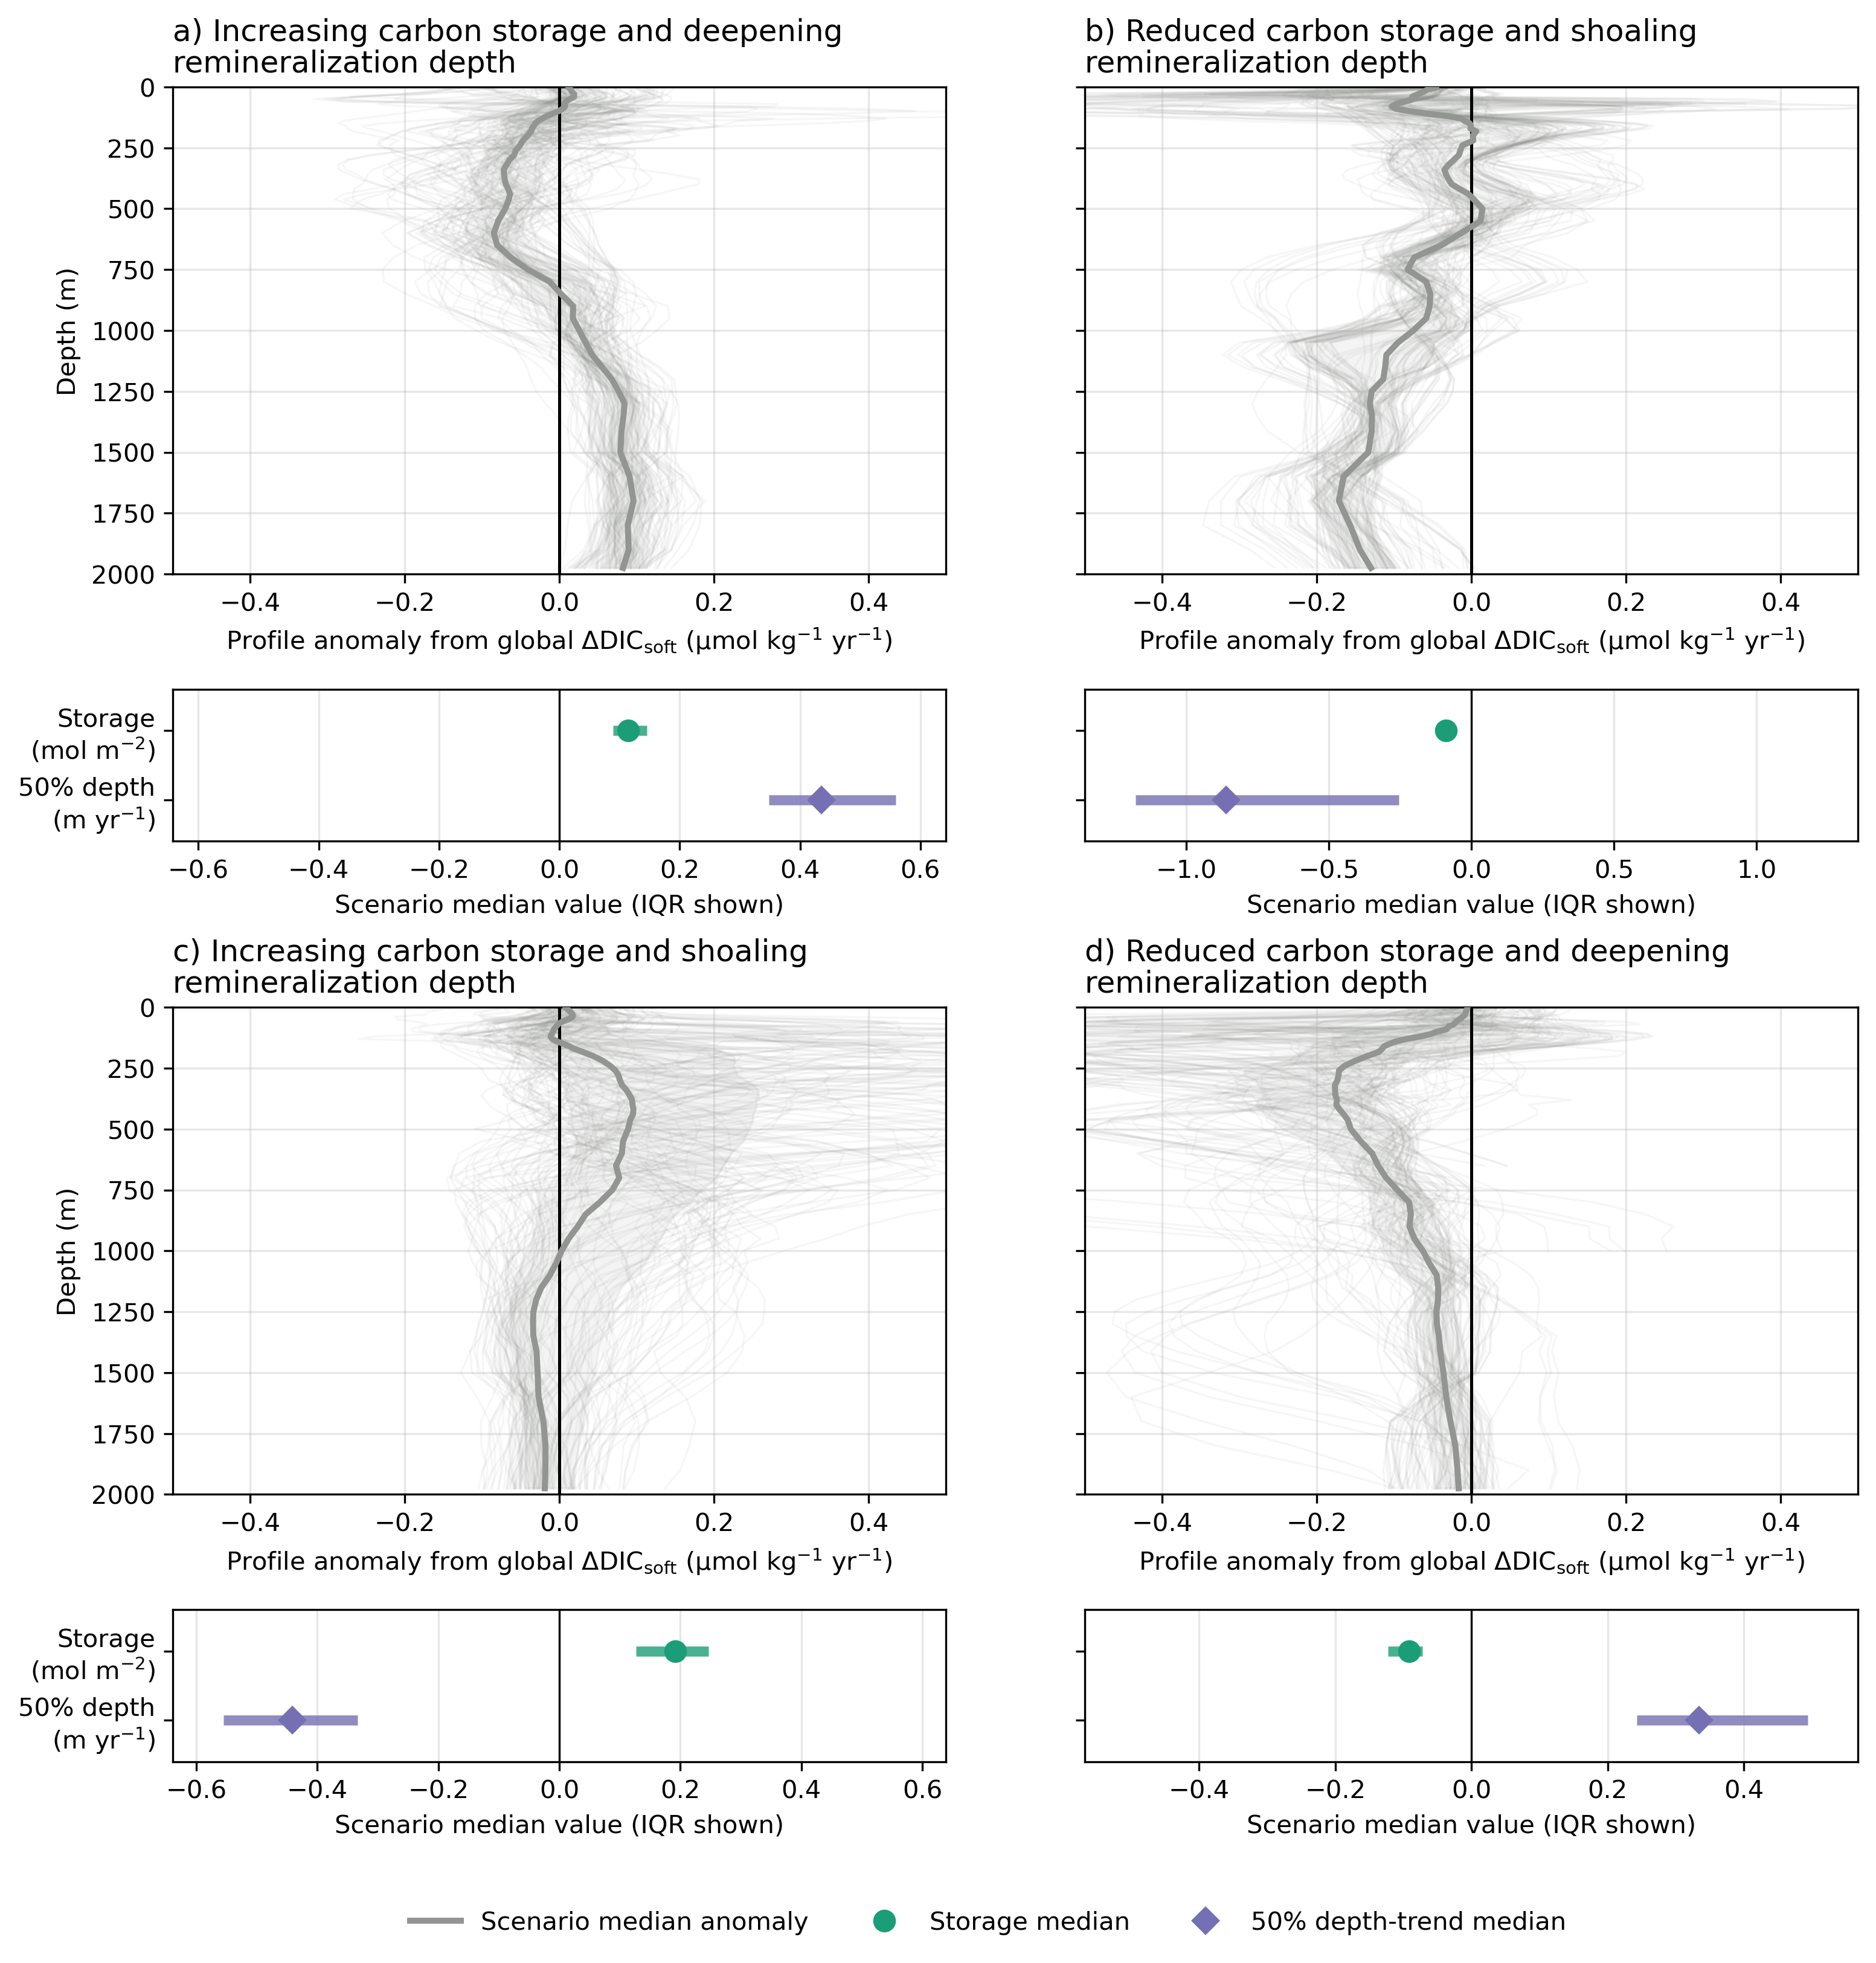 Figure 5. Anomalies in local ΔDIC_{soft} profiles relative to the global mean profile (Fig. 1) grouped into four scenarios: (a) increasing carbon storage and deepening remineralization; (b) reduced carbon storage and shoaling remineralization; (c) increasing carbon storage and shoaling remineralization; and (d) reduced carbon storage and deepening remineralization. Thin grey lines show a random subset of 120 individual profiles, thick grey lines show the scenario median, and grey shading shows the interquartile range. Top panels include only grid cells where ≥80% of Monte Carlo iterations yield a significant vertically integrated DIC_{soft}​ change. Bottom panels show the median and interquartile range of carbon storage change (green; mol m⁻²; Fig. 4a) and the trend in 50% sequestration depth (purple; m yr⁻¹; Fig. 4b) for each scenario.

The redistribution patterns described in the previous section (Figs. 2 and 3) imply that the BCP is being reorganized primarily through changes in physical connectivity—upper-ocean stratification and the depth and efficiency of ventilation—rather than through a uniform change in export magnitude. This reorganization extends beyond surface POC fluxes, altering both the depth and the duration of respired DIC_{soft} retention in the ocean interior. Because the depth at which biologically respired carbon is stored governs its isolation time from the atmosphere, changes in vertical storage geometry are central to the BCP’s climate impact, with deeper sequestration associated with longer residence times (DeVries et al., 2012; Boyd et al., 2019; Ricour et al., 2023). Accordingly, changes in the inventory of DIC_{soft} stored below the climatological winter mixed layer (Fig. 4a) and in the depth of the 50% sequestration horizon (Fig. 4b), interpreted in the context of physical diagnostics (Fig. 3b, d, f), characterize how the vertical distribution of biologically respired carbon has evolved since 2004.

Simultaneous changes in DIC_{soft} inventory and sequestration depth reveal a reorganization of the BCP that involves both the magnitude and the vertical structure of carbon storage (Fig. 4 and 5; Fig. 3). Changes in storage and sequestration depth do not always co-vary: some regions gain carbon and store it deeper (Fig. 5a), others lose carbon while remineralization shoals (Fig. 5b), but many regions show opposing trends in magnitude and depth (Fig. 5c, d), pointing to distinct physical and biogeochemical pathways reshaping the BCP across the ocean. The spread within each scenario (Fig. 5) reflects the varying balance between storage change and sequestration depth trend across regions, though the median vertical structures resolve coherent patterns that distinguish the four modes of reorganization. Importantly, changes in sequestration depth diagnosed here reflect the net outcome of export, remineralization, and circulation acting together. A deepening signal does not uniquely imply faster sinking or enhanced export, nor does shoaling necessarily imply weakened biological production. Instead, variations in interior ventilation, subduction pathways, and mixing rates can shift the vertical distribution of respired DIC_{soft} without proportional changes in surface export (DeVries et al., 2012; Siegel et al., 2016; Ricour et al., 2023). Trends in sequestration depth therefore provide a diagnostic of changing carbon isolation timescales, rather than a direct measure of export efficiency alone.

Regions with increases in both, like in the Southern Ocean and parts of the subtropical South Atlantic, point to strengthened export of POC and deeper remineralization to DIC_{soft}, suggesting enhanced long-term sequestration potential (Fig. 5; Fig. 3c, e). Conversely, regions where both are negative, including parts of the equatorial Atlantic and selected mid-latitude regions, reflect shoaling of DIC_{soft} return pathways and possible decreases in the retention timescale and depth of storage of this respired carbon (Fig. 3c; DeVries et al., 2012; Ricour et al., 2023).

In several regions, however, changes in DIC_{soft} accumulation and sequestration depth are decoupled, revealing divergent trajectories in vertical carbon retention (Figs. 4 and 5c,d). Such decoupling is consistent with shifts in physical connectivity—through ventilation depth, residence time, and mixing—that alter where respired carbon is stored without proportional changes in export (Fig. 4). While the depth-integrated DIC_{soft} signal reflects realized long-term storage, changes in sequestration depth provide insight into future isolation timescales. Shoaling may reflect reduced isolation or enhanced upper-ocean remineralization under warming, without necessarily implying direct re-exposure to the surface mixed layer (Brewer & Peltzer, 2016), whereas deepening may signal enhanced isolation.

The emergence of these divergent patterns suggests that the vertical structure of sequestration is increasingly climate-sensitive, shaped by warming-driven stratification and its impact on ventilation and residence times (Li et al., 2020; Cheng et al., 2025). Even in the absence of a detectable change in the global depth-integrated DIC_{soft} inventory, these signals are consistent with an early structural adjustment of the BCP to climate forcing.

Interpreting the timing of this adjustment, however, requires consideration of the relatively short observational window. The 2004–2024 period encompasses strong internal climate variability, including multiple ENSO cycles, pronounced Southern Ocean variability, and the rapid global expansion of the Argo float network. As a result, some of the regional trends reported here may reflect phase-dependent reorganization associated with decadal variability, rather than monotonic, externally forced change (Deser et al., 2012; Frölicher et al., 2015; Rodgers et al., 2023). At the same time, evidence from multi-decadal observational syntheses indicates that fundamental biogeochemical properties, such as marine Redfield stoichiometry, have already shifted over the past half-century, demonstrating that basin-scale reorganization of biological carbon cycling can emerge on comparable timescales (Liu et al., 2025). While the spatial coherence of several signals and their physical consistency with expected climate responses support their relevance, continued observations will be required to robustly distinguish internally driven variability from longer-term forced trends in the biological carbon pump.

Sequestration of biologically derived carbon, including both particulate organic carbon and respired DIC_{soft}, occurs across a broad range of depths rather than being confined to the deep ocean below 2000 m (Bif et al., 2024). Beyond particulate export, the BCP also includes the accumulation of long-lived dissolved organic matter, which constitutes a substantial interior carbon reservoir in the ocean interior but is not explicitly addressed here (Hansell, 2013). More generally, regional circulation and remineralization patterns govern the depth at which biologically derived carbon is retained, making sequestration depth a key determinant of carbon residence time and climate relevance (Ricour et al., 2023). Variability in the depth of DIC_{soft} storage can therefore alter carbon retention timescales even in the absence of large changes in surface export. Such vertical decoupling between export, remineralization, and storage depth has the potential to reshape regional carbon retention and ultimately alter the depth and residence time of biologically respired carbon storage (Wilson et al., 2022; Ricour et al., 2023). Consistent with this sensitivity, Earth system models diverge strongly in their representation of transfer efficiency at depth, with CMIP6 projections of POC flux at 1000 m ranging from a 4% increase to a 55% decline by 2100, underscoring major uncertainties in how deep-ocean sequestration is parameterized (Walker & Palevsky, 2025).

Current Earth system models do not fully capture the climate-sensitive variability in carbon sequestration revealed here (Henson et al., 2022; Wilson et al., 2022). Although large-scale warming and stratification trends are generally well reproduced, their impacts on nutrient pathways, vertical carbon transport, and ecosystem-mediated export efficiency remain highly uncertain and model dependent (Laufkötter et al., 2016; Bindoff et al., 2019; Wilson et al., 2022). Earth system models indicate that the apparent global-scale compensation in biological carbon sequestration breaks down over the 21st century, leading to net changes in interior carbon storage (Wilson et al., 2022). However, the magnitude, timing, and mechanistic drivers of this breakdown vary widely across models and remain uncertain. In particular, processes central to our analysis—shifts in remineralization depth, changes in sequestration depth, and altered residence times of respired DIC_{soft}—are typically prescribed or weakly parameterized rather than dynamically resolved in most models (Kwon et al., 2009; DeVries et al., 2012; Ricour et al., 2023). As a result, models may reproduce surface export trends while misrepresenting where and for how long biologically derived carbon is stored in the ocean interior. Progress will require tighter observational constraints on vertical carbon redistribution, improved coupling between ecosystem structure and physical circulation, and model formulations in which sequestration depth and carbon residence time emerge dynamically in response to climate forcing. Additional stressors, including ocean acidification, are already modifying carbonate production and seawater buffering capacity, introducing further feedbacks that remain incompletely represented (Barrett et al., 2025). Failure to capture these coupled physical–biogeochemical mechanisms may bias projections of future ocean carbon uptake and its capacity to moderate anthropogenic emissions (Gruber et al., 2023; Koeve et al., 2024).

As model projections diverge on whether POC export will strengthen, weaken, or redistribute under climate change (Henson et al., 2022), the observed changes in the depth and distribution of DIC_{soft} provide a critical constraint on the BCP. The emergence of spatially coherent trends, both positive and negative, point to a reorganization of the BCP arising from a combination of natural variability, non-steady-state behavior, and externally forced change, and may precede a change in its carbon storage geometry and isolation timescales (Fig. 2; Fig. 5; Fig. 3; Gruber et al., 2023; Koeve et al., 2024). Even as a complete mechanistic understanding continues to develop, these depth-resolved signals offer early insight into how climate-driven changes in the upper ocean are reshaping interior ocean carbon storage, potentially foreshadowing future changes in the ocean’s role as a long-term carbon sink.

Methods

GOBAI-O₂ v2.3 database

GOBAI-O₂ v2.3 (Gridded Ocean Biogeochemistry from Artificial Intelligence – Oxygen; Sharp et al., 2023) is a gridded, observation-based product that provides monthly three-dimensional fields of dissolved oxygen on a 1° × 1° latitude–longitude grid from January 2004 to December 2024. The dataset spans 58 pressure levels from 2.5 to 1975 dbar and covers most of the open ocean. The original GOBAI-O₂ framework was developed by training machine-learning models on dissolved oxygen observations from discrete shipboard bottle measurements and BGC-Argo floats, applied to gridded temperature and salinity fields from the Roemmich & Gilson, 2009) Argo Climatology (RG09), with monthly fields constructed from long-term means and monthly anomalies. Relative to the published description, v2.3 introduces several methodological updates: float oxygen adjustments are based on a linear fit of the percent difference in oxygen saturation between Argo and bottle data, the mapped product is generated using feed-forward neural networks only, training domains are defined using Gaussian mixture model clusters in temperature–salinity–depth space rather than basin-based regions, and algorithm-based uncertainty is estimated from an ensemble of five model-simulation experiments. The expansion of the Argo and BGC-Argo observing system enables a temporally consistent, high-resolution reconstruction of interior oxygen fields over the modern period, providing a depth-resolved perspective on AOU and remineralized carbon changes that complements earlier multi-decadal syntheses based on sparse historical hydrography (e.g., Schmidtko et al., 2017). The large-scale patterns of deoxygenation (increasing AOU) documented over the past five decades Schmidtko et al., 2017) are broadly consistent with the regions of decreasing depth-integrated DIC_{soft} identified here, particularly across the tropical Pacific and Indian Oceans. Regional discrepancies — notably in the subpolar North Atlantic and parts of the Southern Ocean — are expected given the different time windows covered (multi-decadal vs. 2004–2024), the substantially improved spatial and temporal sampling from BGC-Argo floats in the modern observational period, and the decomposition of total DIC change into its anthropogenic and biological components performed here, which is not possible from ship-only hydrography.

For the original GOBAI-O₂ product described by Sharp et al., 2023), the total combined uncertainty averaged globally over space and time was 7.6 µmol kg⁻¹, increasing to 11.2 µmol kg⁻¹ at 150 dbar; this was comparable to the independently evaluated global RMSD of 8.8 µmol kg⁻¹ obtained by withholding data from algorithm training.

Robustness to oxygen product choice was evaluated against the independent ML₄O₂ reconstruction (Ito et al., 2024), which yields consistent basin-scale thickness-weighted mean O₂ trend patterns with GOBAI-O₂ over 2004–2020 and 0–1000 m (Text S1 and Figs. S3–S4 of the Supplementary Information). The global oxygen atlas of Roach and Bindoff (2023) was not used for this comparison because it is derived exclusively from ship-based hydrographic profiles in the World Ocean Database, without assimilation of BGC-Argo float data; a comparison between two Argo-informed machine-learning reconstructions (GOBAI-O₂ and ML₄O₂) is more meaningful here, as any disagreement between them reflects differences in algorithm design and predictor choice rather than fundamental differences in the spatio-temporal sampling of the underlying observations.

Reconstruction of DIC and TA time series from GOBAI-O₂ using CANYON-B and CONTENT algorithms
The CANYON-B (CArbonate system and Nutrients concentration from hYdrological properties and Oxygen using a Neural-network) and CONTENT (CONsisTency EstimatioN and amounT) algorithms were developed for estimating dissolved inorganic carbon (DIC), total alkalinity (TA), pH, and partial pressure of CO₂ (pCO₂), as well as nutrients (Key et al., 2015; Sauzède et al., 2017; Bittig et al., 2018). CANYON-B is a Bayesian neural network that estimates nutrients and carbonate system variables from oxygen concentration, temperature, and salinity, based on biogeochemical relationships identified in the GLODAPv2 bottle dataset (Olsen et al., 2016; Sauzède et al., 2017). In contrast, CONTENT refines and integrates the four carbonate system variables by combining observational constraints with carbonate chemistry equilibria, ensuring their internal consistency (Bittig et al., 2018). Both algorithms include uncertainty estimates. The CONTENT algorithm estimates the uncertainty of DIC with values ranging from 7.7 µmol kg⁻¹ at the 10th percentile to 11.8 µmol kg⁻¹ at the 90th percentile, with a median (50th percentile) uncertainty of 9.1 µmol kg⁻¹ (Bittig et al., 2018).

The GOBAI-O₂ dataset (i.e. T, S and O₂; v.2.3; see previous section) was integrated into the CANYON-B and CONTENT algorithms to derive key CO₂ system parameters. Among these, DIC and TA were estimated on a 1° × 1° grid from 2004 to 2024, covering 58 depth levels from 2.5 m to 1975 m (Figs. S1–S2 in Supplementary Information). Throughout this study, the term GCC-DIC (GOBAI-O₂ CANYON-B CONTENT-DIC) refers to DIC estimates derived from the application of the CANYON-B and CONTENT algorithms to the GOBAI-O₂ dataset (see Figs. S1–S2 in the Supplementary Information) and is used interchangeably with “reconstruction.”

Independent ocean CO₂ time series

To validate the changes observed in the GCC-DIC product, we analyzed independent ocean carbonate system time series data at selected ocean time series stations from the Synthesis Product for Ocean Time Series (SPOTS; Table S1, Fig. S7 in Supplementary Information) product (Lange et al., 2024).

Each time series was analyzed to identify either a positive or negative rate of change across their study period in DIC and its components, in relation to its position within the global analysis conducted using the synthetic product. The key objective was to evaluate whether the long-term trends reconstructed by GCC-DIC at selected sites are consistent with independent in situ observations. Results from the in-situ time series validating GCC-DIC are presented in Figures S9, S10 and S12, as well as Table S2 in the Supplementary Information.

The same analytical approach, detailed in the subsequent Methods sections, was applied to both the GCC-DIC product and the SPOTS in situ time series, unless stated otherwise.

Decomposition of DIC components

The changes in DIC within the ocean are primarily governed by three processes: the absorption of anthropogenic CO₂ from the atmosphere (DIC_{anth}), the action of the BCP responsible for natural carbon cycling (DIC_{soft}), and the carbonate pump, which is linked to the formation and dissolution of calcium carbonate (Volk & Hoffert, 1985; Gruber et al., 1996). These processes contribute to DIC as follows:
$${DIC}_{total}={DIC}_{anth}+{DIC}_{soft}+{DIC}_{carb}$$ | (1).

The uptake of anthropogenic CO₂ is often referred to as the solubility pump. Assuming no significant trends in the air-sea CO₂ disequilibrium over the long term, the anthropogenic (DIC_{anth}) is effectively equivalent to the solubility-derived DIC (DIC_{sol}), ignoring short-term and regional disequilibrium variations. The rationale for considering DIC_{diseq} = 0 is supported by the minimal impact of long-term disequilibrium trends on the global carbon uptake over the periods studied (Jones et al., 2014; Nowicki et al., 2024).

$${DIC}_{anth}=DIC_{sol}-DIC_{diseq}≈{DIC}_{sol}$$ | (2),

Biological activity fixes dissolved inorganic carbon into organic matter via photosynthesis, with the concomitant uptake of inorganic nutrients following Redfield stoichiometry (Redfield, 1958; Redfield, 1963; Volk & Hoffert, 1985). The subsequent export and remineralization of this organic matter constitute the soft tissue pump (Redfield, 1958; Redfield, 1963; Volk & Hoffert, 1985). This process drives the downward export of particulate organic carbon (POC) from the surface ocean, followed by its microbial remineralization via repsiration into DIC_{soft} at depth, and the subsequent redistribution of respired DIC_{soft} by ocean circulation (Dugdale & Goering, 1967; Boyd et al., 2019).

This transformation follows specific stoichiometric proportions, quantified by the Redfield ratio, which describes the relationship between the elemental composition of marine organic matter and the nutrients consumed (Redfield, 1958). These materials are transported to deeper waters by gravitational settling and biological transport, where they decompose back to inorganic forms, thereby consuming oxygen and increasing apparent oxygen utilization (AOU). AOU represents the difference between the oxygen concentration at saturation (the theoretical maximum in equilibrium with the atmosphere) and the actual oxygen concentration in seawater, with higher values indicating more oxygen consumption due to remineralization (Garcia & Gordon, 1992). The impact of remineralization on DIC, termed DIC_{soft}, can be quantified using the Redfield ratio as:

$${DIC}_{soft}=-R_{{C/O}_{2}}∙AOU$$ | (3).
In this study, we used the ratio from (Anderson & Sarmiento, 1994) as follows:

$$P:N:C:O_{2}$$  $$1:16:117:-170$$ | (4).

Thus, $R_{{C/O}_{2}}$can be assumed to be a constant value of -0.688 ± 0.092 (Anderson & Sarmiento, 1994).

The formation and dissolution of calcium carbonate, described as the carbonate pump, are associated with changes in total alkalinity (TA). The carbonate-related DIC_{carb} is affected by the ratio of nitrogen to oxygen during these processes, represented as:

$${DIC}_{carb}=0.5∙\left(TA-R_{{N/O}_{2}}∙AOU\right)$$ | (5),

where $R_{{N/O}_{2}}$ is -0.0941 ± 0.0081 (Anderson & Sarmiento, 1994), indicating how carbonate processes alter DIC by a two-fold increase in TA.

While the Redfield ratio is known to exhibit regional and temporal variability, its use as a constant here provides a first-order global estimate of biologically driven DIC changes, consistent with prior large-scale studies (Anderson & Sarmiento, 1994; Gruber et al., 1996). Similarly, the use of AOU as a proxy for remineralization-driven DIC changes offers a widely accepted and practical approach for estimating DIC_{soft} at large spatial scales. Nevertheless, AOU-based methods assume that surface waters are in equilibrium with the atmosphere at the time of subduction, which may not always hold true—particularly in regions such as the North Atlantic and Southern Ocean, where rapid subduction can preserve disequilibrium signals (Ito et al., 2004; Sulpis et al., 2023). While such deviations are unlikely to dominate global-scale estimates, they may introduce regional biases and should be considered when interpreting patterns of biological carbon cycling.

Rates of change in DIC components

To quantify changes in each component of DIC, we employed an ordinary least-squares linear regression on the gridded 4D product GCC-DIC. We first computed annual global mean vertical profiles by area-weighted averaging across all latitude and longitude grid points. Linear trends were then estimated at each depth level based on these yearly global averages (Fig. 1). Equivalent analyses were performed for individual ocean basins using area-weighted means within basin masks, with resulting basin-scale vertical trend profiles shown in Fig. S11 of the Supplementary Information. For simplicity, we use pressure and depth interchangeably, as the difference remains small (<~2%) down to 2k m and does not affect the interpretation of our results (Text S2 of the Supplementary Information; Saunders & Fofonoff, 1976; Wunsch & Webb, 1979).
Then, linear regression was applied to each grid cell's time series to compute annual rates of change (μmol kg⁻¹ yr⁻¹) for DIC and its components. To estimate depth-integrated changes, these trends were first converted to mol m⁻³ yr⁻¹ using in situ density. Each trend value was then scaled by the thickness of the layer it represents, defined as the distance between the midpoints of adjacent pressure levels, with the top and bottom edges of the water column extrapolated accordingly. The resulting values were summed across all levels to obtain the total change over the water column (mol m⁻² yr⁻¹), effectively representing a local DIC budget. To further resolve the vertical redistribution of DIC_soft, depth-integrated trends were also computed separately within three discrete pressure bands: 0–200 dbar, 200–1000 dbar, and 1000–1975 dbar. The methodology follows that described above for the full water column, with layer thickness computed from the pressure levels within each band only, ensuring that integration boundaries align exactly with the band limits.
Uncertainty was propagated using a 1000-iteration Monte Carlo framework. For the global mean vertical profiles (Fig. 1), each iteration simultaneously perturbed total DIC, total alkalinity and AOU using the gridded uncertainty field from CANYON-B, CONTENT and GOBAI-O₂ (Sauzède et al., 2017; Bittig et al., 2018; Sharp et al., 2023), all drawn from zero-mean normal distributions. This allows uncertainty to be propagated through the full decomposition into DIC_{soft}, DIC_{carb}, and DIC_{ant} components. For the per-pixel depth-integrated maps (Fig. 2), only AOU and the stoichiometric constants were perturbed, as those analyses are restricted to DIC_{soft}. For the full component decomposition (Fig. 1), both the soft-tissue pump stoichiometric ratio (117/−170; σ = 0.092) and the carbonate pump ratio (16/−170; σ = 0.0081) were independently sampled from normal distributions in each iteration (Anderson & Sarmiento, 1994). For analyses restricted to DIC_{soft} (Figs. 2–5), only the soft-tissue pump constant was applied. The ensemble mean was taken as the final estimate and the standard deviation across iterations as the uncertainty. Spatial patterns are considered robust where at least 80% of Monte Carlo iterations yield a statistically significant trend of the same sign (p < 0.05); grid cells that do not meet this criterion are stippled in the figures.
Independent ocean time series were not uniformly gridded like GCC-DIC, thus all variables were vertically interpolated along the pressure dimension using piecewise cubic Hermite interpolating polynomials (Fritsch & Carlson, 1980). Then, an ordinary least squares linear regression was applied to each pressure level to determine the rate of change in each variable over time along the water column (Fig. 5, Fig. S9 and S10 of the Supplementary Information).

Calculation of DIC_{soft} storage changes below the MLD

The mixed layer depth (MLD) was derived from an Argo-based climatology (Holte et al., 2017), which uses a combination of profile shape analysis, threshold, and gradient criteria to estimate MLD from individual Argo profiles collected between 2000 and 2022, on a 1° × 1° monthly grid. For each grid cell, we used MLD_{max}, defined as the average of the three deepest monthly MLDs within each bin, and took its annual maximum across all months to define a single conservative lower boundary of the surface mixed layer (Fig. 13 in the Supplementary Information).

DIC_{soft} concentrations at or below this maximum climatological MLD were isolated by masking all pressure levels shallower than the MLD. DIC_{soft} was initially expressed in µmol kg⁻¹ and converted to mol m⁻³ using in situ density. To integrate vertically, layer thickness was assigned to each pressure level as the distance between the midpoints of adjacent pressure centers, with the top and bottom edges of the water column extrapolated symmetrically from the outermost intervals. The depth-integrated DIC_{soft} inventory below the MLD (mol m⁻²) was then obtained by summing the product of concentration (mol m⁻³) and layer thickness across all sub-MLD pressure levels.

Temporal changes in this integrated inventory were assessed using the same Monte Carlo OLS regression framework as described above (1000 iterations, identical AOU and stoichiometric constant perturbation scheme). At each grid cell, the linear trend in the integrated sub-MLD DIC^{soft} time series (mol m⁻² yr⁻¹) was computed and multiplied by 20 years to yield the net accumulated change over the study period (mol m⁻²; Fig. 4). Grid cells where fewer than 80% of Monte Carlo iterations produced a statistically significant trend of consistent sign (p < 0.05) are stippled to indicate low robustness.

Change in 50% DIC_{soft} sequestration depth
To characterize temporal changes in the vertical distribution of biologically sequestered carbon, we computed the 50% DIC_{soft} sequestration depth at each grid cell and time step. DIC_{soft} was masked to the water column at or below the maximum climatological MLD (as defined above), converted to mol m⁻³ using in situ density, and multiplied by layer thickness (computed from midpoints between adjacent pressure centers, with extrapolated top and bottom edges) to obtain a per-layer DIC_{soft} content in mol m⁻². The cumulative sum of this layer content was computed along the pressure axis, and the depth at which this cumulative sum reached 50% of the total sub-MLD integrated DIC_{soft} was determined by linear interpolation between adjacent pressure levels. This yields, at each grid cell and time step, the pressure horizon above which half of the sub-MLD DIC_{soft} inventory resides — a depth-distribution metric sensitive to vertical redistribution independent of total inventory changes.
The resulting time series of 50% sequestration depth at each grid cell was regressed against time using OLS linear regression, yielding a trend in units of dbar yr⁻¹. This regression was embedded within the same 1000-iteration Monte Carlo framework described above, with identical perturbation of AOU and stoichiometric constants. Grid cells are considered robust only where both conditions are simultaneously satisfied: at least 80% of Monte Carlo iterations yield a statistically significant trend of consistent sign (p < 0.05), and the corresponding net depth change over the study period is itself statistically significant. Grid cells failing either condition are stippled in the corresponding figure.

For the analysis at individual SPOTS time-series stations, the 50% sequestration depth time series was additionally smoothed using locally weighted scatterplot smoothing (LOESS; smoothing fraction = 0.5; Cleveland, 1979; Cleveland & Devlin, 1988) prior to OLS regression, to reduce high-frequency variability. Differences in sequestration depth between the first (Q1) and last (Q4) quartiles of the observation period at each station were assessed using a two-sample Welch's t-test (p < 0.05).

Vertical profile classification and quadrant scenarios

Grid cells were classified into one of four scenarios by combining the sign of two diagnostics: the net DIC_{soft} storage change below MLD_{max} (mol⁻² m; Fig. 4a) and the linear trend in the 50% DIC_{soft} sequestration depth (m yr⁻¹; Fig. 4b). Grid cells where fewer than 80% of Monte Carlo iterations yielded a significant signal for either diagnostic were excluded. The remaining grid cells were assigned to one of four scenarios according to the sign combination of the two diagnostics: (1) increased storage and deepening sequestration depth; (2) decreased storage and shoaling sequestration depth; (3) increased storage and shoaling sequestration depth; (4) decreased storage and deepening sequestration depth (Fig. 5).

To characterize the vertical structure of DIC_{soft} change within each scenario, we computed OLS trend profiles (μmol kg⁻¹ yr⁻¹) at each grid cell and pressure level using the full 2004–2024 time series. Anomaly profiles were then obtained by subtracting the global area-weighted mean trend profile, isolating the deviation of each grid cell from the global-mean vertical signal. For each scenario, anomaly profiles were retained only at grid cells where the depth-integrated DIC^{soft} trend was robust, defined as ≥80% of Monte Carlo iterations yielding a significant vertically integrated change.

Change in stratification and ventilation pathways

Band-integrated DIC_soft trends over 0–200 dbar, 200–1000 dbar, and 1000–1975 dbar (computed as described above) were compared against two complementary physical proxies to assess the role of circulation changes in driving the observed carbon redistribution.

Stratification was quantified using the buoyancy frequency squared (N²), computed from the GOBAI-O₂ gridded temperature and salinity fields. For each monthly profile, practical salinity and in situ temperature were converted to Absolute Salinity and Conservative Temperature following TEOS-10 (GSW), and N² was evaluated at midpoint pressures between adjacent levels. A thickness-weighted mean was then computed over 0–200 dbar (N²₀₋₂₀₀), weighting midpoint N² values by the corresponding pressure layer thickness. Linear trends over 2004–2024 were estimated at each grid cell by ordinary least squares regression on annual means.

Ventilation state was assessed using the climatological ideal age from the Ocean Circulation Inverse Model (OCIM; Millet et al., 2024; Millet et al., 2025), which represents the time elapsed since a water parcel last contacted the surface. Thickness-weighted mean ideal age was computed within two depth bands — 200–1000 m and 1000–2000 m — by weighting ideal age by the vertical thickness between adjacent depth levels and normalizing by the total band thickness. OCIM ideal age is retained on its native model grid and is used for qualitative comparison only.

Data availability
All data and analysis scripts can be accessed at https://doi.org/10.5281/zenodo.15790561. The repository includes the raw data and scripts used to generate the results presented in the manuscript to ensure full reproducibility of results.

Author contributions
HC, LD, MPH, OS, and RS conceptualized the project. LD curated the data. GJR, HC, LD, LT, MPH, OS, PWB, and RS performed the investigation. LD conceptualized the methodology, used the necessary software, visualized the data, and prepared the original draft of the paper. GJR, HC, LD, LDT, MPH, OS, PWB, and RS reviewed and edited the paper.

Competing interests
The contact author has declared that neither they nor their co-authors have any competing interests.

Acknowledgements
We thank Jon Sharp for developing the GOBAI-O₂ dataset, which was central to this study. In addition to Jon, we are also grateful to Andrea Fassbender and Stevie Walker for their valuable insights and feedback during the late stages of this work. Special thanks to Marine Fourrier for her assistance with the MATLAB implementation of the CANYON-B and CONTENT algorithms on the GOBAI-O₂ dataset.

References
Anderson, L. A., & Sarmiento, J. L. (1994). Redfield ratios of remineralization determined by nutrient data analysis. Global Biogeochemical Cycles, 8(1), 65-80. https://doi.org/10.1029/93gb03318
Arteaga, L. A., Pahlow, M., Bushinsky, S. M., & Sarmiento, J. L. (2019). Nutrient controls on export production in the Southern Ocean. Global Biogeochemical Cycles, 33(8), 942-956. https://doi.org/https://doi.org/10.1029/2019GB006236
Asselot, R., Carracedo, L. I., Thierry, V., Mercier, H., Bajon, R., & Pérez, F. F. (2024). Anthropogenic carbon pathways towards the North Atlantic interior revealed by Argo-O2, neural networks and back-calculations. Nature Communications, 15(1), 1630. https://doi.org/10.1038/s41467-024-46074-5
Barrett, R. C., Carter, B. R., Fassbender, A. J., Tilbrook, B., Woosley, R. J., Azetsu-Scott, K., Feely, R. A., Goyet, C., Ishii, M., Murata, A., & Pérez, F. F. (2025). Biological Responses to Ocean Acidification Are Changing the Global Ocean Carbon Cycle. Global Biogeochemical Cycles, 39(3), e2024GB008358. https://doi.org/https://doi.org/10.1029/2024GB008358
Behrenfeld, M. J., O’Malley, R. T., Siegel, D. A., McClain, C. R., Sarmiento, J. L., Feldman, G. C., Milligan, A. J., Falkowski, P. G., Letelier, R. M., & Boss, E. S. (2006). Climate-driven trends in contemporary ocean productivity. Nature, 444(7120), 752-755. https://doi.org/10.1038/nature05317
Berzaghi, F., Pinti, J., Aumont, O., Maury, O., Cosimano, T., & Wisz, M. S. (2025). Global distribution, quantification and valuation of the biological carbon pump. Nature Climate Change, 15(4), 385-392. https://doi.org/10.1038/s41558-025-02295-0
Bianchi, D., Dunne, J. P., Sarmiento, J. L., & Galbraith, E. D. (2012). Data‐based estimates of suboxia, denitrification, and N2O production in the ocean and their sensitivities to dissolved O2. Global Biogeochemical Cycles, 26(2). https://doi.org/https://doi.org/10.1029/2011GB004209
Bif, M. B., Long, J. S., & Johnson, K. S. (2024). Seasonality modulates particulate organic carbon dynamics in mid-latitudes of South Pacific and South Atlantic Oceans. Journal of Marine Systems, 241, 103916. https://doi.org/https://doi.org/10.1016/j.jmarsys.2023.103916
Bindoff, N., Cheung, W. W., Kairo, J., Arstegui, J., Guinder, V., Hallberg, R., Hilmi, N., Jiao, N., Karim, M., & Levin, L. (2019). Changing ocean, marine ecosystems, and dependent communities. In IPCC special report on the ocean and cryosphere in a changing climate.
Bittig, H. C., Steinhoff, T., Claustre, H., Fiedler, B., Williams, N. L., Sauzède, R., Körtzinger, A., & Gattuso, J.-P. (2018). An alternative to static climatologies: Robust estimation of open ocean CO2 variables and nutrient concentrations from T, S, and O2 data using Bayesian neural networks. Frontiers in Marine Science, 5, 328. https://doi.org/https://doi.org/10.3389/fmars.2018.00328
Bonino, G., Lovecchio, E., Gruber, N., Münnich, M., Masina, S., & Iovino, D. (2021). Drivers and impact of the seasonal variability of the organic carbon offshore transport in the Canary upwelling system. Biogeosciences, 18(8), 2429-2448. https://doi.org/10.5194/bg-18-2429-2021
Boscolo-Galazzo, F., Crichton, K. A., Ridgwell, A., Mawbey, E. M., Wade, B. S., & Pearson, P. N. (2021). Temperature controls carbon cycling and biological evolution in the ocean twilight zone. Science, 371(6534), 1148-1152. https://doi.org/10.1126/science.abb6643
Boyce, D. G., Lewis, M. R., & Worm, B. (2010). Global phytoplankton decline over the past century. Nature, 466(7306), 591-596. https://doi.org/10.1038/nature09268
Boyd, P. W., Claustre, H., Levy, M., Siegel, D. A., & Weber, T. (2019). Multi-faceted particle pumps drive carbon sequestration in the ocean. Nature, 568(7752), 327-335.
Boyd, P. W., & Trull, T. W. (2007). Understanding the export of biogenic particles in oceanic waters: Is there consensus? Progress in Oceanography, 72(4), 276-312. https://doi.org/https://doi.org/10.1016/j.pocean.2006.10.007
Brewer, P. G., & Peltzer, E. T. (2016). Ocean chemistry, ocean warming, and emerging hypoxia: Commentary. Journal of Geophysical Research: Oceans, 121(5), 3659-3667.
Burd, A. B., Hansell, D. A., Steinberg, D. K., Anderson, T. R., Arístegui, J., Baltar, F., Beaupré, S. R., Buesseler, K. O., DeHairs, F., & Jackson, G. A. (2010). Assessing the apparent imbalance between geochemical and biochemical indicators of meso-and bathypelagic biological activity: What the@ $♯! is wrong with present calculations of carbon budgets? Deep Sea Research Part II: Topical Studies in Oceanography, 57(16), 1557-1571.
Caesar, L., Rahmstorf, S., Robinson, A., Feulner, G., & Saba, V. (2018). Observed fingerprint of a weakening Atlantic Ocean overturning circulation. Nature, 556(7700), 191-196.
Capotondi, A., Alexander, M. A., Bond, N. A., Curchitser, E. N., & Scott, J. D. (2012). Enhanced upper ocean stratification with climate change in the CMIP3 models. Journal of Geophysical Research: Oceans, 117(C4). https://doi.org/https://doi.org/10.1029/2011JC007409
Cavan, E. L., Trimmer, M., Shelley, F., & Sanders, R. (2017). Remineralization of particulate organic carbon in an ocean oxygen minimum zone. Nature Communications, 8(1), 14847. https://doi.org/10.1038/ncomms14847
Chaabane, S., de Garidel-Thoron, T., Meilland, J., Sulpis, O., Chalk, T. B., Brummer, G.-J. A., Mortyn, P. G., Giraud, X., Howa, H., Casajus, N., Kuroyanagi, A., Beaugrand, G., & Schiebel, R. (2024). Migrating is not enough for modern planktonic foraminifera in a changing ocean. Nature, 636(8042), 390-396. https://doi.org/10.1038/s41586-024-08191-5
Cheng, L., Li, G., Long, S.-M., Li, Y., von Schuckmann, K., Trenberth, K. E., Mann, M. E., Abraham, J., Du, Y., Cheng, X., Liu, H., Xu, Z., Liu, M., Peng, Q., Gong, X., Ma, Z., & Yuan, H. (2025). Ocean stratification in a warming climate. Nature Reviews Earth & Environment, 6(10), 637-655. https://doi.org/10.1038/s43017-025-00715-5
Cheng, L., Trenberth, K. E., Fasullo, J., Boyer, T., Abraham, J., & Zhu, J. (2017). Improved estimates of ocean heat content from 1960 to 2015. Science Advances, 3(3), e1601545.
Ciais, P., Sabine, C., Bala, G., Bopp, L., Brovkin, V., & House, J. I. (2014). Carbon and other biogeochemical cycles. In Climate Change 2013: The Physical Science Basis. Contribution of Working Group I to the Fifth Assessment Report of the Intergovernmental Panel on Climate Change Change (pp. 465-570). Cambridge University Press.
Cleveland, W. S. (1979). Robust locally weighted regression and smoothing scatterplots. Journal of the American statistical association, 74(368), 829-836.
Cleveland, W. S., & Devlin, S. J. (1988). Locally weighted regression: an approach to regression analysis by local fitting. Journal of the American statistical association, 83(403), 596-610.
Delaigue, L., Sulpis, O., Reichart, G.-J., & Humphreys, M. P. (2024). The Changing Biological Carbon Pump of the South Atlantic Ocean. Global Biogeochemical Cycles, 38(9), e2024GB008202. https://doi.org/https://doi.org/10.1029/2024GB008202
Deser, C., Phillips, A., Bourdette, V., & Teng, H. (2012). Uncertainty in climate change projections: the role of internal variability. Climate Dynamics, 38(3), 527-546.
DeVries, T., & Deutsch, C. (2014). Large-scale variations in the stoichiometry of marine organic matter respiration. Nature Geoscience, 7(12), 890-894. https://doi.org/10.1038/ngeo2300
DeVries, T., & Primeau, F. (2011). Dynamically and Observationally Constrained Estimates of Water-Mass Distributions and Ages in the Global Ocean. Journal of Physical Oceanography, 41(12), 2381-2401. https://doi.org/https://doi.org/10.1175/JPO-D-10-05011.1
DeVries, T., Primeau, F., & Deutsch, C. (2012). The sequestration efficiency of the biological pump. Geophysical Research Letters, 39(13). https://doi.org/https://doi.org/10.1029/2012GL051963
DeVries, T., & Weber, T. (2017). The export and fate of organic matter in the ocean: New constraints from combining satellite and oceanographic tracer observations. Global Biogeochemical Cycles, 31(3), 535-555. https://doi.org/https://doi.org/10.1002/2016GB005551
Dugdale, R., & Goering, J. (1967). Uptake of new and regenerated forms of nitrogen in primary productivity 1. Limnology and Oceanography, 12(2), 196-206.
Falkowski, P., Scholes, R. J., Boyle, E., Canadell, J., Canfield, D., Elser, J., Gruber, N., Hibbard, K., Högberg, P., & Linder, S. (2000). The global carbon cycle: a test of our knowledge of earth as a system. Science, 290(5490), 291-296.
Feely, R. A., Sabine, C. L., Lee, K., Berelson, W., Kleypas, J., Fabry, V. J., & Millero, F. J. (2004). Impact of anthropogenic CO2 on the CaCO3 system in the oceans. Science, 305(5682), 362-366.
Frenger, I., Landolfi, A., Kvale, K., Somes, C. J., Oschlies, A., Yao, W., & Koeve, W. (2024). Misconceptions of the marine biological carbon pump in a changing climate: Thinking outside the “export” box. Global Change Biology, 30(1), e17124.
Friedlingstein, P., O'Sullivan, M., Jones, M. W., Andrew, R. M., Hauck, J., Landschützer, P., Le Quéré, C., Li, H., Luijkx, I. T., Olsen, A., Peters, G. P., Peters, W., Pongratz, J., Schwingshackl, C., Sitch, S., Canadell, J. G., Ciais, P., Jackson, R. B., Alin, S. R.,…Zeng, J. (2025). Global Carbon Budget 2024. Earth Syst. Sci. Data, 17(3), 965-1039. https://doi.org/10.5194/essd-17-965-2025
Fritsch, F. N., & Carlson, R. E. (1980). Monotone Piecewise Cubic Interpolation. SIAM Journal on Numerical Analysis, 17(2), 238-246. https://doi.org/10.1137/0717021
Fröb, F., Olsen, A., Pérez, F. F., García-Ibáñez, M. I., Jeansson, E., Omar, A., & Lauvset, S. K. (2018). Inorganic carbon and water masses in the Irminger Sea since 1991. Biogeosciences, 15(1), 51-72. https://doi.org/10.5194/bg-15-51-2018
Frölicher, T. L., Sarmiento, J. L., Paynter, D. J., Dunne, J. P., Krasting, J. P., & Winton, M. (2015). Dominance of the Southern Ocean in anthropogenic carbon and heat uptake in CMIP5 models. Journal of Climate, 28(2), 862-886.
Grise, K. M., & Polvani, L. M. (2014). Is climate sensitivity related to dynamical sensitivity? A Southern Hemisphere perspective. Geophysical Research Letters, 41(2), 534-540. https://doi.org/https://doi.org/10.1002/2013GL058466
Gruber, N., Bakker, D. C. E., DeVries, T., Gregor, L., Hauck, J., Landschützer, P., McKinley, G. A., & Müller, J. D. (2023). Trends and variability in the ocean carbon sink. Nature Reviews Earth & Environment, 4(2), 119-134. https://doi.org/10.1038/s43017-022-00381-x
Gruber, N., Clement, D., Carter, B. R., Feely, R. A., van Heuven, S., Hoppema, M., Ishii, M., Key, R. M., Kozyr, A., Lauvset, S. K., Lo Monaco, C., Mathis, J. T., Murata, A., Olsen, A., Perez, F. F., Sabine, C. L., Tanhua, T., & Wanninkhof, R. (2019). The oceanic sink for anthropogenic CO2 from 1994 to 2007. Science, 363(6432), 1193-1199. https://doi.org/10.1126/science.aau5153
Gruber, N., Sarmiento, J. L., & Stocker, T. F. (1996). An improved method for detecting anthropogenic CO2 in the oceans. Global Biogeochemical Cycles, 10(4), 809-837. https://doi.org/10.1029/96gb01608
Hain, M. P., Sigman, D., & Haug, G. (2014). 8.18–The biological Pump in the Past. Reference Module in Earth Systems and Environmental Sciences, Treatise on Geochemistry (Second Edition), The Oceans and Marine Geochemistry, 8, 485-517.
Hansell, D. A. (2013). Recalcitrant dissolved organic carbon fractions. Annual Review of Marine Science, 5, 421-445.
Henley, S. F., Cavan, E. L., Fawcett, S. E., Kerr, R., Monteiro, T., Sherrell, R. M., Bowie, A. R., Boyd, P. W., Barnes, D. K. A., Schloss, I. R., Marshall, T., Flynn, R., & Smith, S. (2020). Changing Biogeochemistry of the Southern Ocean and Its Ecosystem Implications [Original Research]. Frontiers in Marine Science, 7. https://doi.org/10.3389/fmars.2020.00581
Henson, S., Le Moigne, F., & Giering, S. (2019). Drivers of carbon export efficiency in the global ocean. Global Biogeochemical Cycles, 33(7), 891-903.
Henson, S. A., Laufkötter, C., Leung, S., Giering, S. L. C., Palevsky, H. I., & Cavan, E. L. (2022). Uncertain response of ocean biological carbon export in a changing world. Nature Geoscience, 15(4), 248-254. https://doi.org/10.1038/s41561-022-00927-0
Henson, S. A., Sanders, R., Madsen, E., Morris, P. J., Le Moigne, F., & Quartly, G. D. (2011). A reduced estimate of the strength of the ocean's biological carbon pump. Geophysical Research Letters, 38(4).
Holte, J., Talley, L. D., Gilson, J., & Roemmich, D. (2017). An Argo mixed layer climatology and database. Geophysical Research Letters, 44(11), 5618-5626. https://doi.org/https://doi.org/10.1002/2017GL073426
Honda, M. C., Wakita, M., Matsumoto, K., Fujiki, T., Siswanto, E., Sasaoka, K., Kawakami, H., Mino, Y., Sukigara, C., Kitamura, M., Sasai, Y., Smith, S. L., Hashioka, T., Yoshikawa, C., Kimoto, K., Watanabe, S., Kobari, T., Nagata, T., Hamasaki, K.,…Saino, T. (2017). Comparison of carbon cycle between the western Pacific subarctic and subtropical time-series stations: highlights of the K2S1 project. Journal of Oceanography, 73(5), 647-667. https://doi.org/10.1007/s10872-017-0423-3
Humphreys, M. P., Griffiths, A. M., Achterberg, E. P., Holliday, N. P., Rérolle, V. M., Menzel Barraqueta, J. L., Couldrey, M. P., Oliver, K. I., Hartman, S. E., & Esposito, M. (2016). Multidecadal accumulation of anthropogenic and remineralized dissolved inorganic carbon along the Extended Ellett Line in the northeast Atlantic Ocean. Global Biogeochemical Cycles, 30(2), 293-310.
IPCC. (2023). Climate Change 2021 – The Physical Science Basis: Working Group I Contribution to the Sixth Assessment Report of the Intergovernmental Panel on Climate Change. Cambridge University Press. https://doi.org/DOI: 10.1017/9781009157896
Ito, T., Cervania, A., Cross, K., Ainchwar, S., & Delawalla, S. (2024). Mapping Dissolved Oxygen Concentrations by Combining Shipboard and Argo Observations Using Machine Learning Algorithms. Journal of Geophysical Research: Machine Learning and Computation, 1(3), e2024JH000272. https://doi.org/https://doi.org/10.1029/2024JH000272
Ito, T., Follows, M. J., & Boyle, E. A. (2004). Is AOU a good measure of respiration in the oceans? Geophysical Research Letters, 31(17). https://doi.org/https://doi.org/10.1029/2004GL020900
Jones, D. C., Ito, T., Takano, Y., & Hsu, W. C. (2014). Spatial and seasonal variability of the air‐sea equilibration timescale of carbon dioxide. Global Biogeochemical Cycles, 28(11), 1163-1178.
Kawakami, H. (2024). Decadal decreasing trend in biological carbon pump estimated from 234Th in the western subarctic North Pacific. Journal of Radioanalytical and Nuclear Chemistry, 333(4), 1793-1802. https://doi.org/10.1007/s10967-024-09404-x
Keppler, L., Landschützer, P., Lauvset, S. K., & Gruber, N. (2023). Recent Trends and Variability in the Oceanic Storage of Dissolved Inorganic Carbon. Global Biogeochemical Cycles, 37(5), e2022GB007677. https://doi.org/https://doi.org/10.1029/2022GB007677
Key, R. M., Olsen, A., van Heuven, S., Lauvset, S. K., Velo, A., Lin, X., Schirnick, C., Kozyr, A., Tanhua, T., & Hoppema, M. (2015). Global ocean data analysis project, version 2 (GLODAPv2). Ornl/Cdiac-162, Ndp-093.
Khatiwala, S., Primeau, F., & Holzer, M. (2012). Ventilation of the deep ocean constrained with tracer observations and implications for radiocarbon estimates of ideal mean age. Earth and Planetary Science Letters, 325, 116-125.
Koeve, W., Landolfi, A., Oschlies, A., & Frenger, I. (2024). Marine carbon sink dominated by biological pump after temperature overshoot. Nature Geoscience, 17(11), 1093-1099. https://doi.org/10.1038/s41561-024-01541-y
Körtzinger, A., Koeve, W., Kähler, P., & Mintrop, L. (1999). On the development of mixed layer C: N ratios during the productive season in the Northeast Atlantik Ocean. Eingereicht bei Deep-Sea Res I.
Körtzinger, A., Send, U., Wallace, D. W., Karstensen, J., & DeGrandpre, M. (2008). Seasonal cycle of O2 and pCO2 in the central Labrador Sea: Atmospheric, biological, and physical implications. Global Biogeochemical Cycles, 22(1).
Koseki, S., Crespo, L. R., Tjiputra, J., Fransner, F., Keenlyside, N. S., & Rivas, D. (2024). Assessing the tropical Atlantic biogeochemical processes in the Norwegian Earth System Model. Biogeosciences, 21(18), 4149-4168. https://doi.org/10.5194/bg-21-4149-2024
Kwon, E. Y., Primeau, F., & Sarmiento, J. L. (2009). The impact of remineralization depth on the air–sea carbon balance. Nature Geoscience, 2(9), 630-635.
Lange, N., Fiedler, B., Álvarez, M., Benoit-Cattin, A., Benway, H., Buttigieg, P. L., Coppola, L., Currie, K., Flecha, S., Gerlach, D. S., Honda, M., Huertas, I. E., Lauvset, S. K., Muller-Karger, F., Körtzinger, A., O'Brien, K. M., Ólafsdóttir, S. R., Pacheco, F. C., Rueda-Roa, D.,…Tanhua, T. (2024). Synthesis Product for Ocean Time Series (SPOTS) – a ship-based biogeochemical pilot. Earth Syst. Sci. Data, 16(4), 1901-1931. https://doi.org/10.5194/essd-16-1901-2024
Lauderdale, J. M., & Cael, B. (2021). Impact of remineralization profile shape on the air‐sea carbon balance. Geophysical Research Letters, 48(7), e2020GL091746.
Laufkötter, C., Vogt, M., Gruber, N., Aumont, O., Bopp, L., Doney, S. C., Dunne, J. P., Hauck, J., John, J. G., & Lima, I. D. (2016). Projected decreases in future marine export production: the role of the carbon flux through the upper ocean ecosystem. Biogeosciences, 13(13), 4023-4047.
Levitus, S., Antonov, J. I., Boyer, T. P., Baranova, O. K., Garcia, H. E., Locarnini, R. A., Mishonov, A. V., Reagan, J. R., Seidov, D., & Yarosh, E. S. (2012). World ocean heat content and thermosteric sea level change (0–2000 m), 1955–2010. Geophysical Research Letters, 39(10).
Li, G., Cheng, L., Zhu, J., Trenberth, K. E., Mann, M. E., & Abraham, J. P. (2020). Increasing ocean stratification over the past half-century. Nature Climate Change, 10(12), 1116-1123. https://doi.org/10.1038/s41558-020-00918-2
Liniger, G., Sharp, J. D., Takeshita, Y., & Johnson, K. S. (2025). Two Decades of Increase in Southern Ocean Net Community Production Revealed by BGC-Argo Floats. Global Biogeochemical Cycles, 39(8), e2024GB008371. https://doi.org/https://doi.org/10.1029/2024GB008371
Liu, J., Wang, H., Mou, J., Penuelas, J., Delgado-Baquerizo, M., Martiny, A. C., Zhou, G., Hutchins, D. A., Inomura, K., Lomas, M. W., Fakhraee, M., Pellegrini, A., Kohler, T. J., Deutsch, C. A., Planavsky, N., Lapointe, B., Zhang, Y., Li, Y., Zhou, J.,…Chen, J. (2025). Global-scale shifts in marine ecological stoichiometry over the past 50 years. Nature Geoscience. https://doi.org/10.1038/s41561-025-01735-y
Lønborg, C., Carreira, C., Jickells, T., & Álvarez-Salgado, X. A. (2020). Impacts of Global Change on Ocean Dissolved Organic Carbon (DOC) Cycling [Review]. Frontiers in Marine Science, 7. https://doi.org/10.3389/fmars.2020.00466
Marsay, C. M., Sanders, R. J., Henson, S. A., Pabortsava, K., Achterberg, E. P., & Lampitt, R. S. (2015). Attenuation of sinking particulate organic carbon flux through the mesopelagic ocean. Proceedings of the National Academy of Sciences, 112(4), 1089-1094.
Martin, J. H., Knauer, G. A., Karl, D. M., & Broenkow, W. W. (1987). VERTEX: carbon cycling in the northeast Pacific. Deep Sea Research Part A. Oceanographic Research Papers, 34(2), 267-285.
Millet, B., de Lavergne, C., Gray, W., Ethé, C., Madec, G., Holzer, M., Devries, T., Gebbie, G., & Roche, D. (2024). Water-mass fractions and ideal age from three models of ocean transport. (https://doi.org/ https://doi.org/10.17882/103915
Millet, B., de Lavergne, C., Gray, W. R., Éthé, C., Madec, G., Holzer, M., DeVries, T., Gebbie, G., & Roche, D. M. (2025). Deep Ocean Ventilation: A Comparison Between a General Circulation Model and Data-Constrained Inverse Models. Journal of Advances in Modeling Earth Systems, 17(7), e2024MS004914. https://doi.org/https://doi.org/10.1029/2024MS004914
Moràn, X. A. G., Lôpez-Urrutia, Á., Calvo-Díaz, A., & Li, W. K. W. (2010). Increasing importance of small phytoplankton in a warmer ocean. Global Change Biology, 16(3), 1137-1144. https://doi.org/https://doi.org/10.1111/j.1365-2486.2009.01960.x
Müller, J. D., Gruber, N., Carter, B., Feely, R., Ishii, M., Lange, N., Lauvset, S. K., Murata, A., Olsen, A., Pérez, F. F., Sabine, C., Tanhua, T., Wanninkhof, R., & Zhu, D. (2023). Decadal Trends in the Oceanic Storage of Anthropogenic Carbon From 1994 to 2014. AGU Advances, 4(4), e2023AV000875. https://doi.org/https://doi.org/10.1029/2023AV000875
Nowicki, M., DeVries, T., & Siegel, D. A. (2022). Quantifying the carbon export and sequestration pathways of the ocean's biological carbon pump. Global Biogeochemical Cycles, 36(3), e2021GB007083.
Nowicki, M., DeVries, T., & Siegel, D. A. (2024). The Influence of Air-Sea CO2 Disequilibrium on Carbon Sequestration by the Ocean's Biological Pump. Global Biogeochemical Cycles, 38(2), e2023GB007880. https://doi.org/https://doi.org/10.1029/2023GB007880
Olsen, A., Key, R. M., Van Heuven, S., Lauvset, S. K., Velo, A., Lin, X., Schirnick, C., Kozyr, A., Tanhua, T., & Hoppema, M. (2016). The Global Ocean Data Analysis Project version 2 (GLODAPv2)–an internally consistent data product for the world ocean. Earth System Science Data, 8(2), 297-323.
Olsen, A., Lange, N., Key, R. M., Tanhua, T., Bittig, H. C., Kozyr, A., Àlvarez, M., Azetsu-Scott, K., Becker, S., Brown, P. J., Carter, B. R., Cotrim da Cunha, L., Feely, R. A., van Heuven, S., Hoppema, M., Ishii, M., Jeansson, E., Jutterström, S., Landa, C. S.,…Woosley, R. J. (2020). GLODAPv2.2020 – the second update of GLODAPv2. Earth Syst. Sci. Data Discuss., 2020, 1-41. https://doi.org/10.5194/essd-2020-165
Oschlies, A., Brandt, P., Stramma, L., & Schmidtko, S. (2018). Drivers and mechanisms of ocean deoxygenation. Nature Geoscience, 11(7), 467-473. https://doi.org/10.1038/s41561-018-0152-2
Palter, J., Sarmiento, J. L., Gnanadesikan, A., Simeon, J., & Slater, R. (2010). Fueling export production: nutrient return pathways from the deep ocean and their dependence on the Meridional Overturning Circulation. Biogeosciences, 7(11), 3549-3568.
Pillar, H. R., Hetherington, E., Levin, L. A., Cimoli, L., Lauderdale, J. M., van der Grient, J. M. A., Johannes, K., Heimbach, P., Smith, L., Addey, C. I., Annasawmy, P., Antonio, S., Bax, N., Drake, H. F., Escobar, E., Elsler, L. G., Freilich, M. A., Gallo, N. D., Girard, F.,…Trossman, D. (2024). Future directions for deep ocean climate science and evidence-based decision making [Original Research]. Frontiers in Climate, 6. https://doi.org/10.3389/fclim.2024.1445694
Polovina, J. J., Howell, E. A., & Abecassis, M. (2008). Ocean's least productive waters are expanding. Geophysical Research Letters, 35(3). https://doi.org/https://doi.org/10.1029/2007GL031745
Redfield, A. C. (1958). The biological control of chemical factors in the environment. American scientist, 46(3), 230A-221.
Redfield, A. C. (1963). The influence of organisms on the composition of seawater. The Sea, 2, 26-77. https://ci.nii.ac.jp/naid/10003517839/en/
Ricour, F., Guidi, L., Gehlen, M., DeVries, T., & Legendre, L. (2023). Century-scale carbon sequestration flux throughout the ocean by the biological pump. Nature Geoscience, 16(12), 1105-1113. https://doi.org/10.1038/s41561-023-01318-9
Riebesell, U., Körtzinger, A., & Oschlies, A. (2009). Sensitivities of marine carbon fluxes to ocean change. Proceedings of the National Academy of Sciences, 106(49), 20602-20609. https://doi.org/doi:10.1073/pnas.0813291106
Roach, C. J., & Bindoff, N. L. (2023). Developing a new oxygen atlas of the world’s oceans using data interpolating variational analysis. Journal of Atmospheric and Oceanic Technology, 40(11), 1475-1491.
Rodgers, K. B., Schwinger, J., Fassbender, A. J., Landschützer, P., Yamaguchi, R., Frenzel, H., Stein, K., Müller, J. D., Goris, N., Sharma, S., Bushinsky, S., Chau, T.-T.-T., Gehlen, M., Gallego, M. A., Gloege, L., Gregor, L., Gruber, N., Hauck, J., Iida, Y.,…Velo, A. (2023). Seasonal Variability of the Surface Ocean Carbon Cycle: A Synthesis. Global Biogeochemical Cycles, 37(9), e2023GB007798. https://doi.org/https://doi.org/10.1029/2023GB007798
Roemmich, D., & Gilson, J. (2009). The 2004–2008 mean and annual cycle of temperature, salinity, and steric height in the global ocean from the Argo Program. Progress in Oceanography, 82(2), 81-100. https://doi.org/https://doi.org/10.1016/j.pocean.2009.03.004
Sabine, C. L., Feely, R. A., Gruber, N., Key, R. M., Lee, K., Bullister, J. L., Wanninkhof, R., Wong, C. S., Wallace, D. W. R., Tilbrook, B., Millero, F. J., Peng, T.-H., Kozyr, A., Ono, T., & Rios, A. F. (2004). The Oceanic Sink for Anthropogenic CO2. Science, 305(5682), 367-371. https://doi.org/10.1126/science.1097403
Sallée, J.-B., Pellichero, V., Akhoudas, C., Pauthenet, E., Vignes, L., Schmidtko, S., Garabato, A. N., Sutherland, P., & Kuusela, M. (2021). Summertime increases in upper-ocean stratification and mixed-layer depth. Nature, 591(7851), 592-598.
Saunders, P. M., & Fofonoff, N. (1976). Conversion of pressure to depth in the ocean. Deep Sea Research and Oceanographic Abstracts,
Sauzède, R., Bittig, H. C., Claustre, H., Pasqueron de Fommervault, O., Gattuso, J.-P., Legendre, L., & Johnson, K. S. (2017). Estimates of water-column nutrient concentrations and carbonate system parameters in the global ocean: A novel approach based on neural networks. Frontiers in Marine Science, 4, 128.
Schlunegger, S., Rodgers, K. B., Sarmiento, J. L., Frölicher, T. L., Dunne, J. P., Ishii, M., & Slater, R. (2019). Emergence of anthropogenic signals in the ocean carbon cycle. Nature Climate Change, 9(9), 719-725. https://doi.org/10.1038/s41558-019-0553-2
Schmidtko, S., Stramma, L., & Visbeck, M. (2017). Decline in global oceanic oxygen content during the past five decades. Nature, 542(7641), 335-339. https://doi.org/10.1038/nature21399
Sharp, J. D., Fassbender, A. J., Carter, B. R., Johnson, G. C., Schultz, C., & Dunne, J. P. (2023). GOBAI-O2: temporally and spatially resolved fields of ocean interior dissolved oxygen over nearly 2 decades. Earth Syst. Sci. Data, 15(10), 4481-4518. https://doi.org/10.5194/essd-15-4481-2023
Siegel, D. A., Buesseler, K. O., Behrenfeld, M. J., Benitez-Nelson, C. R., Boss, E., Brzezinski, M. A., Burd, A., Carlson, C. A., D'Asaro, E. A., & Doney, S. C. (2016). Prediction of the export and fate of global ocean net primary production: The EXPORTS science plan. Frontiers in Marine Science, 3, 22.
Sulpis, O., Jeansson, E., Dinauer, A., Lauvset, S. K., & Middelburg, J. J. (2021). Calcium carbonate dissolution patterns in the ocean. Nature Geoscience, 14(6), 423-428.
Sulpis, O., Trossman, D. S., Holzer, M., Jeansson, E., Lauvset, S. K., & Middelburg, J. J. (2023). Respiration Patterns in the Dark Ocean. Global Biogeochemical Cycles, 37(8), e2023GB007747. https://doi.org/https://doi.org/10.1029/2023GB007747
Talley, L. D. (2013). Closure of the global overturning circulation through the Indian, Pacific, and Southern Oceans: Schematics and transports. Oceanography, 26(1), 80-97.
Tjiputra, J. F., Couespel, D., & Sanders, R. (2025). Marine ecosystem role in setting up preindustrial and future climate. Nature Communications, 16(1), 2206. https://doi.org/10.1038/s41467-025-57371-y
Volk, T., & Hoffert, M. I. (1985). Ocean Carbon Pumps: Analysis of Relative Strengths and Efficiencies in Ocean-Driven Atmospheric CO2 Changes. In The carbon cycle and atmospheric CO2: Natural variations Archean to present (pp. 99-110). https://doi.org/10.1029/GM032p0099
Wakita, M., Watanabe, S., Watanabe, Y. W., Ono, T., Tsurushima, N., & Tsunogai, S. (2005). Temporal Change of Dissolved Inorganic Carbon in the Subsurface Water at Station KNOT (44°N, 155°E) in the Western North Pacific Subpolar Region. Journal of Oceanography, 61(1), 129-139. https://doi.org/10.1007/s10872-005-0026-2
Walker, S. L., & Palevsky, H. I. (2025). Ocean Carbon Export Flux Projections in CMIP6 Earth System Models Across Multiple Export Depth Horizons. Global Biogeochemical Cycles, 39(4), e2024GB008329. https://doi.org/https://doi.org/10.1029/2024GB008329
Watanabe, Y. W., Chiba, T., & Tanaka, T. (2011). Recent change in the oceanic uptake rate of anthropogenic carbon in the North Pacific subpolar region determined by using a carbon-13 time series. Journal of Geophysical Research: Oceans, 116(C2). https://doi.org/https://doi.org/10.1029/2010JC006199
Waugh, D. W., Haine, T. W., & Hall, T. M. (2004). Transport times and anthropogenic carbon in the subpolar North Atlantic Ocean. Deep Sea Research Part I: Oceanographic Research Papers, 51(11), 1475-1491.
Weber, T., Cram, J. A., Leung, S. W., DeVries, T., & Deutsch, C. (2016). Deep ocean nutrients imply large latitudinal variation in particle transfer efficiency. Proceedings of the National Academy of Sciences, 113(31), 8606-8611.
Wilson, J. D., Andrews, O., Katavouta, A., de Melo Viríssimo, F., Death, R. M., Adloff, M., Baker, C. A., Blackledge, B., Goldsworth, F. W., Kennedy-Asser, A. T., Liu, Q., Sieradzan, K. R., Vosper, E., & Ying, R. (2022). The biological carbon pump in CMIP6 models: 21st century trends and uncertainties. Proceedings of the National Academy of Sciences, 119(29), e2204369119. https://doi.org/doi:10.1073/pnas.2204369119
Wunsch, C., & Webb, S. (1979). The climatology of deep ocean internal waves. Journal of Physical Oceanography, 9(2), 235-243.
Yamaguchi, R., & Suga, T. (2019). Trend and Variability in Global Upper-Ocean Stratification Since the 1960s. Journal of Geophysical Research: Oceans, 124(12), 8933-8948. https://doi.org/https://doi.org/10.1029/2019JC015439
Yang, B., Emerson, S. R., & Bushinsky, S. M. (2017). Annual net community production in the subtropical Pacific Ocean from in situ oxygen measurements on profiling floats. Global Biogeochemical Cycles, 31(4), 728-744.
Yashayaev, I., & Loder, J. W. (2016). Recurrent replenishment of L abrador S ea W ater and associated decadal‐scale variability. Journal of Geophysical Research: Oceans, 121(11), 8095-8114.
Yasuda, I. (1997). The origin of the North Pacific Intermediate Water. Journal of Geophysical Research: Oceans, 102(C1), 893-909. https://doi.org/https://doi.org/10.1029/96JC02938
Zhao, H., Manizza, M., Lozier, M. S., & Cassar, N. (2025). Greener green and bluer blue: Ocean poleward greening over the past two decades. Science, 388(6753), 1337-1340. https://doi.org/doi:10.1126/science.adr9715

