# 1. **Queue**

. A queue is a linear list in which data can only be inserted at one end, called the REAR, and deleted from the other end, called the FRONT. These restrictions ensure that the data is processed through the queue in the order in which it is received. In another words, a queue is a structure in which whatever goes fist comes out first (first in, first out(FIFO) structure.

**REAR**

**FRONT**

FIGURE : Queue representation

* **Types of queues**

There are two types of queues:

• Linear queue

• Circular queue

* **Linear Queue**

Queue data structure is a linear data structure in which the operations are performed based on FIFO principle. Queue Operations using Array before we implement actual operations. follow the steps below to create an empty queue.

• Step 1: Include all the header files which are used in the program and define a constant ‘SIZE’ with specific value.

• Step 2: Declare all the user defined functions which are used in queue implementation.

• Step 3: Create a one-dimensional array with above defined SIZE (int queue [SIZE])

• Step 4: Define two integer variables ‘front’ and ‘rear’ and start both with ‘-1’. (int front = -1, rear = -1)

• Step 5: Then implement main method by displaying menu of operations list and make suitable function calls to perform operation selected by the user on queue.

* **Circular Queue**

Circular Queue is a linear data structure in which the operations are performed based on FIFO (First In First Out) principle and the last position is connected back to the first position to make a circle.

FRONT

REAR

Figure : Circular Queue representation

**Circular Queue Operation**

To implement a circular queue data structure using array, we first create it.

• Step 1: Include all the header files which are used in the program and define a constant ‘SIZE’ with specific value.

• Step 2: Declare all user defined functions used in circular queue implementation.

• Step 3: Create a one-dimensional array with above defined SIZE (int cQueue[SIZE])

• Step 4: Define two integer variables ‘front’ and ‘rear’ and start both with ‘-1’. (int front = -1, rear = -1)

• Step 5: Implement main method by displaying menu of operations list and make suitable function calls to perform operation selected by the user on circular queue.

* **Queue operations**

There are three main operations related to queues.

• **Enqueue**: the enqueue operation inserts an item at the rear of the queue

• **Dequeue**: the dequeue operation deletes the item at the front of the queue

• **Display**: show elements in the array.

# 2. **Stack**

**A stack** is a restricted linear list in which all additions and deletions are made at one end, the top. If we insert a series of data items into a stack and then remove them, the order of the data is reversed. Data input as 5, 10, 15, 20, for example would be removed as 20, 15, 10, and 5. This reversing attribute is why stacks are known as Last in, first out (LIFO) data structures. We use many different types of stacks in our daily lives. We often talk of a stack of coins, stack of books on a table and stack of plates in a kitchen.

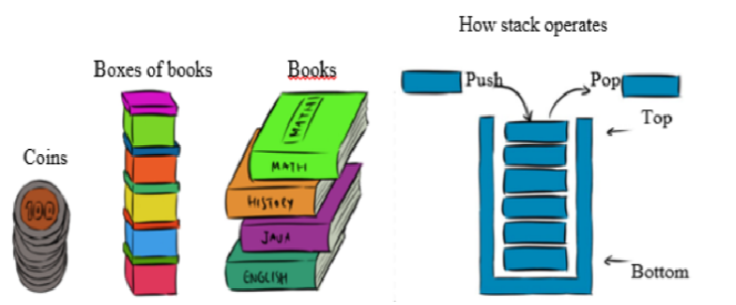

This is case show example of stack in our daily life.

A Stack is a Last in First out (LIFO) dynamic table or data structure. It has the following characteristics:

• List of the same kind of elements.

• Addition and deletion of elements occur only at one end, called the top of the stack.

• Computers use stacks to implement method calls.

• Stacks are also used to convert recursive algorithms into non recursive algorithms.

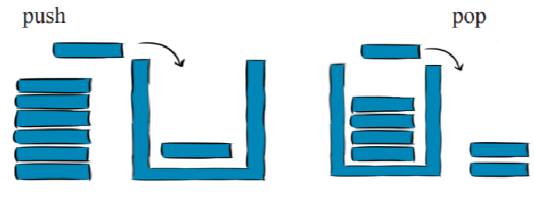

Figure : stacks’ operations (Push and Pop)

**Operations performed on stacks The different operations performed on stacks are as follows:**

• Push: adds an element to the stack.

• Pop: removes an element from the stack.

• Peek: display at top element of the stack.

**push(value) - Inserting value into the stack**

• Step 1: Check whether stack is FULL. (top == SIZE-1)

• Step 2: If it is FULL, then display “Stack is FULL!!! Insertion is not possible!!!” and terminate the function.

• Step 3: If it is NOT FULL, then increment top value by one (top++) and set stack [top] to value (stack[top] = value).

**pop () - Delete a value from the Stack**

• Step 1: Check whether stack is EMPTY. (top == -1)

• Step 2: If it is EMPTY, then display “Stack is EMPTY!!! Deletion is not possible!!!’” and terminate the function.

• Step 3: If it is NOT EMPTY, then delete stack [top] and decrement top value by one(top).

Notec 1: Stack and Queue data structures can be implement in two ways: By using array or by using linked list.