Louise JEAN-CAMPANA
CART 253-A

Written proposal – Project 2

Subject and Description

Since I got in Montreal for my exchange semester, I found myself interested in some new subjects. I have thought a lot about how to create new habits and familiarize myself with new places. The creation of a new routine in a new place is closely related to memories. I realized this process allowed me to feel like home as time keeps going and I found this really moving with the several changes it brings to experience life abroad.

I obviously would love to encourage people to experience this but I know that couldn’t be possible for everyone. As for my reflexions, I chose to work on a sort of simulation inspired by my exchange semester.

I started to think about that for my first project in which I represented my apartment and gave an impression of a morning routine. The action was only taking place in an apartment. For my second project I would like to dig in this concept and aesthetic.

If we think about it, a routine is just a repeted sequence of actions. Those actions could have differents parameters as their location, duration, or with who. The sequence has its own parameters too : how often the sequence is repeted and for how long. The more a sequence is repeted frequently and for a long time, the more the routine is set.
Once again if we think about it, our daily lives are just several routines intertwinted. We can observe sequences of actions that we organized according to our way of dividing time (year, month, week, day…). So as to create an experience that would be immersive enough, I will simulate these different routines with their own rythm and different sequences of tasks or events.

Time
In order to add some interactivity and immersion, I have chosen to present a form of game rather than a simulation in itself. I could add time limits to complete differents lists of tasks or a minimum number of tasks completed in a period of time. In either case, a timer or a clock would be displayed in the top left corner of the window. That would emphasize the relation to time that has its importance in the concept of a routine.

Location
It would be presented as a patchwork of differents maps. To emphasize the importance of the relation between places and actions in memory, I need the user to be able to navigate between different places where they could do specific actions. Each places would be presented as a map and there would be a map of a neighborhood that would be a kind of interface through which the user could be able to navigate between places.

Tasks
The whole effect of routine is based on the concept of achieving tasks. Those are all the things we have or we want to do that drives our lifestyles. This could increase the user’s commitment within the experience. They would be displayed on the different maps as icons. Once done, they would appear on the right of the window.

Events
A routine can’t be a routine if it’s not broken sometimes. Some unexecpected events could punctually occur so as to add some realism to the life rythm we are simulating in this game. I’m thinking about nights outs, hikes or trips in new places with maybe some easter eggs.

Immersion
sound ambiance of places and tasks
As I would like to share some instrospective reflexion with the user through my project, I need them to be in a state where they forget about their real lives such as when watching a movie or reading a book. To increase the immersion of the user, I have thought about adding some sound atmo sphere that are be specific to each places.

Design
I would like to keep improving the aesthetic of the apartment’s map of my first project. I like the overall black and white minimalist aesthetic with some icons that brings details and colors. I chose a pale but saturated colortheme to bring enough ‘pop’ without removing the peacefull and simple atmosphere of my first work.

Even though the process I’m talking about is full of different changes that may appear frightening, it almost always ends peacefully when you find your own rythm and are finally really set up. I want to keep a positive vision of this life changing experience. Some pale touch of color on a minimalistic black and white map seems to contributes well to this process according to me.

The user and the other people they can interact with would be represented as white circles and moving around maps of different places. Those maps would be as characters, some lines in white on black background.

There would be the neighborhood map that would be the interface through which the user could navigate between usual places as supermarket, its home, the university, some friend’s house. The map would be representing some streets and buildings in aerial view. Some black and white icons representing places would be displayed inside buildings drawn as rectangles. They would coloured themselves when the user pass the mouse over it. The different places would be reached either by clicking on the icons or by overlaping buildings with the ‘me’ character.

The ‘inside’ places like the apartment would be represented as aerial view map as well. Some furniture would be visible and possibly interactive.

Maps

Tasks Icons
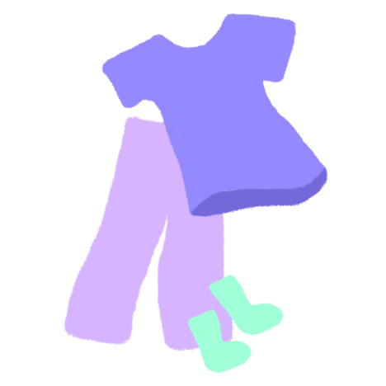
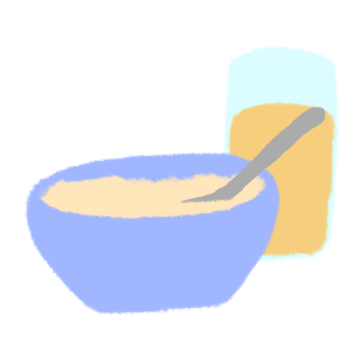


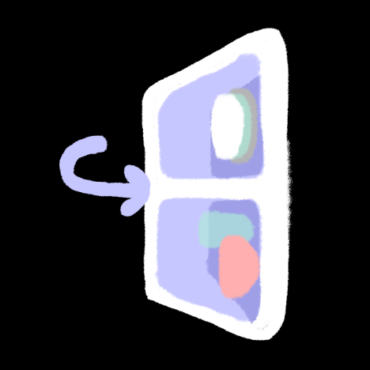

Places Icons

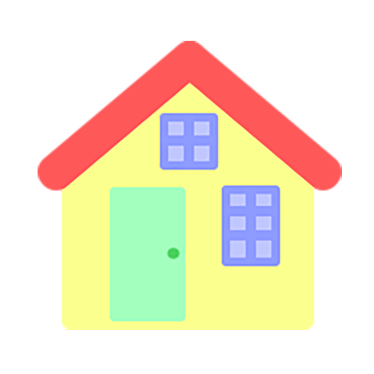


Technical challenges

My biggest technical challenges would probably be to add wall constrains, timers and sound atmosphere. These are three elements I had not the opportunity to practice yet. I think I could figure out how to do wall constrains by myself by creating lines and using the ‘if’ to check if the moving objects are overlaping them. However, I know I have to take a more attentive look on how to implement timers and sound to my code as they are recent concepts I didn’t totally understand yet.

