Asynchronous writethrough (AWT) cache group
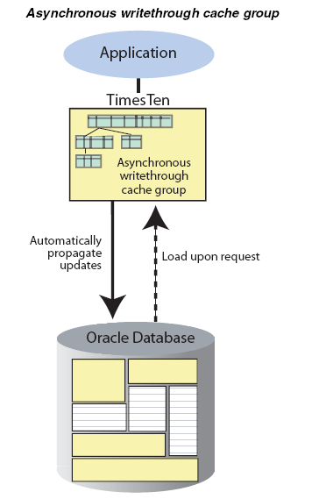

Synchronous writethrough (SWT) cache group
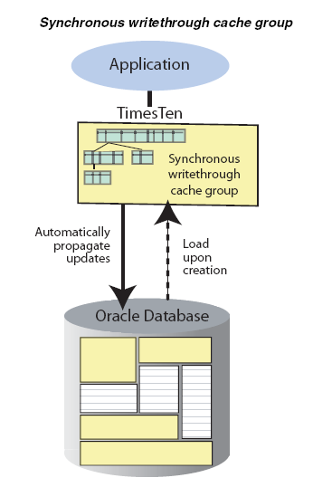

The transaction commit on the TimesTen database occurs synchronously with the commit on the Oracle database. When an application commits a transaction in the TimesTen database, the transaction is processed in the Oracle database before it is processed in TimesTen. The application is blocked until the transaction has completed in both the Oracle and TimesTen databases.

Global cache groups
An Oracle table cannot be cached in more than one cache group within the same TimesTen database. However, the table can be cached in separate cache groups in different TimesTen databases. If the table is cached in separate AWT cache groups and
the same cache instance is updated simultaneously on multiple TimesTen databases,
there is no guarantee as to the order in which the updates will be propagated to the cached Oracle table. Also, the contents of the updated cache table will be inconsistent between the TimesTen databases.
A TimesTen cache grid prevents this problem by providing users with Oracle databases a means to horizontally scale out cache groups across multiple systems with read/write data consistency across the TimesTen databases. A cache grid is a set of TimesTen databases that collectively manage the application data.
Tables that are cached in separate cache groups within different TimesTen databases
must be cached in global cache groups in order for the cache grid to manage consistency of the cache instances across the grid members when updates are committed on the cache tables of the cache group.
Only a dynamic AWT cache group can be defined as global cache group.

Setting a passthrough level

An application can issue statements on a TimesTen connection and either has the statement be executed in the TimesTen database or passed through to the Oracle database for execution.

- PassThrough=0 is the default setting and specifies that all statements are to be executed in the TimesTen database.

- If PassThrough=1, a TimesTen built-in procedure call, such as ttCacheStart is executed in the TimesTen database, while procedure calls whose name TimesTen does not recognize are passed through to the Oracle database for execution. No DDL statements are passed through to Oracle. Except for SELECT statements, if a DML statement contains invalid TimesTen syntax it is not passed through to Oracle.
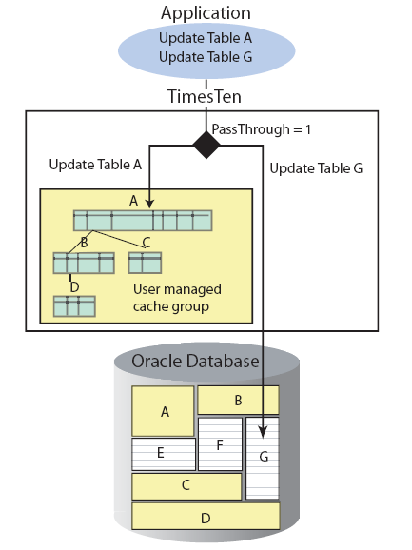

- PassThrough=3 specifies that all statements are to be passed through to the Oracle database for execution, except for INSERT, UPDATE and DELETE statements issued on cache tables in a dynamic AWT global cache group as these statements are to be executed in the TimesTen database.

- PassThrough=4 specifies that, in addition to the PassThrough=3 behavior, all SELECT statements issued on cache tables in a dynamic AWT global cache group that cannot be processed as a dynamic load operation are passed through to the Oracle database for execution.

- PassThrough=5 is similar to the PassThrough=4 behavior except that the SELECT statements will not be passed through to the Oracle database for execution until all committed updates on cache tables in dynamic AWT global cache groups by previous transactions within the connection have been propagated to Oracle.

Implementing aging on a cache group

You can define an aging policy on a cache group which specifies the aging type, the aging attributes, and the aging state. TimesTen supports two aging types, least recently used (LRU) aging and time-based aging.

LRU aging deletes the least recently used or referenced data based on a specified database usage range. Time-based aging deletes data based on a specified data lifetime and frequency of the aging process. You can use both LRU and time-based aging in the same TimesTen database, but you can define only one aging policy on a particular cache group.

Example - fining an LRU aging policy on a cache group
The following statement defines an LRU aging policy on the AWT cache group
new_customers:
CREATE ASYNCHRONOUS WRITETHROUGH CACHE GROUP new_customers
FROM oratt.customer
(cust_num NUMBER(6) NOT NULL,
region VARCHAR2(10),
name VARCHAR2(50),
address VARCHAR2(100),
PRIMARY KEY(cust_num))
AGING LRU ON

Example - defining a time-based aging policy on a cache group
The following statement defines a time-based aging policy on the AWT cache group
ordered_items:
CREATE ASYNCHRONOUS WRITETHROUGH CACHE GROUP ordered_items
FROM oratt.orders
(ord_num NUMBER(10) NOT NULL,
cust_num NUMBER(6) NOT NULL,
when_placed DATE NOT NULL,
when_shipped DATE NOT NULL,
PRIMARY KEY(ord_num))
AGING USE when_placed LIFETIME 45 DAYS CYCLE 60 MINUTES ON,
oratt.order_item
(orditem_id NUMBER(12) NOT NULL,
ord_num NUMBER(10),
prod_num VARCHAR2(6),
quantity NUMBER(3),
PRIMARY KEY(orditem_id),
FOREIGN KEY(ord_num) REFERENCES oratt.orders(ord_num))

Example - Starting a one-time aging process
The following procedure call starts a one-time aging process on the oratt.orders
table based on the time ttAgingScheduleNow is called:
CALL ttAgingScheduleNow('oratt.orders')
Rows in the oratt.orders root table that are candidates for aging will be deleted as
well as related rows in the oratt.order_item child table.

User managed cache group

If the system managed cache groups (read-only, AWT, SWT) do not satisfy your
application’s requirements, you can create a user managed cache group that defines
customized caching behavior.

Example- Creating a single-table user managed cache group
The following statement creates a user managed cache group update_anywhere_customers that caches the oratt.active_customer table :
CREATE USERMANAGED CACHE GROUP update_anywhere_customers
AUTOREFRESH MODE INCREMENTAL INTERVAL 30 SECONDS
FROM oratt.active_customer
(custid NUMBER(6) NOT NULL,
name VARCHAR2(50),
addr VARCHAR2(100),
zip VARCHAR2(12),
PRIMARY KEY(custid),
PROPAGATE)

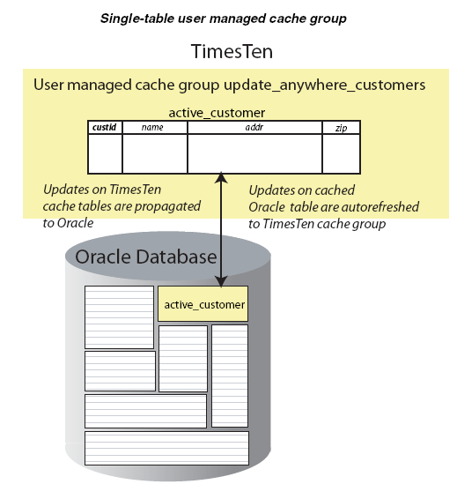

Example - Creating a multiple-table user managed cache group

The following statement creates a user managed cache group western_customers
that caches the oratt.active_customer, oratt.ordertab, oratt.cust_interests, and oratt.orderdetails tables.

CREATE USERMANAGED CACHE GROUP western_customers
FROM oratt.active_customer
(custid NUMBER(6) NOT NULL,
name VARCHAR2(50),
addr VARCHAR2(100),
zip VARCHAR2(12),
region VARCHAR2(12),
PRIMARY KEY(custid),
PROPAGATE)
WHERE (oratt.active_customer.region = 'West'),
oratt.ordertab
(orderid NUMBER(10) NOT NULL,
custid NUMBER(6) NOT NULL,
PRIMARY KEY(orderid),
FOREIGN KEY(custid) REFERENCES oratt.active_customer(custid),
PROPAGATE),
oratt.cust_interests
(custid NUMBER(6) NOT NULL,
interest VARCHAR2(10) NOT NULL,
PRIMARY KEY(custid, interest),
FOREIGN KEY(custid) REFERENCES oratt.active_customer(custid),
READONLY),
oratt.orderdetails
(orderid NUMBER(10) NOT NULL,
itemid NUMBER(8) NOT NULL,
quantity NUMBER(4) NOT NULL,
PRIMARY KEY(orderid, itemid),
FOREIGN KEY(orderid) REFERENCES oratt.ordertab(orderid))
WHERE (oratt.orderdetails.quantity >= 5)

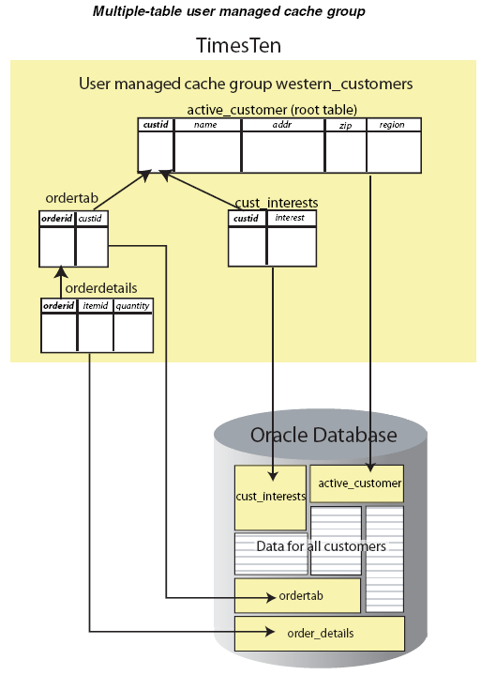

Replication agents
Replication between data stores is controlled by a replication agent. Each data store is identified by:
■ A data store name derived from the file system's path name for the data store
■ A host name

The replication agent on the master data store reads the records from the transaction log and forwards any detected changes to replicated elements to the replication agent on the subscriber data store. The replication agent on the subscriber data store then applies the updates to its data store. If the subscriber agent is not running when the updates are forwarded by the master, the master retains the updates in the log until
they can be transmitted.

Performance and recovery tradeoffs

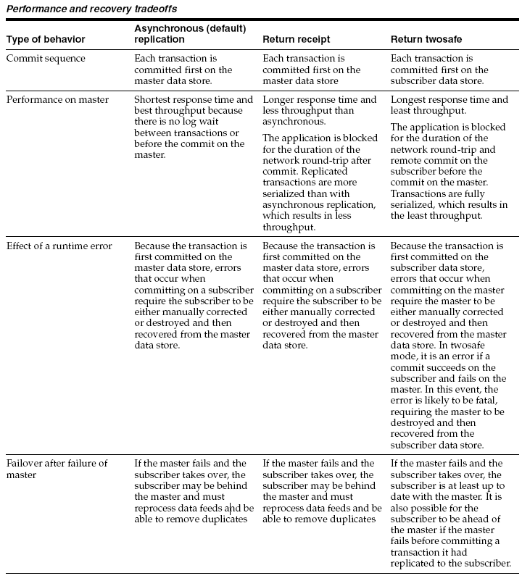

Default replication (Asynchronous)

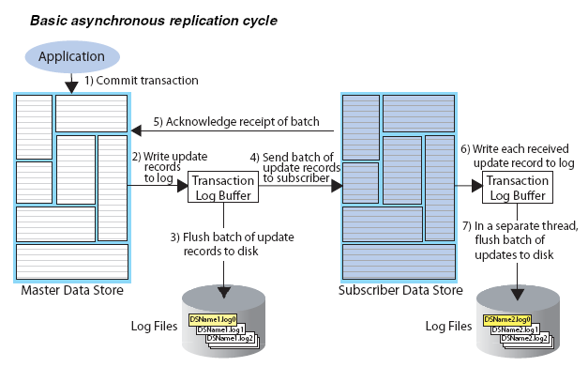

Return receipt replication

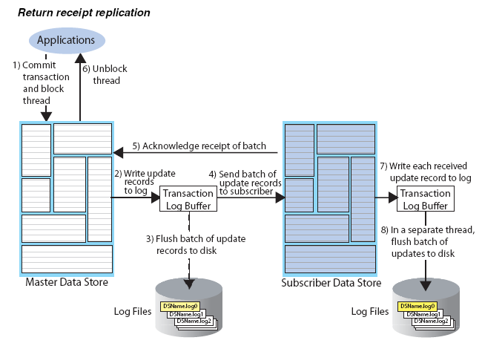

Return twosafe replication
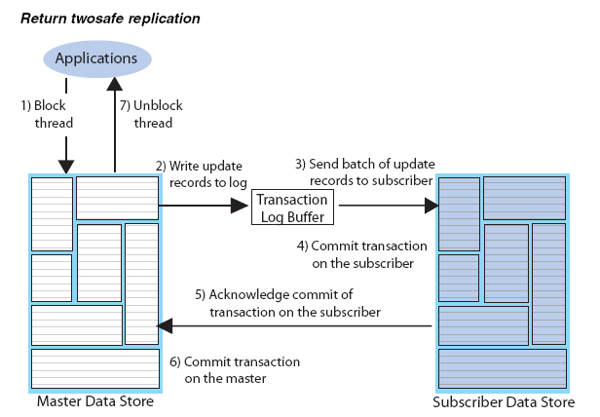

Bidirectional general workload scheme
The following figure shows a general workload bidirectional replication scheme in which the accounts table can be updated on either the eastds or westds data store. Each data store is both a master and a subscriber for the accounts table.
When elements are replicated in this manner, your applications should write to each
data store in a coordinated manner to avoid simultaneous updates on the same data.
To manage update conflicts, you can include a timestamp column of type BINARY(8)
in your table (as shown by the tstamp column in Example 7–33) and enable
timestamp comparison.

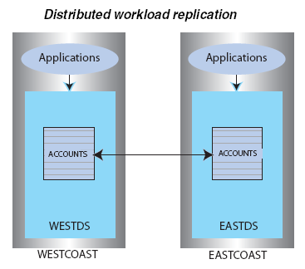

Example 7–32 Bidirectional general workload scheme
CREATE REPLICATION r1
ELEMENT elem_accounts_1 TABLE accounts
MASTER westds ON "westcoast"
SUBSCRIBER eastds ON "eastcoast"
ELEMENT elem_accounts_2 TABLE accounts
MASTER eastds ON "eastcoast"
SUBSCRIBER westds ON "westcoast";

Example 7–33 Include a timestamp column to manage update conflicts
CREATE TABLE accounts (custname VARCHAR2(30) NOT NULL,
address VARCHAR2(80),
curbalance DEC(15,2),
tstamp BINARY(8),
PRIMARY KEY (custname));

Replication conflict detection and resolution

