Programming Pattern

//sych
Request req=new Request();
Response res=app.invokeAndWait(req);

//asych
Callback cb=new Callback();
Request req=new Request();
app.invokeLater(req,cb);

//Interface Declaration

public interface ISychInvocation{
public Response invokeAndWait(Request req);
}

public interface IASychInvocation{
public void invokeLater(Request req,Callback cb);
}

Runnable

Method Summary
void | run()  When an object implementing interface Runnable is used to create a thread, starting the thread causes the object's run method to be called in that separately executing thread.

Callable

Method Summary
V | call()  Computes a result, or throws an exception if unable to do so.

ThreadPoolExecutor

Method Summary
protected void | afterExecute(Runnable r, Throwable t)  Method invoked upon completion of execution of the given Runnable.
boolean | awaitTermination(long timeout, TimeUnit unit)  Blocks until all tasks have completed execution after a shutdown request, or the timeout occurs, or the current thread is interrupted, whichever happens first.
protected void | beforeExecute(Thread t, Runnable r)  Method invoked prior to executing the given Runnable in the given thread.
void | execute(Runnable command)  Executes the given task sometime in the future.
protected void | finalize()  Invokes shutdown when this executor is no longer referenced.
int | getActiveCount()  Returns the approximate number of threads that are actively executing tasks.
long | getCompletedTaskCount()  Returns the approximate total number of tasks that have completed execution.
int | getCorePoolSize()  Returns the core number of threads.
long | getKeepAliveTime(TimeUnit unit)  Returns the thread keep-alive time, which is the amount of time which threads in excess of the core pool size may remain idle before being terminated.
int | getLargestPoolSize()  Returns the largest number of threads that have ever simultaneously been in the pool.
int | getMaximumPoolSize()  Returns the maximum allowed number of threads.
int | getPoolSize()  Returns the current number of threads in the pool.
BlockingQueue<Runnable> | getQueue()  Returns the task queue used by this executor.
RejectedExecutionHandler | getRejectedExecutionHandler()  Returns the current handler for unexecutable tasks.
long | getTaskCount()  Returns the approximate total number of tasks that have been scheduled for execution.
ThreadFactory | getThreadFactory()  Returns the thread factory used to create new threads.
boolean | isShutdown()  Returns true if this executor has been shut down.
boolean | isTerminated()  Returns true if all tasks have completed following shut down.
boolean | isTerminating()  Returns true if this executor is in the process of terminating after shutdown or shutdownNow but has not completely terminated.
int | prestartAllCoreThreads()  Starts all core threads, causing them to idly wait for work.
boolean | prestartCoreThread()  Starts a core thread, causing it to idly wait for work.
void | purge()  Tries to remove from the work queue all Future tasks that have been cancelled.
boolean | remove(Runnable task)  Removes this task from the executor's internal queue if it is present, thus causing it not to be run if it has not already started.
void | setCorePoolSize(int corePoolSize)  Sets the core number of threads.
void | setKeepAliveTime(long time, TimeUnit unit)  Sets the time limit for which threads may remain idle before being terminated.
void | setMaximumPoolSize(int maximumPoolSize)  Sets the maximum allowed number of threads.
void | setRejectedExecutionHandler(RejectedExecutionHandler handler)  Sets a new handler for unexecutable tasks.
void | setThreadFactory(ThreadFactory threadFactory)  Sets the thread factory used to create new threads.
void | shutdown()  Initiates an orderly shutdown in which previously submitted tasks are executed, but no new tasks will be accepted.
List<Runnable> | shutdownNow()  Attempts to stop all actively executing tasks, halts the processing of waiting tasks, and returns a list of the tasks that were awaiting execution.
protected void | terminated()  Method invoked when the Executor has terminated.

Methods inherited from class java.util.concurrent.AbstractExecutorService
invokeAll, invokeAll, invokeAny, invokeAny, submit, submit, submit

Typical relationship between threads and processes.

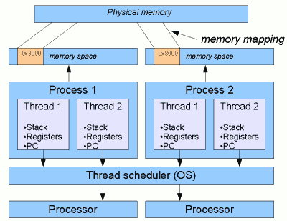

Typical Thread Pool Architecture

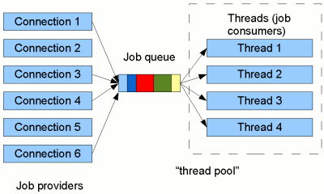

Concurrency on a single-processor machine

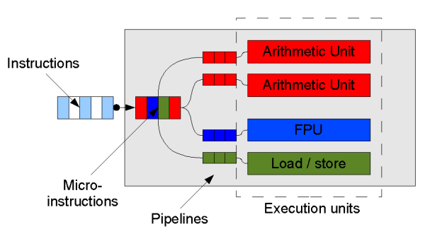

Thread State

A thread can be in one of the following states:
- NEW
A thread that has not yet started is in this state.
- RUNNABLE
A thread executing in the Java virtual machine is in this state.
- BLOCKED
A thread that is blocked waiting for a monitor lock is in this state.
- WAITING
A thread that is waiting indefinitely for another thread to perform a particular action is in this state.
- TIMED_WAITING
A thread that is waiting for another thread to perform an action for up to a specified waiting time is in this state.
- TERMINATED
A thread that has exited is in this state.
A thread can be in only one state at a given point in time. These states are virtual machine states which do not reflect any operating system thread states.
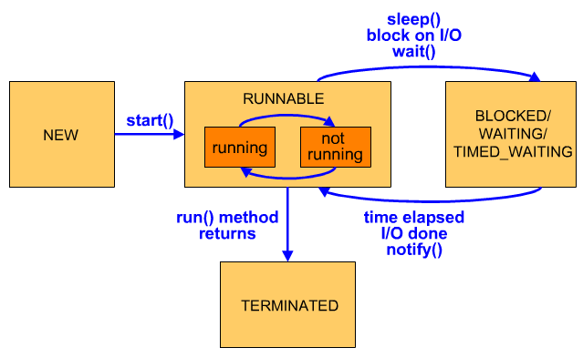

Java VisualVM Thread Tool


Monitor— It is a dead lock.

Dead Lock Example

Deadlock describes a situation where two or more threads are blocked forever, waiting for each other. Here's an example.
Alphonse and Gaston are friends, and great believers in courtesy. A strict rule of courtesy is that when you bow to a friend, you must remain bowed until your friend has a chance to return the bow. Unfortunately, this rule does not account for the possibility that two friends might bow to each other at the same time.
public class Deadlock {
static class Friend {
private final String name;
public Friend(String name) {
this.name = name;
}
public String getName() {
return this.name;
}
public synchronized void bow(Friend bower) {
System.out.format("%s: %s has bowed to me!%n",
this.name, bower.getName());
bower.bowBack(this);
}
public synchronized void bowBack(Friend bower) {
System.out.format("%s: %s has bowed back to me!%n",
this.name, bower.getName());
}
}

public static void main(String[] args) {
final Friend alphonse = new Friend("Alphonse");
final Friend gaston = new Friend("Gaston");
new Thread(new Runnable() {
public void run() { alphonse.bow(gaston); }
}).start();
new Thread(new Runnable() {
public void run() { gaston.bow(alphonse); }
}).start();
}
}

When Deadlock runs, it's extremely likely that both threads will block when they attempt to invoke bowBack. Neither block will ever end, because each thread is waiting for the other to exit bow.

