Access Link

http://localhost:8080/portal/public/mytest/

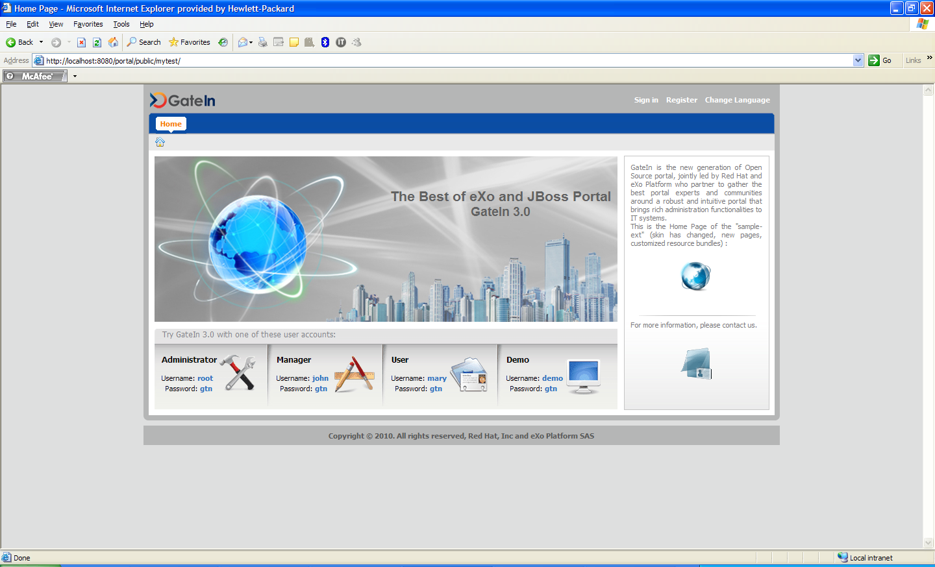

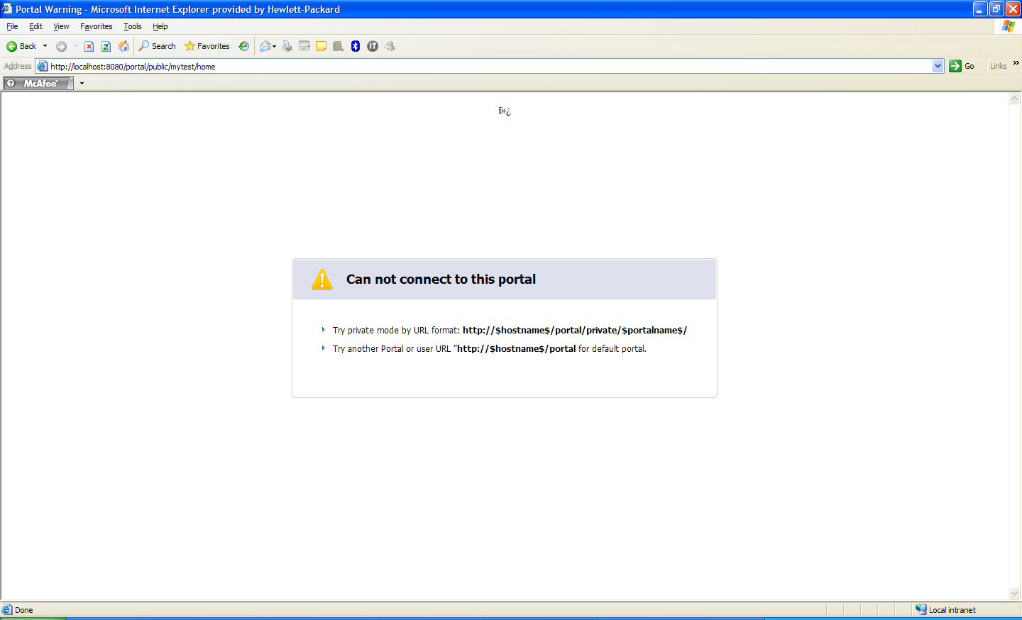

- Try private mode by URL format: http://$hostname$/portal/private/$portalname$/
- Try another Portal or user URL "http://$hostname$/portal for default portal.

Permission

View Permission

Edit Permission

