JGroup Architecture Overview

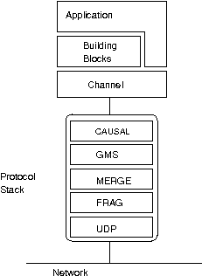

Typical Cluster Application (Cache/Session) Architecture Overview

Application
Application
Object
Object
Oracle RAC
Group Communication
Node-1
Node-2
Load Balancer

