Channel Pipeline

- Decoder is Upstream Handler for incoming request
- Encoder is Downstream Handler for outgoing request

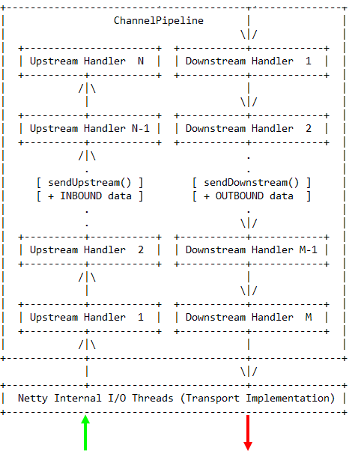

An upstream event is handled by the upstream handlers in the bottom-up direction as shown on the left side of the diagram. An upstream handler usually handles the inbound data received from the I/O thread on the bottom of the diagram. If an upstream event goes beyond the top upstream handler, it is discarded silently.
A downstream event is handled by the downstream handler in the top-down direction as shown on the right side of the diagram. A downstream handler usually generates or transforms the outbound traffic such as write requests. If a downstream event goes beyond the bottom downstream handler, it is handled by an I/O thread associated with the Channel.
For example, let us assume that we created the following pipeline:
ChannelPipeline p = Channels.pipeline();
p.addLast("1", new UpstreamHandlerA());
p.addLast("2", new UpstreamHandlerB());
p.addLast("3", new DownstreamHandlerA());
p.addLast("4", new DownstreamHandlerB());
p.addLast("5", new UpstreamHandlerX());

In the example above, the class whose name starts with Upstream means it is an upstream handler. The class whose name starts with Downstream means it is a downstream handler.
In the given example configuration, the handler evaluation order is 1, 2, 3, 4, 5 when an event goes upstream. When an event goes downstream, the order is 5, 4, 3, 2, 1. On top of this principle, ChannelPipeline skips the evaluation of certain handlers to shorten the stack depth:
- 3 and 4 don't implement ChannelUpstreamHandler, and therefore the actual evaluation order of an upstream event will be: 1, 2, and 5.
- 1, 2, and 5 don't implement ChannelDownstreamHandler, and therefore the actual evaluation order of a downstream event will be: 4 and 3.
- If 5 extended SimpleChannelHandler which implements both ChannelUpstreamHandler and ChannelDownstreamHandler, the evaluation order of an upstream and a downstream event could be 125 and 543 respectively.

SimpleChannelUpstreamHandler

public void handleUpstream(
ChannelHandlerContext ctx, ChannelEvent e) throws Exception {

if (e instanceof MessageEvent) {
messageReceived(ctx, (MessageEvent) e);
} else if (e instanceof WriteCompletionEvent) {
WriteCompletionEvent evt = (WriteCompletionEvent) e;
writeComplete(ctx, evt);
} else if (e instanceof ChildChannelStateEvent) {
ChildChannelStateEvent evt = (ChildChannelStateEvent) e;
if (evt.getChildChannel().isOpen()) {
childChannelOpen(ctx, evt);
} else {
childChannelClosed(ctx, evt);
}
} else if (e instanceof ChannelStateEvent) {
ChannelStateEvent evt = (ChannelStateEvent) e;
switch (evt.getState()) {
case OPEN:
if (Boolean.TRUE.equals(evt.getValue())) {
channelOpen(ctx, evt);
} else {
channelClosed(ctx, evt);
}
break;
case BOUND:
if (evt.getValue() != null) {
channelBound(ctx, evt);
} else {
channelUnbound(ctx, evt);
}
break;
case CONNECTED:
if (evt.getValue() != null) {
channelConnected(ctx, evt);
} else {
channelDisconnected(ctx, evt);
}
break;
case INTEREST_OPS:
channelInterestChanged(ctx, evt);
break;
default:
ctx.sendUpstream(e);
}
} else if (e instanceof ExceptionEvent) {
exceptionCaught(ctx, (ExceptionEvent) e);
} else {
ctx.sendUpstream(e);
}
}

SimpleChannelDownstreamHandler
public void handleDownstream(ChannelHandlerContext ctx, ChannelEvent e)
throws Exception {

if (e instanceof MessageEvent) {
writeRequested(ctx, (MessageEvent) e);
} else if (e instanceof ChannelStateEvent) {
ChannelStateEvent evt = (ChannelStateEvent) e;
switch (evt.getState()) {
case OPEN:
if (!Boolean.TRUE.equals(evt.getValue())) {
closeRequested(ctx, evt);
}
break;
case BOUND:
if (evt.getValue() != null) {
bindRequested(ctx, evt);
} else {
unbindRequested(ctx, evt);
}
break;
case CONNECTED:
if (evt.getValue() != null) {
connectRequested(ctx, evt);
} else {
disconnectRequested(ctx, evt);
}
break;
case INTEREST_OPS:
setInterestOpsRequested(ctx, evt);
break;
default:
ctx.sendDownstream(e);
}
} else {
ctx.sendDownstream(e);
}
}

OneToOneEncoder

public abstract class OneToOneEncoder implements ChannelDownstreamHandler {

protected OneToOneEncoder() {
super();
}

public void handleDownstream(
ChannelHandlerContext ctx, ChannelEvent evt) throws Exception {
if (!(evt instanceof MessageEvent)) {
ctx.sendDownstream(evt);
return;
}

MessageEvent e = (MessageEvent) evt;
Object originalMessage = e.getMessage();
Object encodedMessage = encode(ctx, e.getChannel(), originalMessage);
if (originalMessage == encodedMessage) {
ctx.sendDownstream(evt);
} else {
write(ctx, e.getFuture(), encodedMessage, e.getRemoteAddress());
}
}

protected abstract Object encode(
ChannelHandlerContext ctx, Channel channel, Object msg) throws Exception;
}

OneToOneDecoder

public abstract class OneToOneDecoder implements ChannelUpstreamHandler {

/**
* Creates a new instance with the current system character set.
*/
protected OneToOneDecoder() {
super();
}

public void handleUpstream(
ChannelHandlerContext ctx, ChannelEvent evt) throws Exception {
if (!(evt instanceof MessageEvent)) {
ctx.sendUpstream(evt);
return;
}

MessageEvent e = (MessageEvent) evt;
Object originalMessage = e.getMessage();
Object decodedMessage = decode(ctx, e.getChannel(), originalMessage);
if (originalMessage == decodedMessage) {
ctx.sendUpstream(evt);
} else {
fireMessageReceived(ctx, decodedMessage, e.getRemoteAddress());
}
}

protected abstract Object decode(
ChannelHandlerContext ctx, Channel channel, Object msg) throws Exception;
}

