

**Practical Introduction to Creating Textile Models Using TexGen**

Louise Brown

TexGen is open source software developed at the University of Nottingham for modelling of textile and textile composite structures. <http://texgen.sourceforge.net>

This interactive workshop will demonstrate the use of the TexGen graphical user interface (GUI) to automatically create 2D and 3D woven structures. An outline of the modelling theory used in the TexGen software will be given which will enable the user to make better use of the features available in the software for customising textile models.

The Python scripting facility will be introduced and will be demonstrated both for editing models within the GUI and for creating custom scripts for maximum control over the textile structures created.

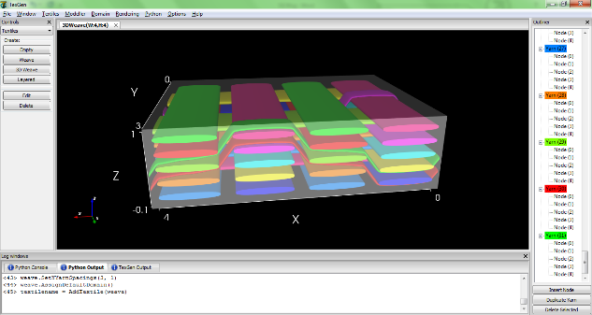Export options will be demonstrated which allow TexGen models to be easily exported to third-party software such as ABAQUS to be used in simulations for prediction of material properties.

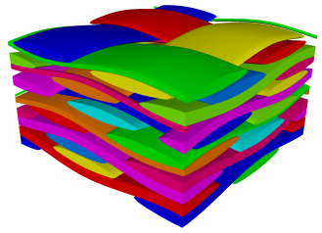

In order to gain full benefit from the workshop please bring a laptop with you with the most recent version of TexGen downloaded and installed from <https://sourceforge.net/projects/texgen/>.