Report

1.

Model architecture:

Convolution (inchannel = 3, outchannel = 32, kernel size = 3) -> Relu

MaxPool (kernel size = 2)

Convolution (inchannel = 32, outchannel = 16, kernel size = 3) -> Relu

MaxPool (kernel size = 2)

MaxUnpool (kernel size = 2)

DeConvolution (inchannel = 16, outchannel = 32, kernel size = 3) -> Relu

MaxUnpool (kernel size = 2)

DeConvolution (inchannel = 32, outchannel = 3, kernel size = 3) -> Relu

Loss Function: MSE

2.

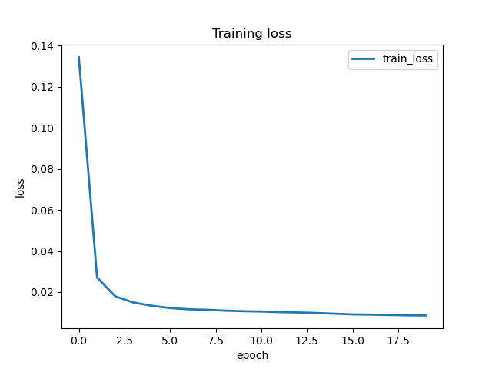

3.

