**作業三  機器人大變身**

405262180

資工三乙

劉育騏

討論:本次作業，知道許多新的參數，函式用法，計時器等等之類的。還有物件，畫3D圖形，以及一些動作基本旋轉，放大，位移設定。以及許許多多東西，蠻有趣的。獲益良多。

程式架構:

部位關係

身體->頭部

身體->左手->左下臂->手->手2

身體->右手->右下臂->手->手2

身體->左腳->左下腳->腳掌

身體->右腳->右下腳->腳掌

執行畫面:

初始:

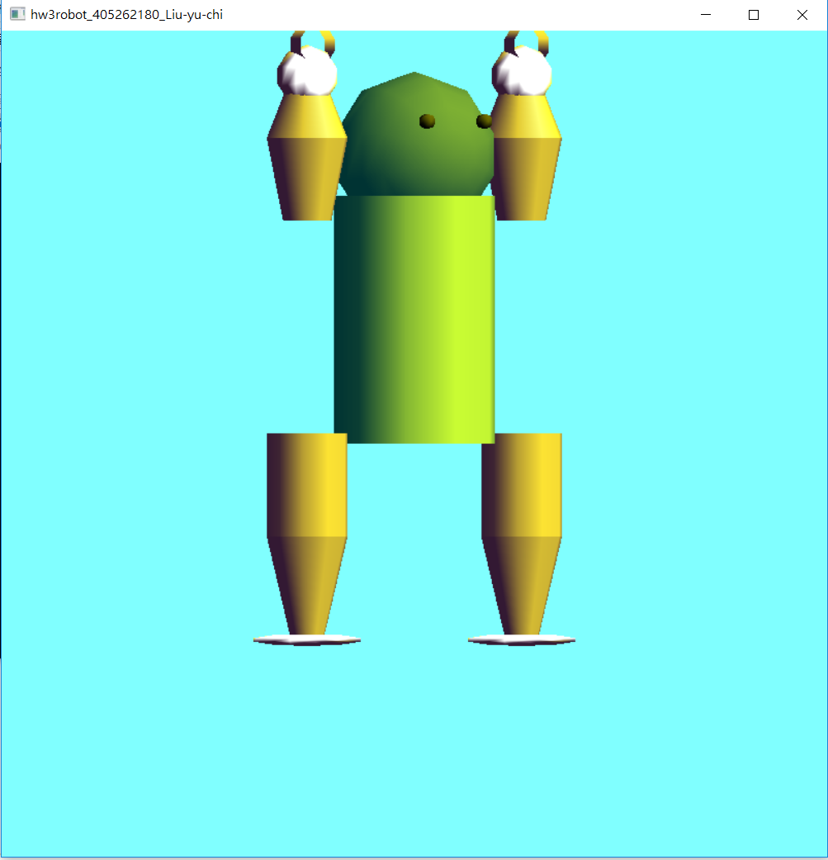

操作選項:

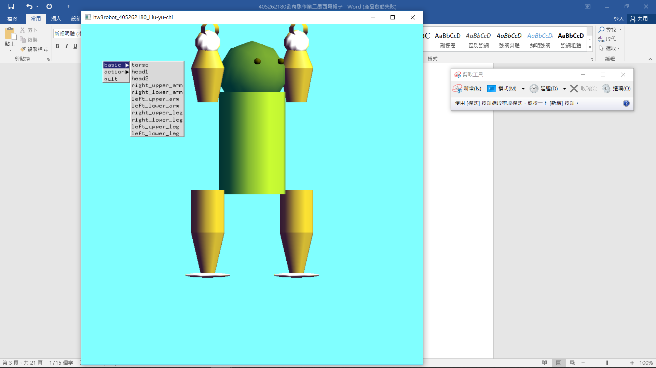

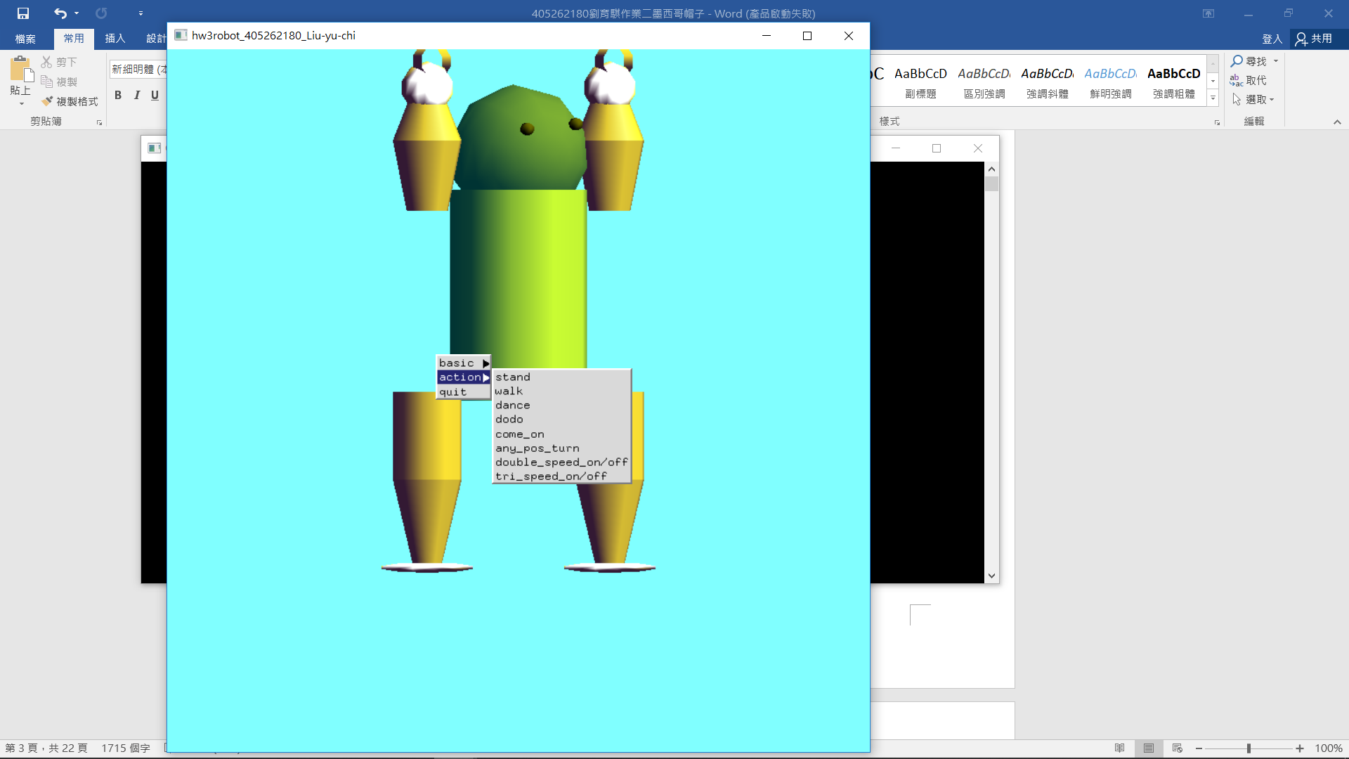

**程式碼**

#include <stdlib.h>

#include <math.h>

#include <stdio.h>

#ifdef __APPLE__

#include <GLUT/glut.h>

#else

#include <GL/glut.h>

#endif

#define TORSO_HEIGHT 6

#define TORSO_RADIUS 2

#define UPPER_ARM_HEIGHT 2.0

#define LOWER_ARM_HEIGHT 1.5

#define UPPER_ARM_RADIUS 1

#define LOWER_ARM_RADIUS 1

#define UPPER_LEG_RADIUS 1

#define LOWER_LEG_RADIUS 1

#define LOWER_LEG_HEIGHT 2.5

#define UPPER_LEG_HEIGHT 2.5

#define HEAD_HEIGHT 2

#define HEAD_RADIUS 2

static GLfloat theta[11] = {30.0, 0.0, 0.0, 0.0, 0.0, 0.0, 0.0, 180.0, 0.0, 180.0, 0.0}; //身體部位旋轉

static GLfloat atheta[8] = {0.0, 0.0, 0.0, 0.0, 0.0, 0.0, 0.0, 0.0}; // 對z軸旋轉

static GLint angle = 2; //index

const GLfloat rot = 5.0;// rotate angle

GLUquadricObj *t, *h, *lua, *lla, *rua, *rla, *lll, *rll, *rul, *lul;

int time_clock = 0;

int state = 0; //機器人狀態

int mills = 22; //倒數時間

GLboolean isDoubleSpeed = false;

GLboolean isThirdSpeed = false;

void torso()

{

glPushMatrix();

glRotatef(-90.0, 1.0, 0.0, 0.0);

gluCylinder(t,TORSO_RADIUS, TORSO_RADIUS, TORSO_HEIGHT,10,10);

glPopMatrix();

}

void head()

{

glPushMatrix();

glTranslatef(0.0, 0.5*HEAD_HEIGHT,0.0);

glScalef(HEAD_RADIUS, HEAD_HEIGHT, HEAD_RADIUS);

gluSphere(h,1.0,10,10);

glPushMatrix();

glColor3f(0.0, 0.0, 0.0);

glTranslatef(0.4, 0.4, 1.0);

gluSphere(h,0.1,10,3);

glPopMatrix();

glPushMatrix();

glColor3f(0.0, 0.0, 0.0);

glTranslatef(-0.4, 0.4, 1.0);

gluSphere(h,0.1,10,3);

glPopMatrix();

glPopMatrix();

}

void left_upper_arm()

{

glPushMatrix();

glRotatef(-90.0, 1.0, 0.0, 0.0);

glColor3f(1, 0.5, 1);

gluCylinder(lua,UPPER_ARM_RADIUS*0.6, UPPER_ARM_RADIUS, UPPER_ARM_HEIGHT,10,10);

glPopMatrix();

}

void left_lower_arm()

{

glPushMatrix();

glRotatef(-90.0, 1.0, 0.0, 0.0);

gluCylinder(lla,LOWER_ARM_RADIUS, LOWER_ARM_RADIUS*0.4, LOWER_ARM_HEIGHT,10,10);

glPopMatrix();

}

void right_upper_arm()

{

glPushMatrix();

glRotatef(-90.0, 1.0, 0.0, 0.0);

gluCylinder(rua,UPPER_ARM_RADIUS*0.6, UPPER_ARM_RADIUS, UPPER_ARM_HEIGHT,10,10);

glPopMatrix();

}

void right_lower_arm()

{

glPushMatrix();

glRotatef(-90.0, 1.0, 0.0, 0.0);

gluCylinder(rla,LOWER_ARM_RADIUS, LOWER_ARM_RADIUS*0.4, LOWER_ARM_HEIGHT,10,10);

glPopMatrix();

}

void left_upper_leg()

{

glPushMatrix();

glRotatef(-90.0, 1.0, 0.0, 0.0);

gluCylinder(lul,UPPER_LEG_RADIUS, UPPER_LEG_RADIUS, UPPER_LEG_HEIGHT,10,10);

glPopMatrix();

}

void left_lower_leg()

{

glPushMatrix();

glRotatef(-90.0, 1.0, 0.0, 0.0);

gluCylinder(lll,LOWER_LEG_RADIUS, LOWER_LEG_RADIUS*0.4, LOWER_LEG_HEIGHT,10,10);

glPopMatrix();

}

void right_upper_leg()

{

glPushMatrix();

glRotatef(-90.0, 1.0, 0.0, 0.0);

gluCylinder(rul,UPPER_LEG_RADIUS, UPPER_LEG_RADIUS, UPPER_LEG_HEIGHT,10,10);

glPopMatrix();

}

void right_lower_leg()

{

glPushMatrix();

glRotatef(-90.0, 1.0, 0.0, 0.0);

gluCylinder(rll,LOWER_LEG_RADIUS, LOWER_LEG_RADIUS*0.4, LOWER_LEG_HEIGHT,10,10);

glPopMatrix();

}

void left_hand()

{

glPushMatrix();

glScalef(0.5, 0.5, 0.5);

gluSphere(h,1.5,10,10);

glPopMatrix();

}

void left_hand2()

{

glPushMatrix();

glScalef(0.5, 0.5, 0.5);

gluCylinder(t, 1, 1, 1, 10, 10);

glPopMatrix();

}

void right_hand()

{

glPushMatrix();

glScalef(0.5, 0.5, 0.5);

gluSphere(h,1.5,10,10);

glPopMatrix();

}

void right_hand2()

{

glPushMatrix();

glScalef(0.5, 0.5, 0.5);

gluCylinder(t, 1, 1, 1, 10, 10);

glPopMatrix();

}

void left_foot()

{

glPushMatrix();

glScalef(1, 0.1, 0.5);

gluSphere(h,1.5,10,10);

glPopMatrix();

}

void right_foot()

{

glPushMatrix();

glScalef(1, 0.1, 0.5);

gluSphere(h,1.5,10,10);

glPopMatrix();

}

void

display(void)

{

glClear(GL_COLOR_BUFFER_BIT|GL_DEPTH_BUFFER_BIT);

glLoadIdentity();

glColor3f(0, 1, 1);

glRotatef(theta[0], 0.0, 1.0, 0.0);

torso();

glPushMatrix();

glTranslatef(0.0, TORSO_HEIGHT+0.5*HEAD_HEIGHT, 0.0);

glRotatef(theta[1], 1.0, 0.0, 0.0);

glRotatef(theta[2], 0.0, 0.0, 1.0);

glTranslatef(0.0, -0.5*HEAD_HEIGHT, 0.0);

head();

glPopMatrix();

glPushMatrix();

glColor3f(0, 1, 1);

glTranslatef(-(TORSO_RADIUS+UPPER_ARM_RADIUS), 0.9*TORSO_HEIGHT, 0.0);

glRotatef(theta[3], 1.0, 0.0, 0.0);

glRotatef(atheta[0], 0.0, 0.0, 1.0);

left_upper_arm();

glTranslatef(0.0, UPPER_ARM_HEIGHT, 0.0);

glRotatef(theta[4], 1.0, 0.0, 0.0);

glRotatef(atheta[1], 0.0, 0.0, 1.0);

left_lower_arm();

glTranslatef(0.0, LOWER_ARM_HEIGHT, 0.0);

left_hand();

glTranslatef(0.0, LOWER_ARM_HEIGHT*0.5, 0.0);

left_hand2();

glPopMatrix();

glPushMatrix();

glTranslatef(TORSO_RADIUS+UPPER_ARM_RADIUS, 0.9*TORSO_HEIGHT, 0.0);

glRotatef(theta[5], 1.0, 0.0, 0.0);

glRotatef(atheta[2], 0.0, 0.0, 1.0);

right_upper_arm();

glTranslatef(0.0, UPPER_ARM_HEIGHT, 0.0);

glRotatef(theta[6], 1.0, 0.0, 0.0);

glRotatef(atheta[3], 0.0, 0.0, 1.0);

right_lower_arm();

glTranslatef(0.0, LOWER_ARM_HEIGHT, 0.0);

right_hand();

glTranslatef(0.0, LOWER_ARM_HEIGHT*0.5, 0.0);

right_hand2();

glPopMatrix();

glPushMatrix();

glTranslatef(-(TORSO_RADIUS+UPPER_LEG_RADIUS), 0.1*UPPER_LEG_HEIGHT, 0.0);

glRotatef(theta[7], 1.0, 0.0, 0.0);

glRotatef(atheta[4], 0.0, 0.0, 1.0);

left_upper_leg();

glTranslatef(0.0, UPPER_LEG_HEIGHT, 0.0);

glRotatef(theta[8], 1.0, 0.0, 0.0);

glRotatef(atheta[5], 0.0, 0.0, 1.0);

left_lower_leg();

glTranslatef(0.0, LOWER_LEG_HEIGHT, 0.0);

left_foot();

glPopMatrix();

glPushMatrix();

glTranslatef(TORSO_RADIUS+UPPER_LEG_RADIUS, 0.1*UPPER_LEG_HEIGHT, 0.0);

glRotatef(theta[9], 1.0, 0.0, 0.0);

glRotatef(atheta[6], 0.0, 0.0, 1.0);

right_upper_leg();

glTranslatef(0.0, UPPER_LEG_HEIGHT, 0.0);

glRotatef(theta[10], 1.0, 0.0, 0.0);

glRotatef(atheta[7], 0.0, 0.0, 1.0);

right_lower_leg();

glTranslatef(0.0, LOWER_LEG_HEIGHT, 0.0);

right_foot();

glPopMatrix();

glFlush();

glutSwapBuffers();

}

void recover(void)

{

theta[0] = 30.0;

theta[1] = 0.0;

theta[2] = 0.0;

theta[3] = 0.0;

theta[4] = 0.0;

theta[5] = 0.0;

theta[6] = 0.0;

theta[7] = 180.0;

theta[8] = 0.0;

theta[9] = 180.0;

theta[10] = 0.0;

for(int i = 0; i < 8; i++){

atheta[i] = 0.0;

}

}

void midPunch(void)

{

theta[0] = 0.0;

theta[1] = 0.0;

theta[2] = 0.0;

theta[3] = 0.0;

theta[4] = 0.0;

theta[5] = 0.0;

theta[6] = 0.0;

theta[7] = 180.0;

theta[8] = 0.0;

theta[9] = 180.0;

theta[10] = 0.0;

atheta[0] = 90.0;

atheta[1] = 0.0;

atheta[2] = 0.0;

atheta[3] = 90.0;

atheta[4] = 10.0;

atheta[5] = 100.0;

atheta[6] = -90.0;

atheta[7] = 0.0;

}

void leftPunch(void)

{

theta[0] -= 6.0;

theta[1] = 0.0;

theta[2] = 0.0;

theta[3] = 0.0;

theta[4] = 0.0;

theta[5] = 0.0;

theta[6] = 0.0;

theta[7] = 180.0;

theta[8] = 0.0;

theta[9] = 180.0;

theta[10] = 0.0;

atheta[0] = 90.0;

atheta[1] = 0.0;

atheta[2] = 0.0;

atheta[3] = 10.0;

atheta[4] = 90.0;

atheta[5] = -90.0;

atheta[6] = 10.0;

atheta[7] = 0.0;

}

void rightPunch(void)

{

theta[0] += 6.0;

theta[1] = 0.0;

theta[2] = 0.0;

theta[3] = 0.0;

theta[4] = 0.0;

theta[5] = 0.0;

theta[6] = 0.0;

theta[7] = 180.0;

theta[8] = 0.0;

theta[9] = 180.0;

theta[10] = 0.0;

atheta[0] = 90.0;

atheta[1] = -90.0;

atheta[2] = -90.0;

atheta[3] = 0.0;

atheta[4] = 90.0;

atheta[5] = 0.0;

atheta[6] = -90.0;

atheta[7] = 90.0;

}

void TimerFunction(int value)

{

switch(state){

case 1:/**走路時間**/

time_clock++;

if(time_clock < 10){

theta[0] = 30.0;

theta[1] = 0.0;

theta[2] = -10.0;

theta[3] = 230.0;

theta[4] = -30.0;

theta[5] = 140.0;

theta[6] = -30.0;

theta[7] = 100.0;

theta[8] = 70.0;

theta[9] = 180.0;

theta[10]= 0.0;

for(int i = 0 ; i < 8 ; i++)

atheta[i] = 0.0;

}

else if(time_clock < 20){

theta[0] = 30.0;

theta[1] = 0.0;

theta[2] = 10.0;

theta[3] = 140.0;

theta[4] = -30.0;

theta[5] = 230.0;

theta[6] = -30.0;

theta[7] = 180.0;

theta[8] = 0.0;

theta[9] = 120.0;

theta[10] = 70.0;

for(int i = 0 ; i < 8 ; i++)

atheta[i] = 0.0;

}

else{

time_clock = 0;

}

break;

case 2:/**跳舞時間**/

time_clock++;

if(time_clock < 10)

rightPunch();

else if(time_clock < 20)

leftPunch();

else if(time_clock < 30)

midPunch();

else

time_clock = 0;

break;

case 3:/**抖動**/

time_clock++;

if(time_clock < 10){

theta[0] = 30.0;

theta[1] = 0.0;

theta[2] = -10.0;

theta[3] = 230.0;

theta[4] = -30.0;

theta[5] = 140.0;

theta[6] = -30.0;

theta[7] = 100.0;

theta[8] = 70.0;

theta[9] = 180.0;

theta[10]= 0.0;

for(int i = 0 ; i < 8 ; i++)

atheta[i] = 30.0;

}

else if(time_clock < 20){

theta[0] = 30.0;

theta[1] = 0.0;

theta[2] = 10.0;

theta[3] = 140.0;

theta[4] = -30.0;

theta[5] = 230.0;

theta[6] = -30.0;

theta[7] = 180.0;

theta[8] = 0.0;

theta[9] = 120.0;

theta[10] = 70.0;

for(int i = 0 ; i < 8 ; i++)

atheta[i] = -30.0;

}

else{

time_clock = 0;

}

break;

case 4:/**挑釁**/

time_clock++;

if(time_clock < 5){

theta[2] += rot;

}

else if(time_clock < 5+18){

theta[3] += rot;

theta[5] += rot;

}

else if(time_clock < 10+18){

theta[4] -= rot;

theta[6] -= rot;

}

else if(time_clock < 15+18){

theta[4] += rot;

theta[6] += rot;

}

else if(time_clock < 20+18){

theta[4] -= rot;

theta[6] -= rot;

}

else if(time_clock < 25+18){

theta[4] += rot;

theta[6] += rot;

}

else{

time_clock = 0;

theta[2] = 0;

theta[3] = 0;

theta[5] = 0;

theta[6] = 0;

}

break;

case 5:/**轉轉轉**/

time_clock++;

if(time_clock < 36){

theta[3] += 2*rot;

theta[5] -= 2*rot;

}

else if(time_clock < 36+9)

theta[0] += rot;

else{

time_clock = 0;

}

break;

}

glutPostRedisplay();

glutTimerFunc(mills ,TimerFunction, 1);

}

void mouse(int btn, int state, int x, int y)

{

if(btn==GLUT_LEFT_BUTTON && state == GLUT_DOWN)

{

theta[angle] += rot;

if( theta[angle] > 360.0 ) theta[angle] -= 360.0;

}

if(btn==GLUT_RIGHT_BUTTON && state == GLUT_DOWN)

{

theta[angle] -= rot;

if( theta[angle] < 360.0 ) theta[angle] += 360.0;

}

glutPostRedisplay();

}

void menu(int id)

{

if(id == 2)

exit(0);

}

void bas_menu(int id){

angle=id;

}

void act_menu(int id){

switch(id){

case 0:

state = 0;

recover();

break;

case 1:

state = 1;

break;

case 2:

state = 2;

break;

case 3:

state = 3;

break;

case 4:

recover();

time_clock = 0;

state = 4;

break;

case 5:

state = 5;

break;

case 6:

isDoubleSpeed ^= 1;

if(isDoubleSpeed){

mills = 11;

isThirdSpeed = false;

}

else

mills = 22;

break;

case 7:

isThirdSpeed ^= 1;

if(isThirdSpeed){

mills = 5;

isDoubleSpeed = false;

}

else

mills = 22;

break;

}

}

void myReshape(int w, int h)

{

glViewport(0, 0, w, h);

glMatrixMode(GL_PROJECTION);

glLoadIdentity();

if (w <= h)

glOrtho(-10.0, 10.0, -10.0 * (GLfloat) h / (GLfloat) w,

10.0 * (GLfloat) h / (GLfloat) w, -10.0, 10.0);

else

glOrtho(-10.0 * (GLfloat) w / (GLfloat) h,

10.0 * (GLfloat) w / (GLfloat) h, 0.0, 10.0, -10.0, 10.0);

glMatrixMode(GL_MODELVIEW);

glLoadIdentity();

}

void myinit()

{

GLfloat mat_specular[]={1.0, 1.0, 1.0, 1.0};

GLfloat mat_diffuse[]={1.0, 1.0, 1.0, 1.0};

GLfloat mat_ambient[]={1.0, 1.0, 1.0, 1.0};

GLfloat mat_shininess={100.0};

GLfloat light_ambient[]={0.0, 0.0, 0.0, 1.0};

GLfloat light_diffuse[]={1.0, 1.0, 0.0, 1.0};

GLfloat light_specular[]={1.0, 1.0, 1.0, 1.0};

GLfloat light_position[]={10.0, 10.0, 10.0, 0.0};

glLightfv(GL_LIGHT0, GL_POSITION, light_position);

glLightfv(GL_LIGHT0, GL_AMBIENT, light_ambient);

glLightfv(GL_LIGHT0, GL_DIFFUSE, light_diffuse);

glLightfv(GL_LIGHT0, GL_SPECULAR, light_specular);

glMaterialfv(GL_FRONT, GL_SPECULAR, mat_specular);

glMaterialfv(GL_FRONT, GL_AMBIENT, mat_ambient);

glMaterialfv(GL_FRONT, GL_DIFFUSE, mat_diffuse);

glMaterialf(GL_FRONT, GL_SHININESS, mat_shininess);

glShadeModel(GL_SMOOTH);

glEnable(GL_LIGHTING);

glEnable(GL_LIGHT0);

glDepthFunc(GL_LEQUAL);

glEnable(GL_DEPTH_TEST);

glColorMaterial(GL_FRONT_AND_BACK,GL_AMBIENT);

glEnable(GL_COLOR_MATERIAL);

glClearColor(0.5, 1, 1, 1);

/** allocate quadrics with filled drawing style **/

h=gluNewQuadric();

gluQuadricDrawStyle(h, GLU_FILL);

t=gluNewQuadric();

gluQuadricDrawStyle(t, GLU_FILL);

lua=gluNewQuadric();

gluQuadricDrawStyle(lua, GLU_FILL);

lla=gluNewQuadric();

gluQuadricDrawStyle(lla, GLU_FILL);

rua=gluNewQuadric();

gluQuadricDrawStyle(rua, GLU_FILL);

rla=gluNewQuadric();

gluQuadricDrawStyle(rla, GLU_FILL);

lul=gluNewQuadric();

gluQuadricDrawStyle(lul, GLU_FILL);

lll=gluNewQuadric();

gluQuadricDrawStyle(lll, GLU_FILL);

rul=gluNewQuadric();

gluQuadricDrawStyle(rul, GLU_FILL);

rll=gluNewQuadric();

gluQuadricDrawStyle(rll, GLU_FILL);

}

int main(int argc, char **argv)

{

int basic_menu, action_menu;

glutInit(&argc, argv);

glutInitDisplayMode(GLUT_DOUBLE | GLUT_RGB | GLUT_DEPTH);

glutInitWindowSize(800, 800);

glutCreateWindow("hw3robot_405262180_Liu-yu-chi");

myinit();

glutReshapeFunc(myReshape);

glutTimerFunc(mills, TimerFunction, 1);

glutDisplayFunc(display);

glutMouseFunc(mouse);

basic_menu = glutCreateMenu(bas_menu);

glutAddMenuEntry("torso", 0);

glutAddMenuEntry("head1", 1);

glutAddMenuEntry("head2", 2);

glutAddMenuEntry("right_upper_arm", 3);

glutAddMenuEntry("right_lower_arm", 4);

glutAddMenuEntry("left_upper_arm", 5);

glutAddMenuEntry("left_lower_arm", 6);

glutAddMenuEntry("right_upper_leg", 7);

glutAddMenuEntry("right_lower_leg", 8);

glutAddMenuEntry("left_upper_leg", 9);

glutAddMenuEntry("left_lower_leg", 10);

action_menu = glutCreateMenu(act_menu);

glutAddMenuEntry("stand", 0);

glutAddMenuEntry("walk", 1);

glutAddMenuEntry("dance", 2);

glutAddMenuEntry("dodo", 3);

glutAddMenuEntry("come_on", 4);

glutAddMenuEntry("any_pos_turn", 5);

glutAddMenuEntry("double_speed_on/off", 6);

glutAddMenuEntry("tri_speed_on/off", 7);

glutCreateMenu(menu);

glutAddSubMenu("basic", basic_menu);

glutAddSubMenu("action", action_menu);

glutAddMenuEntry("quit", 2);

glutAttachMenu(GLUT_MIDDLE_BUTTON);

glEnable(GL_DEPTH_TEST);

glutMainLoop();

}