1. (a) 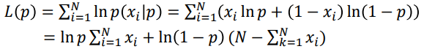

程式碼對上述式子 計算對p微分=0結果

Bernoulli samples, p = 0.25, N = 1000,

Maximum likelihood 𝑝̂ = 0.2560

1. (b)

Bernoulli samples, p = 0.5, N = 1000,

Maximum likelihood 𝑝̂ = 0.4810

1. 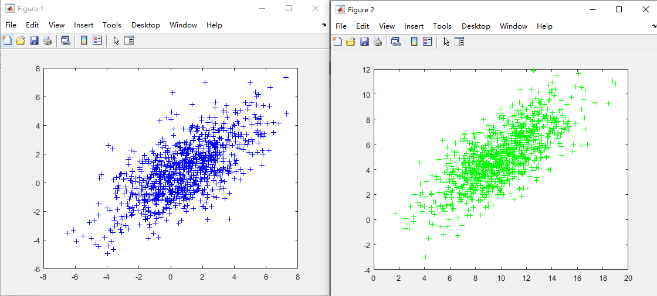
2. 藍色 資料1, 綠色 資料2

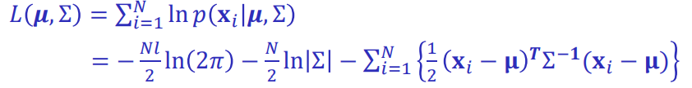

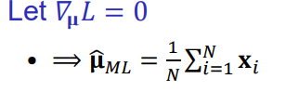

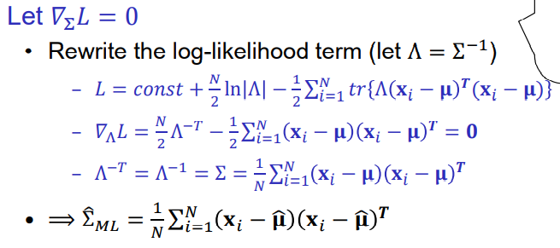

第二題程式碼估算 直接使用最後微分完的結果

2-D normal samples x, μ = [1; 1], Ʃ = [5 3; 3 4]

${\hat{μ}}_{ML}$ = [1.0033; 1.0093]

$Ʃ_{ML}$ = [5.0694 3.2737; 3.2737 4.37]

1. (b)

2-D normal samples x, μ = [10; 5], Ʃ = [7 4; 4 5]

${\hat{μ}}_{ML}$ = [10.0756; 4.9446]

$Ʃ_{ML}$ = [7.1255 4.0990; 4.0990 5.1915]