Hw3 109062502 劉育騏

1. (a)

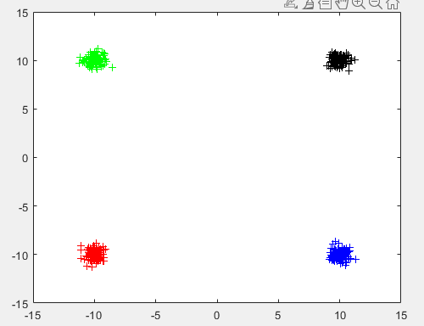

Sw = [0.2060,0.0067;0.0067,0.2010]

Sb = [100,0;0,100]

Sm = [1.002e+02,0.0067; 0.0067,1.002e+02]

J3 = 985.8789

(b)

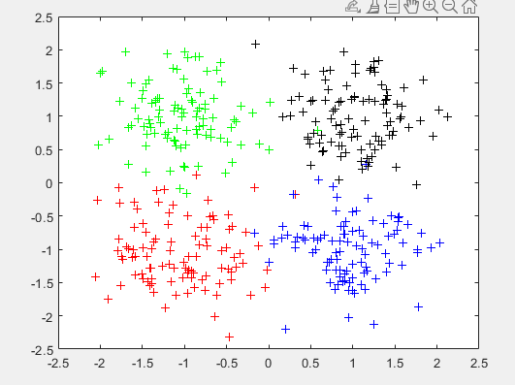

Sw = [0.2173,-0.01517; -0.01517,0.2170]

Sb = [1,0;0,1]

Sm = [1.2173,-0.0151; -0.0151,1.21708]

J3 = 11.2537

(c)

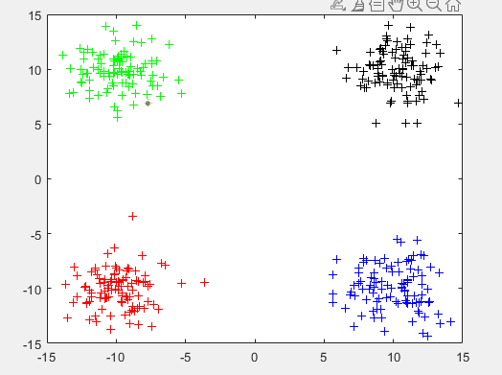

Sw = [3.1896,-0.1222;-0.1222,3.1475]

Sb = [100,0;0,100]

Sm = [103.1897,-0.1223; -0.1223,103.1475]

J3 = 65.2161

1. (a)

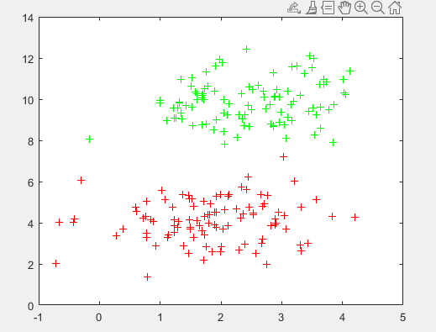

FDR (x1軸, x2 軸) = [0.2334,15.6594]

(b)

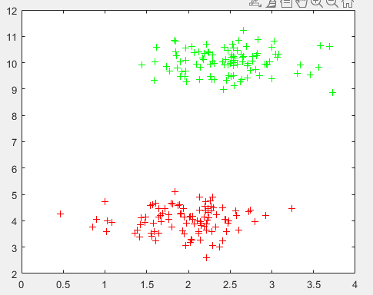

FDR (x1軸, x2 軸) = [0.5938, 80.0505]

(c) 共變異數越小，FDR值越大

3.

(a)

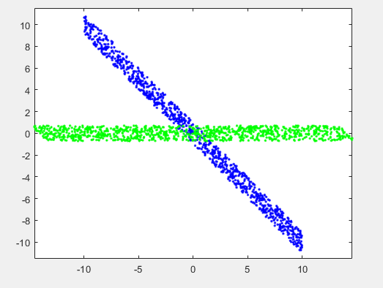

藍色 是原本 x 資料, 綠色是經過PCA運算過的資料

(b)

PCA 將原本的資料 投影到x1軸上