GymTrack — Implementation Documentation
Louis Francis Lim | IT342-G01 | Generated July 06, 2026

1. GitHub Commit History
Repository: https://github.com/louisflim/gymtrack
Commits page: https://github.com/louisflim/gymtrack/commits/main
Note: Insert a screenshot of the GitHub commit history page in the space below (GitHub → gymtrack repository → Commits tab).
[ SCREENSHOT PLACEHOLDER — GitHub Commit History ]

# | Commit Hash | Date | Commit Message | Description
1 | b9449f6  b9449f6c12627b4f8da64460ddc13294d25aad5b | 2026-07-01 07:45:22 +0800 | Initial Commit | Project repository initialization.
2 | ccb74f8  ccb74f8d23c301123722094621dc05a73332c82e | 2026-07-01 18:00:46 +0800 | second commit | Spring Boot backend scaffold: JWT security, AuthController, User entity, login/register API, React frontend auth pages, Supabase datasource configuration.
3 | aa881cd  aa881cd7bc1ec9d2f57a29800a990d789360fa4b | 2026-07-01 19:18:57 +0800 | fix some bugs | Fixed API proxy configuration for web dev server and database connection properties.
4 | 2b11064  2b11064f1cc99f3063290e0d826c28db05249956 | 2026-07-01 19:24:18 +0800 | Create README.md | Added project README with SRS summary, tech stack, and setup instructions.
5 | 6b9b568  6b9b568ffe249b8c187d24e38ca19b6ea2215b9e | 2026-07-01 19:47:13 +0800 | added dashboard | Renamed frontend to web/, added web dashboard page shell, included final SRS PDF in docs.
6 | 38ec787  38ec7878b0ad5b012f122f0ee28077796eec51ea | 2026-07-02 10:17:29 +0800 | Initializes the mobile | Android Kotlin project setup: Retrofit API client, DataStore session, Compose auth screens, navigation graph, GymTrack theme.
7 | d47a6ce  d47a6ce09f9fb42456563a940e42dedd9c9ec4d2 | 2026-07-02 19:05:50 +0800 | Added the mobile login and register | Web auth UI refactor, QR attendance backend (QrController, AttendanceController), staff creation endpoint, mobile dashboard with QR scanner and member QR card.
8 | 284c6d0  284c6d0b379731278d07444e15c05e2c8db550a7 | 2026-07-04 08:05:49 +0800 | updates | Major feature batch: membership/plans/payments (PayMongo), admin dashboard KPIs, member/staff management APIs, gym enrollment QR flow, full web admin panels and mobile parity.
9 | 0e3151b  0e3151b367b5fd2373b1eb6f1059c430cf7a86f0 | 2026-07-05 08:20:29 +0800 | layout updates and ui | Mobile UI migration from Jetpack Compose to XML layouts with Fragments, ViewBinding, RecyclerView adapters, and QrScannerDialogFragment.

Commit-to-Feature Mapping
Feature Area | Primary Commit
User Authentication (backend + web) | ccb74f8
Web dashboard shell | 6b9b568
Android project initialization | 38ec787
QR attendance + web/mobile auth UI | d47a6ce
Plans, payments, membership, admin dashboard | 284c6d0
Mobile XML UI migration | 0e3151b

Submission note: Commits 284c6d0 and 0e3151b bundle multiple features. For future work, split each SRS feature into its own commit with a descriptive message (e.g., feat(backend): add PayMongo checkout endpoint).

2. Implementation Explanation Report

Feature 1: User Authentication and Account Management
Purpose: Secure registration and login with role-based access. Gym Owners register as Admin, Members self-register, and Admin creates Staff accounts.
ReactJS components: Login/index.jsx, Register/index.jsx, RegisterForm.jsx, CreateStaffForm.jsx, api/auth.js
Android screens/fragments: LoginFragment, RegisterFragment (XML), AuthViewModel, AuthRepository
Spring Boot — Controller: AuthController | Service: AuthService | Repository: UserRepository, GymRepository | Entity: User, Gym, Role | DTO: LoginRequest, RegisterRequest, AuthResponse, StaffAccountResponse
API endpoints:
HTTP Method | Endpoint | Description
POST | /api/auth/register | Create Admin or Member account
POST | /api/auth/login | Authenticate and return JWT
POST | /api/auth/staff | Admin creates Staff account

Database tables: users, gyms
Data flow: User submits form → React/Android calls API → AuthController → AuthService validates role, hashes password (BCrypt), saves User → JwtUtil issues token → client stores session → subsequent requests include JWT via interceptor.
Key source files:
- • backend/.../config/SecurityConfig.java — JWT filter, endpoint security rules
- • backend/.../security/JwtAuthFilter.java — Validates Bearer token on each request
- • web/src/api/axiosInstance.js — Attaches JWT to API calls
- • mobile/.../data/remote/AuthInterceptor.kt — Mobile JWT interceptor
Testing result: Verified login/register on web and Android. Admin can create staff; staff cannot self-register. Invalid credentials return clear error messages.
[ SCREENSHOT PLACEHOLDER — insert UI test screenshot for this feature ]

Feature 2: Member Management
Purpose: Admin views, searches, filters, edits members and assigns plans. Members view profile, QR code, payment and attendance history.
ReactJS components: MemberTable.jsx, MemberDashboardPanel.jsx, MemberOnboardingCard.jsx, api/members.js
Android screens/fragments: DashboardFragment (member sections), MemberAdapter, layout_member_onboarding.xml
Spring Boot — Controller: MemberController, MembershipController | Service: MemberService, MembershipService | Repository: UserRepository, MembershipRepository | Entity: User, Membership, MembershipStatus | DTO: MemberResponse, MemberUpdateRequest, AssignPlanRequest, MembershipResponse
API endpoints:
HTTP Method | Endpoint | Description
GET | /api/members | List/search/filter members (Admin)
PUT | /api/members/{id} | Update member profile (Admin)
POST | /api/members/assign-plan | Assign subscription plan
GET | /api/membership/me | Member views own membership

Database tables: users, memberships
Data flow: Admin opens Members tab → GET /api/members → MemberService filters by gym → table renders → Edit dialog → PUT /api/members/{id} → User row updated in Supabase.
Key source files:
- • backend/.../service/MemberService.java — Member CRUD and plan assignment
- • web/src/components/admin/MemberTable.jsx — Search, status chips, edit/assign dialogs
Testing result: Member list loads with search/filter. Edit member and assign plan succeed. Member dashboard shows onboarding steps and gym enrollment status.
[ SCREENSHOT PLACEHOLDER — insert UI test screenshot for this feature ]

Feature 3: Subscription Plan Management
Purpose: Admin creates, edits, activates, and deactivates subscription tiers. Members see active plans for payment.
ReactJS components: PlanForm.jsx, PlanList.jsx, PlanPicker.jsx, api/plans.js
Android screens/fragments: PlanAdminAdapter, PlanAdapter, layout_plan_form.xml, item_plan.xml
Spring Boot — Controller: PlanController | Service: PlanService | Repository: SubscriptionPlanRepository | Entity: SubscriptionPlan | DTO: PlanRequest, PlanResponse
API endpoints:
HTTP Method | Endpoint | Description
GET | /api/plans | List plans (active for members, all for admin)
POST | /api/plans | Create plan
PUT | /api/plans/{id} | Update plan

Database tables: subscription_plans
Data flow: Admin fills plan form → POST /api/plans → PlanService saves plan linked to gym → Member Plans tab loads active plans via GET /api/plans.
Key source files:
- • backend/.../service/PlanService.java — Plan CRUD scoped to admin gym
- • backend/.../util/MembershipStatusUtil.java — Computes Active/Expiring Soon/Expired
Testing result: Create/edit plan works. Inactive plans hidden from member picker. Membership status badges display correctly.
[ SCREENSHOT PLACEHOLDER — insert UI test screenshot for this feature ]

Feature 4: Online Payment (PayMongo)
Purpose: Members pay for subscriptions online. Payment records stored; membership activates after payment confirmation.
ReactJS components: PlanPicker.jsx, PaymentHistory.jsx, PaymentSuccess/index.jsx, api/payments.js
Android screens/fragments: PlanAdapter, PaymentAdapter, Custom Tabs checkout in DashboardViewModel
Spring Boot — Controller: PaymentController | Service: PaymentService, PayMongoService, MembershipService | Repository: PaymentRepository | Entity: Payment, PaymentStatus | DTO: CheckoutRequest, CheckoutResponse, PaymentResponse
API endpoints:
HTTP Method | Endpoint | Description
POST | /api/payments/checkout | Create PayMongo checkout session
POST | /api/payments/webhook | PayMongo payment confirmation webhook
POST | /api/payments/confirm-mock | Dev mock payment confirmation
GET | /api/payments/me | Member payment history
GET | /api/payments | Admin views all gym payments

Database tables: payments, memberships
Data flow: Member selects plan → POST /api/payments/checkout → PayMongoService creates session → browser opens checkout URL → on success webhook or mock confirm → PaymentService marks PAID → MembershipService.activateMembership() sets start/end dates.
Key source files:
- • backend/.../service/PayMongoService.java — PayMongo API integration (GCash, Maya, card)
- • backend/.../service/PaymentService.java — Checkout, webhook handling, activation
Testing result: Mock checkout flow completes and activates membership. Payment history visible on member Activity tab and admin Payments tab.
[ SCREENSHOT PLACEHOLDER — insert UI test screenshot for this feature ]

Feature 5: Attendance Tracking (QR)
Purpose: QR-based gym enrollment and member check-in/check-out. Staff/Admin scan member QR; members scan gym QR to enroll.
ReactJS components: QrScanner.jsx, GymQrCard.jsx, MemberQrCard.jsx, AttendanceLogTable.jsx, api/qr.js
Android screens/fragments: QrScannerDialogFragment, layout_qr_card.xml, AttendanceLogAdapter
Spring Boot — Controller: QrController, AttendanceController | Service: QrAttendanceService | Repository: AttendanceLogRepository, GymRepository | Entity: AttendanceLog, Gym | DTO: QrCodeResponse, ScanRequest, AttendanceScanResponse, AttendanceLogResponse, MemberGymScanResponse
API endpoints:
HTTP Method | Endpoint | Description
GET | /api/qr/me | Member personal QR code
GET | /api/qr/gym | Staff/Admin gym enrollment QR
POST | /api/attendance/scan | Staff scans member QR (check-in/out)
POST | /api/attendance/scan-gym | Member scans gym QR to enroll
GET | /api/attendance/me | Member attendance history
GET | /api/attendance/gym | Admin attendance logs with filters

Database tables: attendance_logs, users, gyms
Data flow: Staff opens scanner → camera reads QR payload → POST /api/attendance/scan → QrAttendanceService validates membership → creates/updates AttendanceLog (check_in_time, check_out_time) → returns member name, plan, status, action.
Key source files:
- • backend/.../service/QrAttendanceService.java — QR generation, scan logic, enrollment
- • web/src/components/qr/QrScanner.jsx — Webcam QR scanner with camera cleanup
Testing result: Gym QR enrollment works. Member QR scan toggles check-in/out. Expired memberships denied. Attendance logs filterable by date and name.
[ SCREENSHOT PLACEHOLDER — insert UI test screenshot for this feature ]

Feature 6: Admin Dashboard
Purpose: Admin overview of gym KPIs, staff management, and consolidated admin tabs for plans, members, staff, attendance, and payments.
ReactJS components: AdminDashboardPanel.jsx, KpiSummaryGrid.jsx, Dashboard/index.jsx, api/dashboard.js
Android screens/fragments: DashboardFragment admin sections, KpiAdapter, layout_create_staff.xml
Spring Boot — Controller: DashboardController, StaffController | Service: DashboardService, StaffService | Repository: UserRepository, PaymentRepository, AttendanceLogRepository | Entity: User (staff/members), Payment, AttendanceLog | DTO: DashboardStatsResponse, StaffResponse, StaffUpdateRequest
API endpoints:
HTTP Method | Endpoint | Description
GET | /api/dashboard/stats | KPI metrics for admin home
GET | /api/staff | List staff accounts
PUT | /api/staff/{id} | Edit/deactivate staff

Database tables: users, memberships, payments, attendance_logs
Data flow: Admin opens Home tab → GET /api/dashboard/stats → DashboardService aggregates members, active subs, expired, today check-ins, total payments → KPI grid renders.
Key source files:
- • backend/.../service/DashboardService.java — Aggregates gym statistics
- • web/src/components/admin/AdminDashboardPanel.jsx — Tabbed admin UI
Testing result: KPI cards populate with live data. Staff create/edit works from Overview tab. All admin tabs load without errors on web and mobile.
[ SCREENSHOT PLACEHOLDER — insert UI test screenshot for this feature ]

3. System Architecture Diagram
GymTrack uses a three-tier architecture: ReactJS web app and Android Kotlin app both consume the same Spring Boot REST API, which persists data in Supabase (PostgreSQL) and integrates PayMongo for online payments.
Component | Layer | Connection | Responsibility
ReactJS Web App | Browser UI | axios → REST API | Login, Dashboard, QR scanner, Admin panels
Android Kotlin App | Mobile UI | Retrofit → REST API | Fragments, ViewBinding, ZXing QR scanner
Spring Boot Backend | REST API layer | Controllers → Services → Repositories | JWT auth, business logic
Supabase PostgreSQL | Database | JDBC / Hibernate JPA | users, gyms, plans, memberships, payments, attendance_logs
PayMongo | External payment gateway | HTTPS webhook + checkout API | GCash, Maya, credit/debit card

Architecture Diagram
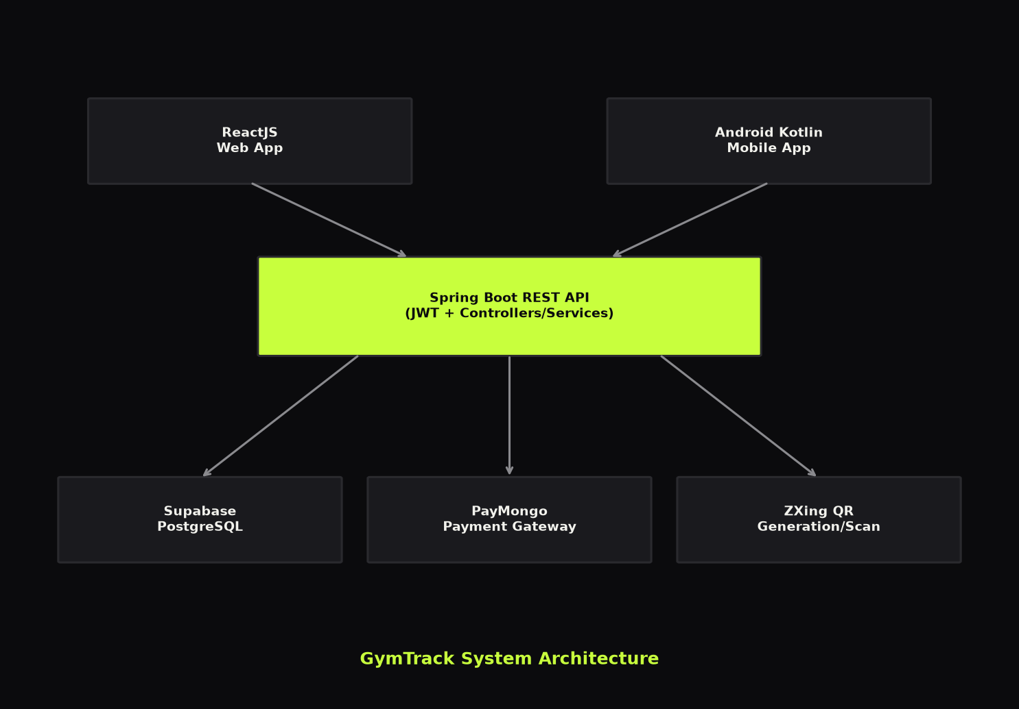

┌─────────────────────┐ ┌─────────────────────┐
│ ReactJS Web App │ │ Android Kotlin App │
│ (Chrome/Firefox) │ │ (Retrofit + ZXing) │
└──────────┬──────────┘ └──────────┬──────────┘
│ HTTPS / JSON │
└──────────────┬───────────────┘
▼
┌───────────────────────┐
│ Spring Boot Backend │
│ REST API + JWT Auth │
│ Port 8080 │
└───────────┬───────────┘
│
┌──────────────┼──────────────┐
▼ ▼ ▼
┌──────────────┐ ┌──────────┐ ┌─────────────┐
│ Supabase │ │ PayMongo │ │ ZXing QR │
│ PostgreSQL │ │ Checkout │ │ (embedded) │
└──────────────┘ └──────────┘ └─────────────┘

Request Flow (Example: Member Payment)
- 1. Member taps Subscribe on web or Android Plans tab.
- 2. Client sends POST /api/payments/checkout with planId and JWT.
- 3. PaymentController → PaymentService creates PENDING payment row.
- 4. PayMongoService creates checkout session; returns checkout URL.
- 5. Client opens PayMongo hosted page (GCash/Maya/card).
- 6. PayMongo sends POST /api/payments/webhook on success.
- 7. PaymentService marks payment PAID; MembershipService activates membership.
- 8. Member dashboard refreshes; status shows Active with new end date.

Request Flow (Example: QR Check-in)
- 1. Staff opens QR scanner on web or mobile Scan tab.
- 2. Camera reads member QR payload (gymtrack:member:{userId}).
- 3. Client sends POST /api/attendance/scan with qrData and JWT.
- 4. QrAttendanceService validates membership status (Active/Expiring).
- 5. If no open visit: creates attendance_logs row with check_in_time.
- 6. If open visit exists: sets check_out_time on same row.
- 7. Response shows member name, plan, status, and CHECK_IN or CHECK_OUT.

