Supernova software website evaluation
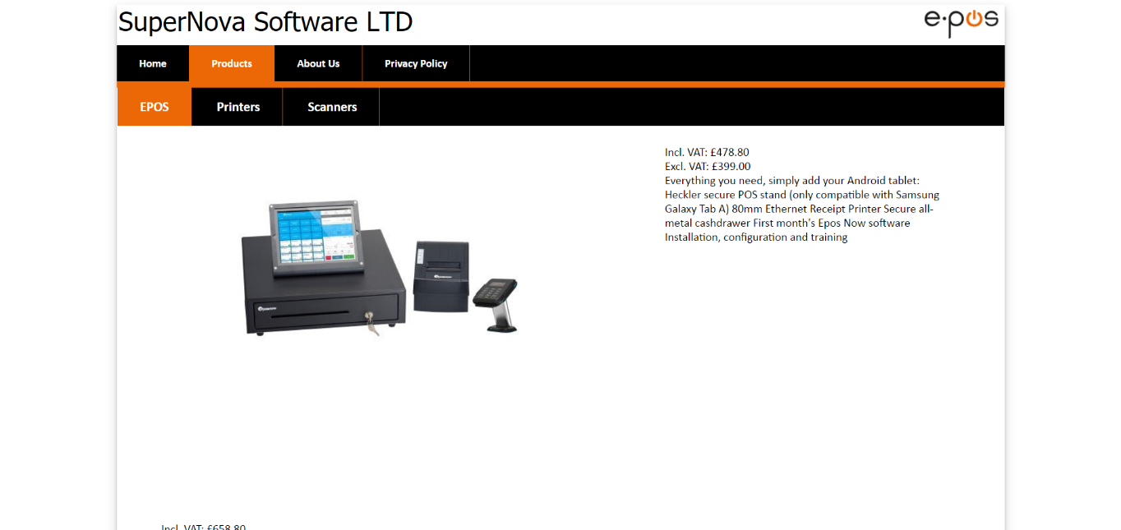
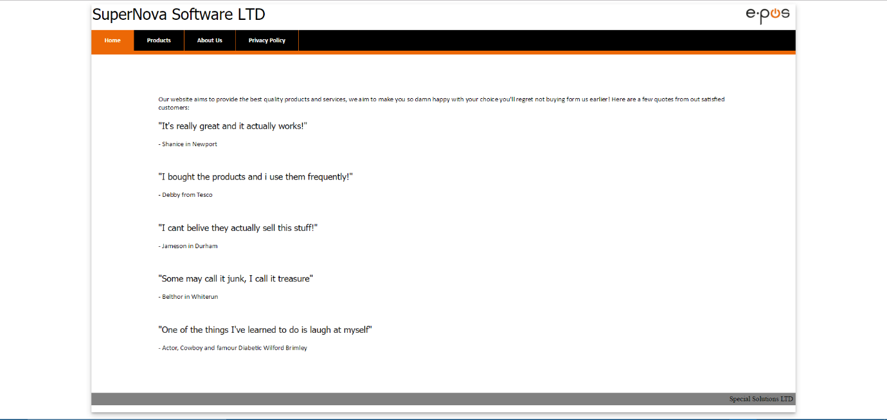
The house style of the website adheres to the logo, keeping the same orange and black simple aesthetic throughout the pages, appearing on the navigation bars and highlighting orange when on a current page.
The home page, or ‘index’ is of an incredibly simple appearance consisting of quotes from customers commending the products. It needn’t be complex or overwhelming, as the first page a customer sees should not be repelling.
The first content page is the EPOS products page. The products element in the main navigation bar acts as a drop-down menu, providing three more unorganised list anchors, each of which link to their respective products page. Once again, the currently-viewed pages navigation-bar elements are highlighted in orange, and as EPOS is a sub-page of products, it is also highlighted.

There is a significant issue with the products pages; they all have bad image and text positioning:
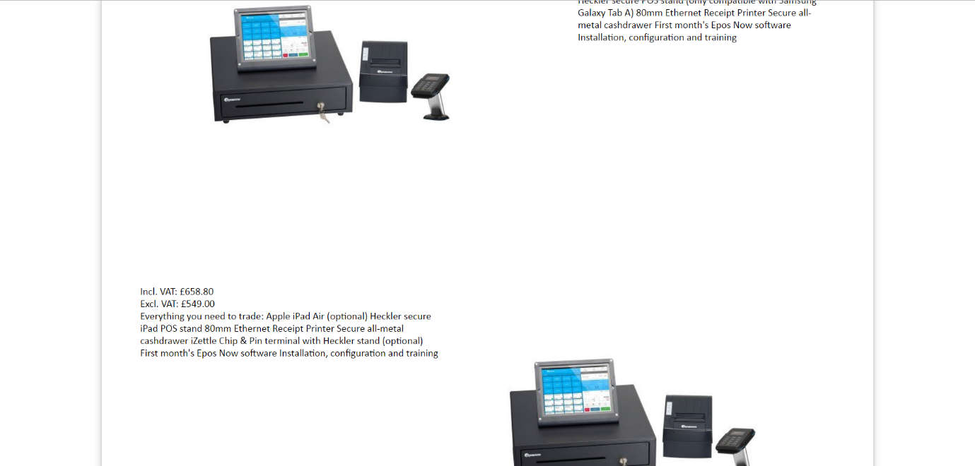
This is a truly unappealing layout as it looks completely unprofessional and shoddy. The idea is effective, in essence as having the first product appear to the left with its description on the right followed by an image underneath on the right side with its decription on the left makes for a good flow of visuals, however the implementation is weak and need revising. This is consistent throughout each product page.

The ‘about us’ page proceeds the products dropdown. The pages consists of a simple clear image which displays varios facts regarding the SuperNova Software company. The image is followed by some persuasive and descriptive text, further selling the company. The page adheres to the house style and is clearly presented.
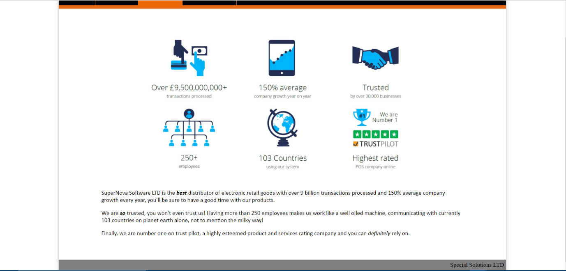
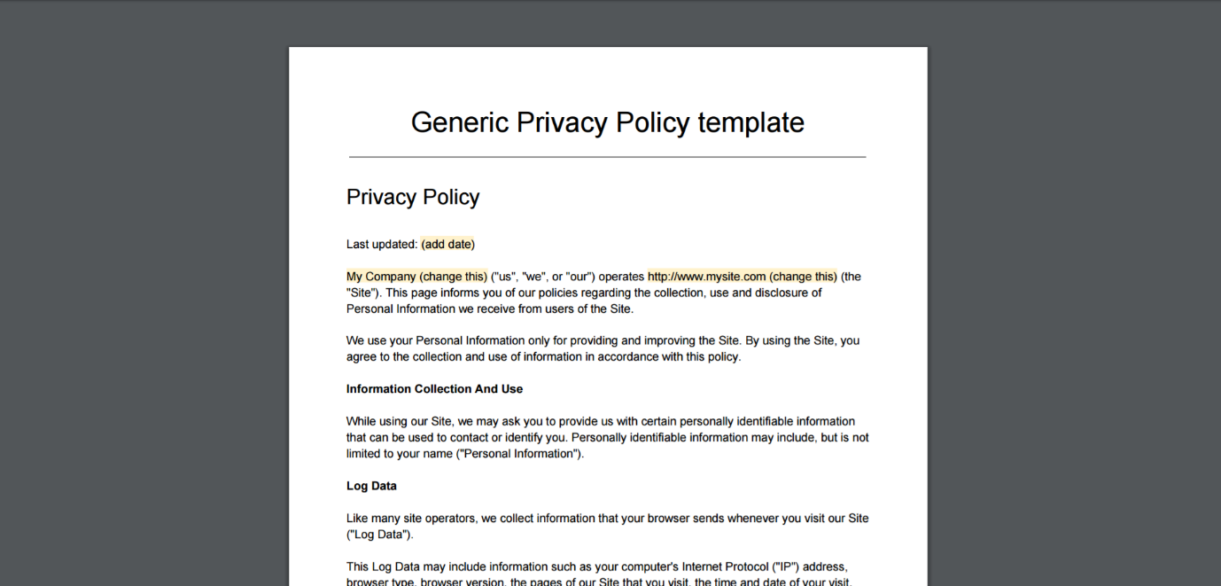
The privacy policy on the navigation bar downloads a copy of the SuperNova Software’s privacy policy in the pdf file format. This allows a user to read a portable copy of the privacy policy anywhere.

This simple input rating test shows how well the SuperNova Software fares in terms of respective elements and as an entire entity. The website fares well in terms of navigability as the bars are clear, simple, and well indicated. The images used are relevant but lack professional editing and could have been placed much more effectively and seamlessly. The house style is clearly one of the websites’ strength, as it is consistent and well implemented throughout the website. Overall the website scored 65% which is a fair score, given its simplicity and niche use. With more dedication to image and content spacing, the website would be incredibly professional.

