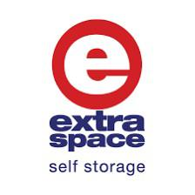

Revenue – Inventory Naming Convention

Jan 2026

POLICY
Establish the convention for the Inventory Setup in Sitelink to facilitate the Rate Management & Standardize Reporting.

PROCEDURES

1-Scope:

Applicable to all Storage Management Systems (e.g. Sitelink, Storeganise).

2-Responsibilities:

 |  | Team
Category | Role | Revenue | Marketing | Operations | Customer Service
Inventory Conventions &Rules | Define the Naming convention | ü | - | - | -
Inventory Conventions &Rules | Check adaptability to OPS processes | - | - | ü | -
Implementation | Update Unit Category on Sitelink | ü | - | - | -
Implementation | Update Unit Description on Sitelink | - | - | ü | -

3-Naming Convention

Unit Size Category- Mandatory
Code | Description | Range
S | Small | ≥0 sqft to <30 sqft
M | Medium | ≥30 sqft to <60 sqft
L | Large | ≥60 sqft to <90 sqft
XL | X-Large | ≥90 sqft

Unit Size Range- Mandatory
Range (SQFT) | Description
0-6 | ≥0 sqft to <6 sqft
6-8 | ≥6 sqft to <8 sqft
8-10 | ≥8 sqft to <10 sqft
10-12 | ≥10 sqft to <12 sqft
12-14 | ≥12 sqft to <14 sqft
14-16 | ≥14 sqft to <16 sqft
16-18 | ≥16 sqft to <18 sqft
18-20 | ≥18 sqft to <20 sqft
20-22 | ≥20 sqft to <22 sqft
22-24 | ≥22 sqft to <24 sqft
24-26 | ≥24 sqft to <26 sqft
26-28 | ≥26 sqft to <28 sqft
28-30 | ≥28 sqft to <30 sqft
30-35 | ≥30 sqft to <35 sqft
35-40 | ≥35 sqft to <40 sqft
40-45 | ≥40 sqft to <45 sqft
45-50 | ≥45 sqft to <50 sqft
50-60 | ≥50 sqft to <60 sqft
60-70 | ≥60 sqft to <70 sqft
70-80 | ≥70 sqft to <80 sqft
80-90 | ≥80 sqft to <90 sqft
90-110 | ≥90 sqft to <110 sqft
110-130 | ≥110 sqft to <130 sqft
130-150 | ≥130 sqft to <150 sqft
150-175 | ≥150 sqft to <175 sqft
175-200 | ≥175 sqft to <200 sqft
200-225 | ≥200 sqft to <225 sqft
225-250 | ≥225 sqft to <250 sqft
250+ | ≥250 sqft

Unit Type - Mandatory
Code | Description | Notes
Walk-In
W | Walk-In
E | Executive Walk-In | Co Workspace & Biz+
S | Smart Walk-In | Noke or Other Smart Lock
Locker
U | Locker Upper
M | Locker Middle
L | Locker Lower
SU | Smart Locker Upper | Noke or Other Smart Lock
SM | Smart Locker Middle | Noke or Other Smart Lock
SL | Smart Locker Lower | Noke or Other Smart Lock
EU | Executive Locker Upper | Co Workspace & Biz+
EM | Executive Locker Middle | Co Workspace & Biz+
EL | Executive Locker Lower | Co Workspace & Biz+
Wine
WN | Wine Walk-In
WNU | Wine Locker Upper
WNM | Wine Locker Middle
WNL | Wine Locker Lower
Others
DV | Drive-Up
RB | Wardrobe
MB | Mailbox
BZ | BizPlus
SC | Showcase
SB | SubTenant
PR | Parking

Deleted / Merged
Code | Description | Notes
BW | BFS Walk-In | Merged with Executive

Climate Type - Mandatory
Code | Description
NC | No Climate Control
A | Aircon Only
D | Dehumidifier Only
AD | Aircon + Dehumidifier
RF | Refrigerated

Unit Shape- Mandatory
Code | Description | Rule
SS | Square | Ratio Length/Width ≥0.8 to ≤1.2
WR | Wide Rectangle | Ratio not 0.8-1.2, AND Length & Width both ≥1500mm
NR | Narrow Rectangle | Ratio not 0.8-1.2, AND Length OR Width <1500mm
OS | Odd Shape | Manual verification

Pillar- Mandatory
Code | Description
P | Pillar in unit
NP | No pillar in unit

Labeling / Sorting
Field | Value
Field Type | Alpha-numerical
Character Limit | 30 characters
Structure | Size / Range / Type / Climate / Shape / Pillar
Separator | /

Sitelink Setup

Unit Types Creation
- On Sitelink go to Site Management->Unit Management->Unit Types
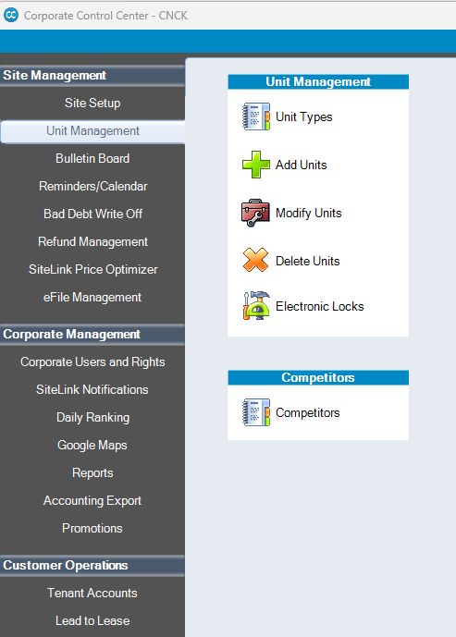
- Rename or create the appropriate Unit Type based on each Site inventory specification.
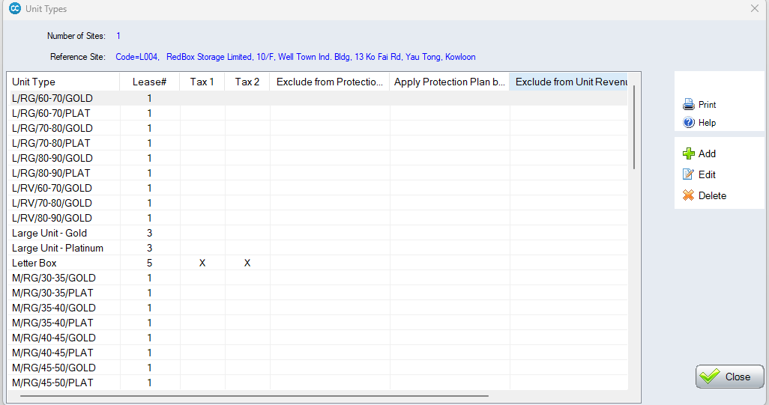

Inventory
- Once the Unit Type is created go to Site Management->Unit Management->Modify Units

- Select the Units that you need to modify & click Edit Selections.
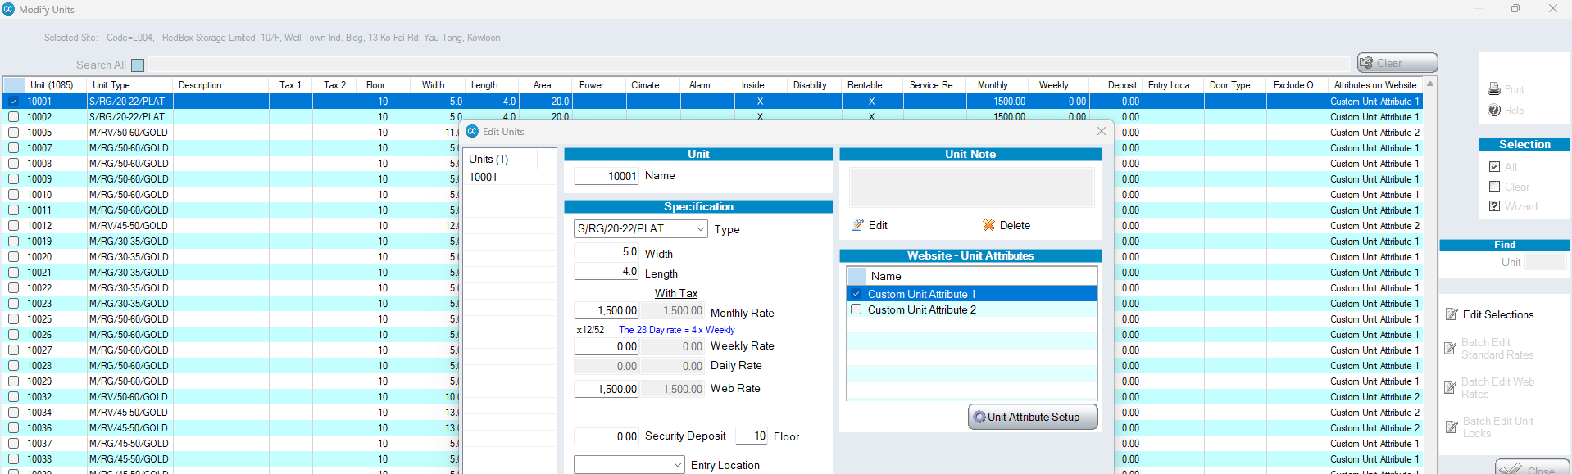
- Edit the Type as per the Unit Specification. Bulk update are possible but must be used carefully.
- Click OK to Save.

