CASTLE RAVENLOFT
ADVANCED RULES

INTRODUCTION

Now that you have played the standard game, perhaps
you would care to try something a bit more complex.
These Advanced Rules are meant to enhance what
is already present, increasing the strategic level involved
and allowing a (hopefully) deeper level of experience and
enjoyment. These rules come from many sources. They are
inspired by classic Dungeons and Dragons, variants posted
online, and personal ideas. These rules are meant
to be used in addition to the basic game, not a complete
replacement. If something is not included here, please refer
to the original RULEBOOK for clarification. Copyright
infringement is not the intent of this manual, it is provided
purely for added enjoyment of an already great game.

OVERVIEW of GAMEPLAY CHANGES

These are the changes that take place under the Advanced Rules, and are
always superseded by special scenario or card specific rules. Detailed information
follows the list.

- You may now create a character.
- The ability to level up from 1st through 9th level.
- Heroes have an unlimited number of “Free Actions” which they may
perform during their Hero Phase.
- Heroes usually start with 1 Healing Surge each, which are not pooled (but can be shared).
- Heroes may give items to other adjacent Heroes as a Free Action during their own Hero Phase.
- If a Player's Hero dies, other Players may continue the adventure.
- Instead of 1 Monster Card, draw a Monster Token to determine the number of
Monsters per tile.
- Initiative: White Arrow for Heroes, Black Arrow for Monsters.
- Exploration does not end the Hero Phase if you have Initiative.
- Encounters are only drawn when laying Black Arrow tiles, or if you neither explored nor attacked during your Hero Phase.
- Scaling Difficulty for High Level (6th or higher) Heroes.

Free Actions

Heroes have an unlimited number of of “Free Actions” which they may perform
during their Hero Phase. These are typically (but not always) scenario specific actions
which do not count as an attack or movement. Examples include: Using a Healing Surge,
taking the Icon of Ravenloft (in Adventure 2), giving an item to an adjacent Hero, etc.
Any action your Hero may perform which does not count as an attack or movement
may be considered a Free Action.

PLAYER SETUP

Players may choose to use one of the pre-generated characters
included in the basic game, variant characters provided online,
or they may create their own character using the blank
Character Record Sheet provided at the end of this manual.
A character is created by filling in the Name, Race/Class, and
other information on the card. The basic Race/Class combinations
are: Human Rogue, Human Ranger, Dwarf Cleric, Dragonborn Fighter,
and Eladrin Wizard. Any Race may be combined with any Class, however,
Dragon's Breath may only be used by the Dragonborn race, and Fey Step
only by the Eladrin race. Further examples of Race/Class combinations
can be found online. Use the 1st level stats when filing in the blank Character Record Sheet. Feel free to draw a picture of your new character, or use image editing software to add one in the space provided. Heroes start with 1 Healing Surge each at the beginning
of every adventure unless specified otherwise by the scenario. They are not pooled,
but can be “given” to an adjacent fallen Hero. A Hero with zero Hit Points and no Healing Surges left may use that adjacent Hero's Healing Surge as if it were their own at the beginning of their own Hero Phase. There is no time limit for when this must happen.
They were simply laying unconcious and wounded, waiting to be revived.
Remember: Heroes who reach Level 6 begin with 2 Healing Surges.

LEVELING

Characters begin at 1st level unless determined otherwise before
play. Characters may increase their level by paying 6 experience as
a Free Action any time during their Hero Phase. Record the character level at
the bottom of the Character Record Sheet. Benefits of advanced
levels are listed below. Additional Powers must be chosen from those
available for their class. Players may retain their level from previous
adventures, but all treasure is sold or given away at the end of each scenario-
it's expensive maintaining your heroic lifestyle!

Level Benefit
2 +1AC, +2HP, +1HP to Surge Value, Choose 1 additional Daily Power.
3 Choose 1 additional At-Will Power and 1 additional Utility Power.
4 +2HP.
5 Choose 1 additional Daily Power or 1 additional Utility Power.
6 Hero immediately gains an additional Healing Surge, and
begins new adventure with 2.
7 +1AC
8 Choose 1 Additional At-Will Power or 1 additional Utility Power.
9 Heroes gain access to ALL of their class powers.

EXPLORING THE DUNGEON

Unlike the basic game, in the Advanced Rules the Hero Phase does not
always end when the Exploration Phase begins. If a Hero arrives at an
Unexplored Edge and wishes to Explore, they lay a Dungeon Tile as normal.
If the tile has a White Arrow, the Hero may continue their movement into
the tile and may attack any Monsters they find (if able). They have Initiative, and
managed to surprise the Monsters. However, if the tile has a Black Arrow,
the Hero was surprised by the sudden appearance of the Monsters and
the Hero Phase ended when the tile was laid down. In this case, the Monsters
have initiative. Rather than simply drawing a Monster Card for each tile,
Monster Tokens are drawn randomly to determine the number of Monsters
present, 0 to 3. If no Monster is to be placed on the tile, the Hero still stops
due to Encounters (if any). In any case, a Hero may explore only one tile per turn.

Encounter cards are normally drawn when a Hero lays a tile with a Black Arrow,
or if the Hero ends its Hero Phase on a tile but does not Explore or make an
attack during that turn.
A Hero with no Healing Surges (or friends willing to lend one) and 0 HP dies.
If a Player's Hero dies, other Players may continue the adventure. There is no reason for
the rest of the group to give up, unless specified in the scenario. A Player with a dead Hero
may choose to join in the scenario again with a new one, or take over running the Monsters
if that is acceptable to the other Players involved.

SCALING DIFFICULTY

Obviously the included scenarios will be much easier for higher level characters.
The basic game was designed for 1st and 2nd level Heroes only. This
may suit some players who feel the game is too difficult. However, to modify
the difficulty of the game consider these optional changes:
To make things easier for lower level characters, reduce the number of 3 Monster Tokens. To
make things more difficult, reduce the number of 0 Monster Tokens. For
each 6th level Hero, include 1 Villain Token in the pile of Monster Tokens
drawn randomly. When high level characters (6th or higher) are forced to attack each other (due to events/Monster tactics) they will use a Daily Power if available.

Also, Monsters instinctively sense powerful Heroes.
Therefore, they hunt high level characters more effectively. When attacking or
moving towards Heroes of 6th level or higher, Monsters may treat diagonal tiles as
“within 1 tile”. That is, they can move diagonally when moving by tiles, but only in relation to
Heroes of 6th level or higher. This makes the “kiting” strategy very difficult. Epic Heroes rarely
run in circles trying to get away from Monsters!
It is also recommended that Players attempt to position foes more advantageously (for the Monster), rather than to the Player's benefit.
Additionally, it is not recommended to have more than 3 High Level Heroes
playing at once. Certainly, even 2 Heroes at 9th level could easily handle most adventures.

FINAL TIPS

So that's it. With these rules you are only limited by your own imagination...
until you reach 9th level, that is. You get out of the game what you put in, so
a little effort can go a long way towards increasing fun and enjoyment.
Try making a character! Give them personal touches. Try giving them life by
creating the story as you play. If a Hero dies, it is a sad occasion. But unlike
real life, you can always start over with a new one.
Attempt running through several Scenarios in a row. Your Hero will grow as
their epic story unfolds. Try some of the excellent variant adventures posted
online, there are more every day. And most of all, have fun. If something isn't
working or doesn't work for you, change it!

Disclaimer: This Manual was created by the Author for fans of Castle Ravenloft and distribution on Boardgamegeek.com.
It is intended for entertainment purposes only and not connected to Wizards of the Coast in any way. For information or comments, send a message to Psykoduck on www.boardgamegeek.com. Thanks to NinjaDorg and others for template materials. © 2010. V.2

Blank Character Record Sheet
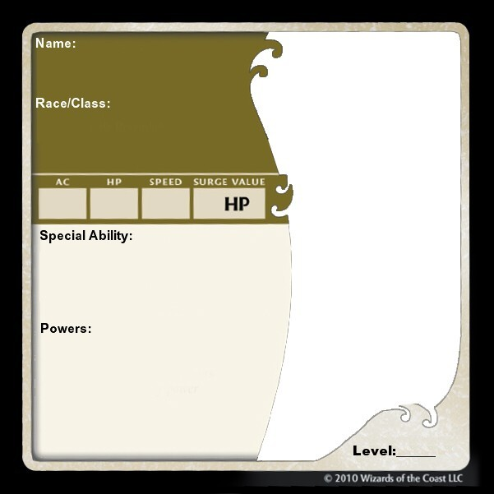

Example 9th Level Dragonborn Fighter

